“AMERICAN PROGRESS” PHOTO DECONSTRUCTION

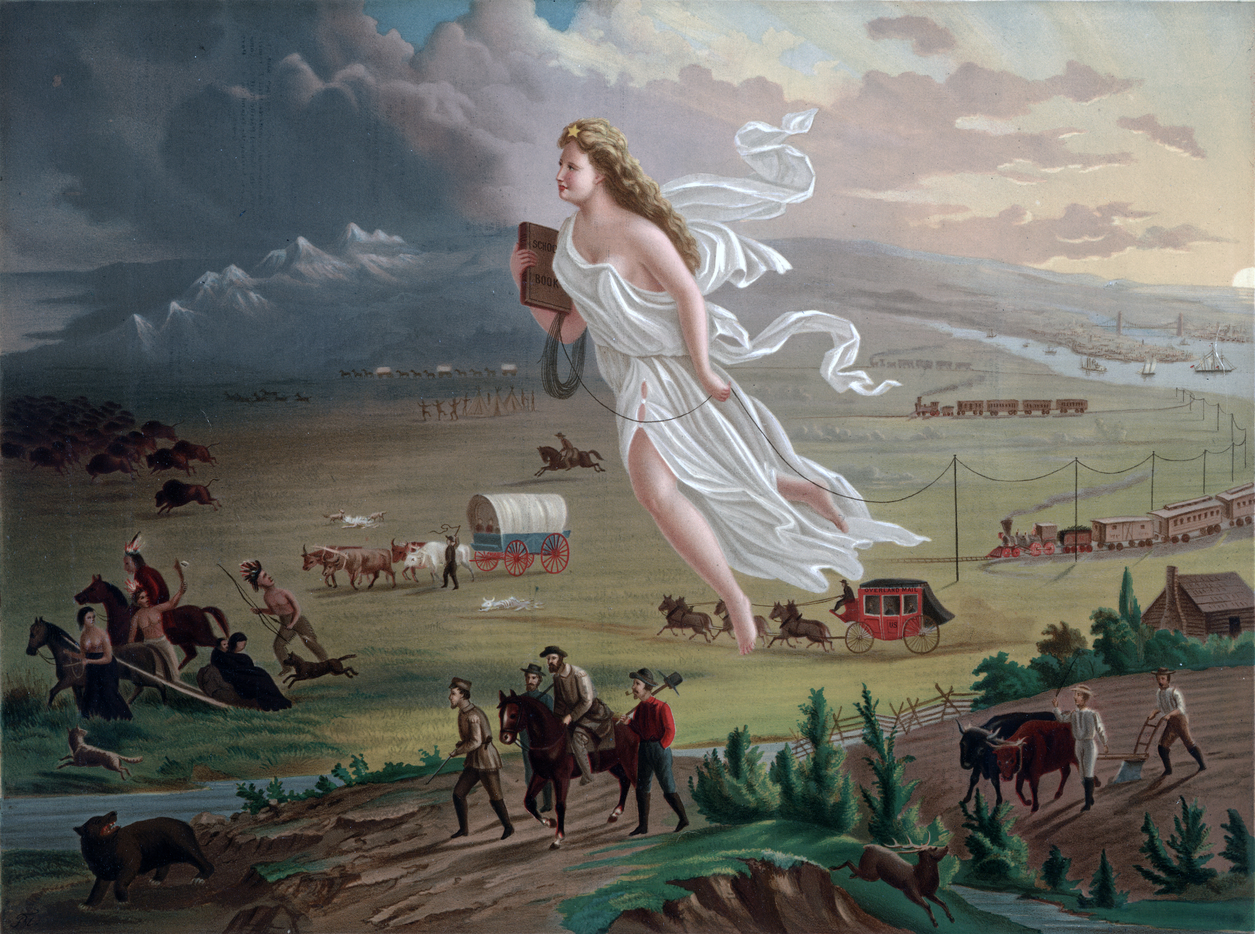
American Progress by John Gast, 1872

Observations  (What do you see?) | Inferences  (What conclusions can you make or interpret, based on what you see?)

Source: Gast, J. (1872). American Progress. Chromolithograph published by George A, Crofutt. Prints and Photographs Division, Library of Congress. Retrieved from: https://upload.wikimedia.org/wikipedia/commons/f/fd/American_Progress_%28John_Gast_painting%29.jpg

