WHAT IS MANIFEST DESTINY?
Use the following quotes to help you determine what you think the term “Manifest Destiny” means. With your group, summarize each quote in 1–2 sentences.
In 1811, John Quincy Adams, sixth president of the United States (1825-1829), wrote:

“The whole continent appears to be destined...to be peopled by one nation. The [pursuit] of a definite line of boundary to the [Pacific Ocean] forms a great [time] in our history.”

Summary:

In 1816, John Melish published the following map and wrote:

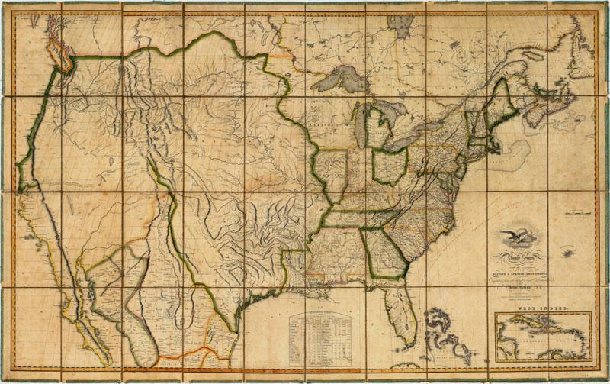

“To present a picture of it was desirable in every point of view. The map so constructed, shows at a glance the whole extent of the United States territory from sea to sea; and in tracing the probable expansion of the human race from east to west, the mind finds an agreeable resting place on its western limits. The view is complete, and leaves nothing to be wished for.”

Summary:

In 1845, John O'Sullivan, a New Yorker and editor, wrote:

“The American claim is by the right of our manifest destiny to overspread and to possess the whole of the continent which [God] has given us for the development of the great experiment of liberty and… self-government. It is a right such as that of the tree to the space of air and earth suitable for the full expansion of its… destiny of growth...”

Summary:

MANIFEST DESTINY IS…
My group’s brainstorms
Class response

Sources:
Adams, John Quincy. Letter to John Adams. August 31, 1811
https://founders.archives.gov/documents/Adams/99-03-02-2020

Melish, John. Map of the United States: With the Contiguous British & Spanish Possessions (1816). Retrieved from: http://digitalcollections.baylor.edu/cdm/ref/collection/tx-maps/id/404

Melish, John. A geographical description of the United States, with the contiguous British and Spanish possessions, intended as an accompaniment to Melish's map of these countries. (1818). Retrieved from: https://catalog.hathitrust.org/Record/009592230

O’Sullivan, John. A true title. New York Morning News. (December 27, 1845).

