Contents
Life is a Highway: Overview…………………………………………………………………………………….  - Materials  - Instructions | 3
Activity #1: Entering the On-Ramp of Your Life ……………………………………………………… | 4
Activity #2: Finding Your Lane ………………………………………………………………………………. | 6
Activity #3: Documenting Your Journey …………………………………………………………………. | 8
Activity #4: Toll Roads: Paying Your Way ………………………………………………………………. | 17
Activity #5: Mapping Out Your Future …………………………………………………………………… | 19
Sources …………………………………………………………………………………………………………………. | 21

LIFE IS A HIGHWAY: OVERVIEW

Just like in the popular board game, “The Game of Life,” you have to make occasional pit stops along the journey that is life. You will soon be making important decisions that will affect your entire life. Now is the time to choose the career you want. You want to make sure you select the right colleges, technical schools, or certification programs that will help you achieve your career goals. All of these are important considerations to keep in mind as you continue your journey.

Some of the resources that will help you make this journey more efficiently are listed below:

Materials
- High School Resume Tracker  - Scholarship Tracker  - 3-Column Chart  - Section Dividers with the following headings:  - Volunteer Work  - Awards  - Leadership  - Extracurricular  - Academics Beyond the Classroom | - Tablet or personal device  - Internet access  - 3-Ring Binder, file box, or organizer  - Sheet protectors  - Poster Board  - Pens/Pencils/Markers/Pens/Glue  - Old Magazines  - Vision Board Templates  - My Vision Board  - How to Create a Vision Board (Optional)

Instructions
- Entering the On-Ramp of Your Life. Begin by getting yourself organized by researching basic information for the career you are interested in having.
- Finding Your Lane. Once you have begun the journey, determine which exit is right for you. Does the job you want require a college degree? Technical training? Certification programs? An apprenticeship?
- Documenting Your Journey. Begin early in high school so that writing those essays, letters, and resumes will be easy by the time you are a senior.
- Toll roads: Paying Your Way: Apply early for scholarships to help pay for your education and training.
- Mapping Out Your Future. Create a vision board or a plan that outlines and displays your goals.

ACTIVITY #1: ENTERING THE ON-RAMP OF YOUR LIFE

You may already have a strong idea of what you want to do when you’re out of high school, what your future career will be, and where you want to go to school. But are you fully prepared?
This activity will help you find specific information about your career choice and what you need to do to achieve that goal:
- Knowing what skills, training, and education are necessary to help you determine where you need to increase your skill set.
- Knowing education and skills requirements will help you narrow your focus and enable you to choose the right colleges.
- Knowing ahead of time what the average salary is for your preferred job/career will help you determine how much you are willing to spend on an educational/training program.
- Knowing your potential salary will influence your decisions about potential student loans.
Materials:
- Tablet or personal device
- Internet access
- Pen or pencil

Instructions:

- Visit the website My Next Move. This website will help you gather the necessary information about the careers you are interested in.
- There are three ways you can research for information about your desired career:

  - Search Careers with Key Words. Type in words that relate to what you want to do.

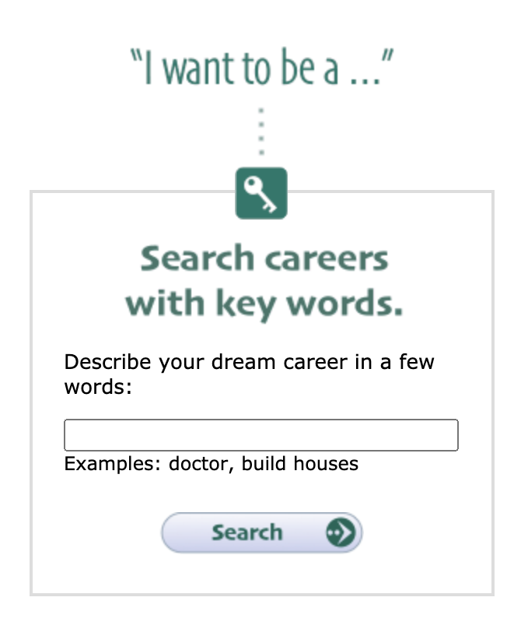

  - Browse Careers by Industry. Use the drop-down menu to scroll down to careers you are interested in.
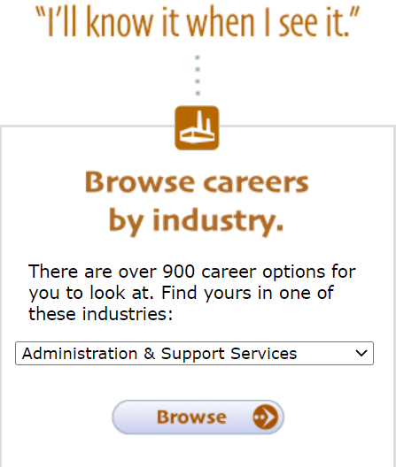

  - Tell Us What You Like to Do. Create your own personal “career profile” by answering questions in the O-Net Interest Profiler. Be candid about your likes and dislikes and your strengths and weaknesses.

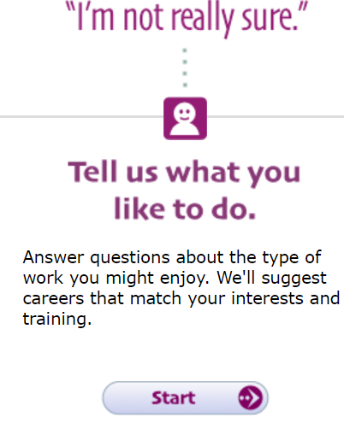

- As you are planning your profile, consider the following questions:
- What is the career title?
- What career cluster does this fall under?
- What does someone in this job do?
- What skills do I need in order to do this job?
- What kind of education or training do I need to do this job?
- What is the average salary for this career field?

Don’t close the website. You will need it for the next activity.

ACTIVITY #2: FINDING YOUR LANE
At this point in your journey, you have an idea of what you would like to do for a living. The first question you should ask is “How do I get there?”
Materials:

- Tablet or personal device
- Internet access
- Pen or pencil
- 3-Column Chart

Instructions:
- Imagine that you want to become an elementary school teacher. In the Search Careers with Key Words box, type the word teacher. The search results will take you to a menu page with a list of different kinds of teacher choices. Select Elementary School Teachers. The screen below is your starting point. Review the general information related to your preferred career: required/recommended Knowledge/Skills/Abilities/Education. Check out the infromation regarding recommended technical skills and potential salary.

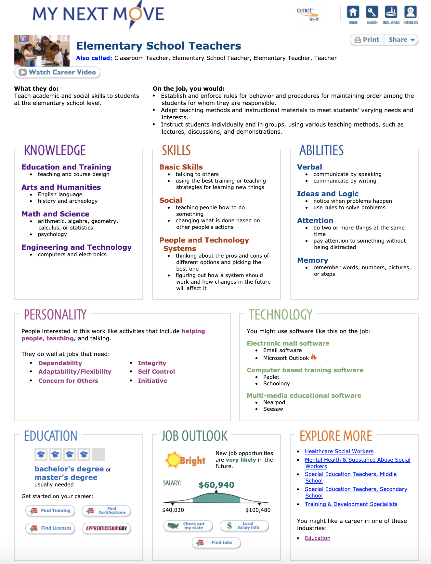

- Locate the Education block in the bottom left corner of the page. There are links for you to select:

  - Find Training
  - Find Certifications
  - Find Licenses
  - Apprenticeship.gov

- Select Find Training.
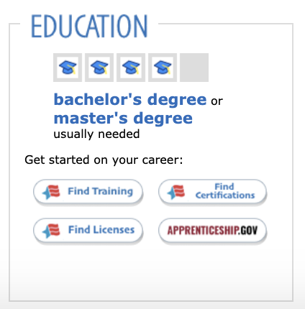
- You will be prompted to select the state you want to search. Select Oklahoma.

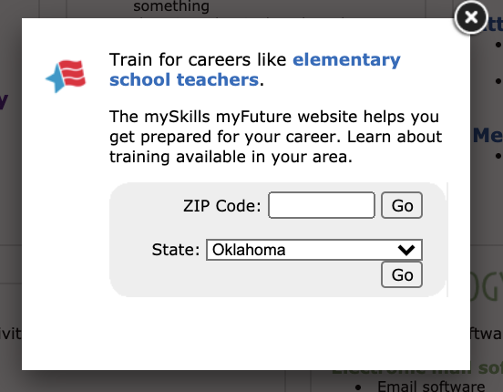
- A list of appropriate programs will come up for you to search based on your location.

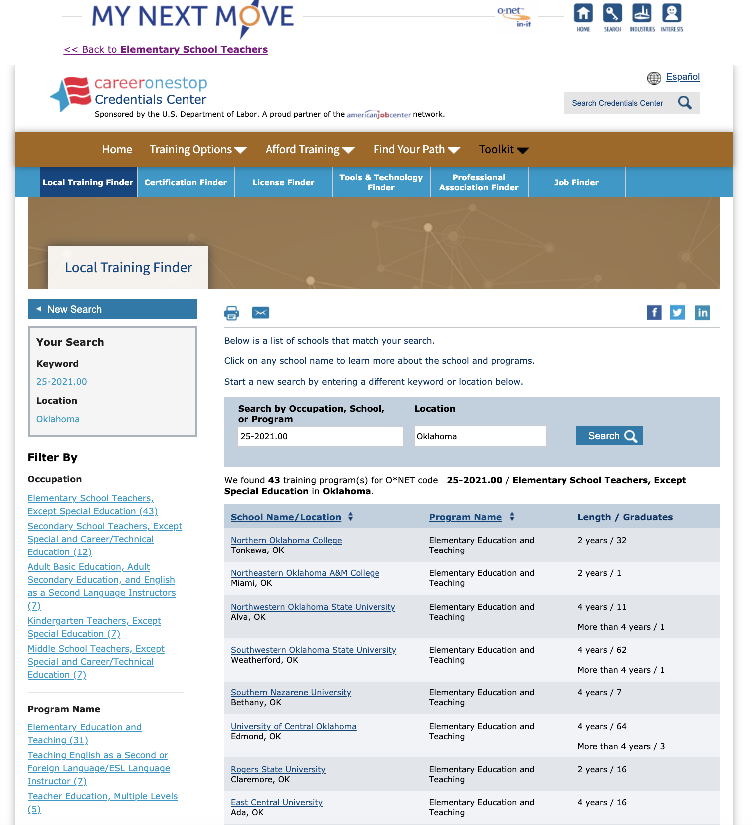
- Take time to review at least five (5) of the schools you think you might be interested in.
- For each of the programs you visit, create a Pro/Con/Requirements 3-Column Chart. You can print the chart on the next page five (5) times or simply create your own on a separate sheet of paper. You may want to create your own electronic copy.
  - Pros
    - What draws you to that program?
    - What are the benefits of choosing that school?
  - Cons
    - What turns you off about the school?
    - What are the reasons you might not want to attend that program?
  - Requirements
    - Entrance requirements
    - GPA
    - SAT/ACT required scores
    - Required prerequisites

Continue to build your chart as you explore other education/training options.

THREE-COLUMN CHART
PROS | CONS | REQUIREMENTS

ACTIVITY #3: DOCUMENTING YOUR JOURNEY
Fast forward... It’s your senior year in high school, and it is time to start writing college application essays and highlighting your accomplishments. Trying to remember everything you have done for the past three or four years ago is challenging. Now is a good time to sit down and set up a system to keep track of your activities and accomplishments so that you do not have to rely solely on your memories.
Do you have what you need to get into the school or program of your choice? What if you are entering straight into the job force, how do you make sure you’re sharing all of the wonderful things about you that you’ve done and can do based on your life experiences?
Materials:
- Three-Ringed Binder, file box, or similar organizer
- Section Dividers with the following headings
  - Volunteer
  - Awards
  - Leadership
  - Extracurricular
  - Academics Beyond the Classroom
- Sheet protectors (optional to keep awards and documents safe)
- Pen or Pencil
- High School Resume Tracker (these forms are included below and in the Activity Packet.)
Instructions:
- Set up a three-ring binder, file box, or similar organizer with dividers
  - Label your dividers with the following (you may include others as well):
    - Volunteer
    - Awards
    - Leadership (for example, secretary of class, organized an event, attended leadership retreat)
    - Extracurricular (may have more than one section for Extracurricular, such as Band, Football, Art Club, Technology Club, etc.)
    - Academics (beyond the classroom; include study groups, lessons to build skills such as music lessons or art lessons, practices and performances, competitions such as bridge building, robotics performances, spelling or math bees, etc.)
- Your organizer is now ready to hold your records. If you chose a three-ring binder as your organizer, use sheet protectors to save certificates and other documents that you don’t want to hole punch. Take photos of trophies and plaques to place in your organizer.
- Use the High School Resume Tracker to capture and organize your experiences. In the following pages, you will find useful logs and forms for you to print and use in your organizer.
Note: As you continue on your high school journey, you will want to revisit and update this information to include everything.

VOLUNTEER LOG SHEET
Name: _____________________________________________________________________
Date | Project/Task/Event/Activity Description | Hours
VOLUNTEER VERIFICATION FORMS
Name of Volunteer:
Date: Number of hours served:
Volunteer Organization:
Description of Volunteer Service:

Print name of Organization Contact:
Signature of Organization Contact:
Name of Volunteer:
Date: Number of hours served:
Volunteer Organization:
Description of Volunteer Service:

Print name of Organization Contact:
Signature of Organization Contact:

AWARDS LOG SHEET
Date: | Title of Award: | Rank:
Description: (should be short and specific)

Date: | Title of Award: | Rank:
Description: (should be short and specific)

Date: | Title of Award: | Rank:
Description: (should be short and specific)

Date: | Title of Award: | Rank:
Description: (should be short and specific)

Date: | Title of Award: | Rank:
Description: (should be short and specific)

LEADERSHIP OPPORTUNITIES
Date: | Grade level:
Description:

Date: | Grade level:
Description:

Date: | Grade level:
Description:

Date: | Grade level:
Description:

EXTRACURRICULAR ACTIVITIES
Date: | Grade level: | Activity:
Description: (position played, offices held, personal stats, accomplishments, etc.)

Date: | Grade level: | Activity:
Description: (position played, offices held, personal stats, accomplishments, etc.)

Date: | Grade level: | Activity:
Description: (position played, offices held, personal stats, accomplishments, etc.)

ACADEMICS - BEYOND THE CLASSROOM
Date: | Grade level:
Description:

Date: | Grade level:
Description:

Date: | Grade level:
Description:

Date: | Grade level:
Description:

ACTIVITY #4: TOLL ROADS: PAYING YOUR WAY
Based on your review of the schools and programs, you may have concluded that attending colleges and training institutions can be expensive. But just because it costs a lot doesn’t mean there aren’t many resources and scholarship opportunities available to help with the costs. There are two things to keep in mind: (1) In order to receive an award, a grant, or s scholarship, you have to apply for them. It is rare that a scholarship provider will seek you out. Apply for any scholarships that you qualify for; (2) Keep in mind that you do not have to wait to apply for scholarships. You can begin the process of finding and applying for scholarships and grants as early as 9th grade. Set up and keep track of all the scholarship awards you receive and the important information the providers require.
Materials:
- Personal device
- Access to the internet
- Scholarship Tracker
Instructions:
- Take some time to get familiar with the Scholarship Tracker.
- Set up a file folder on your computer or personal device to keep digital copies of information that you may need to upload for applications, such as the following:
  - Essays you write
  - Letters of recommendations from teachers, coaches, employees, etc.
  - Drafts of letters to grant and scholarship providers
  - Most up-to-date transcripts
- Begin by visiting one of the following websites and reviewing some of the scholarships available for you to apply for now.
- www.finaid.org
- www.fastweb.com
- www.collegeboard.com
- www.scholarships.com
- www.unigo.com/scholarships
- As you apply for a scholarship, fill in the information on your Scholarship Tracker.

Remember that being awarded a scholarship, a grant, or an award, no matter how small or large, speaks well of you, so information regarding scholarships and monetary awards should be added to your resume. Even if you receive a small scholarship, you will have been evaluated by a scholarship committee of some organization or club and you will have competed with others for the award. List that information.

If you have not been selected for a scholarship, grant, or award that you have applied for, do not be discouraged. Remember that there are thousands of students across the country competing for financial aid in one form or another. Not being awarded one scholarship or grant does not indicate that you will not receive others. Be diligent.

Keep your materials up-to-date throughout your high school journey. You will find, too, that as you go through college, technical training, or on-the-job training, you will benefit by keeping this document current.

Remember: Never assume that your current job is your permanent or last job. Most individuals find that they change jobs several times throughout their lives. The work and community activity log will help with job applications.

Note: As you continue on your high school journey, you will want to revisit and update this information to include everything noteworthy that you are doing in your life.

ACTIVITY #5: MAPPING OUT YOUR FUTURE
Now that you know where you want to go and how you want to get there, it is important to create a vision board so that you can walk by and see it every day. Creating a vision board will give you an opportunity to envision your professional and personal goals and aspirations. A visual representation of your plans creates an emotional connection that will motivate you. It enables you to see what steps you need to take in order to make your DREAMS a REALITY, it helps keep you focused on your goals and enables your support system to see and assist you in achieving your goals and aspirations.
Materials:
- Poster board
- Markers/pens
- Old magazines
- Glue
- My Vision Board (optional)
Instructions for the Poster Vision Board:
- Create category names that you can use to help brainstorm what you want to include on your vision board. Some examples that may help you are:
  - Career - What career is your focus?
  - Education
    - What type of education do you need for this career?
    - What are some clubs or activities that you can focus on to help you accomplish your goals?
    - Have you selected a few schools that you want to apply for? Include them in your vision board!
  - Support Systems - Who will help you get where you want to be?
  - Self-Care - What are some things that you can do along the way to take care of your mind, body, and soul to ensure the best and happiest version of you meets these goals?
- Look through old magazines or on the internet for images that can represent your goals and each of the keywords that came up during your brainstorming session.
- Cut the images out and paste them onto your poster board. They can be organized a specific way, or they can be glued on randomly! The choice is up to you!!
- Once you have completed your vision board, share it with those in your support system and hang it up where you will see it often.

Instructions for the Digital Vision Board:
- Using the Digital Vision Board link, develop your vision board as a Powerpoint slidedeck. Create category names or identify themes. Make a separate slide to represent each particular category. The list below offers suggestions for your categories:
  - Career
  - Education
  - Self-Care
  - Support systems
- Surf the web for visual representations of your goals. Use online images, illustrations, words, or even songs to communicate your particular goals for that slide.
- Once you have decided on pictures, place them on the appropriate slides and create a layout that is pleasing to you.
- When your vision board is decorated and completed, share it with your support system.

Sources
All of the sources that were linked throughout the activity are listed below. Providing a list of resources enables us to give credit for the work done by other individuals and .
- CollegeBoard.org. (2021, June 3). College starts here. https://www.collegeboard.org/
- CollegeStats.org. (2016, Feb 8). Find the best college degree programs. https://collegestats.org/
- Fastweb. (n.d.). Fastweb is your connection to scholarships, colleges, financial aid and more. https://www.fastweb.com/
- Finaid.org. (n.d.). The go-to guide for college financial aid. https://finaid.org/
- My Next Move. (n.d.). What do you want to do for a living? https://www.mynextmove.org/
- Scholarships.com. (n.d.). Get matched to scholarships today. https://www.scholarships.com/
- Unigo. (2021, June 2). College scholarships. https://www.unigo.com/scholarships

