8TH GRADE ACTIVITY: CAREER COLLECTIONS
Welcome! This college- and career-awareness activity will provide you an opportunity to reflect on the common obstacles that might keep you from pursuing postsecondary education (that is, education after high school, such as a 4-year college, 2-year college, career technical centers, or military training). You will also explore the solutions that can help you overcome those obstacles and make your postsecondary education goals a reality. You will also discover various careers that require and benefit from postsecondary education.

Essential Questions
What are the challenges you will face in trying to go to college or pursue postsecondary education? What can you do to overcome these challenges? How will college benefit you in your career choice? What postsecondary education, job skills, and other requirements are needed for various careers you might be interested in?

Objectives
After this activity, you will be able to:
- Recognize challenges that might prevent you from pursuing postsecondary education.
- Identify solutions that can help you overcome obstacles to pursuing postsecondary education.
- Understand the benefits of pursuing postsecondary education.
- Identify the required postsecondary education, skills, and majors (chosen fields of study) associated with different careers.

Barriers & Benefits
Students often face barriers to postsecondary education (that is, education after high school), such as applying and paying for college. When you encounter challenges like these, there are many great resources to help you break through and find new opportunities! This survey will help you consider the challenges you might face, discover resources that can help you, and explore the benefits of postsecondary education.
In this section, you will fill out a Google Form survey. After you complete this survey and submit your answers, be sure to click “View Score” to see common answers from students like you and links to resources. (Your score will appear as "0/0" since answers vary, but you can scroll down to see answers and links.)

Click HERE to access the Google Form survey, or go to http://k20.ou.edu/benefitsbarriersform and answer the questions.

What Are Career Clusters?
Career clusters are groupings of similar careers. For example, a nurse and a doctor would both fall under the Health Science career cluster. There are 16 total career clusters, which are made up of several occupations, programs, and majors related to that field.

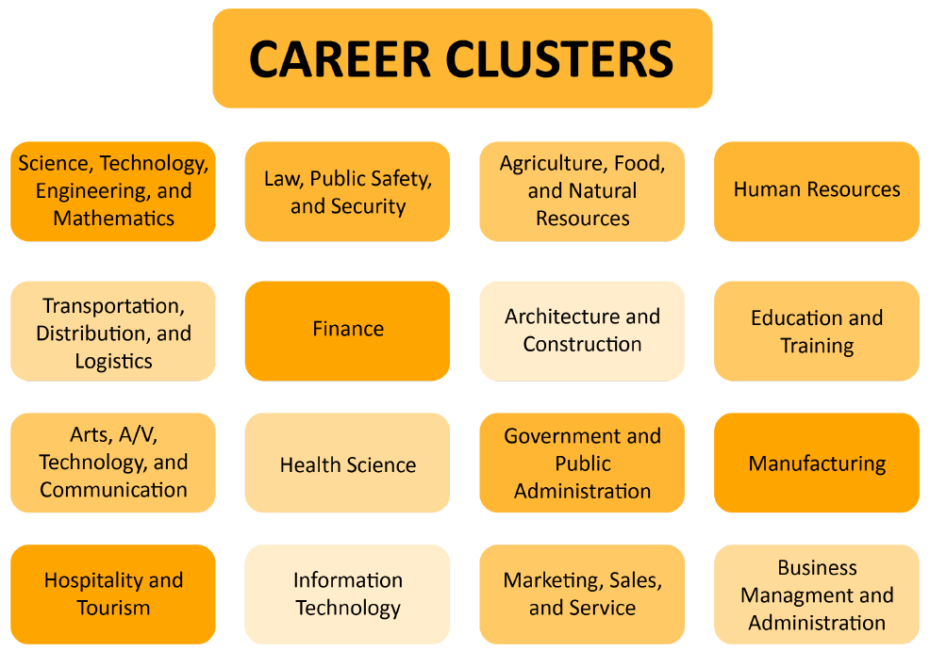
8TH GRADE ACTIVITY: CAREER COLLECTIONS
Guess That Career
It is never too early to begin exploring careers that interest you. Careers often require some type of postsecondary education, such as a certificate or bachelor's degree. The education required for the job you want should help you determine what to study in college or at a career tech center. For the next part of this activity, you will explore careers from nine different career clusters and learn about the required education, important skills, and average salary for each of those careers. Follow the steps below to begin.

- Put your detective skills to work! Read Career Clue Card #1 and make your best guess at what career it describes. Then, write or type your guess in the space provided.
- Once you have guessed the career title, find out if your answer is correct by completing the jigsaw puzzle linked in the Career Clue Card. The correct answer will be revealed once you complete the puzzle!
- The puzzles are set to 12 pieces, but if you would like to play with more or fewer pieces, click “Play As” and select your desired piece number.
- If the revealed career interests you, you can explore similar careers under the same career cluster by clicking on the link provided in the Career Clue Card.
- Repeat steps 1–3 for the remaining eight Career Clue Cards.

Career Clue Card #1
Hospitality and Tourism Career Cluster
A professional in this field has a keen sense of taste. Their daily responsibilities may include creating menus, directing the preparation of dishes, ordering supplies, setting menu prices, and keeping records and accounts. For this job, a certificate or associate degree is required. Common majors for those in this career include culinary arts, baking and pastry arts, restaurant and hotel management, or professional cooking. The average salary for this career in Oklahoma is $42,140.

Career Title: ______________________________________________________________

To access the jigsaw puzzle and reveal the career, click HERE or go to https://tinyurl.com/careerclue1.

To explore more about the Hospitality and Tourism Career Cluster, click HERE or go to https://tinyurl.com/hospitalitycareercluster.

Career Clue Card #2
Transportation, Distribution and Logistics Career Cluster
A professional in this field might have a strong interest in airplanes. Their daily responsibilities may include aircraft maintenance or diagnosing, repairing, or overhauling aircraft and helicopter engines. An associate degree is required in this specific field of study. The average salary for this career in Oklahoma is $47,830.

Career Title: ______________________________________________________________
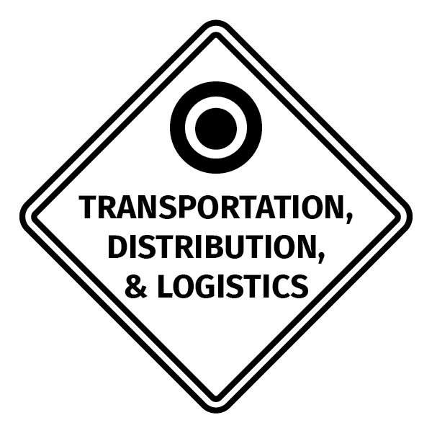
To access the jigsaw puzzle and reveal the career, click HERE or go to https://tinyurl.com/careerclue2.

To explore more about the Transportation Career Cluster, click HERE or go to https://tinyurl.com/transportationcareercluster.

Career Clue Card #3
Agriculture, Food, and Natural Resources Career Cluster
A professional in this field likes caring for and helping animals. Their daily responsibilities may include animal check-ups and surgeries. A bachelor’s degree and doctoral degree are required in this specific field of study. Common majors for those in this career include chemistry, animal biology, zoology, and biochemistry. The average salary for this career in Oklahoma is $79,340.

Career Title: ______________________________________________________________
To access the jigsaw puzzle and reveal the career, click HERE or go to https://tinyurl.com/careerclue3.

To explore more about the Agriculture, Food, and Natural Resources Career Cluster, click HERE or go to https://tinyurl.com/agriculturecareercluster.

Career Clue Card #4
Information Technology Career Cluster
A professional in this field knows how to code and develop websites. Their daily responsibilities may include consulting, designing, and coding to create websites. Individuals working in this field often have an associate degree. Common majors for those in this career include programming and computer science. The average salary for this career in Oklahoma is $56,660.

Career Title: ______________________________________________________________
To access the jigsaw puzzle and reveal the career, click HERE or go to https://tinyurl.com/careerclue4.

To explore more about the Information/Communication Technology Career Cluster, click HERE or go to https://tinyurl.com/itcareercluster.

Career Clue Card #5
Arts, Audio/Visual Technology, and Communications Career Cluster
A professional in this field enjoys art and the history behind artwork. Their daily responsibilities may include researching and acquiring artwork, restoring artwork, and overseeing the institution’s artwork collection. A bachelor’s and master’s degree are required to work in this career. Common majors for those in this career include art history and history. The average salary for this career in Oklahoma is $44,540.

Career Title: ______________________________________________________________
To access the jigsaw puzzle and reveal the career, click HERE or go to https://tinyurl.com/careerclue5.

To explore more about the Arts, Audio/Visual Technology and Communications Career Cluster, click HERE or go to https://tinyurl.com/artcareercluster.

Career Clue Card #6
Law, Public Safety, Corrections, and Security Career Cluster
A professional in this field helps keep our highways safe by making sure drivers follow the law. Their daily responsibilities may include monitoring state and federal highways, checking the speed of vehicles, and responding to emergencies. Some college hours are required depending on experience. Common majors for those in this career include criminal justice, sociology, and political science. The average salary for this career in Oklahoma is $47,830.

Career Title: ____________________________________________________

To access the jigsaw puzzle and reveal the career, click HERE or go to https://tinyurl.com/careerclue6.

To explore more about the Law, Public Safety, Corrections, and Security Career Cluster, click HERE or go to https://tinyurl.com/lawcareercluster.

Career Clue Card #7
Education and Training Career Cluster
A professional in this field is an expert when it comes to recommending books or online articles. Their daily responsibilities may include selecting, acquiring, and classifying materials; providing reference help to visitors; and researching. Both bachelor’s and master’s degrees are required to work in this career. Common majors for those in this career include English and history. The average salary for this career in Oklahoma is $43,810.

Career Title: ______________________________________________________________
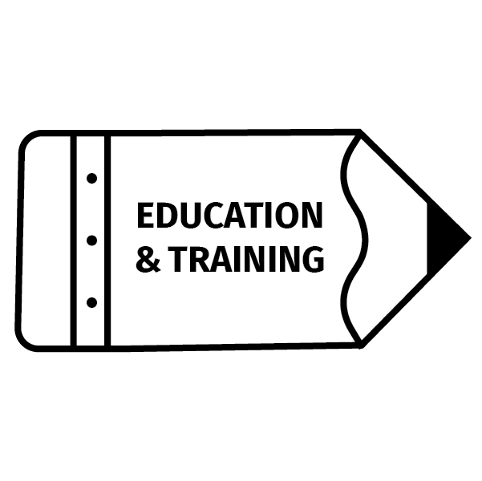
To access the jigsaw puzzle and reveal the career, click HERE or go to https://tinyurl.com/careerclue7.

To explore more about the Education and Training Career Cluster, click HERE or go to https://tinyurl.com/educationcareercluster.

Career Clue Card #8
Manufacturing Career Cluster
A professional in this field is not afraid of heights! They use their green energy skills to help generate electricity using wind. Their daily responsibilities may include diagnosing problems with technology and systems; climbing wind turbine towers to inspect, maintain or repair equipment; and testing electrical components. A certificate is required for this field. The average salary for this career in Oklahoma is $43,810.

Career Title: ______________________________________________________________

To access the jigsaw puzzle and reveal the career, click HERE or go to https://tinyurl.com/careerclue8.
To explore the Manufacturing Career Cluster more, click HERE or go to https://tinyurl.com/manufacturingcareercluster.

Career Clue Card #9
Health Science Career Cluster
A professional in this field likes caring for and helping people, but they are not a doctor or nurse! Their daily responsibilities may include completing physicals, providing treatment, and counseling patients. Both bachelor’s and master’s degrees are required to work in this career. Common majors for those in this career include biology, chemistry, nursing, nutrition, and neuroscience. The average salary for this career in Oklahoma is $103,860.

Career Title: ______________________________________________________________
To access the jigsaw puzzle and reveal the career, click HERE or go to https://tinyurl.com/careerclue9.

To explore the Manufacturing Career Cluster more, click HERE or go to https://tinyurl.com/healthcareercluster.

We hope you enjoyed this activity!
See below for additional resources, including information about Oklahoma’s Promise scholarship.
Part 2: Virtual Campus Visits

Now that you’ve learned about the college admission factors, it’s time for you to check out college and career tech campuses! Click on the Virtual Campus Tours Spreadsheet below to discover new colleges and career techs you can virtually visit today. Use the Scavenger Hunt for a more interactive campus visit.

You’ll see many choices on this spreadsheet. Don’t know where to start? Begin by selecting the University of Oklahoma or Oklahoma State University, or you can choose to explore whichever you want!

Virtual Campus Tours Spreadsheet
Scavenger Hunt

Image source: Riva, E. (2017 July). Technology. Pixabay. https://pixabay.com/illustrations/technology-equipment-responsive-web-2468063/

Additional Resources

- If you would like to explore more careers or learn more about the ones you reviewed today, visit MyNextMove.org and bls.gov.
- You can research colleges at bigfuture.collegeboard.org.
- Oklahoma’s Promise is a state-supported college tuition scholarship for families earning $55,000 or less per year. You can learn more about the scholarship by clicking HERE or going to https://tinyurl.com/OKPromisescholarship. You must apply in the 8th, 9th, or 10th grades. To keep the scholarship, you must meet academic and conduct requirements in high school. The scholarship tuition will pay for:
  - Oklahoma public two-year colleges.
  - Oklahoma public four-year universities.
  - Oklahoma public technology centers (Career Tech Centers) for certain programs that meet the requirements to be eligible for federal student aid offered at Oklahoma public technology centers.
  - A portion of tuition at Oklahoma accredited private colleges or universities.
- The Dream.US is another scholarship opportunity for students with undocumented citizenship status. You can learn more about this scholarship by clicking HERE or going to https://tinyurl.com/thedreamscholarship.

Sources
- College Board. (2020). BigFuture. https://bigfuture.collegeboard.org/
- Jigsaw Planet. (n.d.). Jigsaw Planet. https://www.jigsawplanet.com
- Minnesota State Colleges and Universities. (2020). Career Clusters. Minnesota State CAREERwise. https://careerwise.minnstate.edu/careers/clusters.html
- National Center for O*NET Development. (n.d.). My Next Move. https://www.mynextmove.org/
- Oklahoma State Department of Education. (n.d.). 6 Career Fields. Career Pathways. https://sde.ok.gov/sites/default/files/documents/files/1-2-4%20PlanningForYourCareer%20flyer.pdf%20-%20cluster%20page.pdf

Answer Key for Barriers & Benefits
Challenges:
Money
Bad grades
Laziness or lack of motivation
Not feeling smart enough
Drugs
Pregnancy
Family or life situations
Need to work
Fear

Resources and Solutions:
Scholarships
Student loans
Tutoring
Surrounding yourself with positive influences
Setting aside time to focus on schoolwork
Part-time jobs
Work-study
Payment plan
On-site college/university daycare centers

Benefits:
More money
More education
Better life
To get a career you want
Role model for younger siblings, family, friends, etc.
Prestige
Meet new people
Experience different things (cultures, communities, etc.)
More job opportunities

Answer Key for Guess That Career
- Chef
- Aircraft Equipment Mechanic/Technician
- Veterinarian
- Web Developer
- Museum Curator
- Highway Patrol Officer
- Librarian
- Wind Turbine Technician
- Physician’s Assistant

