DISTANCE LEARNING: STEPS TO SUCCESS

Welcome! This college- and career-awareness activity will provide you an opportunity to learn more about admissions to postsecondary education (PSE), or education after high school, and identify what steps you can take to be prepared for pursuing the PSE option of your choice. Work through this activity at your own pace and don’t forget to have fun!

Essential Questions
What steps do you need to take to reach your future goals? How can you fund your postsecondary education goals?

Objectives
After this activity, you will be able to:
- Find out what you need to do to get into the postsecondary education (PSE) option of your choice.
- Learn about an option to help you pay for your education.
- Create a plan that will help you pursue your educational goals.

Part 1: Steps to Success

What are colleges looking for?

Did you know that you have to apply to be accepted to the college of your choice? Applying to college is an exciting process that happens during your senior year of high school, but it’s important that you start preparing for your college application now! Colleges and universities consider different factors during the college admissions process. Today we will learn about these factors. There may be words you’re unfamiliar within this activity. Use the College Knowledge Terminology handout to learn more by clicking the link (or using the attached handout).

What do you think colleges look for when they are selecting students for admission? Make a list below of the things you believe colleges look for when accepting students.

The GPA Game

Your GPA can make a big impact on whether or not you get accepted to the college or technical program of your choice, but that’s not the only thing postsecondary schools consider when accepting students. Watch the video The GPA Game to find out what factors are considered for postsecondary education acceptance. You’ll see questions and other information pop up throughout the video. Take your time answering and reading the information, then hit play once you are ready to continue watching the video.

College Admissions Factors

Did you know all the factors you saw in the GPA video are considered for acceptance to postsecondary education? Advanced classes, attendance, college entrance exams, extracurricular activities, and GPA are all important to the admissions process. Now, see what you learned and try to match examples to each of the above factors in this drag and drop activity.

You know what it takes to get into a career tech or college, but how do you pay for it?

Oklahoma’s Promise

Put a checkmark next to any question you would answer “yes” to below:

❐ Do you want to attend a technical school or college after high school?
❐ Would you like up to $30,000 to help cover the cost of college?
❐ Are you in the 8th, 9th, or 10th grade?

If you checked the box for at least one of the above questions, then it’s time to check out Oklahoma’s Promise!

Oklahoma’s Promise can help you pay for your postsecondary education. This includes tech schools, such as vo-tech or training programs, and two-year or four-year colleges located in Oklahoma.

To apply for Oklahoma’s Promise, you must meet the following qualifications listed below:
- Be an Oklahoma resident
- Enrolled in the 8th, 9th, or 10th grade
- Your parents’ income must be less than $55,000 a year

Ask your parent or guardian to help you complete the application. You can get started by visiting the website https://www.okhighered.org/okpromise/.

Let’s Get Smart about Goals!

Your 9th grade year is the perfect time to set a goal that will help you reach your future goals after high school. Think about the college admissions factors you just reviewed. Which of those areas could you focus on to improve this school year?

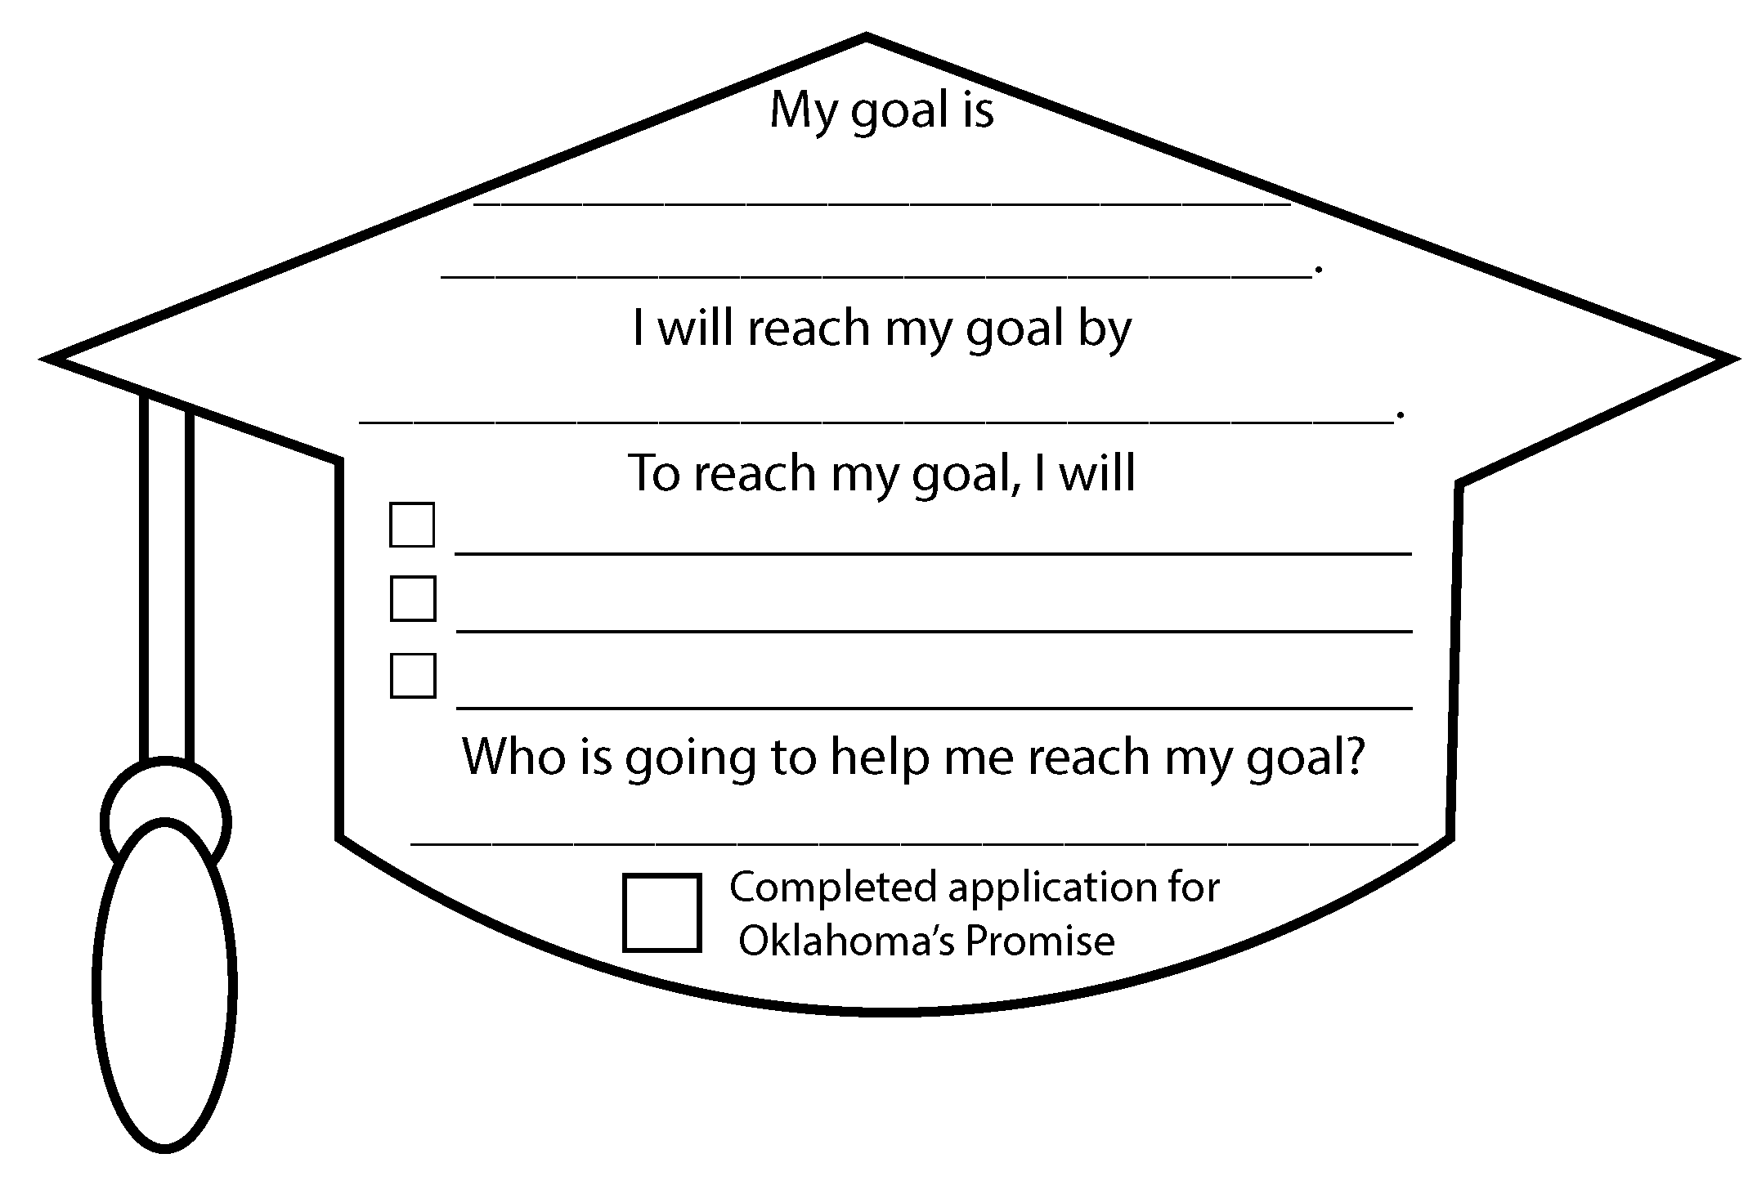
Use the goal-setting tool in the graduation cap below to identify one goal that you will work on this school year and the specific action steps you will take to complete it.

- Sample Goal: My goal is to increase my GPA to 3.5 from 3.25. I will reach this goal by the end of this school year. To reach my goal, I will have no missing assignments, attend tutoring once a week for help, and study 20 minutes a day. My mom will help me keep on track with this goal.
- Oklahoma’s Promise: Check the box next to Oklahoma’s Promise once you’ve completed the application.

*You are 42% more likely to achieve your goal if you write it down (Morrissey, 2017). So write down your 9th-grade goal to improve your chances for college admission later on!

Part 2: Virtual Campus Visits

Now that you’ve learned about the college admission factors, it’s time for you to check out college and career tech campuses! Click on the Virtual Campus Tours Spreadsheet below to discover new colleges and career techs you can virtually visit today. Use the Scavenger Hunt for a more interactive campus visit.

You’ll see many choices on this spreadsheet. Don’t know where to start? Begin by selecting the University of Oklahoma or Oklahoma State University, or you can choose to explore whichever you want!

Virtual Campus Tours Spreadsheet
Scavenger Hunt

Image source: Riva, E. (2017 July). Technology. Pixabay. https://pixabay.com/illustrations/technology-equipment-responsive-web-2468063/
We hope you enjoyed this activity! See below for additional resources.

Additional Resources
- If you would like to explore careers, visit MyNextMove.org and bls.gov.
- You can research colleges at bigfuture.collegeboard.org.
- The Dream.US is another scholarship opportunity for students with undocumented citizenship status. You can learn more about this scholarship by going to thedream.us/scholarships/.

Sources
Bureau of Labor Statistics. (2016). https://www.bls.gov
College Board. (2020). BigFuture. https://bigfuture.collegeboard.org/
Leslie Keller. (2014, May 23). College Admissions Game Video [Video]. YouTube. https://www.youtube.com/watch?v=PSLfE6ld5dU
Morrissey, M. (2017, December 6). The power of writing down your goals and dreams. HuffPost. https://www.huffpost.com/entry/the-power-of-writing-down_b_12002348
National Center for O*NET Development. (n.d.). My Next Move. https://www.mynextmove.org/
Oklahoma State Regents for Higher Education. (2020). Oklahoma’s Promise. https://www.okhighered.org/okpromise/
The Dream.Us. (2020). Scholarships. https://www.thedream.us/scholarships/

