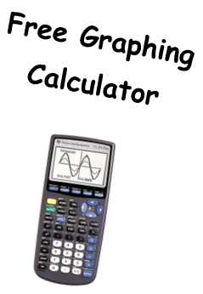
Opening Session Date with one hour special time
Session 1 Date
Session 2 Date
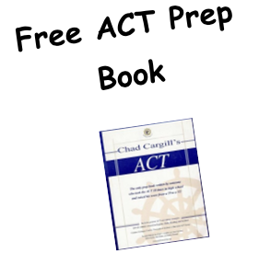
Session 3 Date
Session 4 Date
Session 5 Date
Session 6 Date
*School Supplies
&
Snacks Provided!
Session 7 Date

Time (2-hour block)
@ (school name)
In Room (number)

This is a free workshop offered to all 10th and 11th grade students interested in understanding the ACT and increasing their composite score.

Sign up in student services!

For more information, contact (teacher name, room number and email info here)

