TIME LOG
Record each task and how long it takes to complete. Come up with categories for each item in your time log to fit into. Label each item based on those categories in the third column. You decide what the categories will be (work, play, relationships, health, school, spirituality, etc.). It’s okay to come up with these later on after you see patterns in how you spend your time.

Task | Time | Category
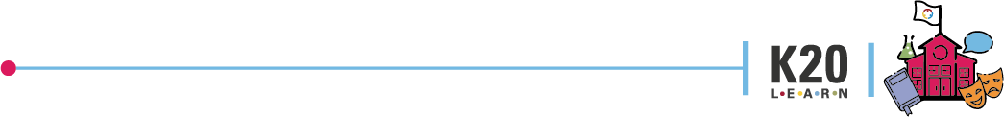
KEEPING TRACK

