WHEEL OF TIME
- Choose 4–12 categories that reflect how you want to spend your time. Consider what kinds of time you need to reach your personal goals in life. These may not be the same ones you used to label how you currently spend your time.
- Label the Wheel of Time sections for the categories you have chosen.
- Give each category a score from 0–5 based on if you feel you are giving enough time to this area. Color in that section up to the line 0–5 based on the score you gave that area.
- Choose one area that you are neglecting and write a goal for how you will spend more time on that area next week.
Note: Revisit and recolor a Wheel of Time every week or two so you can continue to reflect on if you are balancing your time according to your needs and goals. It’s more important to balance your time than to have a perfect score in each category.
Example
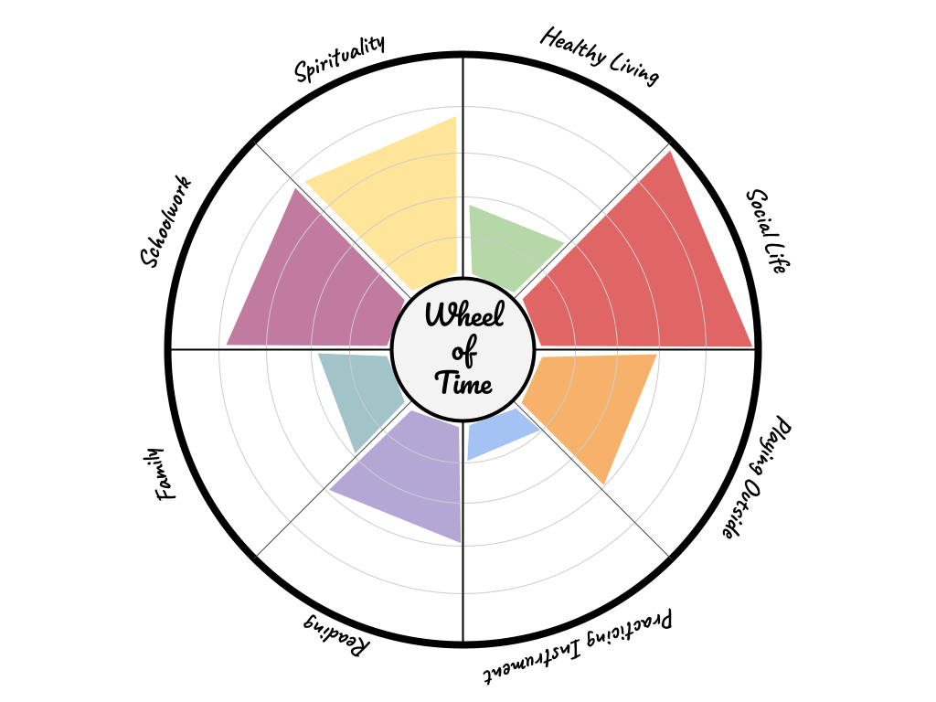

Wheel of
Time
Time Management Goal
Write down something you will do to improve your score in one area of your Wheel of Time.
Date: | Category:
Action:

