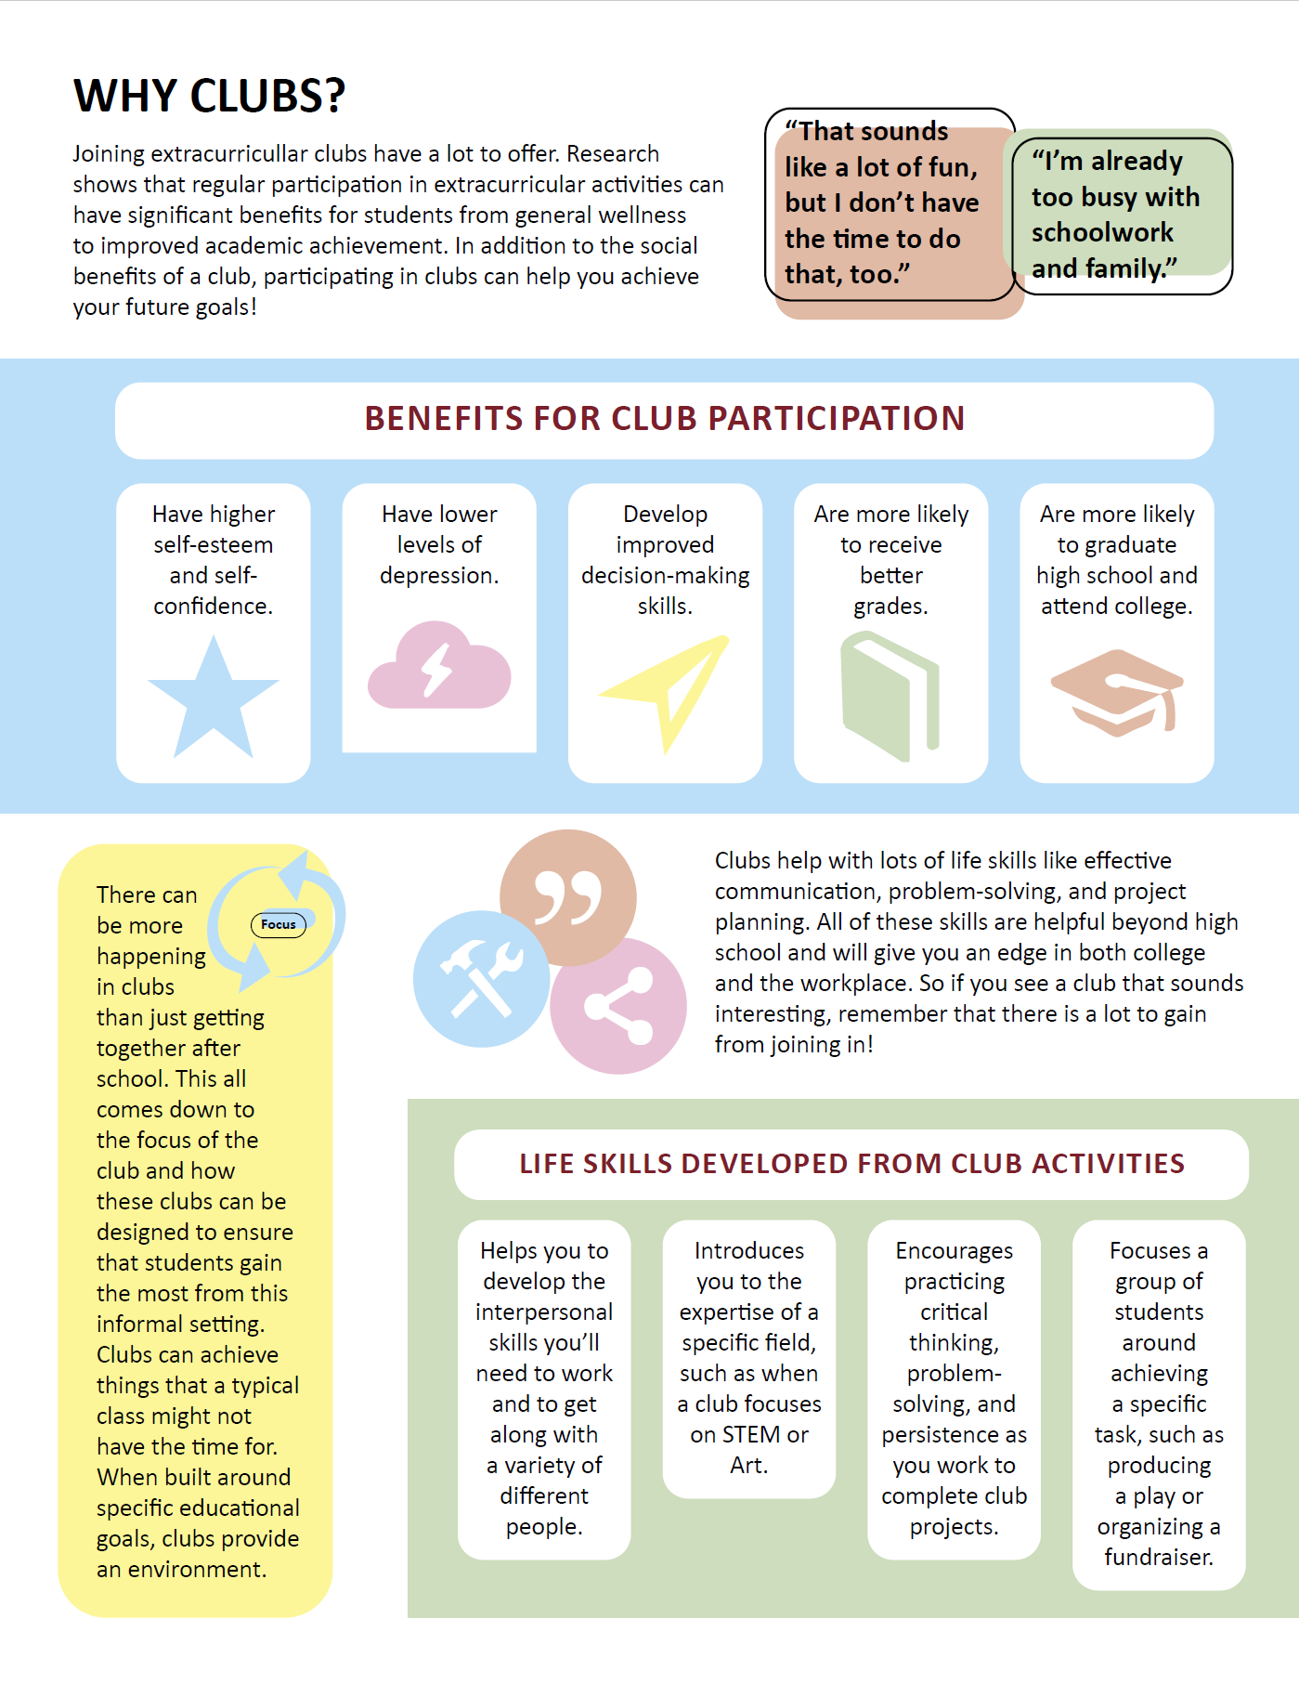
CLUBs INFOGRAPHIC

