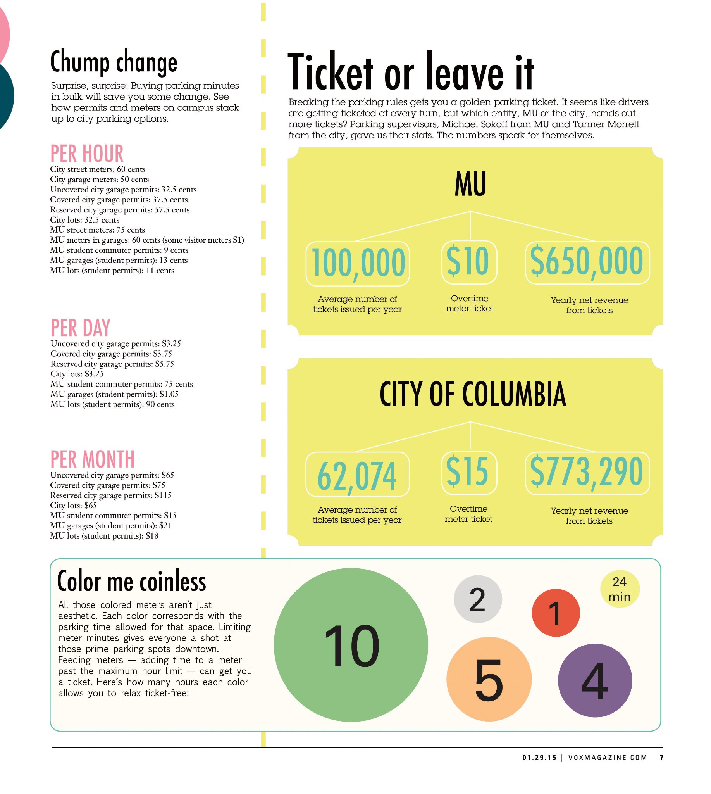
EXAMPLE INFOGRAPHIC: PARKING

