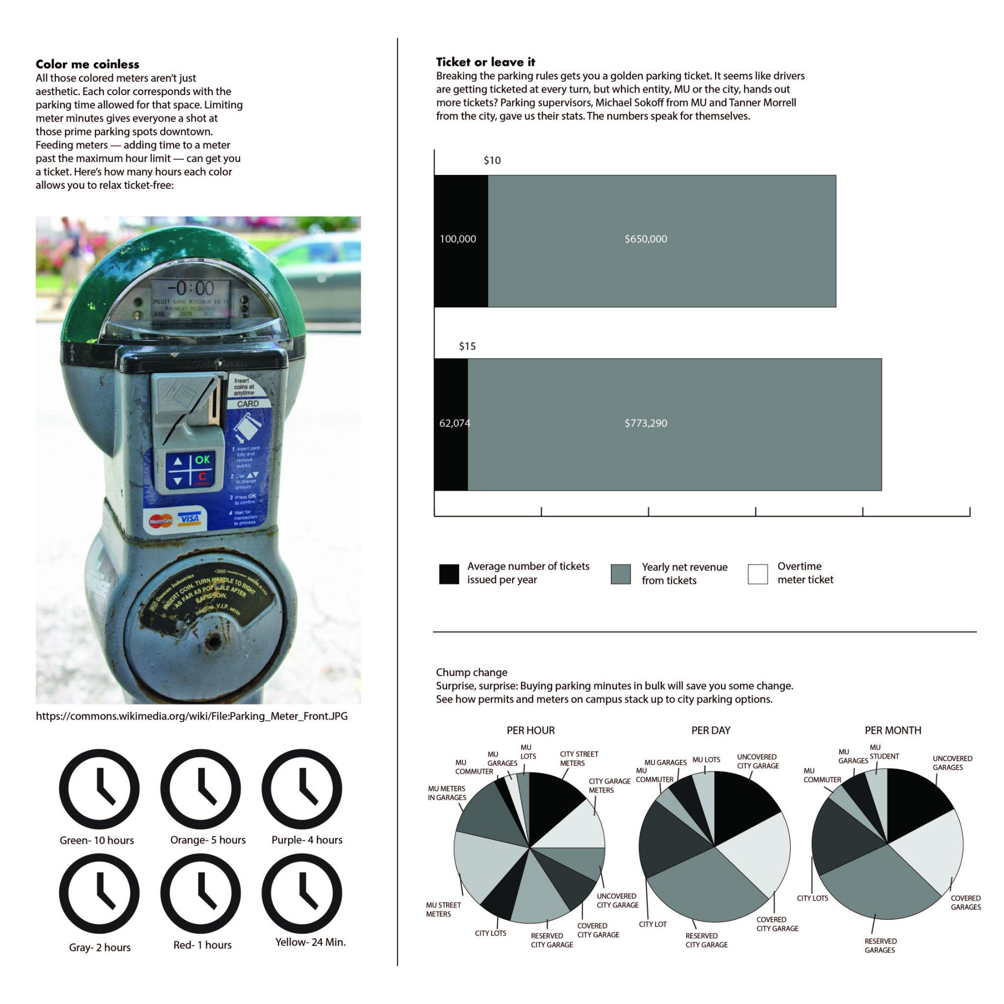
NON-EXAMPLE INFOGRAPHIC: PARKING

