Digital research poster guide

How to Create a Digital Poster Using Google Slides

Brainstorm
- Keep the following questions in mind as you brainstorm ideas for your digital poster:
  - Who is the famous person and what are they known for?
  - Why are they important to you?
  - What challenges did they face throughout their journey?
  - How did they overcome these challenges?

Create your poster
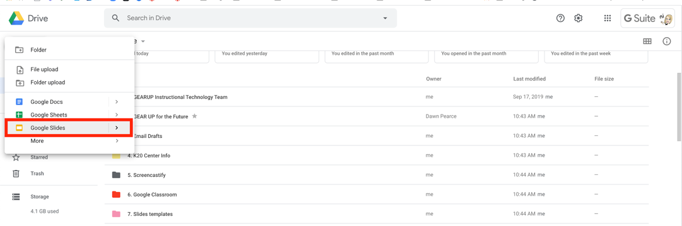
- Open Google Slides
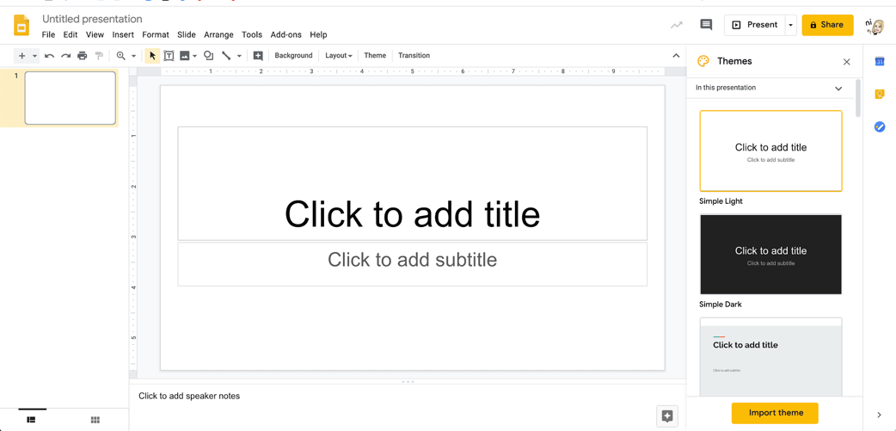
- Select a theme

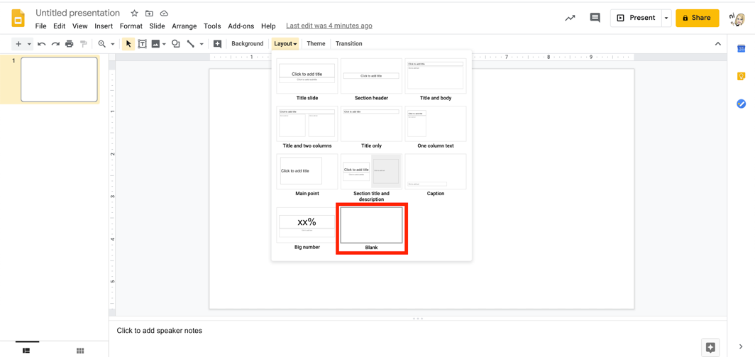
- Change the background to blank
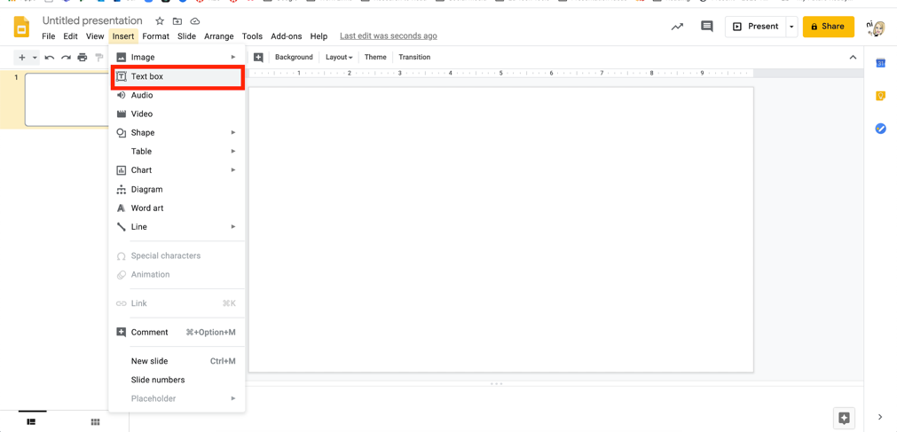
- Insert a text box to use for your title
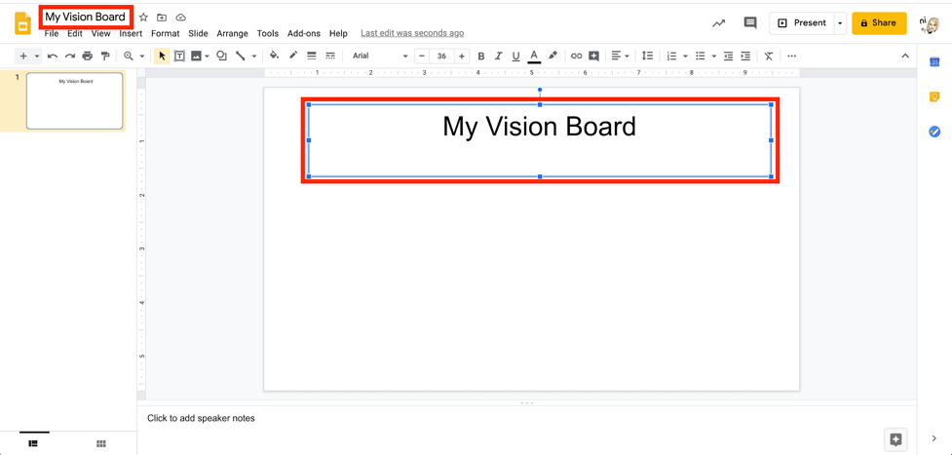
- Title your poster

- Add images
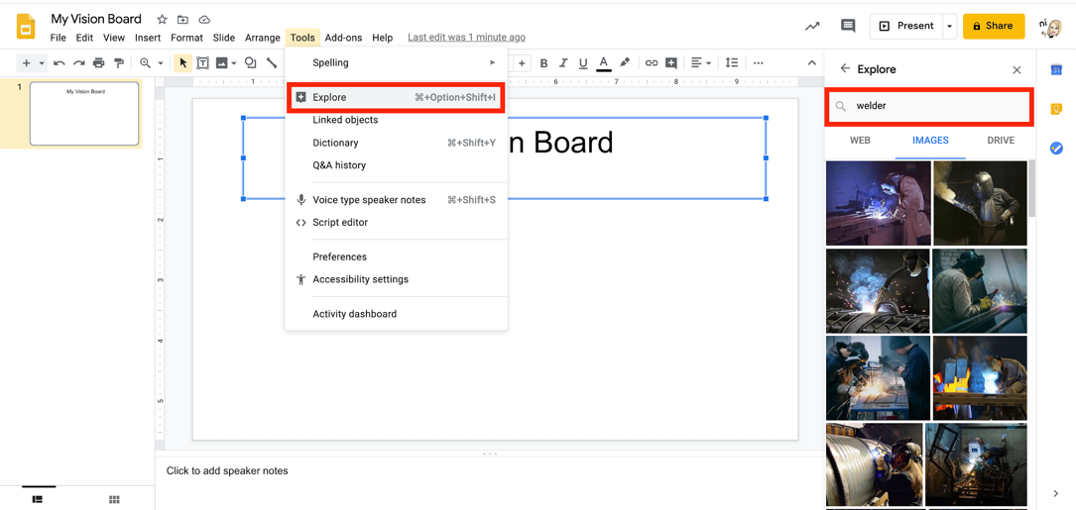
  - Select “Tools,” then “Explore.” Then, type in a word to search.

  - Select images
- Add words, GIFs, lines, arrows, etc.
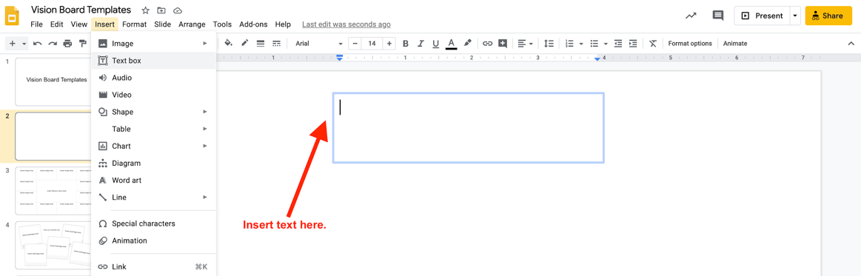
  - Select “Insert,” then “Text Box”

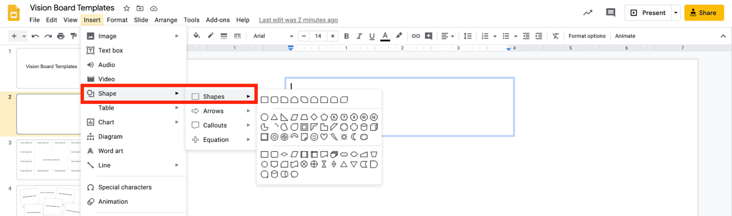
  - Select “Insert,” then “Shapes”

Resources
- Google Teacher Center
- Google Slides Product Guide

