GRAPHING CALCULATORS: TI-NSPIRE CX II SCAVENGER HUNT
Complete the following steps to become familiar with the calculator.
Steps | Responses
- Press the [on] key ( ). How many options do you see?
- What choice is a New Document? Select it by pressing the number. Select Add Calculator from the second menu or press [1].
- Press the template button (), which is next to the number 9. This brings up a list of templates to use. What does the first template represent? Press [esc] to leave that screen.
- Perform the following operations:
  - –478 – 381.2
  - 52 (Use the [^] button for an exponent.)
  - 38 – 45 (Press the right arrow to leave the exponent input before pressing the [–] button.)
  - |–28.87| + 2|19.3|
  - 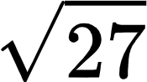
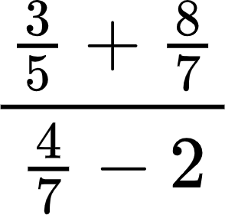
- What button(s) did you press to find the square root of 27?
- There was a typo on 4(d). It should be –2, not +2. Instead of retyping the expression, press the up arrow to highlight the expression. Press [enter]. What happened? Fix the mistake. What is the correct answer?
- Now we’re ready to graph. Press [ctrl] [doc] to insert a new page. If I want to create a graph, which option should I select? Notice the number on the tab at the top of the screen shows 1.2. This means problem #1, page 2.
- Type 3x–3 next to f1(x)=. Then press [enter].
- Press the [menu] button and select [4] Window/Zoom, then [1] Window Settings. Change the following, then describe what happened.
• Xmin= –1 • Ymin= –1
• Xmax= 15 • Ymax= 10
• Xscl= 0.5 • Yscl= 1
- Oooops! We need to make a correction. The equation should be $\frac{3}{2}x-2$. How can you change it without typing next to f2(x)= ?
- Now I prefer a different viewing window. Press [zoom] and select 6:ZStandard. Now your viewing window is reset back to default. Hint: Use the Touchpad (between the arrow keys).
- How do I hide the axes? Hint: Press [menu].
- We did a lot of work today. To reset the calculator: Press home [on] button. Press [5] or select Settings, then [8] or select Restore Factory Defaults. Click OK.
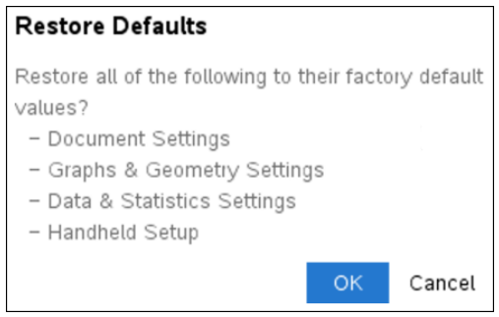
- Turn off the calculator: Press [ctrl] [on].

GRAPHING CALCULATORS: PRE-ALGEBRA and ALGEBRA 1
Given the following equations, make a prediction, and then use the graphing calculator to check your prediction. Make corrections in the reflection column or put a check mark to indicate that your prediction was correct.

Equation A: y = 2x + 3
Question | Prediction | Responses
What is the slope?
What is the y-intercept?
What is the x-value when the y-value is 0?
Where does the line cross the x-axis?
If you translate the line up 5 units and left 7 units, what will the new equation be?

Equation B: –2y = 5x + 7
Question | Prediction | Responses
What is the slope?
What is the y-intercept?
What is the x-value when the y-value is 0?
Where does the line cross the x-axis?
If you translate the line down 3 units and right 8 units, what will the new equation be?

GRAPHING CALCULATORS: GEOMETRY
What shape would the following vertices create? State the shape and justify your claims using properties and mathematical vocabulary. After you predict, graph the points on your calculator and use the software to check whether you are correct. Make corrections in the reflection column or put a check mark to indicate that your prediction was correct.

Shape A: W (1, –4), X (3, 0), Y (–1, 2), Z (–3, –2)
Question | Prediction | Responses
What shape would it make?
What makes you think it will create that shape?

Shape B: A (–1, 1), B (1, 3), C (3, –1), D (1, –3)
Question | Prediction | Responses
What shape would it make?
What makes you think it will create that shape?

GRAPHING CALCULATORS: GEOMETRY
What shape would the following vertices create? State the shape and justify your claims using properties and mathematical vocabulary. After you predict, graph the points on your calculator and use the software to check whether you are correct. Make corrections in the reflection column or put a check mark to indicate that your prediction was correct.

Shape A: W (1, –4), X (3, 0), Y (–1, 2), Z (–3, –2)
Question | Prediction | Responses
What shape would it make?
What makes you think it will create that shape?

Shape B: A (–1, 1), B (1, 3), C (3, –1), D (1, –3)
Question | Prediction | Responses
What shape would it make?
What makes you think it will create that shape?

GRAPHING CALCULATORS: ALGEBRA 2
Create a picture that contains the following functions.
- f(x) = mx + b
- f(x) = a(x – h)² + k
- f(x) = a|x – h| + k

How to Adjust the Viewing Window (What You See of the Graph)
TI-Nspire CX II | TI-84 Plus CE
- Press the [menu] button. | - Press the [Window] button in the top row.
- Press [4] or select Window/Zoom. | - Adjust viewing window settings:  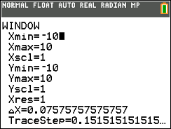
- Press [1] or select Window Settings.
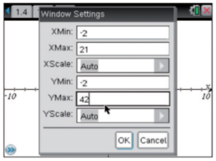

GRAPHING CALCULATORS: PRECALCULUS
Create a picture that contains the following functions.
- f(x) = (x – h)³ + k
- f(x) = a·sin(x) + k
- f(x) = a·e^{x – h} + k
- f(x) = ln(x – h) + k

How to Adjust the Viewing Window (What You See of the Graph)
TI-Nspire CX II | TI-84 Plus CE
- Press the [menu] button. | - Press the [Window] button in the top row.
- Press [4] or select Window/Zoom. | - Adjust viewing window settings:
- Press [1] or select Window Settings.

