SMART GOAL ORGANIZER
As we work through the steps of the SMART goal model, write notes for your own goal in the table below.
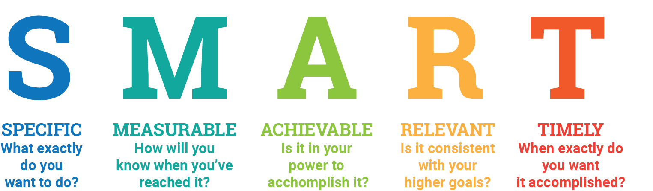 | What exactly do you want to do?  What three (3) steps will you do each day to help you achieve this goal?
What will success look like?

How will you measure your progress?

How often will you check your progress?
Do you expect to encounter obstacles? How will you address them?

What do you need to succeed? Do you have the necessary skills and resources to accomplish this goal? If not, how will you ensure you have what you need?

How does this align with my bigger goals?

Why is it important for me to accomplish this goal?

When will this begin?

When do I plan to be done with this goal?

Reword your original goal to include all of the elements from the SMART model

