GRAPHING CALCULATORS: TI-84 PLUS SCAVENGER HUNT
Complete the following steps to become familiar with the calculator.
Steps | Responses
- Press the [on] button in the bottom-left corner. You are ready to start calculating.
- Press the [math] button to locate the available math, statistics, and other basic functions. Use the arrows to look through all five lists. Which option is a cube root?
- Press the [clear] button or [2nd] [mode] to leave that screen.
- Press [alpha] [y=] to access the F1 menu. What options are available?
- Leave that screen. Then perform the following operations:
  - –478 – 381.2
  - 5² (Use the [^] button for an exponent.)
  - 3⁸ – 4⁵ (Press the right arrow to leave the exponent input before pressing the [–] button.)
  - |–28.87| + 2|19.3|
  - 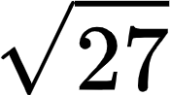
  - 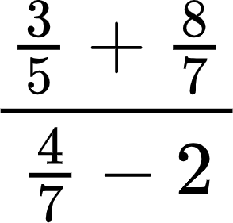

- What button(s) did you press to find the square root of 27?
- There was a typo on 5(d). It should be –2, not +2. Instead of retyping the expression, press the up arrow to highlight the expression. Press [enter]. What happened? Fix the mistake. What is the correct answer?
- Now you’re ready to graph. Press [y=]. Type 3X–3 next to \Y1=. Then press [graph].

- Press the [Window] button. Change the following, then describe what happened.
• Xmin= –1 • Ymin= –1
• Xmax= 15 • Ymax= 10
• Xscl= 0.5 • Yscl= 1
- Oooops! You need to make a correction. The equation should be $\frac{3}{2}x-2$. How can you change it without typing next to \Y₂= ?
- Now I prefer a different viewing window. Press [zoom] and select 6:ZStandard. Now your viewing window is reset back to the default.
- How do you hide the axes? Hint: Press [2nd] [zoom].
- You made a lot of changes today. Reset the calculator: Press [2nd] [+] to access the memory menu. Then press [7] [1] [2] to reset all RAM and confirm.

- Turn off the calculator: Press [2nd] [on].

GRAPHING CALCULATORS: PRE-ALGEBRA and ALGEBRA I
Given the following equations, make a prediction, and then use the graphing calculator to check your prediction. Make corrections in the reflection column or put a check mark to indicate that your prediction was correct.

Equation A: y = 2x + 3
Question | Prediction | Responses
What is the slope?
What is the y-intercept?
What is the x-value when the y-value is 0?
Where does the line cross the x-axis?
If you translate the line up 5 units and left 7 units, what will the new equation be?

Equation B: –2y = 5x + 7
Question | Prediction | Responses
What is the slope?
What is the y-intercept?
What is the x-value when the y-value is 0?
Where does the line cross the x-axis?
If you translate the line down 3 units and right 8 units, what will the new equation be?

GRAPHING CALCULATORS: GEOMETRY
What shape would the following vertices create? State the shape and justify your claims using properties and mathematical vocabulary. After you predict, graph the points on your calculator and use the software to check if you are correct. Make corrections in the reflection column or put a check mark to indicate that your prediction was correct.

Shape A: W (1, –4), X (3, 0), Y (–1, 2), Z (–3, –2)
Question | Prediction | Responses
What shape would it make?
What makes you think it will create that shape?

Shape B: A (–1, 1), B (1, 3), C (3, –1), D (1, –3)
Question | Prediction | Responses
What shape would it make?
What makes you think it will create that shape?

GRAPHING CALCULATORS: ALGEBRA II
Create a picture that contains the following functions.
- f(x) = mx + b
- f(x) = a(x – h)² + k
- f(x) = a|x – h| + k

How to Adjust the Viewing Window (What You See of the Graph)
TI-Nspire CX II | TI-84 Plus CE
- Press the [menu] button. | - Press the [Window] button in the top row.
- Press [4] or select Window/Zoom. | - Adjust viewing window settings:  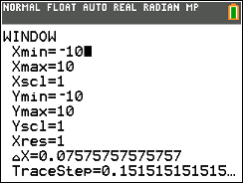
- Press [1] or select Window Settings.
