Question 1
The outer square in the given figure contains square L and square M. If square L has an area of 9 square units and square M has an area of 4 square units, what is the perimeter of the shaded region?
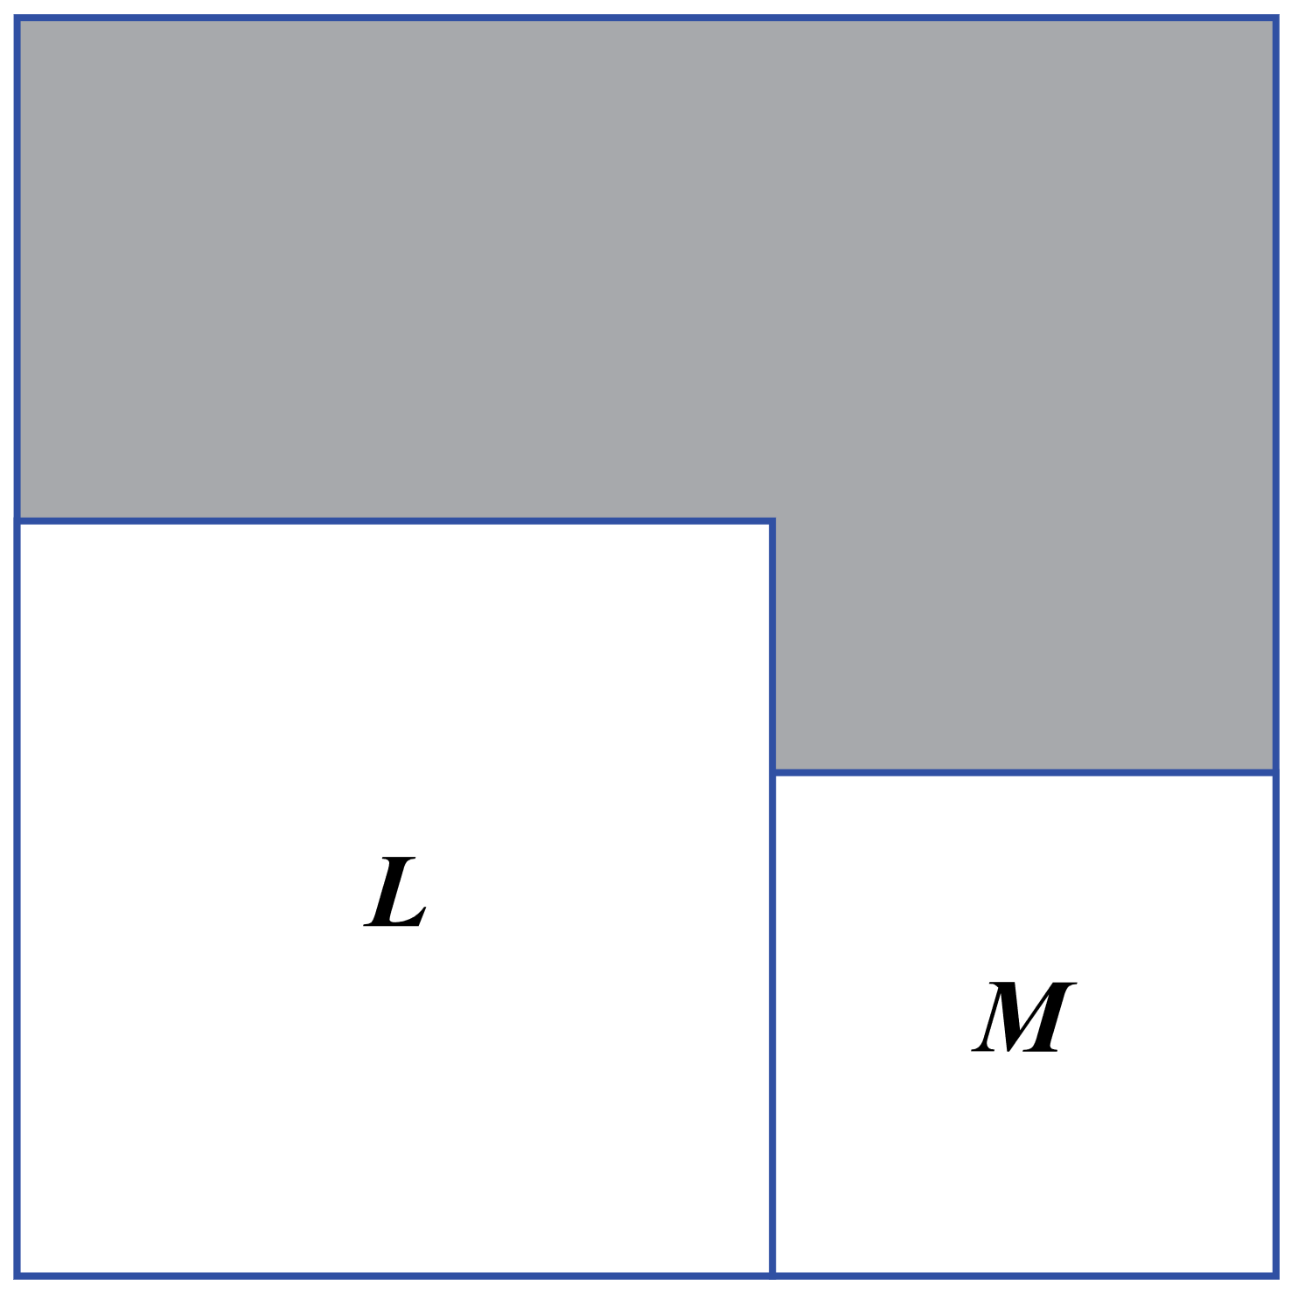
(A) 11 (B) 13 (C) 15
(D) 16 (E) 17

MATH ACT PREP, WEEK 3

Question 2
The ratio of the perimeters of two squares is 3:4. If the area of the larger square is 400 square feet, what is the length, in feet, of the side of the smaller square?

(F) 6
(G) 15
(H) 20
(J) 28
(K) 40

EXIT TICKET

Question 1
The outer square in the given figure contains square L and square M. If square L has an area of 9 square units and square M has an area of 4 square units, what is the perimeter of the shaded region?

(A) 11 (B) 13 (C) 15

Question 2
The ratio of the perimeters of two squares is 3:4. If the area of the larger square is 400 square feet, what is the length, in feet, of the side of the smaller square?

(F) 6
(G) 15
(H) 20
(J) 28
(K) 40

(D) 16 (E) 17

