IT’S-A-ME, THE RECTANGLE!

Part A

Question 1
In the following figure, all angles are right angles and the given side lengths are in feet. What is the area, in square feet, of the figure?
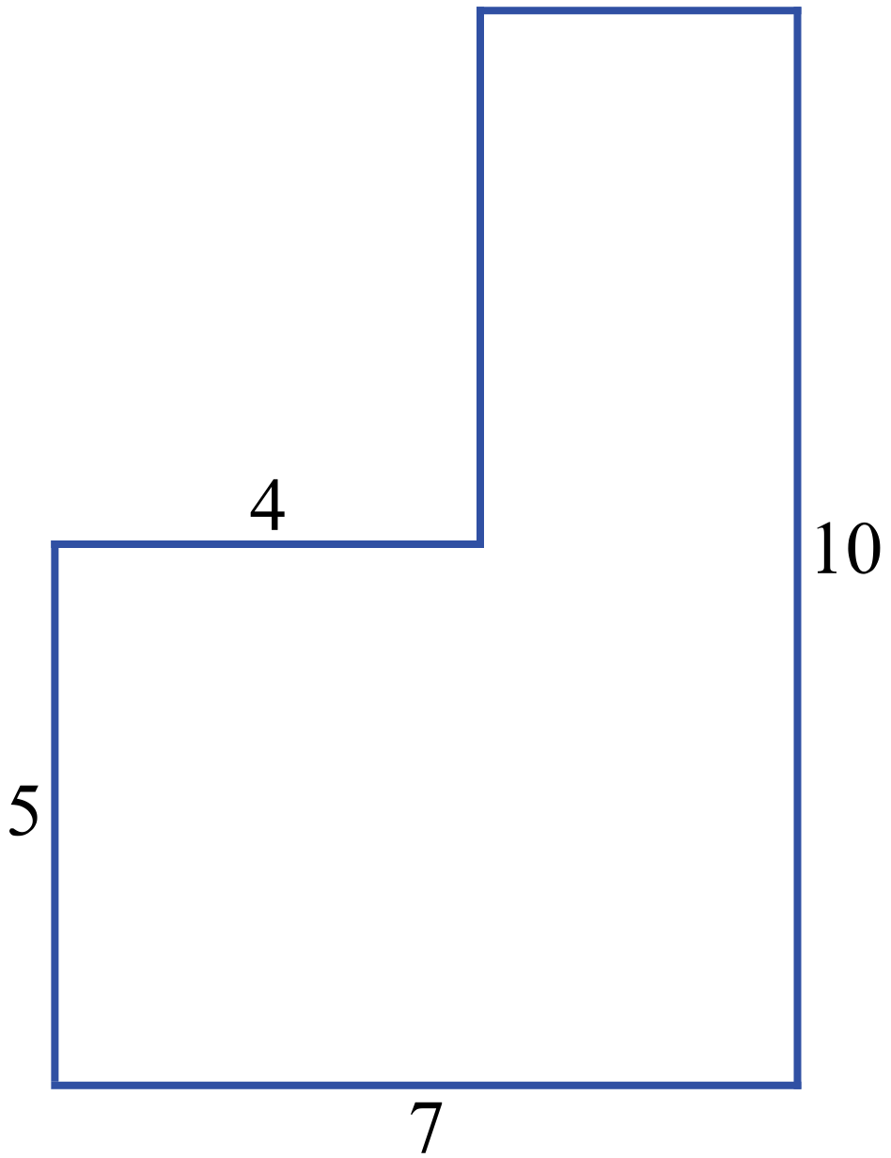

Question 2
The following rectangle was drawn on a grid of 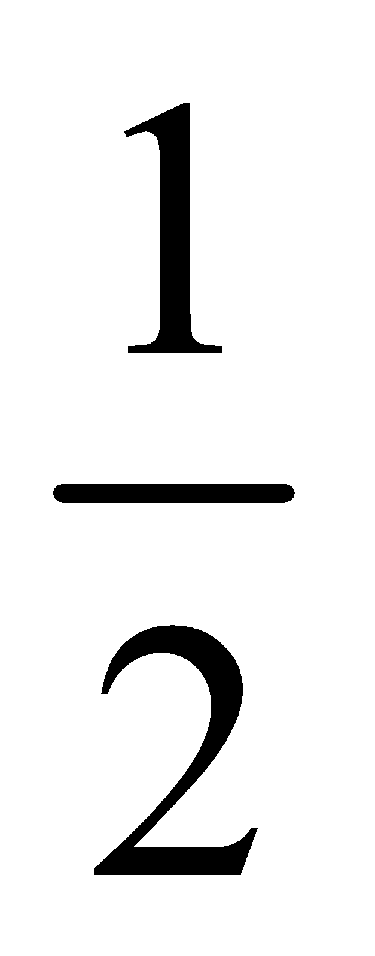 inch squares. Find the perimeter and area of that rectangle.
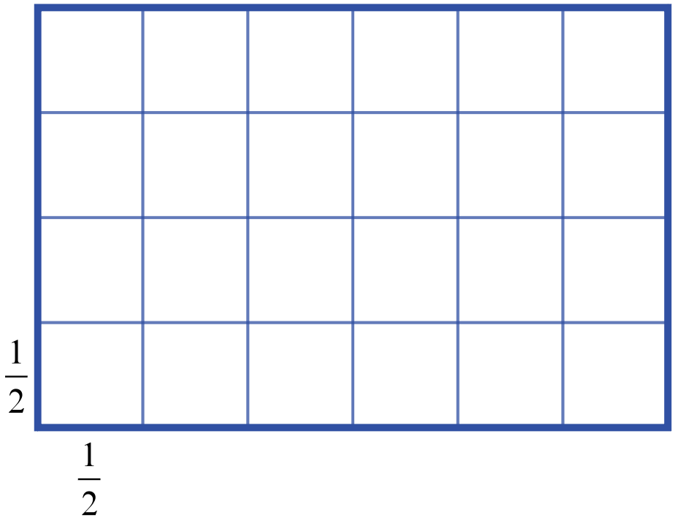

Part B

Question 3
One side of square KLMN has a length of 13 cm. Rectangle ABCD has the same area and a length of 10 cm. What is the width of the rectangle (in centimeters)?

Question 4
A rectangular field is 300 feet long and 150 feet wide. What is the area, in square yards, of this field?

