**Question 1**  
A jar contains 20 tokens, 2 red, 8 yellow, 4 green, and 6 blue. What is the probability of randomly selecting 1 token that is not yellow?

**(A)** 

**(B)** 

**(C)** 

**(D)** 

**(E)** 

# Question 2

A bag contains 8 blue marbles, 5 green marbles, and 9 purple marbles. How many additional blue marbles must be added to the 22 marbles already in the bag so that the probability of randomly drawing a blue marble is ?

**(F)** 8

**(G)** 13

**(H)** 17

**(J)** 22

**(K)** 28

# Question 3

The probability of Event *R* will occur is 0.4. The probability that Event *T* will occur is 0.5. Given that Events *R* and *T* are mutually exclusive, what is the probability that Event *R* *or* Event *T* will occur?

**(A)** 0.1

**(B)** 0.2

**(C)** 0.4

**(D)** 0.6

**(E)** 0.9

# Question 4

A 52-card deck contains 4 suits: 13 hearts, 13 diamonds, 13 clubs, and 13 spades. Which of the following expressions gives the probability of drawing, at random and without replacement, a heart on the 1st draw, a club on the 2nd draw, and a heart on the third draw?

**(F)** 

**(G)** 

**(H)** 

**(J)** 

**(K)** 

# Question 5

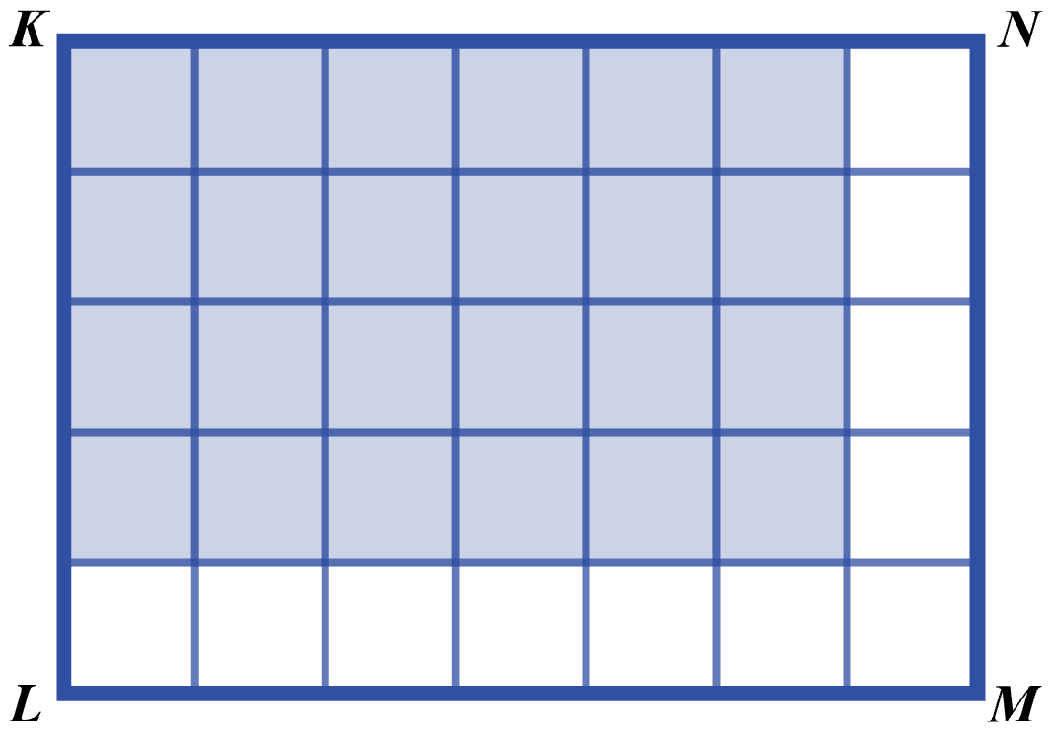In the figure below, all of the small squares are equal in area, and the area of rectangle *KLMN* is 1 square unit. If a ball were thrown at rectangle *KLMN* and all of the small squares have the same probability of being hit, what is the probability of the ball hitting the shaded region?

**(A)** 

**(B)** 

**(C)** 

**(D)** 

**(E)**  