PROBABILIDAD: ESTUDIO CIENTÍFICO DE LA INCERTIDUMBRE

# outcomes: los resultados de un experimento

# event: conjunto de resultados; suele representarse con mayúsculas

# probability: posibilidad que ocurra un suceso

# Los sucesos son mutuamente excluyentes (mutually exclusive) si no pueden ocurrir al mismo tiempo.

# Sucesos Mutuamente Excluyentes

# Digamos que G = sacar una gema verde (marcadas con una G para green) de la bolsa de arriba.

## A black background with a black square Description automatically generated with medium confidenceProbabilidad de Suceso A



|  |  |  |
| --- | --- | --- |
| What is the probability of drawing a **green** gem?  ¿Cuál es la probabilidad de sacar una gema **verde**? |  |  |

## Probabilidad del Complemento de Suceso A



|  |  |  |
| --- | --- | --- |
| What is the probability of drawing a gem that is **not green**?  ¿Cuál es la probabilidad de sacar una gema que **no sea verde**? |  |  |

## Probabilidad de Suceso A o Suceso B



|  |  |  |
| --- | --- | --- |
| What is the probability of drawing a **green** or **red** gem?  ¿Cuál es la probabilidad de sacar una gema **verde** o **roja**? |  |  |

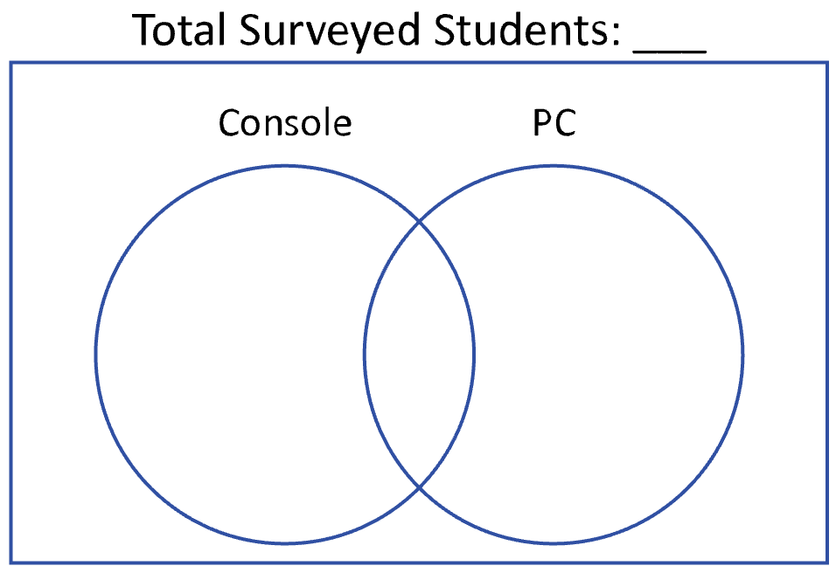

# NOT Mutually Exclusive Events

A survey asked 100 students on what device they played video games. The results showed that 50 students play video games on their console, 45 students play video games on their PC, and 15 students play video games on their console and PC.

**1)** What is the probability that a randomly chosen student neither plays video games on a console nor PC?

**2)** What is the probability that a randomly chosen student plays video games on either a console or PC?

**3)** What is the probability that a randomly chosen student plays video games either console or PC, but not both?

**4)** What is the probability that a randomly chosen student does not play video games on a console?