# outcomes: the results of an experiment

# event: a collection of outcomes; usually represented with capital letters

# probability: the likelihood an event will happen

# Events are mutually exclusive if the events cannot occur at the same time.

# Mutually Exclusive Events

# Let G = drawing a green gem from the bag above.

## Probability of Event A



|  |  |  |
| --- | --- | --- |
| What is the probability of drawing a green gem? |  |  |

## Probability of the Complement of Event A



|  |  |  |
| --- | --- | --- |
| What is the probability of drawing a gem that is not green? |  |  |

## Probability of Event A or Event B



|  |  |  |
| --- | --- | --- |
| What is the probability of drawing a green or red gem? |  |  |

**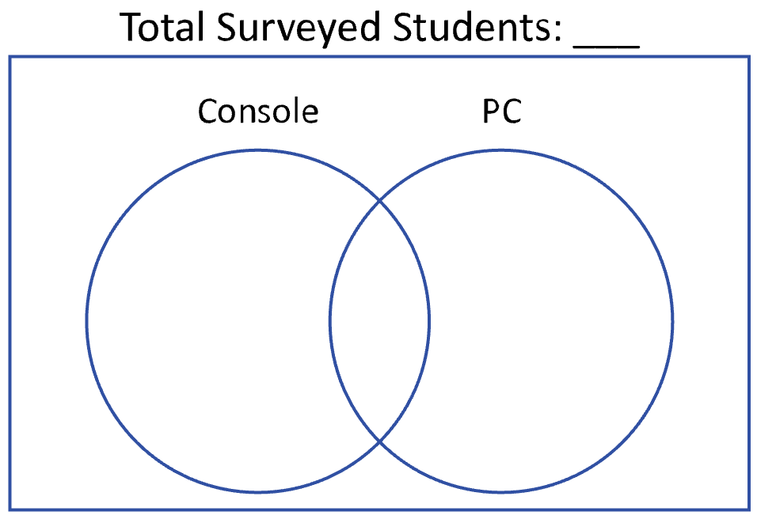  
NOT Mutually Exclusive Events**

A survey asked 100 students on what device they played video games. The results showed that 50 students play video games on their console, 45 students play video games on their PC, and 15 students play video games on their console and PC.

**1)** What is the probability that a randomly chosen student neither plays video games on a console nor PC?

**2)** What is the probability that a randomly chosen student plays video games on either a console or PC?

**3)** What is the probability that a randomly chosen student plays video games either console or PC, but not both?

**4)** What is the probability that a randomly chosen student does not play video games on a console?