# Question 1

The table below gives the exact probability of randomly drawing a card of a particular color from a deck of solid-colored cards.

|  |  |
| --- | --- |
| **Card Color** | **Probability** |
| Blue | 0.2 |
| Green | 0.1 |
| Orange | 0.1 |
| Purple | 0.2 |
| Yellow | 0.4 |

What is the probability of randomly drawing a card that is NOT blue and is NOT yellow?

**(A)** 0.4

**(B)** 0.48

**(C)** 0.6

**(D)** 0.72

**(E)** 0.8

# Question 2

For what value of *k* does the quadratic equation  have solutions of  and ?

**(F)** –12

**(G)** –1

**(H)** 1

**(J)** 7

**(K)** 12

# Question 3

Given the function  defined as  has domain , what is the range of ?

**(A)** 

**(B)** 

**(C)** 

**(D)** 

**(E)** 

# Question 4

Data Set A consists of 6 numbers listed below. Data Set B consists of the 6 numbers in Data Set A and a 7th number, which is less than 40. How will the mean and the median of Data Set B compare to the median and mean of Data Set A?

32, 39, 48, 50, 50, 61

**(A)** The median and mean of Data Set B will be less than the median and mean of Data Set A.

**(B)** The median of Data Set B will be less than the median of Data Set A and the mean will be the same for both sets.

**(C)** The median and mean of Data Set B will be the same as the median and mean of Data Set A.

**(D)** The mean will be the same for both sets and median of Data Set B will be greater than the median of Data Set A.

**(E)** The median and mean of Data Set B will be greater than the median and mean of Data Set A.

# Question 5

In the figure below,  is on , and the measures of  and  are 90° and 110° , respectively. If it can be determined, what is the measure of ?

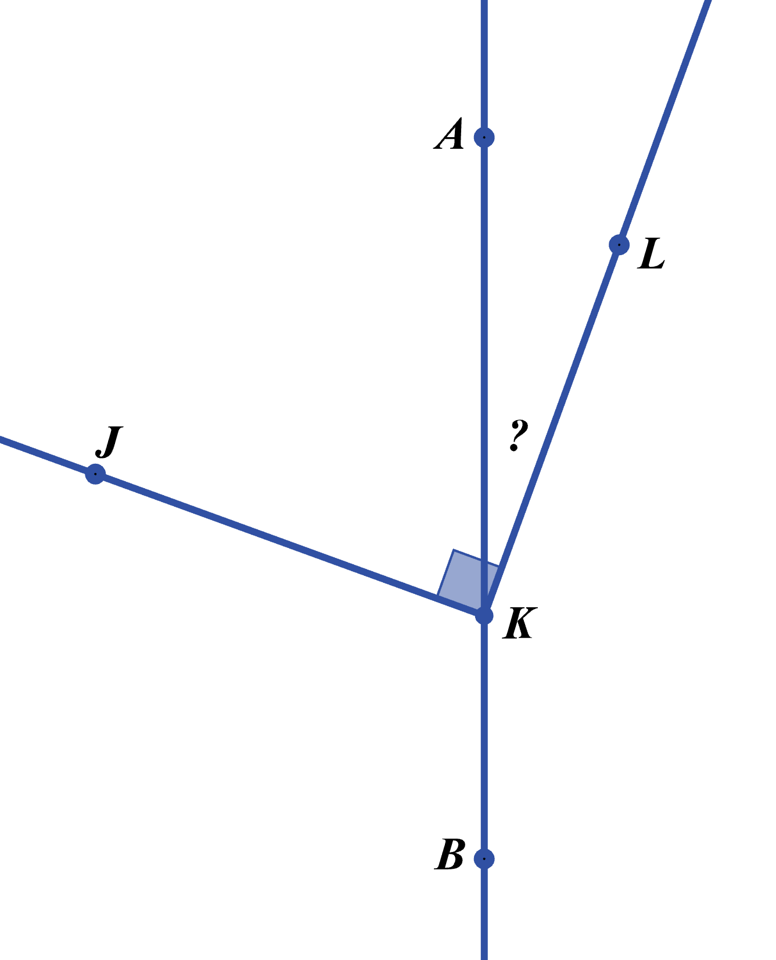

**(J)** 40°

**(K)** Cannot be determined from the given information

**(F)** 10°

**(G)** 20°

**(H)** 30°

# Question 6

The statement  is true for which of the following?

**(F)** 

**(G)** 

**(H)** 

**(J)** 

**(K)** 

# Question 7

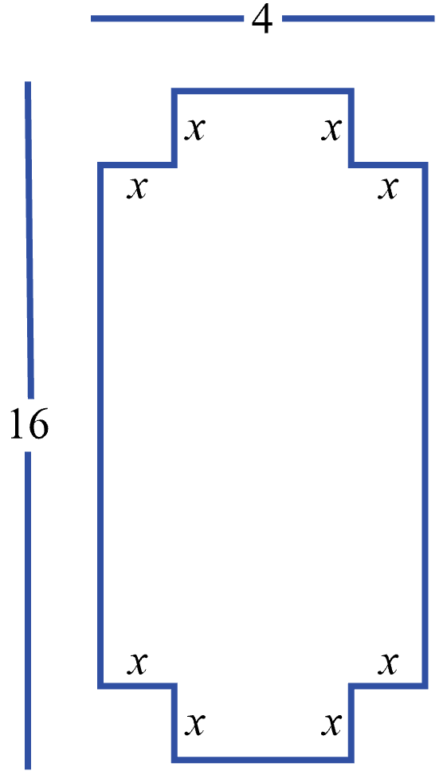Squares with sides of length *x* in. have been removed from each corner of a rectangle measuring 4 in. by 16 in., resulting in the figure shown below. In terms of *x*, what is the area, in square inches, of the figure?

**(A)** 

**(B)** 

**(C)** 

**(D)** 

**(E)** 

# Question 8

For all values of *a* such that *a* < –1, which of the following expressions has the greatest value?

**(F)** 

**(G)** 

**(H)** 

**(J)** 

**(K)** 

# Question 9

The solution to the equation  is which of the types of numbers listed below?

1. Positive
2. Negative
3. Rational
4. Irrational
5. Integer

**(F)** I and III only

**(G)** I and IV only

**(H)** II and III only

**(J)** II and IV only

**(K)** I, III, and V only

# Question 10

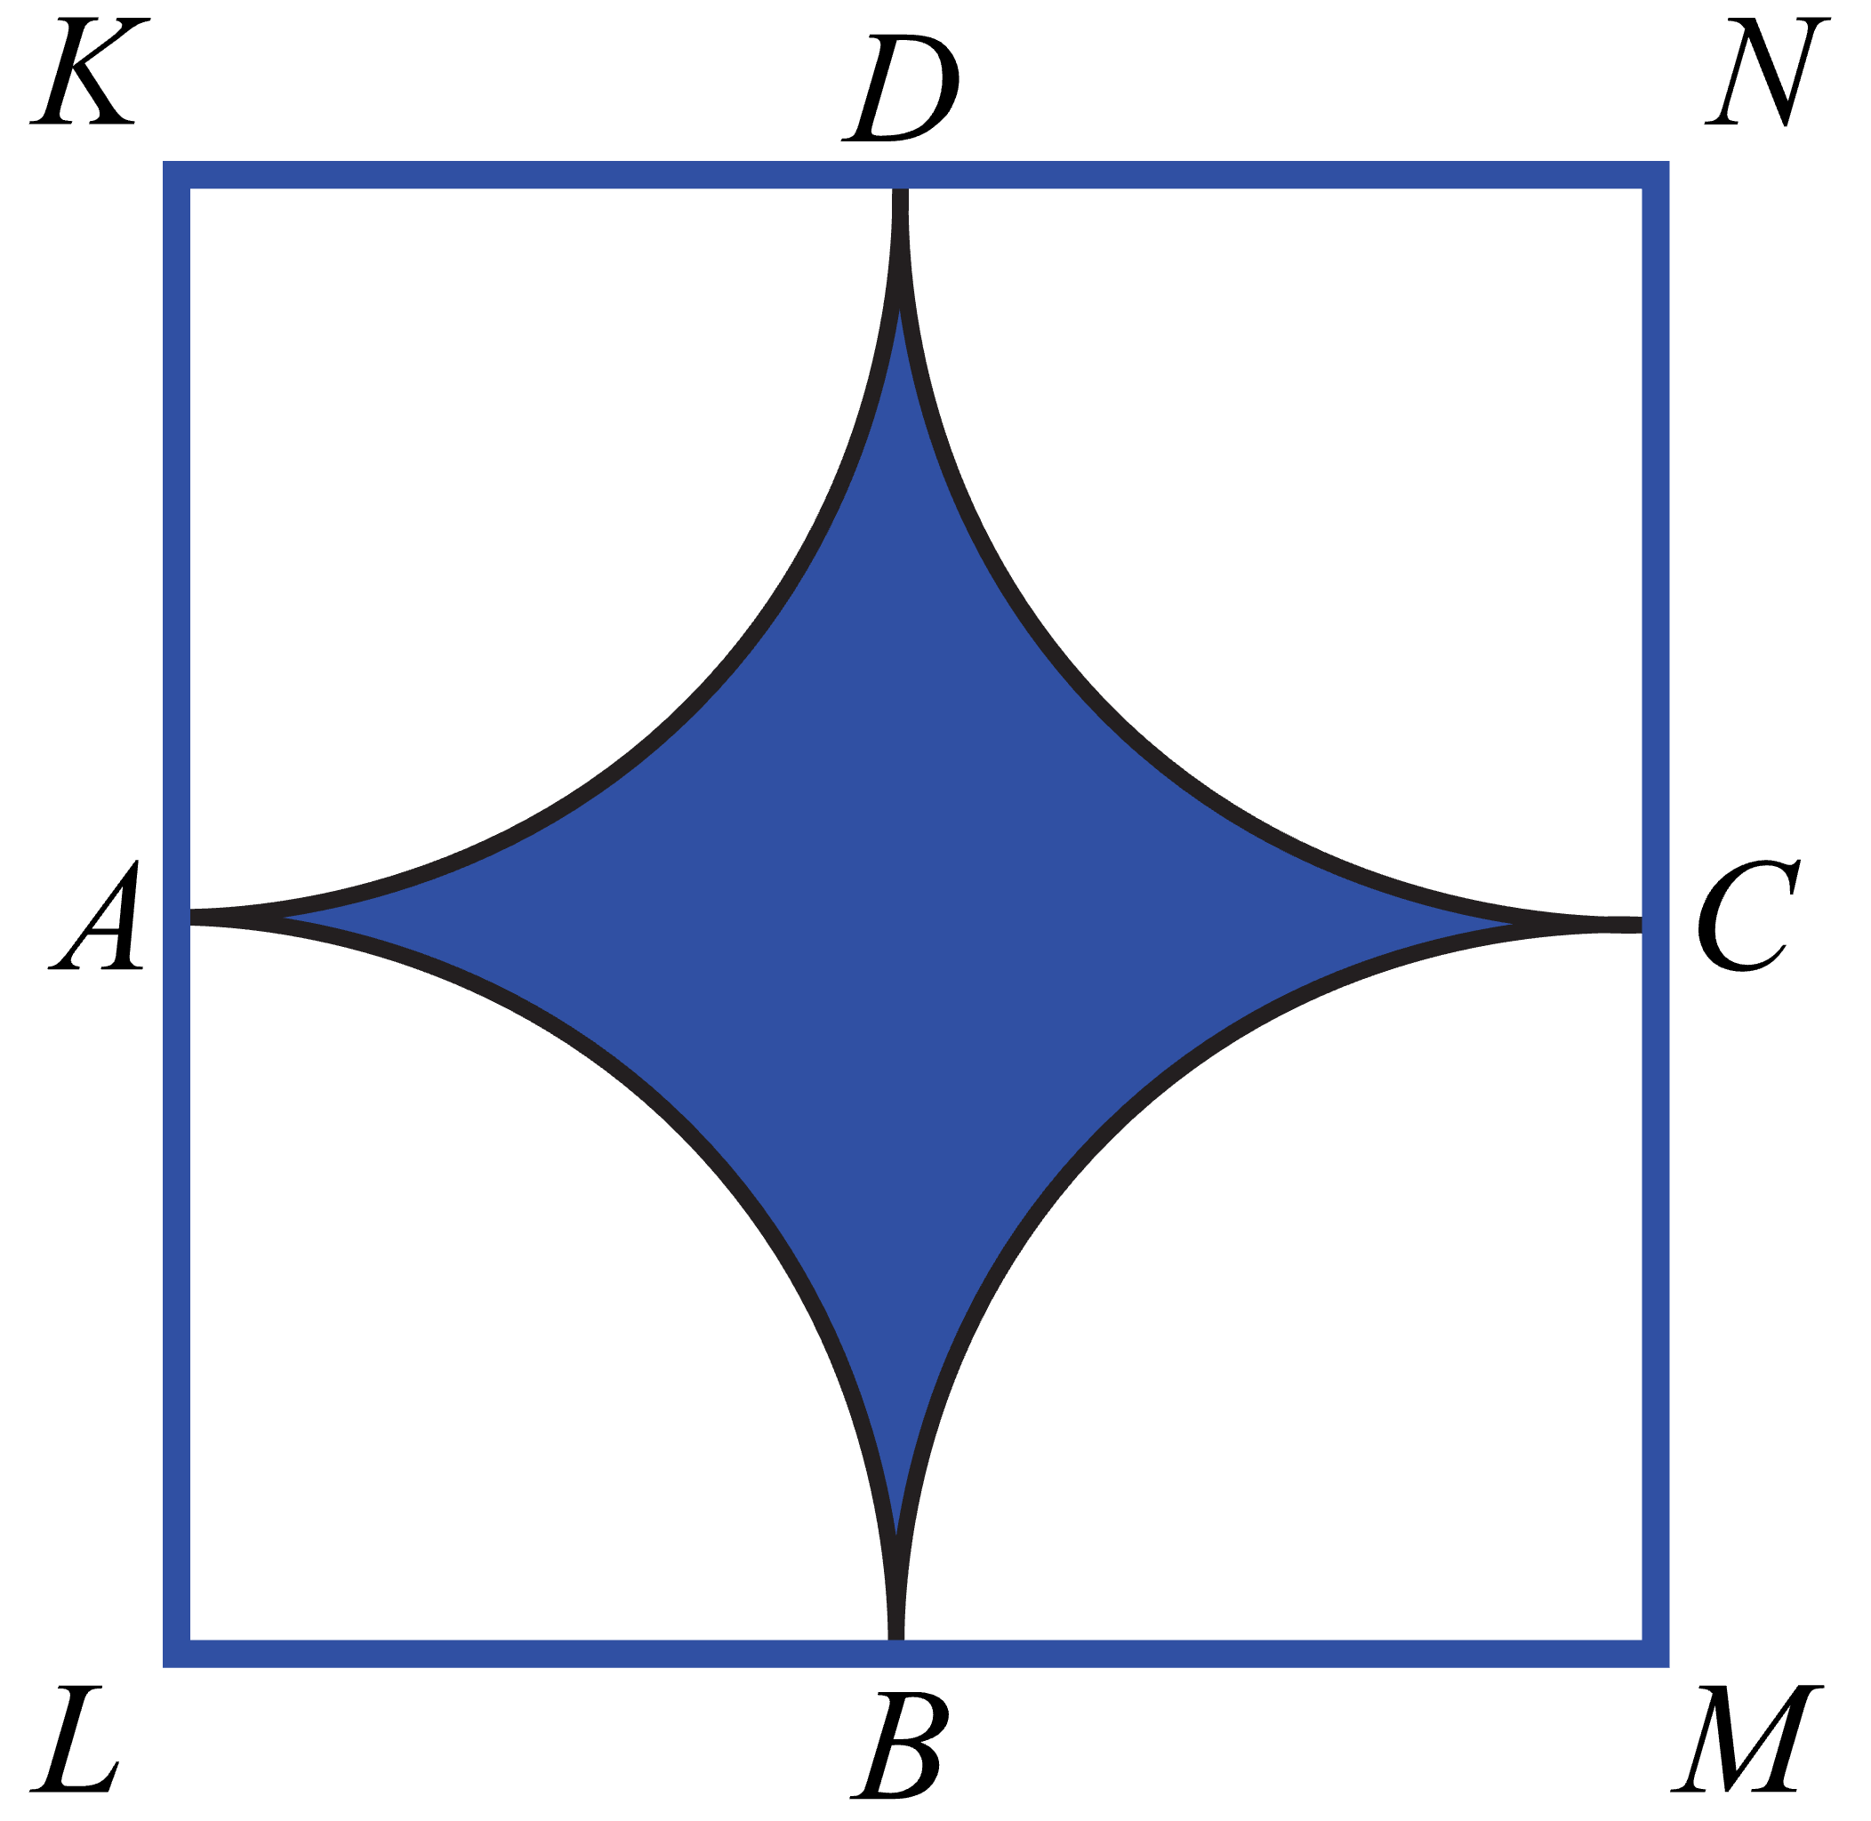In the figure below, points *A*, *B*, *C*, and *D* are on the sides of the square *KLMN*. Arc  has center at *L*,  at *M*,  at *N*, and  at *K*. All of the arcs have a radius of 5 feet. What is the area, in square feet of the shaded region?

**(A)** 

**(B)** 

**(C)** 

**(D)** 

**(E)** 