PROBLEMAS VERBALES

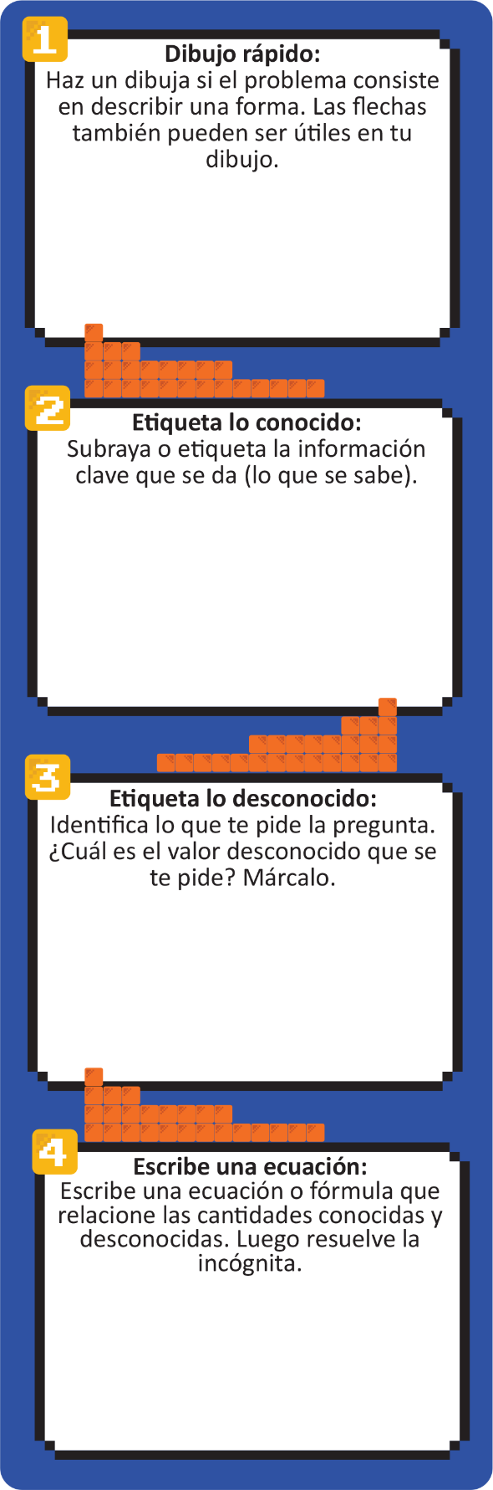
Question 1) The diagonal of a rectangular movie theater screen is 84.1 feet. The width of the screen is 74.0 feet, and the height of the screen is 34 feet less than the width of the screen. Which of the following is the closest to the area, in square feet, of the television screen?
(A) 1680
(B) 2515
(C) 2960
(D) 6225

Question 2) Of the 450 tickets to see a local artist, there are three types of tickets for sale. 8% of the tickets are VIP tickets. Of those tickets NOT reserved for VIP, 18 are general admission tickets. How many tickets are available for sale that are NOT reserved for VIP and are NOT general admission tickets?
(F) 432
(G) 424
(H) 414
(J) 369

