EXIT TICKET

Question 1
The parallelogram below has consecutive angles with measures a° and 124°. What is the value of a?
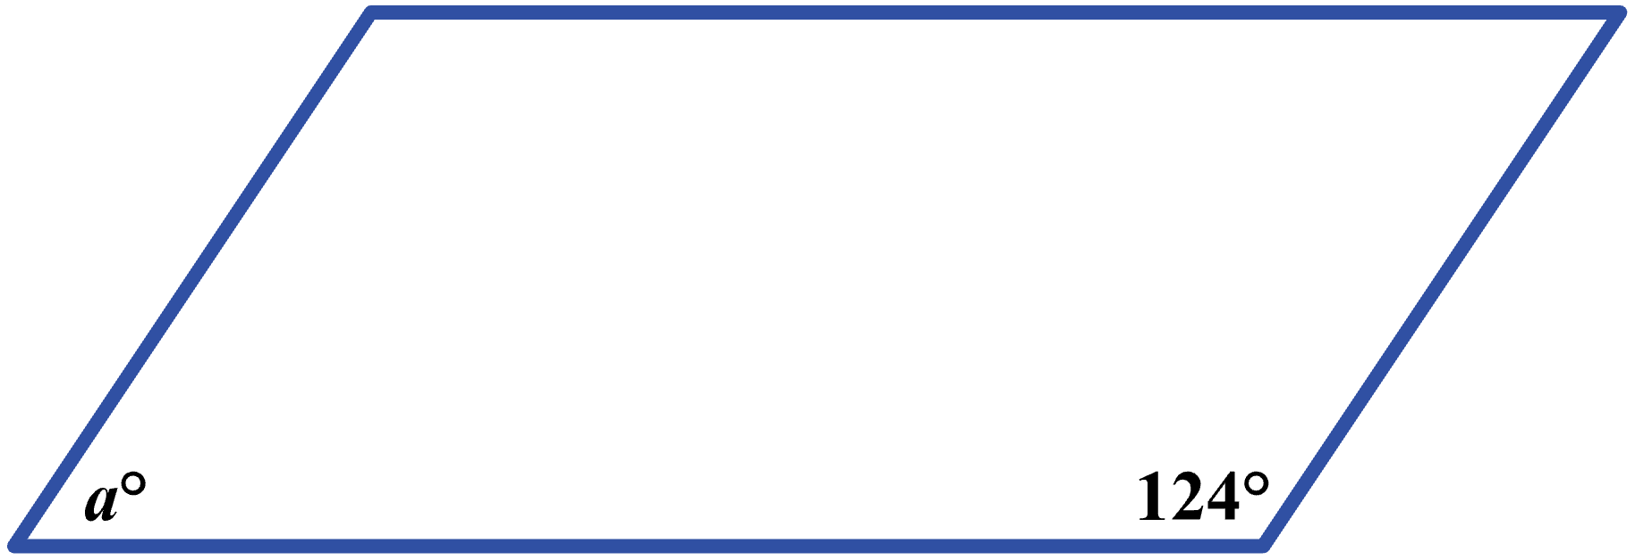
(A) 16
(B) 56
(C) 68
(D) 73

Question 2
When Karla began a driving trip, her car’s odometer read 30 miles. After Karla drove 4 hours, the odometer read 210 miles. Which of the following values is the closest to Karla’s average driving speed, in miles per hour, during those 4 hours?

(F) 45
(G) 53
(H) 60
(J) 90

Question 3
In the standard (x, y) coordinate plane, only one parabola of the form y = a(x – h)² + k has x-intercepts of –2 and 6. Which of the following equations represents the axis of symmetry of this parabola?

(A) x = –2
(B) x = 2
(C) y = 2
(D) y = –2x + 6
Question 4
In a window display at a costume shop, there are 3 mannequins for 1 costume each. To dress these 3 mannequins, Lan has 8 costumes to select from, each of a different style. Selecting from the 8 costumes, Lan can make how many possible display arrangements with 1 costume on each mannequin?

(Note: The positions of the unselected costumes do not matter.)

(F) 24
(G) 56
(H) 336
(J) 512

Question 5
The list of numbers 11, A, B, 22, 31, and 33 has a median of 20. The mode of the list of numbers is 11. To the nearest whole number, what is the mean of the list?

(A) 18
(B) 20
(C) 21
(D) 22

