# Question 1

In  shown below,  and the length of  is 6 cm. What is the length, in centimeters, of ?

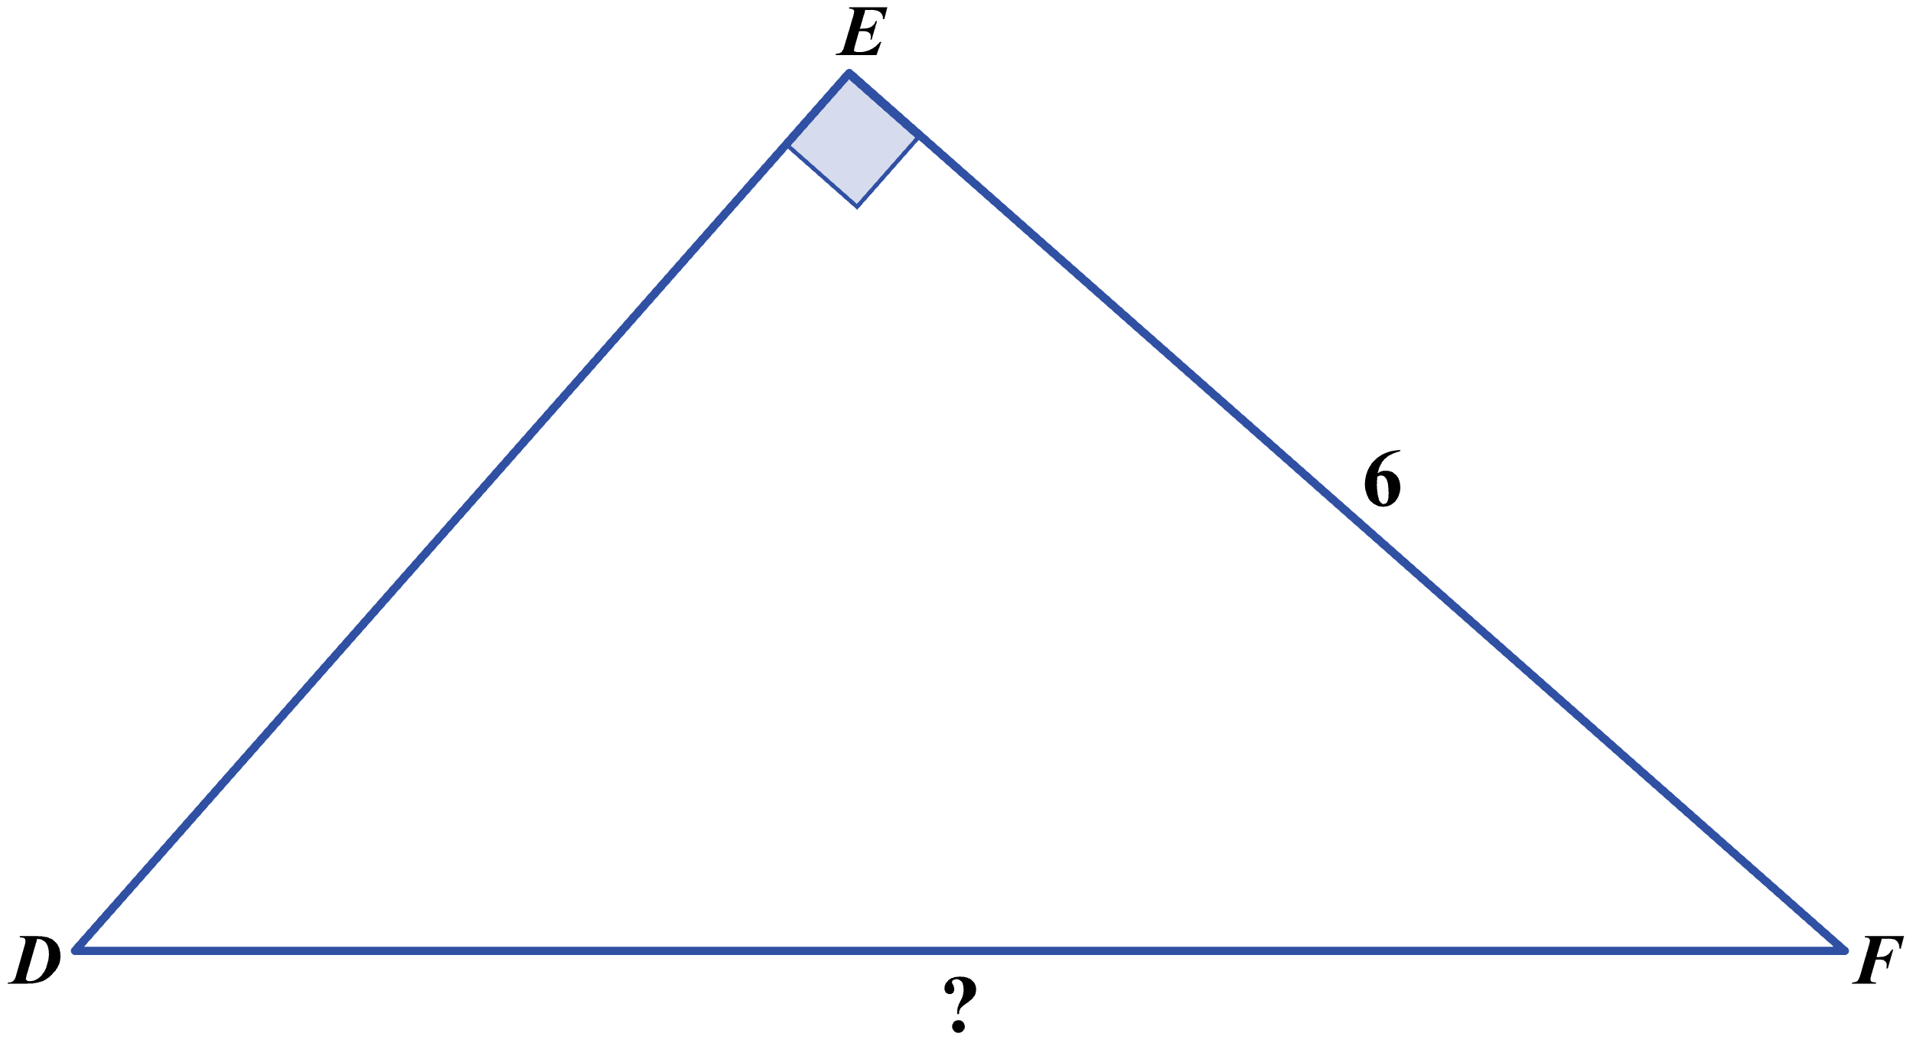

**(A)** 

**(B)** 

**(C)** 

**(D)** 

**(E)** 

# Question 2

For an angle with measure *θ* in a right triangle,  and . What is the value of ?

**(F)** 

**(G)** 

**(H)** 

**(J)** 

**(K)** 

**Question 3**

In the figure shown below, a 12-foot ladder forms an angle of 55° with the level ground as it leans against the building. The distance, in feet, between the bottom of the ladder and the building is equal to which of the following expressions?

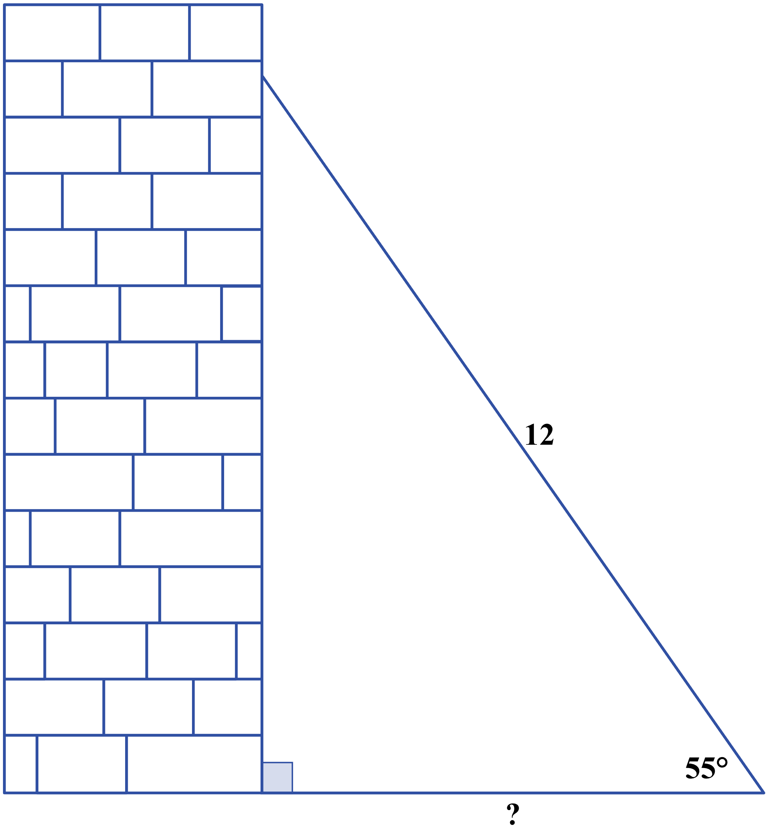

**(A)** 

**(B)** 

**(C)** 

**(D)** 

**(E)** 

# Question 4

In  shown below, the given side lengths are in inches. What is the area, in square inches, of ?

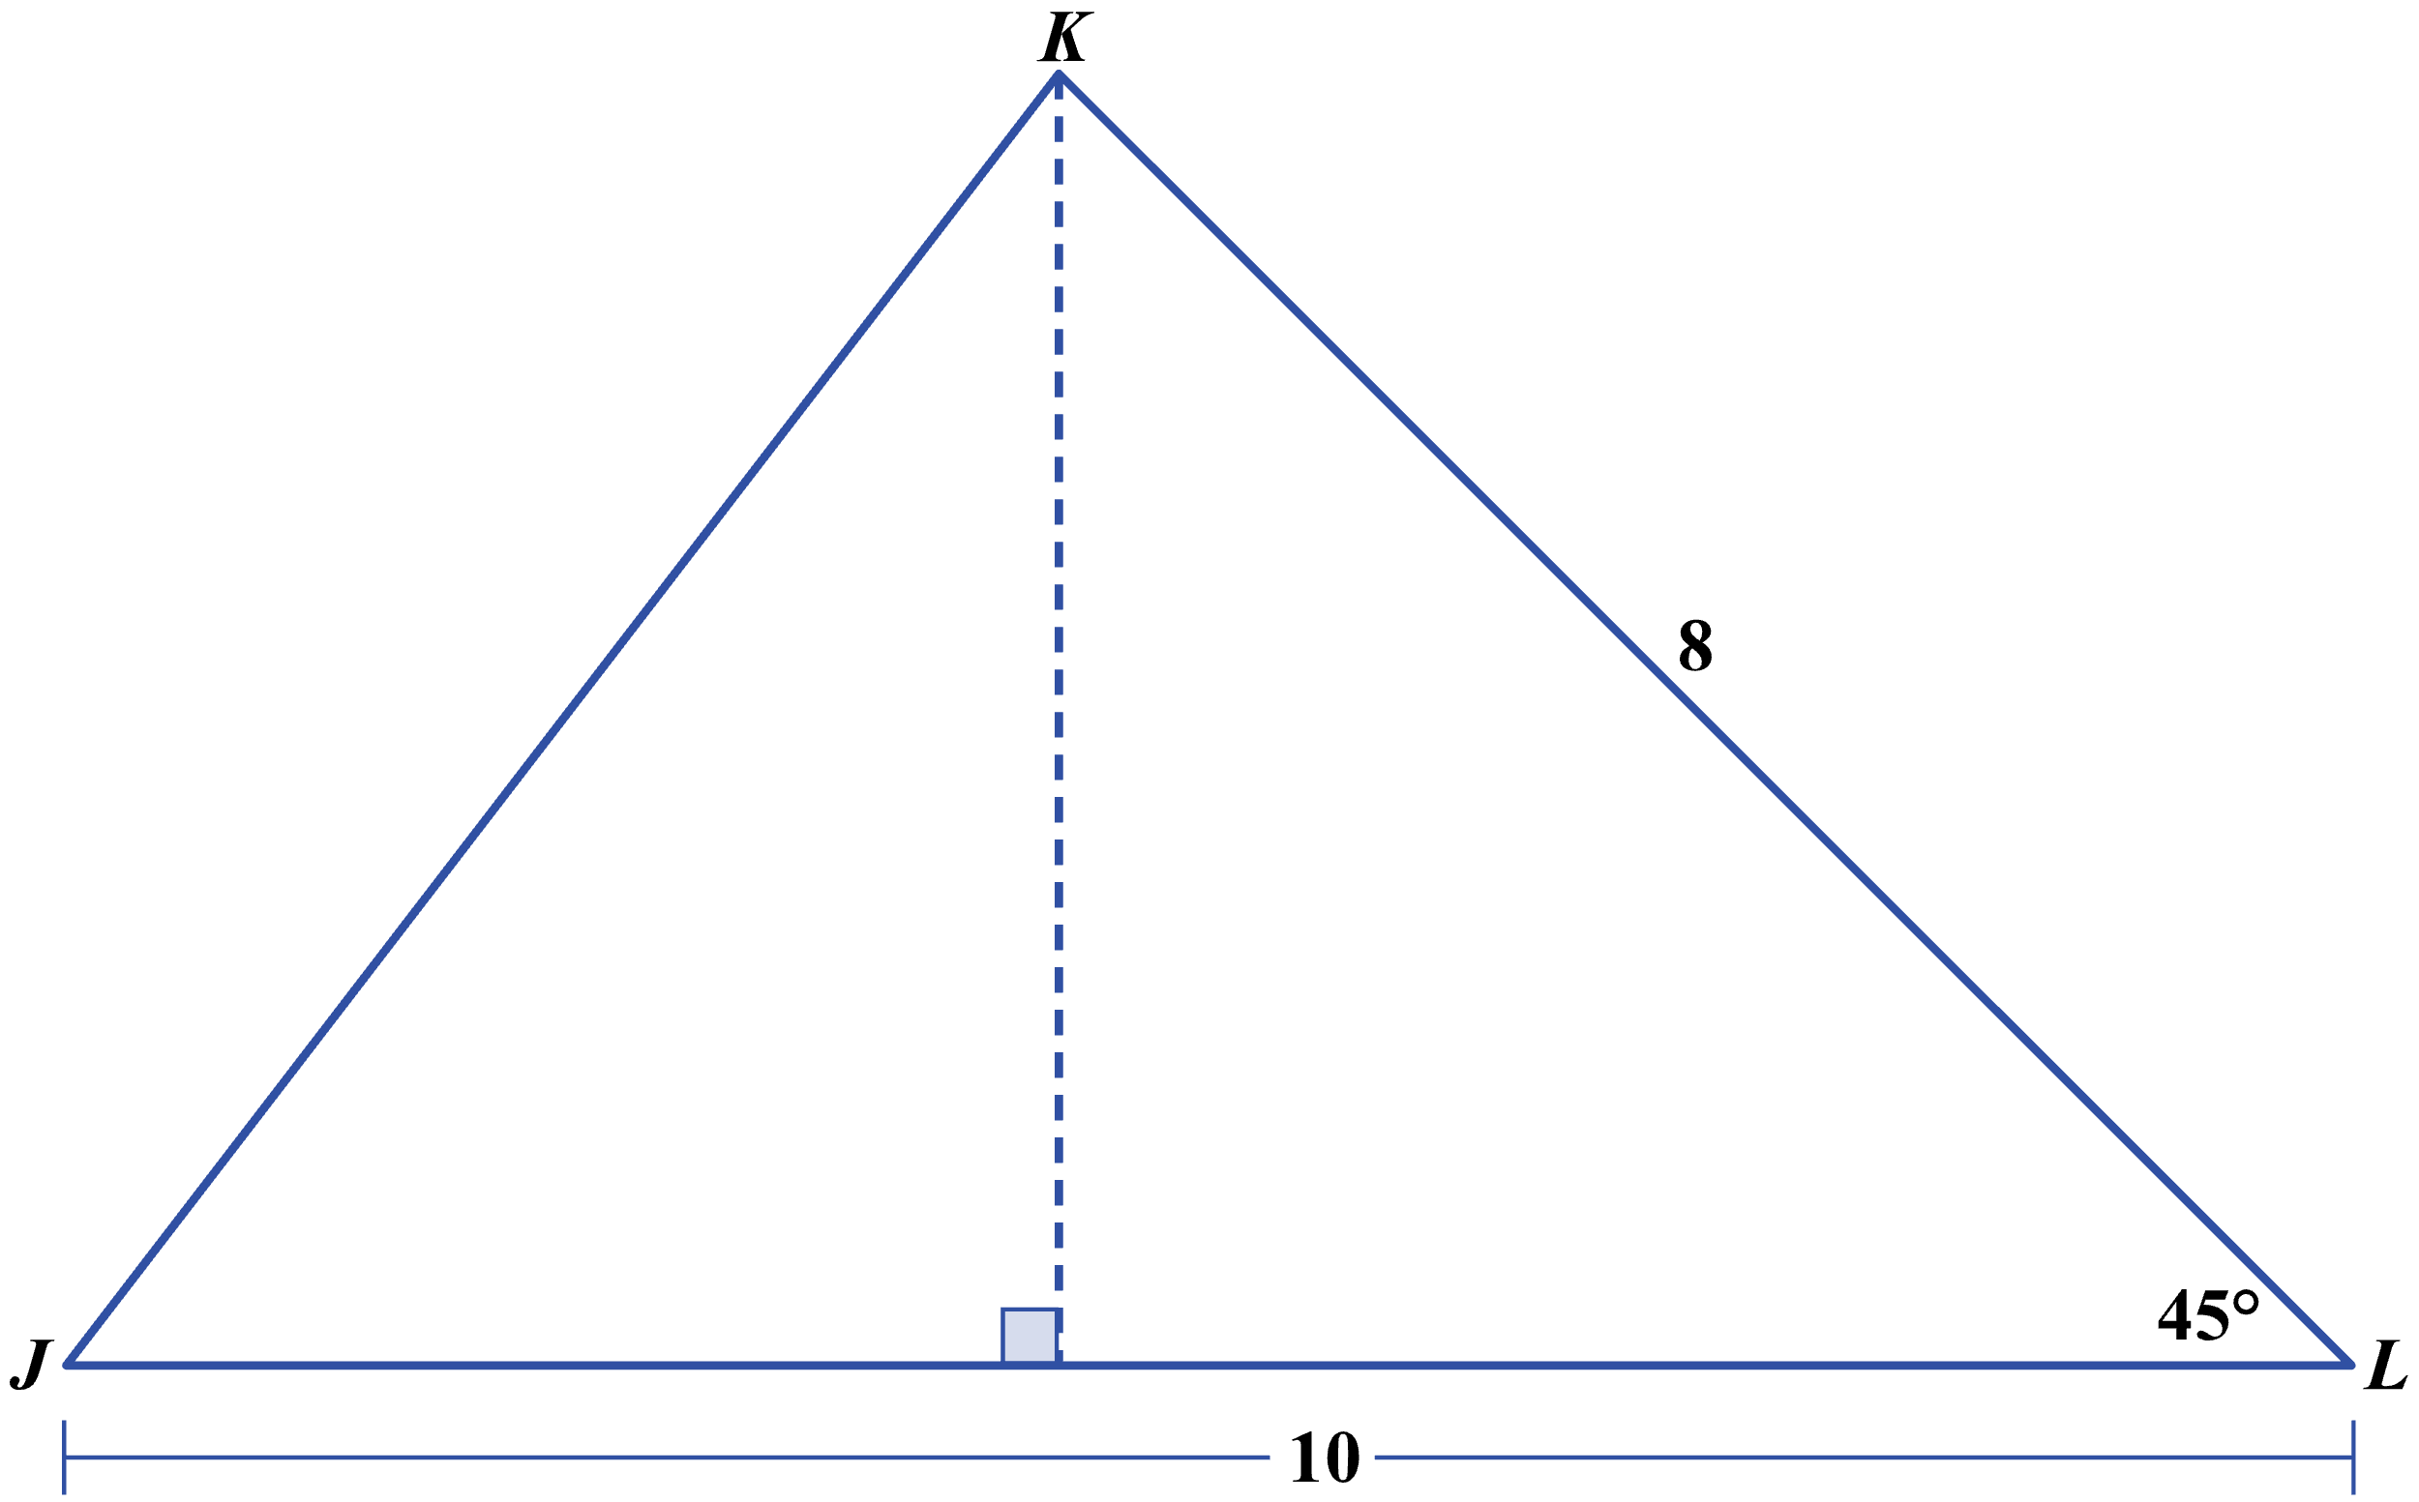

**(F)** 

**(G)** 

**(H)** 

**(J)** 

**(K)** 

**Question 5**

A 20-foot-tall flagpole casts a shadow at 2:00 p.m. that extends 10 feet horizontally along the ground. Then at 4:00 p.m., the shadow extends to 28 feet horizontally along the ground, as shown below. Which of the following expressions equals the positive difference in the measures of the angle of elevation from the end of the shadow to the top of the flagpole at 2:00 p.m. and at 4:00 p.m.?

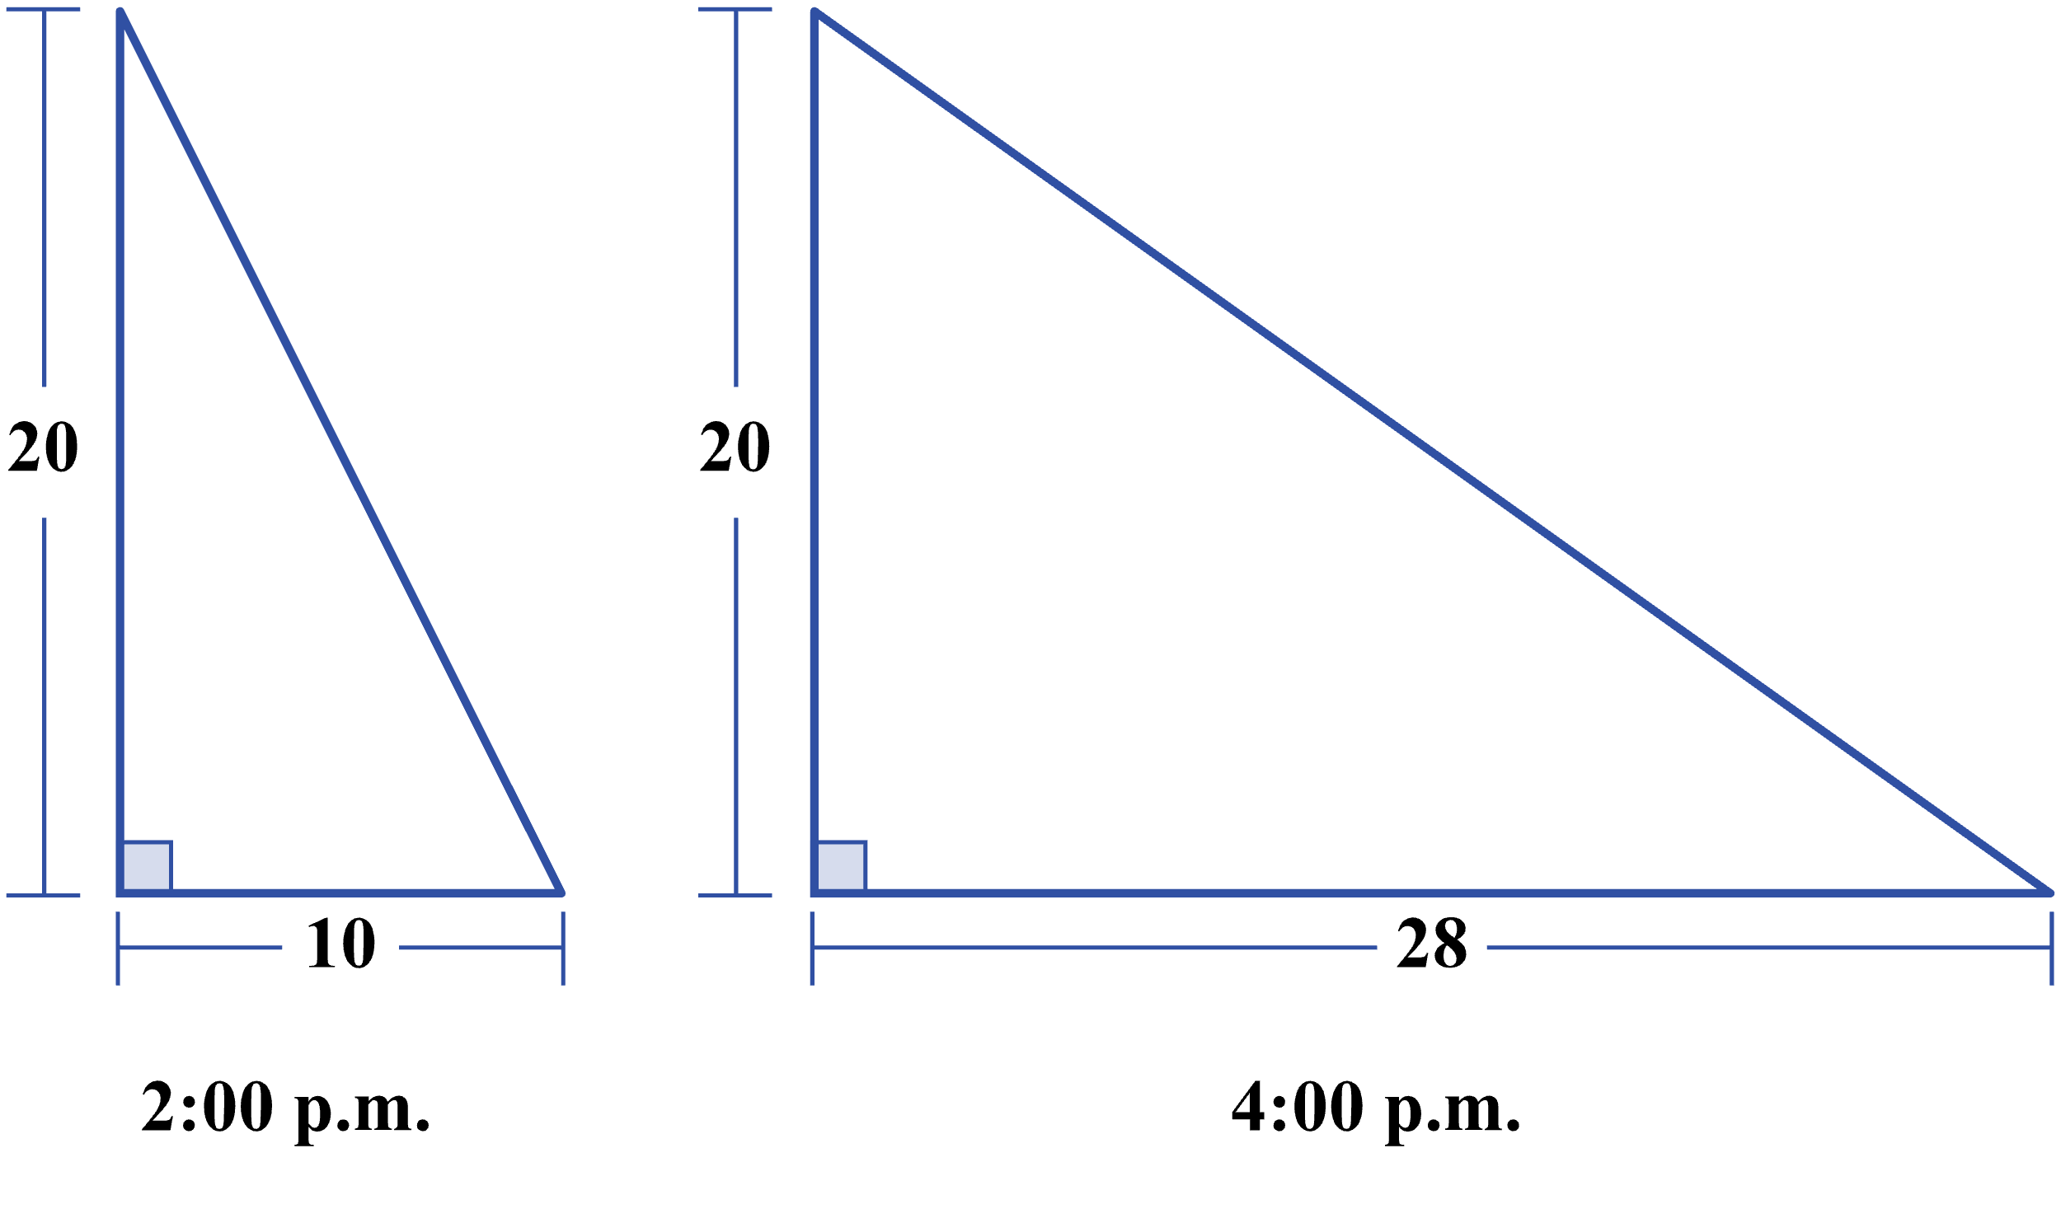

**(A)** 

**(B)** 

**(C)** 

**(D)** 

**(E)** 