|  |  |  |
| --- | --- | --- |
|  |  | |
| Find the Missing Side:   **Find the value of *y*.**      **Find the value of *h*.** | | **Find the Missing Angle:**    **Find the value of *θ*.** |

# Find the Unknown Value

# Question 1

In right triangle , where *B* is the right angle, the length of  is 8 inches, and . What is the value of ?

**(A)** 

**(B)** 

**(C)** 

**(D)** 

**(E)** 

# Question 2

In , shown in the figure below, ,  feet,  is a right angle, and the measure of  is 30°. What is the value of , in feet?

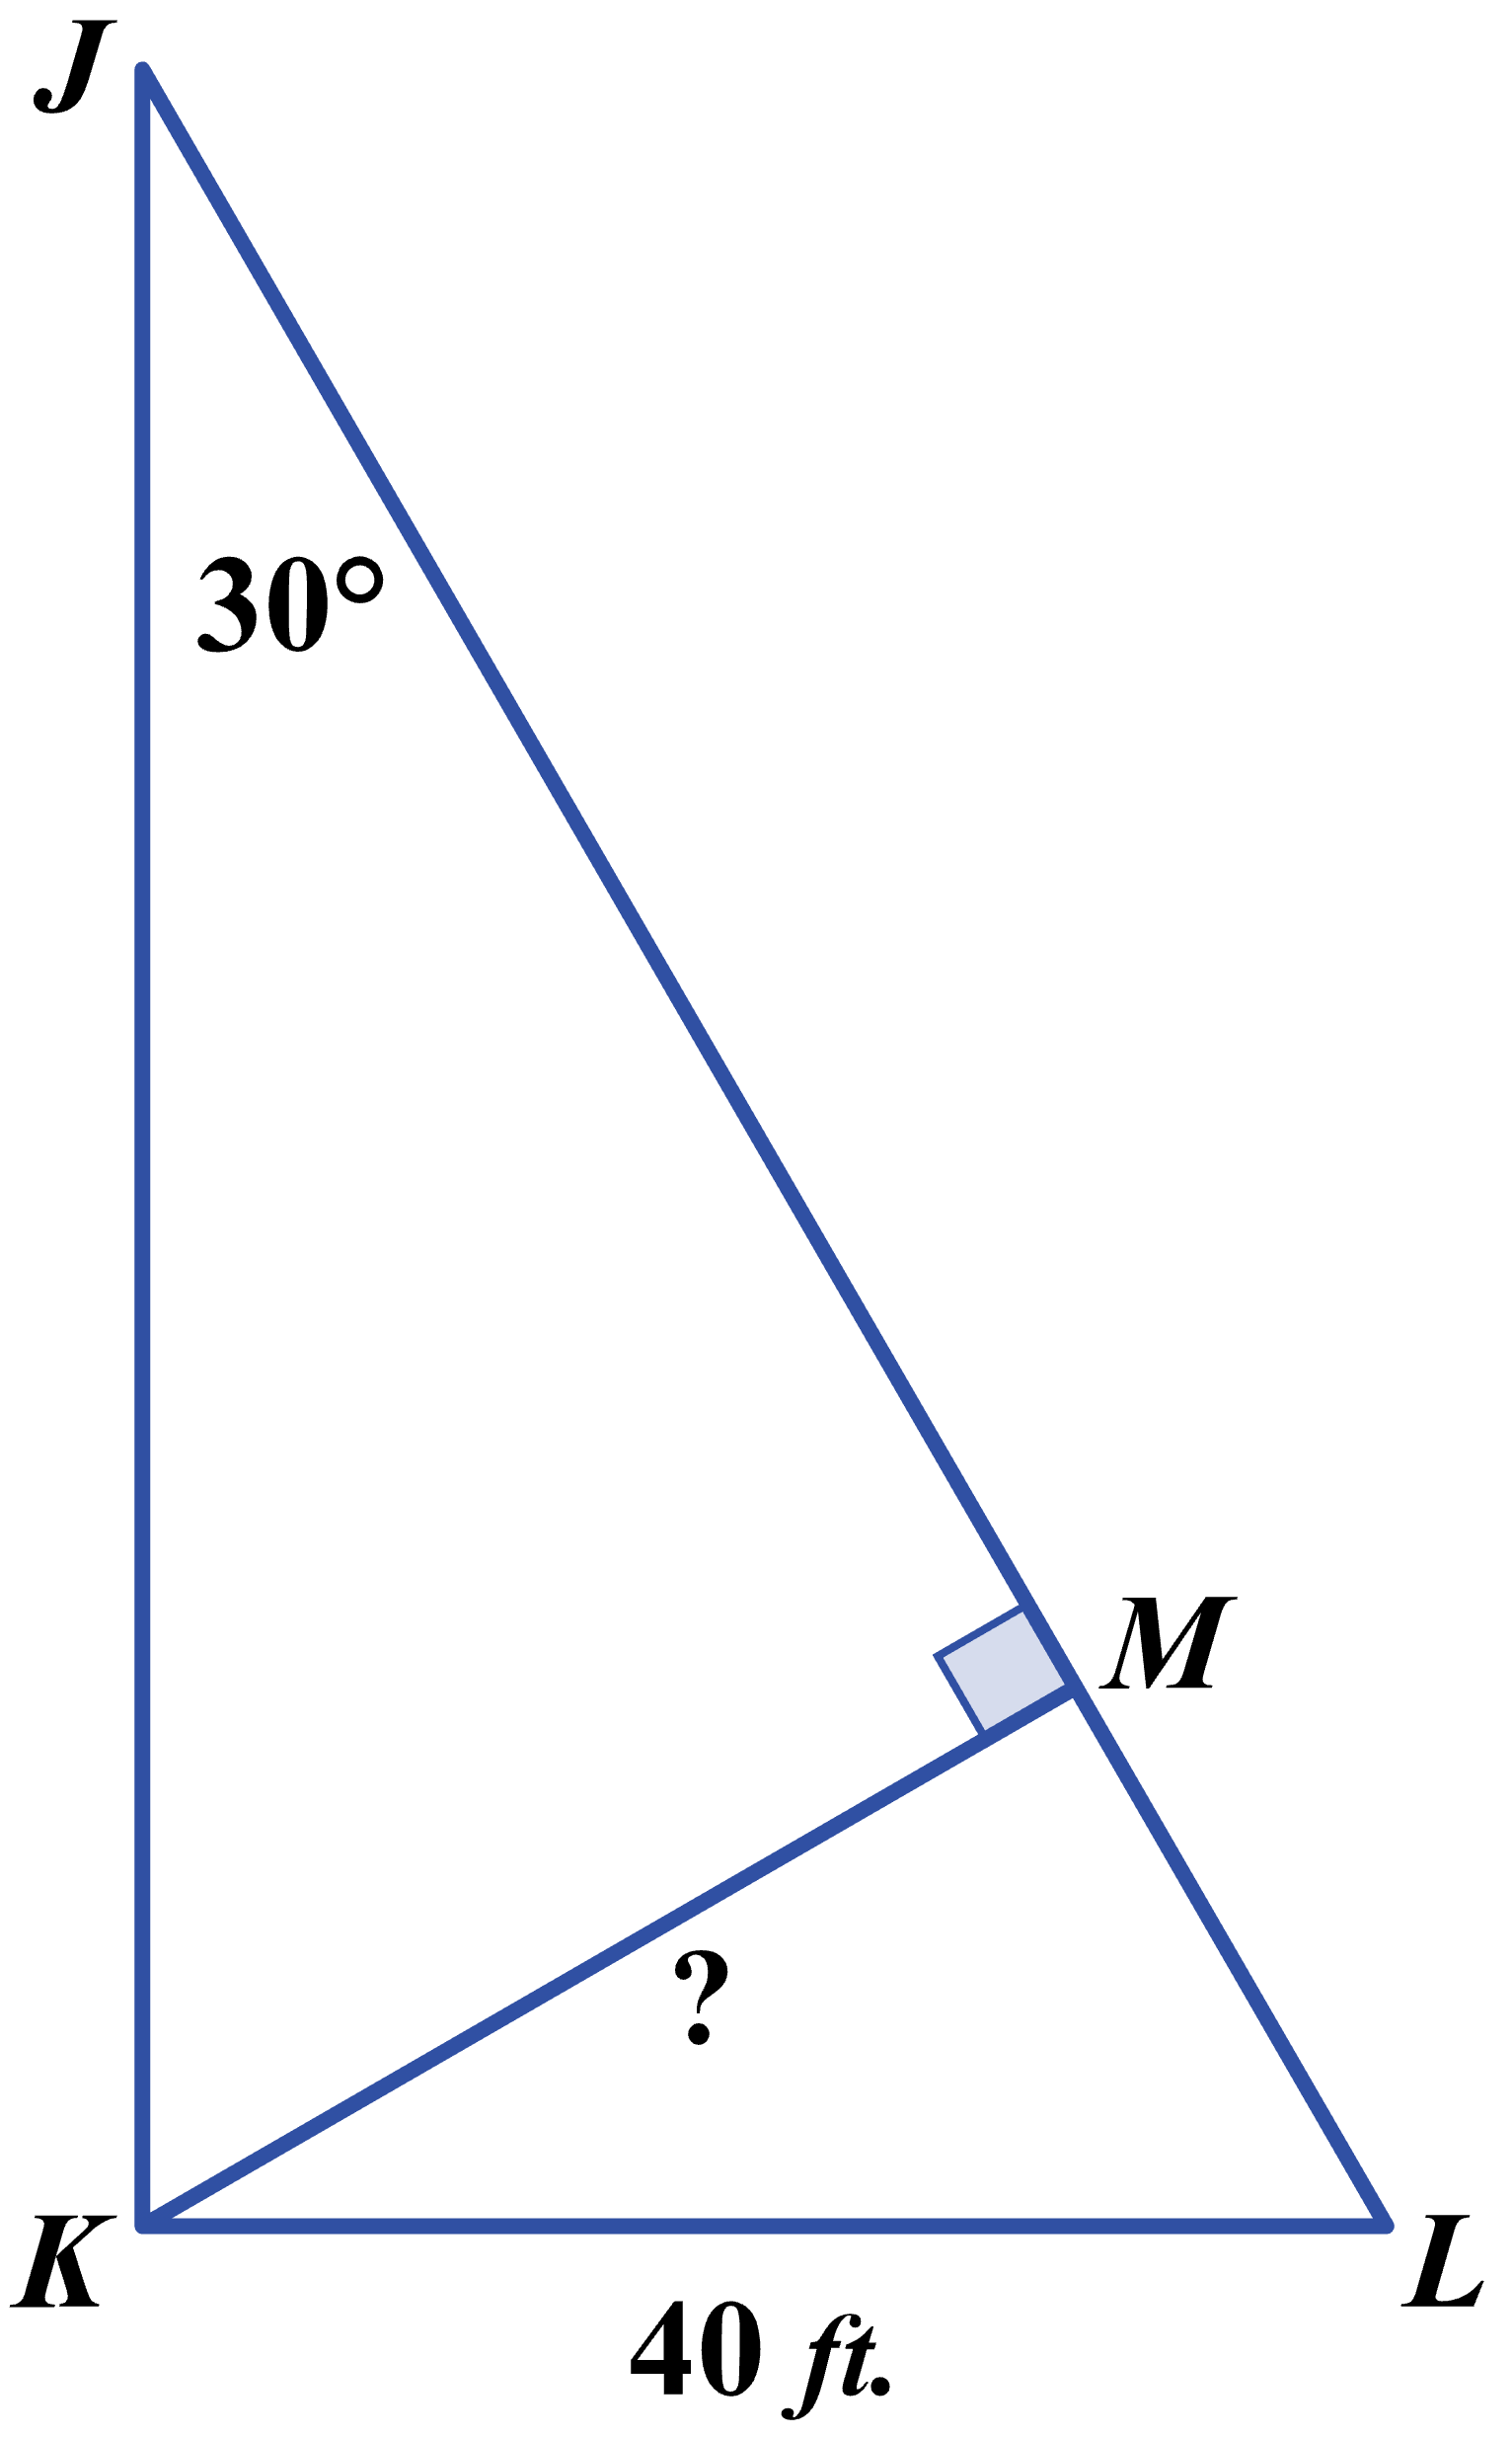

**(F)** 

**(G)** 

**(H)** 

**(J)** 

**(K)** 