VOCABULARY

Opposite – Adjacent – Hypotenuse
Use one of the following words to label each side of the two triangles: opposite, adjacent, or hypotenuse.

Triangle 1

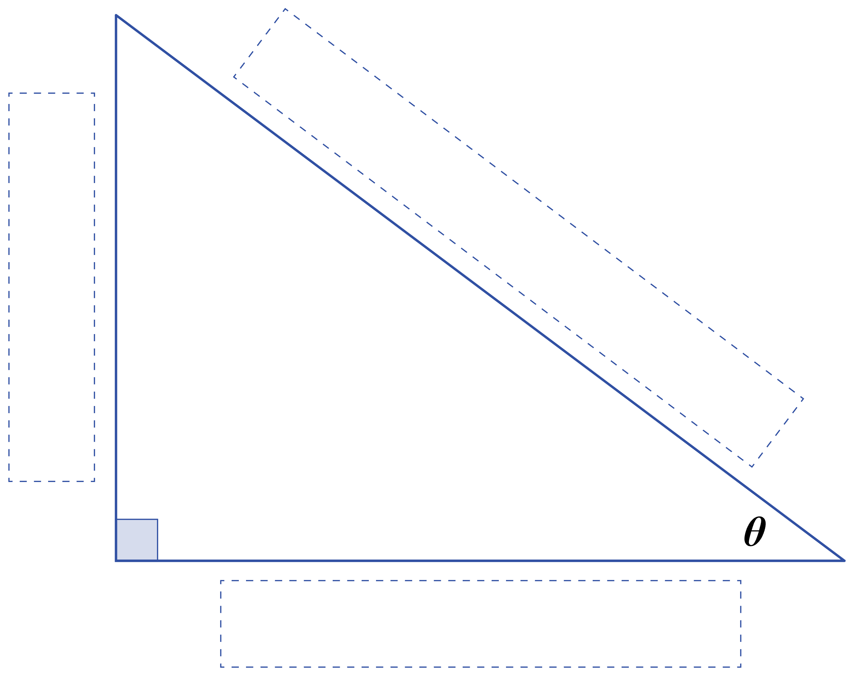

Triangle 2

