WHAT DO YOU MEME?
Choose a template from below or create your own meme using the blank frame provided.
Create Your Own

Meme 1

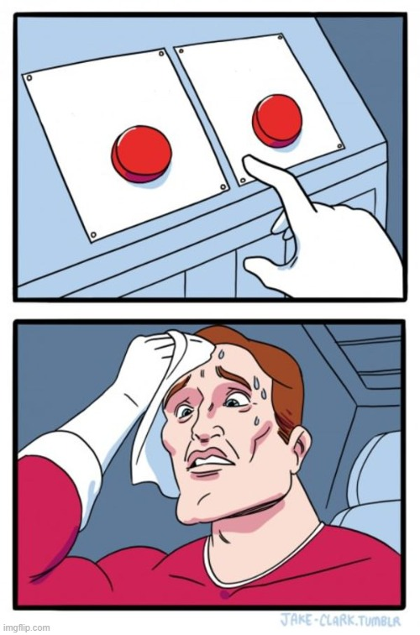
Source: Clark, J. (n.d.). Two buttons meme generator. Imgflip. https://imgflip.com/memegenerator/Two-Buttons

Meme 2
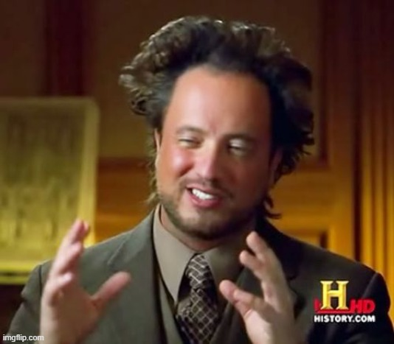
Source: Tsoukalos, G. A. (n.d.). Ancient aliens meme generator. Imgflip. https://imgflip.com/memegenerator/Ancient-Aliens

Create Your Own

