ESPIANDO LOS DETALLES
Instrucciones: Para cada tabla, gráfico o figura, resalta los títulos, leyendas/claves, variables independientes y variables dependientes. Circula cualquier otra parte que te ayude a entender los datos.

Table 1. Catfish Sizes

Average mass and length of Giant catfish at different sites along the Mekong River
Location | Length (cm) | Mass (kg)
Site A | 75 | 90
Site B | 200 | 250
Site C | 120 | 150
Site D | 155 | 200

Table 2. Light from Flames

Properties of Light
Speed (m/s) | Energy (x10-21 J) | Wavelength (nm) | Color
3.00 x 10⁸ | 269-318 | 625-740 | Red
3.00 x 10⁸ | 318-337 | 590-625 | Orange
3.00 x 10⁸ | 337-352 | 565-590 | Yellow
3.00 x 10⁸ | 352-382 | 520-565 | Green
3.00 x 10⁸ | 382-452 | 440-520 | Blue
3.00 x 10⁸ | 452-523 | 380-440 | Violet

Figure 1. Fugate Genetic Family Tree
The Fugate family tree. Recessive gene traits caused a number of people to have blue skin in Kentucky.
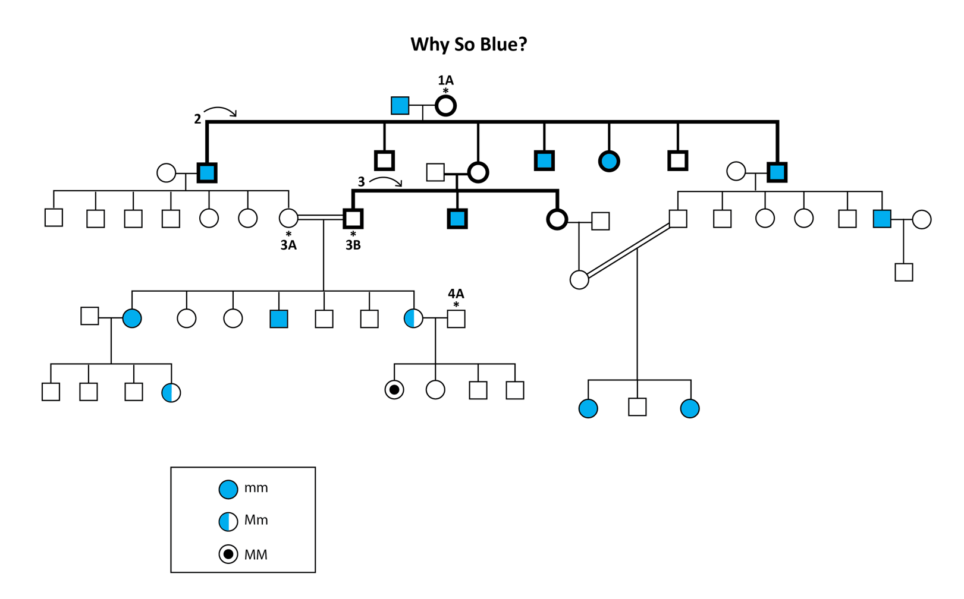

Figure 2. Leaf Area Index

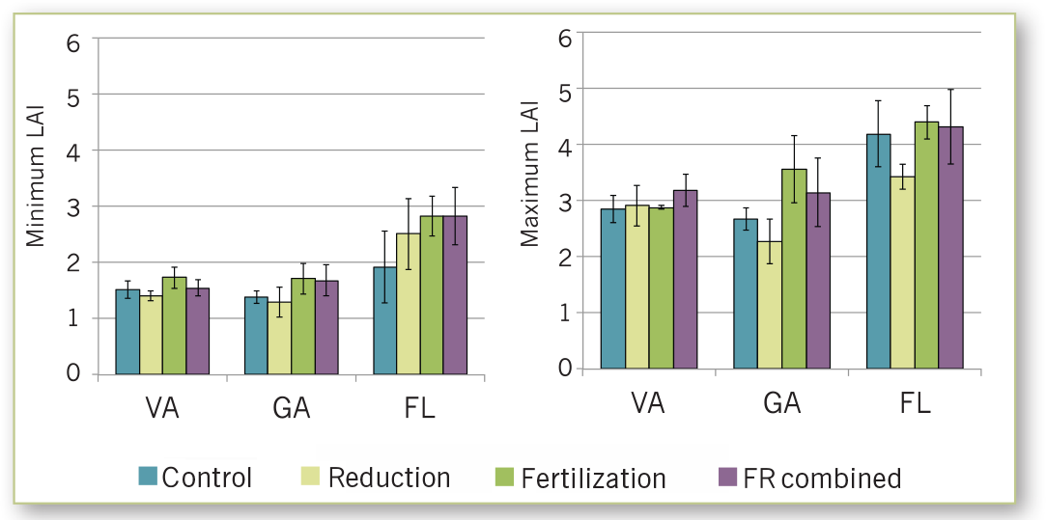
Mean leaf area index for sites in Virginia, Georgia, and Florida.

PINEMAP. Pine Integrated Network: Education, Migration, and Adaptation Project. (2014). Using the Tier III Experiments to Investigate the Effects of Drought and Fertilization on Forest Water Use and Stomatal Conductance. http://www.pinemap.org/reports/annual-reports/Year_3_Annual_Report.pdf

