SPYING OUT SPECIFICS
Instructions: For each table, graph, or figure, highlight any titles, legends/keys, independent variables, and dependent variables. Circle any other parts that help you to understand the data.

Table 1. Catfish Sizes

Average mass and length of Giant catfish at different sites along the Mekong River
Location | Length (cm) | Mass (kg)
Site A | 75 | 90
Site B | 200 | 250
Site C | 120 | 150
Site D | 155 | 200

Table 2. Light from Flames

Properties of Light
Speed (m/s) | Energy (x10-21 J) | Wavelength (nm) | Color
3.00 x 10⁸ | 269-318 | 625-740 | Red
3.00 x 10⁸ | 318-337 | 590-625 | Orange
3.00 x 10⁸ | 337-352 | 565-590 | Yellow
3.00 x 10⁸ | 352-382 | 520-565 | Green
3.00 x 10⁸ | 382-452 | 440-520 | Blue
3.00 x 10⁸ | 452-523 | 380-440 | Violet

Figure 1. Fugate Genetic Family Tree
The Fugate family tree. Recessive gene traits caused a number of people to have blue skin in Kentucky.
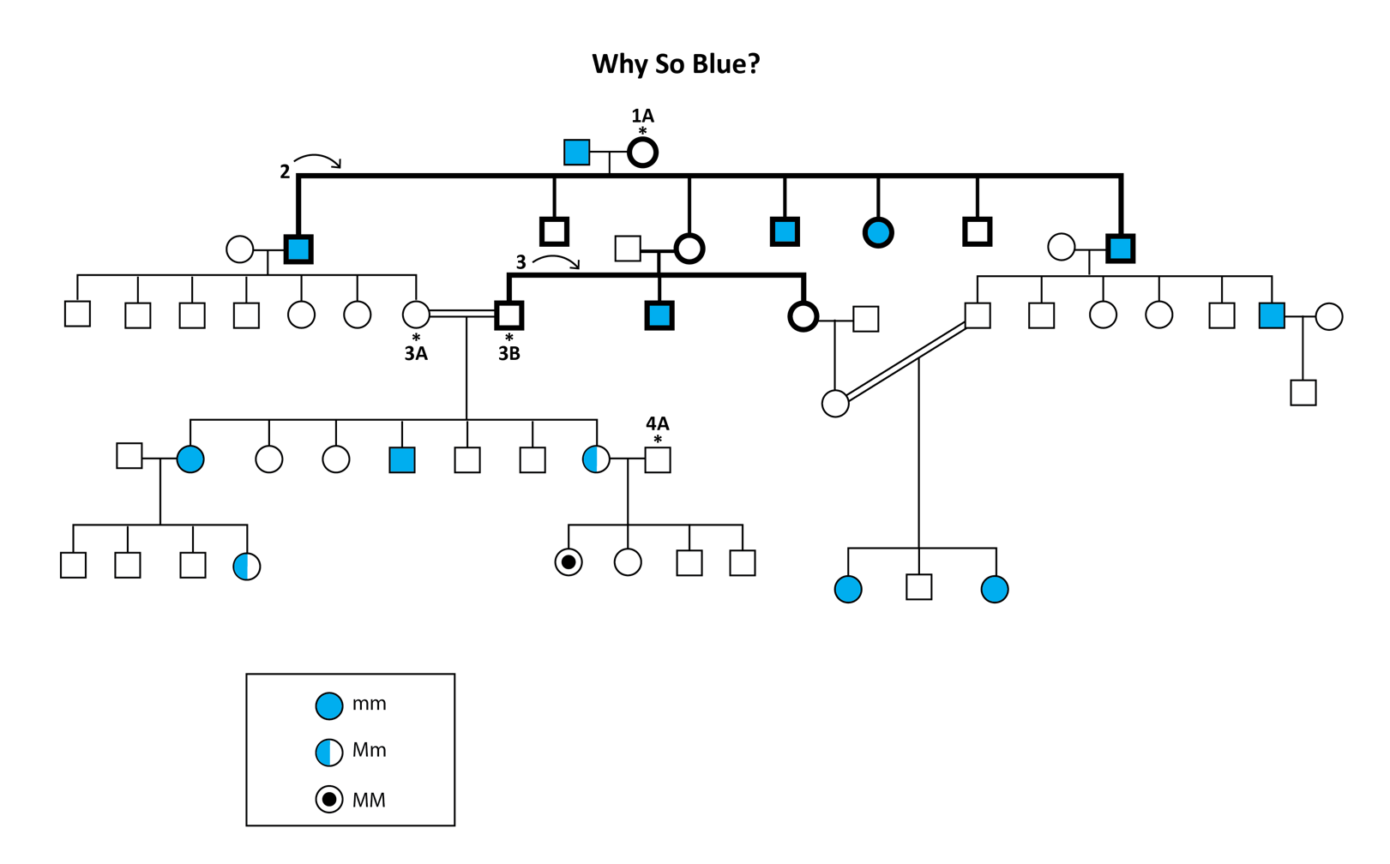

Figure 2. Leaf Area Index

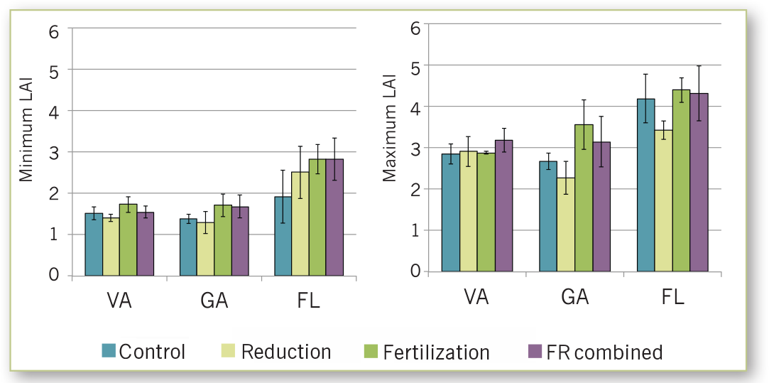
Mean leaf area index for sites in Virginia, Georgia, and Florida.

PINEMAP. Pine Integrated Network: Education, Migration, and Adaptation Project. (2014). Using the Tier III Experiments to Investigate the Effects of Drought and Fertilization on Forest Water Use and Stomatal Conductance. http://www.pinemap.org/reports/annual-reports/Year_3_Annual_Report.pdf

