GETTING SALTY

Passage 1

The salinities, or saltiness, of the water in H2O and salt (NaCl) solutions are found by measuring the melting point of ice in the solution and then using a formula or table to determine the salinity based on that temperature in which the ice began to melt. In the formula below, Y is the dependent variable of salinity as a percentage of weight of the solution and x is the independent variable melting point in degrees Celsius:

Y = 1.78x – 0.0442x² + 0.000557x³

Table 1 shows the salinity of H2O-NaCl solutions based on the melting point of solutions.

Table 1. Melting Points for Differing Levels of Salinity
Melting points | 0.0 - 5.9 | 6.00 - 10.9 | 11.0 - 15.5 | 16.0 - 21.9
Saltiness | 0.00 - 9.08 | 9.21 - 14.87 | 14.97 - 19.37 | 19.45 - 22.98

Recent studies have found that if purity of the water is not considered, there are differences in the findings of salinity for a solution. Figure 1 shows the differences in findings between two studies, one that accounted for water purity and one that did not. Each point on the graph shows the difference in findings of salinity between the two studies by subtracting the outcome for the study that did not account for water purity from the outcome for the study that did consider water purity.

Figure 1. Salinity Difference
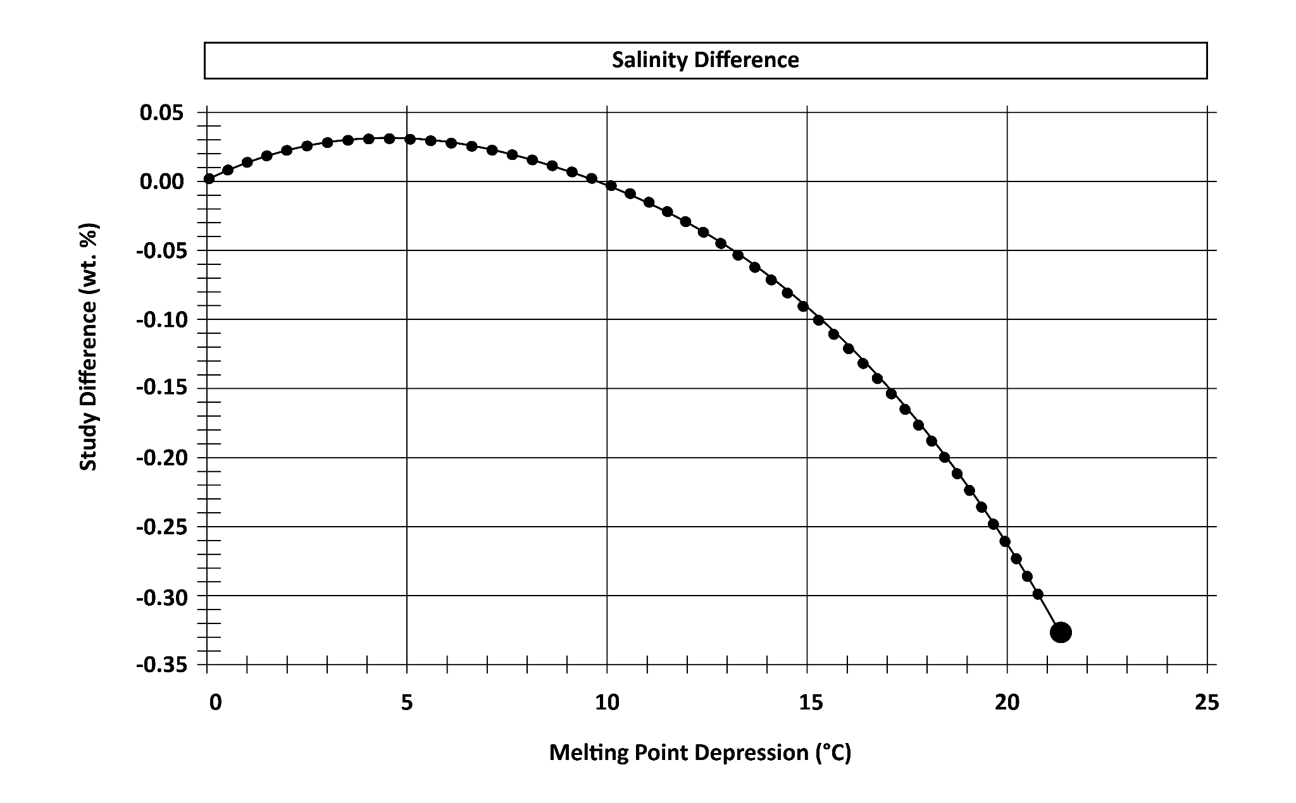
Adapted from: Bodnar, R. J. (1993). Revised equation and table for determining the freezing point depression of H2O-NaCl solutions. Geochimica et Cosmochimica acta, 57(3), 683-684.

Questions

- Based on Figure 1, what is the difference in salinity between the study that accounted for water purity and the study that did not at 15 degrees Celsius?
  - 0.05
  - -0.09
  - -0.20
  - -0.35

- According to Table 1 and Figure 1, what is the maximum melting point for a H2O-NaCl solution?
  - 9.08°C
  - 14.87°C
  - 19.38°C
  - 21.9°C

- Which substance is considered the solvent in the solution for this experiment?
  - salt
  - water
  - melting point
  - water purity

- If another study accounted for additional factors that could affect water quality or the quality of the NaCl, the greatest differences in findings would more likely occur at which melting point?
  - 5°C
  - 8°C
  - 15°C
  - 22°C

- The melting point for a solution was 10.2 degrees Celsius. What is a possible salinity for this solution?
  - 4.32
  - 9.07
  - 13.65
  - 15.76

