WHAT’S TRENDING

Part A
Instructions: Draw a line to match the graph or table to its description.

Graph or Table |  | Notes
Graph 1. Estimated Cases of MRSA By Year  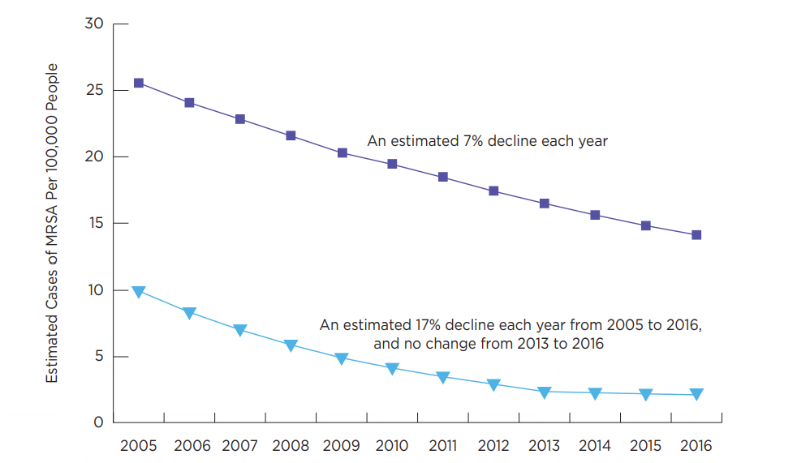  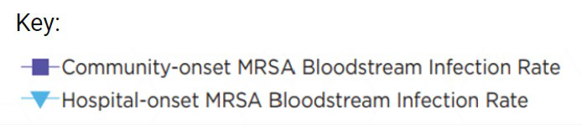 |  | Negative. As energy increases, wavelength decreases.
Table 1. Catfish Sizes  Average mass and length of Giant catfish at different sites along the Mekong River  Location Length (cm) Mass (kg)  Site A 75 90  Site B 200 250  Site C 120 150  Site D 155 200 |  | Negative, same trends. As the year increases, cases decrease. Community trend is higher than the hospital trend.
Graph 2. Properties of Light  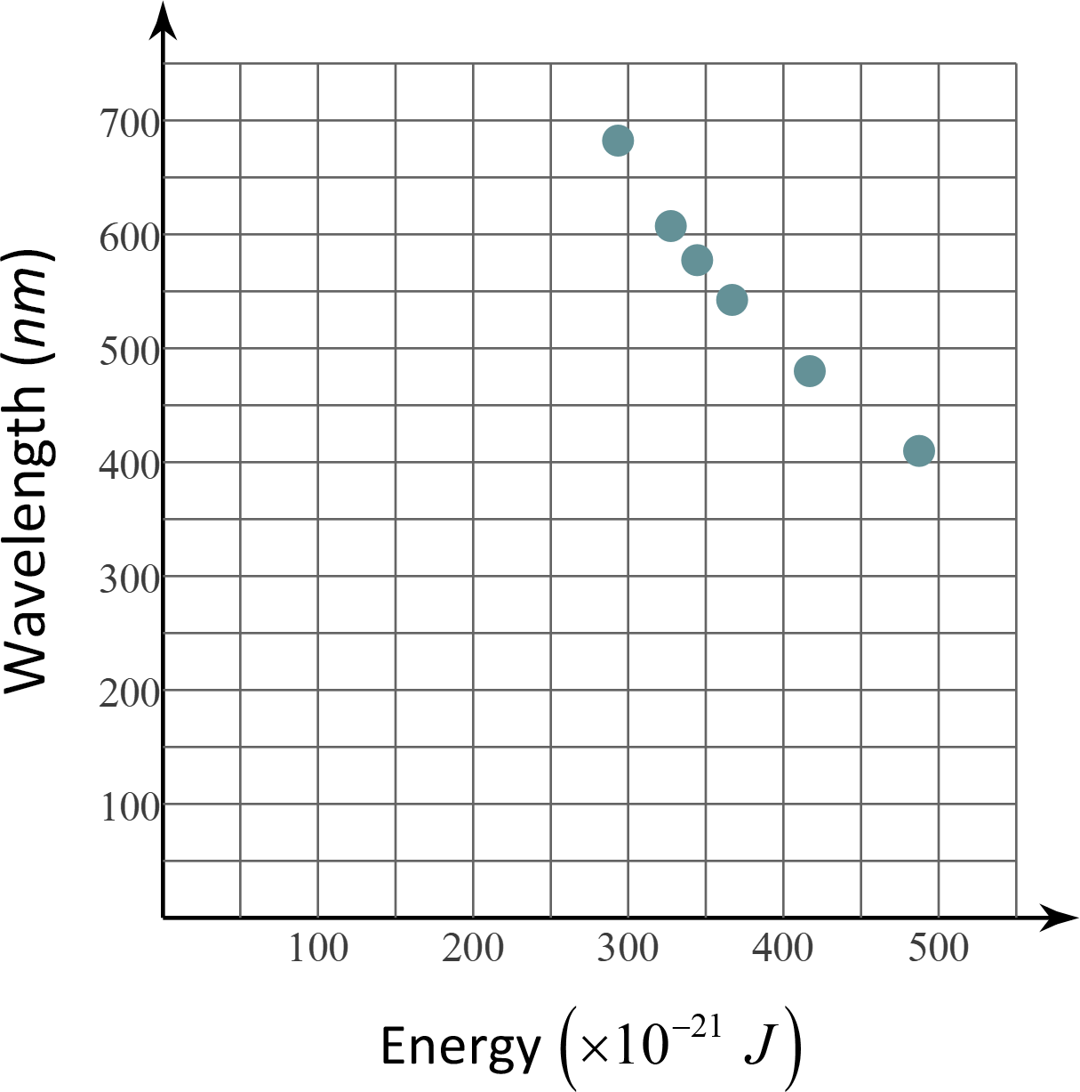 |  | Positive. As length gets bigger, mass gets bigger, true for all sites. Site D has the largest.

Part B
Instructions: Write a description for trends and other information you can infer from the table and figures below.

Graph, Table, or Figure | Notes

Graph 3. Animal Development
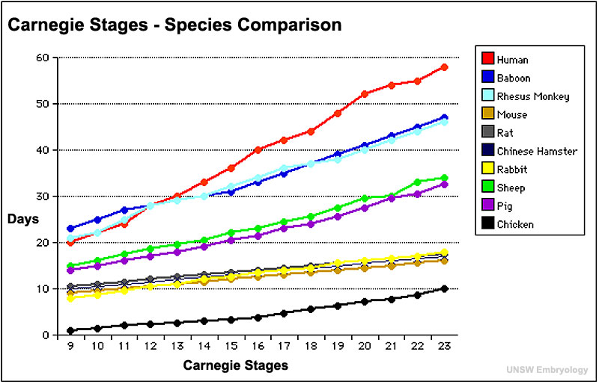
Adapted from: http://php.med.unsw.edu.au/embryology/index.php?title=K12_Comparative_Embryology’

Graph 4. High and Low Temperatures by Month for Dallas and London
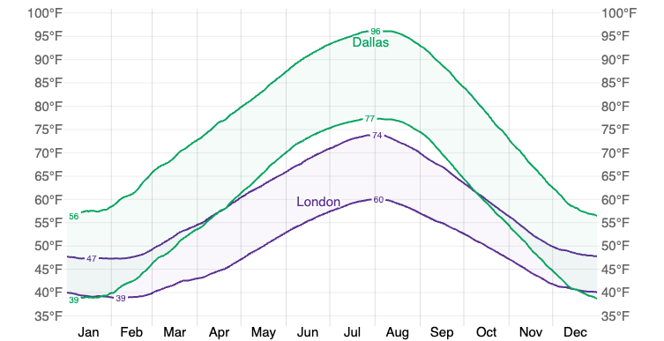
Source: https://weatherspark.com/compare/y/45062~8813/Comparison-of-the-Average-Weather-in-London-and-Dallas

Table 2. Airplane Weights and Take Off Speeds
Model | Weight  (lbs) | Take Off Speed (mph)
Boeing 787 Dreamliner | 254,300 | 185
Airbus A340 | 284,000 | 165
Embraer E190 | 61,180 | 150
ATR 72 | 49272 | 120

