AC-TEAM UP

The questions below require you to use one table or figure to help you find an answer in a different table or figure.

Make sure you select the correct tables or figures and information within them when answering each question.

Three students set up an experiment as illustrated in Figure 1. For each experiment they zeroed out a scale holding a crucible and measured out the magnesium. For each experiment, they burned a different amount of magnesium, lifting the lid slightly in the middle of the experiment to ensure all of the magnesium burned then quickly replacing the lid before any oxygen could escape. After sealing the lid and allowing time for cooling, they weighed the crucible again. Students deducted the weight of the magnesium from this combined weight to find the weight of the oxygen and recorded it in Table 1. They compared their findings to Figure 2 which displays the mass of magnesium and oxygen in the compounds: Mg₂0, MgO, and Mg0₂.

Figure 1  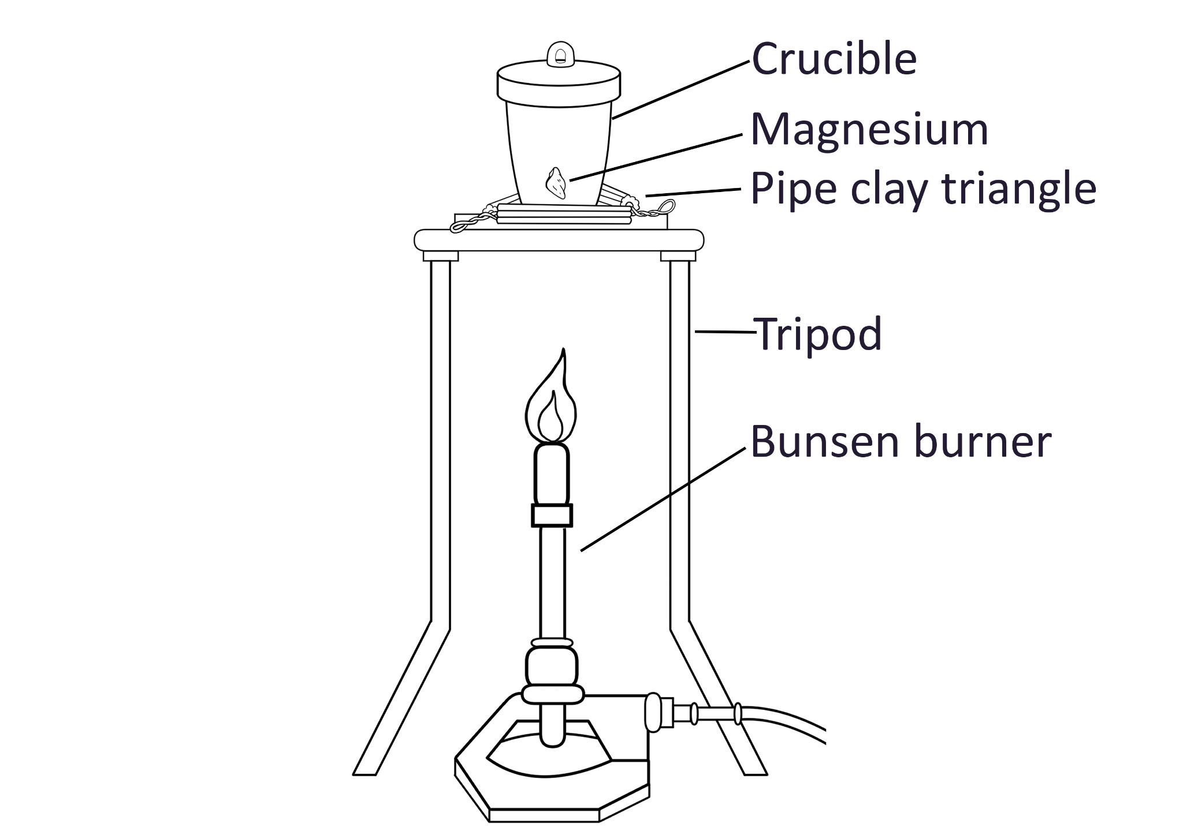 | Table 1  Experiment Magnesium Total Oxygen  1 0.1 0.17 0.07  2 0.2 0.34 0.14  3 0.3 0.50 0.20  4 0.4 0.67 0.27  4 0.4 0.55 0.13 | Figure 2  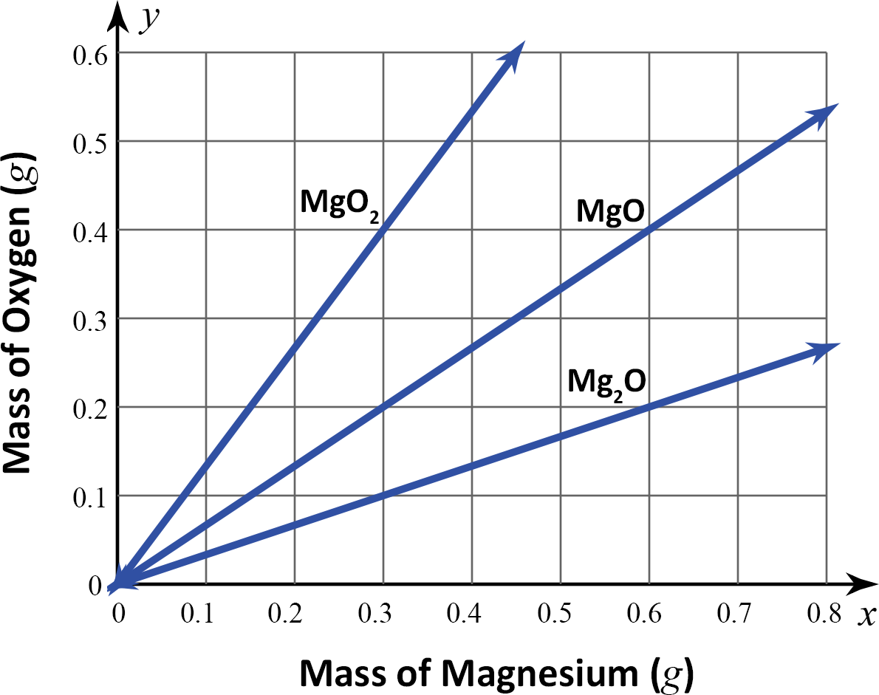
Nuffield Foundation. (2016, January 29). The change in mass when magnesium burns. RSC Education. https://edu.rsc.org/experiments/the-change-in-mass-when-magnesium-burns/718.article

- The students had the same results for experiments 1-3. Based on those 3 results, what compound was created as a result of the chemical change that occurred in those three experiments.
  - MgO₂
  - MgO
  - Mg₂O
  - MgO₃

- Student 3 completed experiment 4 and had different results, recorded at the bottom row of Table 1. Based on that experiment 4 what substance did student 3 determine she had in her crucible?
  - MgO₂
  - MgO
  - Mg₂O
  - MgO₃

- Students 1 and 2 argue that there must have been a mistake when Student 3 set up the experiment to have such different results. Based on the element she had less of in her crucible, which part of the experiment could have led to her results?
  - Crucible lid
  - Magnesium weight
  - Tripod distance from heat
  - Level of the flame

