DIAGRAM DOUBLES
Determining the Concentration of an Acid:  This experiment involves using a flask containing an acid solution that is being stirred while a base solution drips in from a buret. | 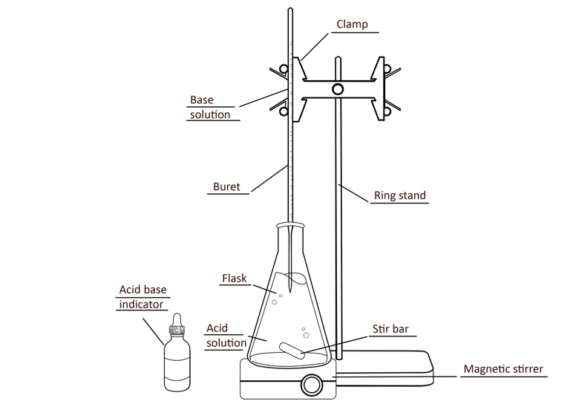
Pulley Systems:  This experiment uses a spring scale to test the force needed to move a weight based on its position using multiple pulleys. | 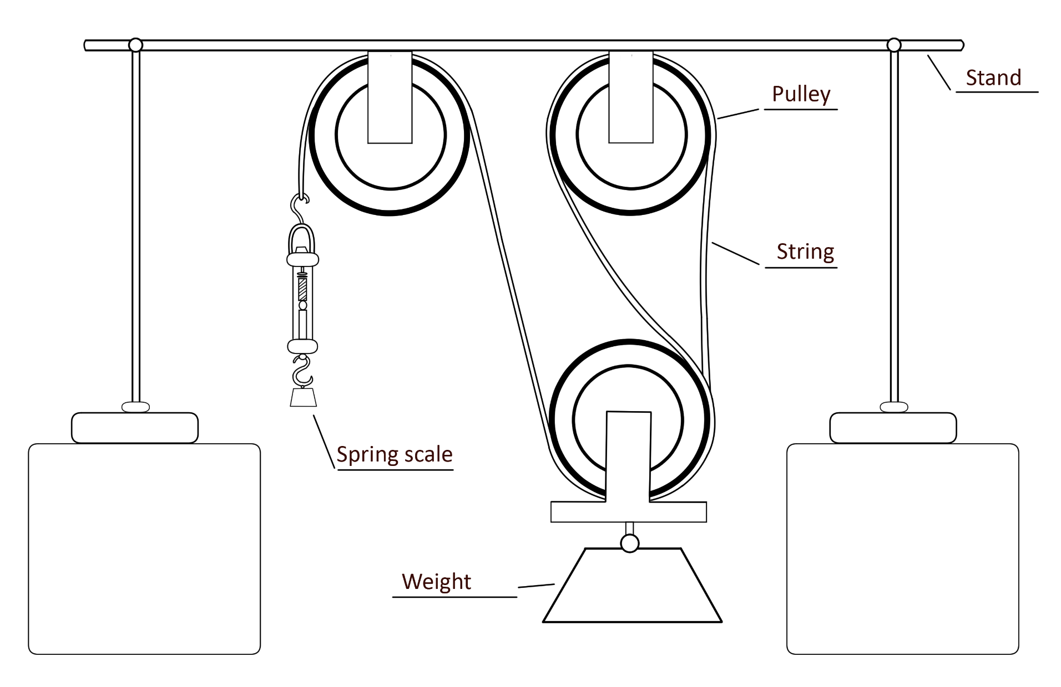
Carbohydrate Test:  A series of test tubes in a beaker of water are heated over a hotplate. | 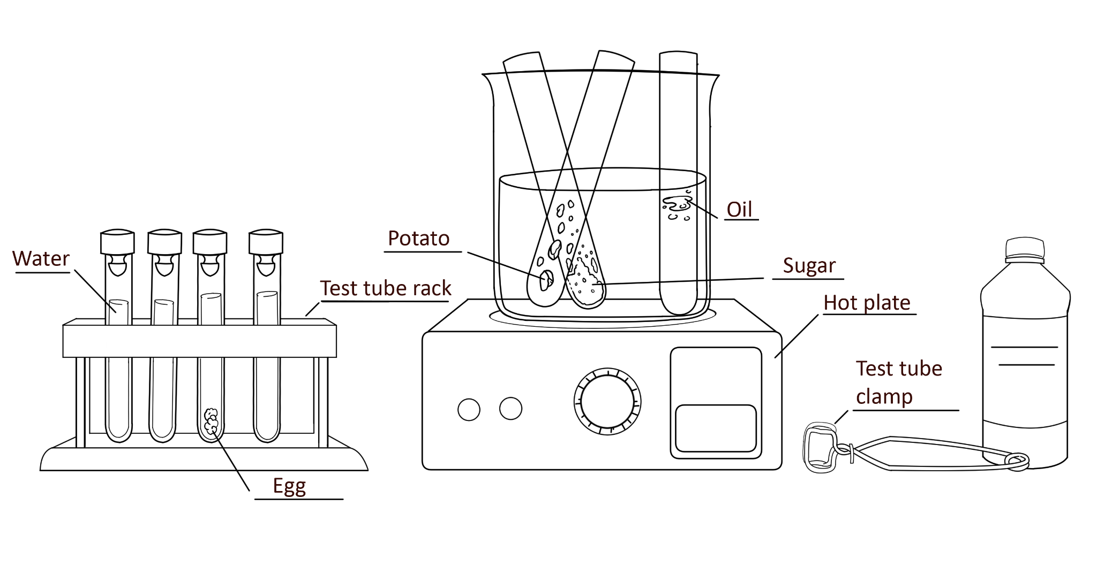
DNA Electrophoresis:  A gel box is connected to a power source. Wells are filled using a pipet for testing. | 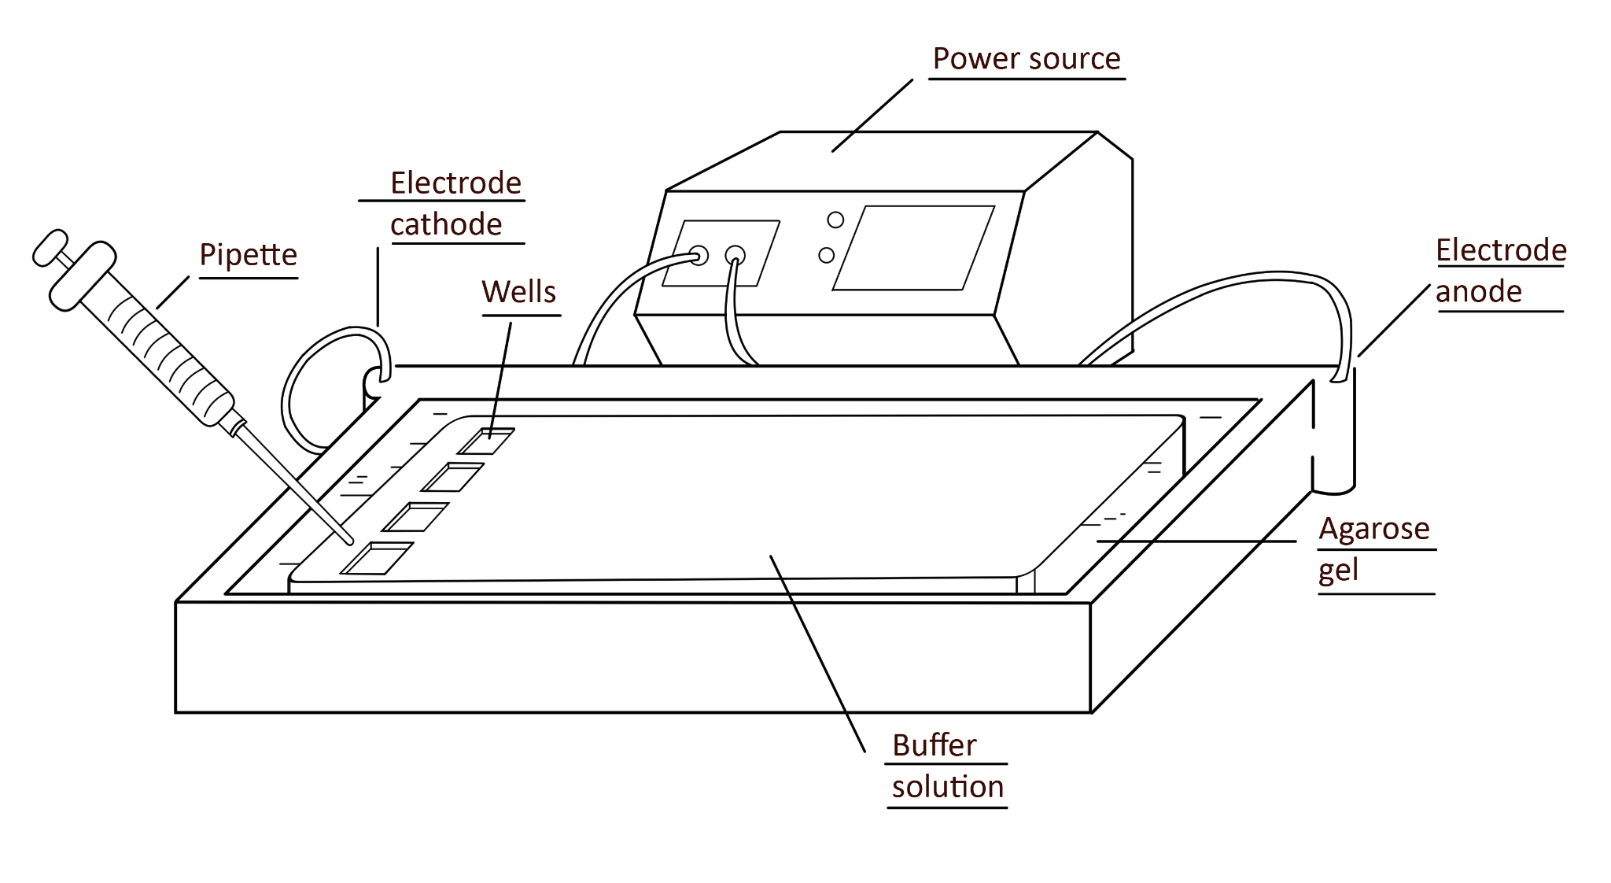
Creating Carbon Dioxide:  Vinegar is added to a bottle. On top of the bottle is placed a balloon containing baking soda. | 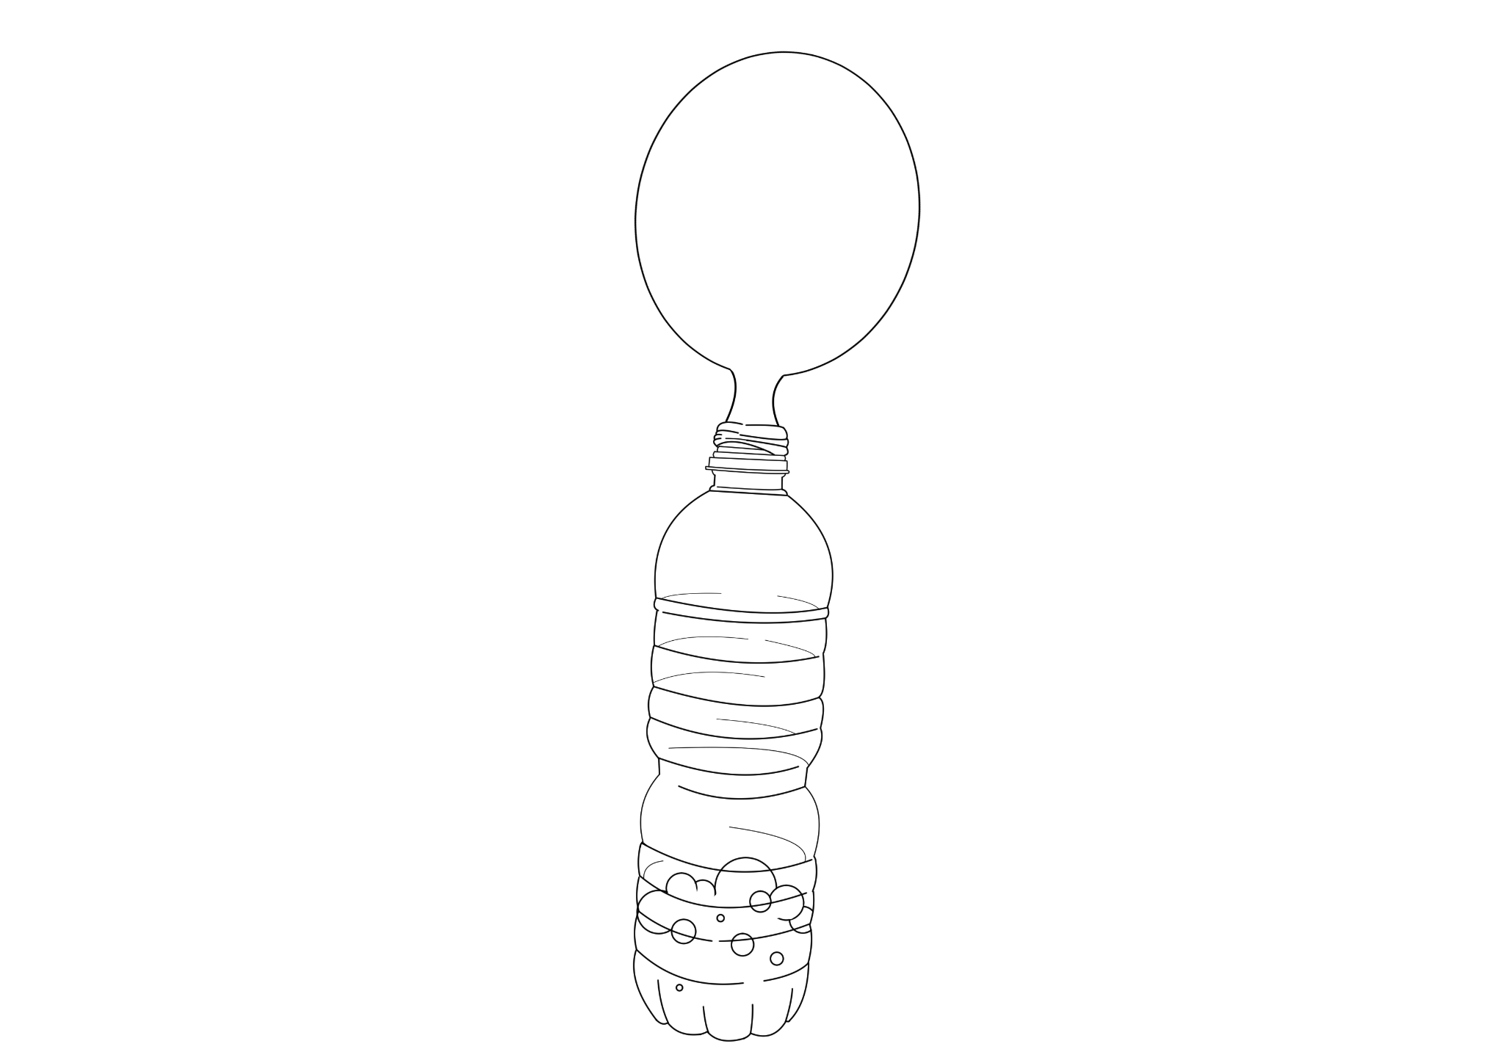
Animal Cells:  The cell is made up of several parts each with a unique function. These parts include mitochondrion, ribosomes, and golgi apparatus. | 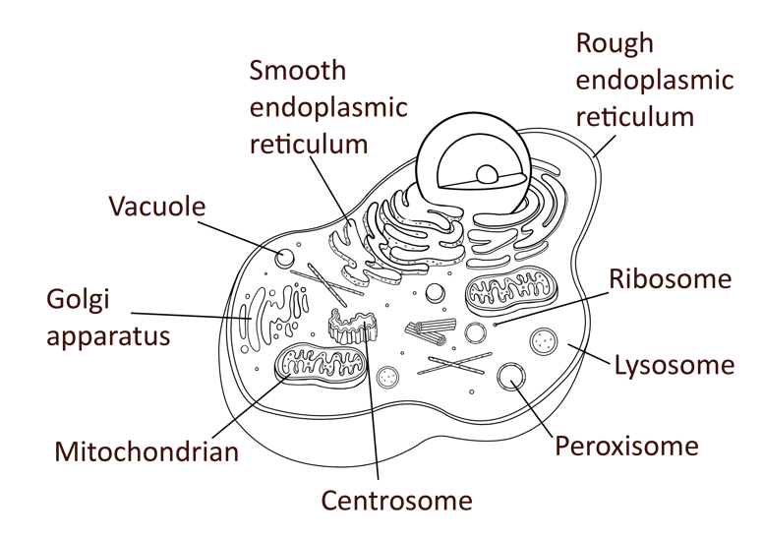
Circuit Diagram:  This circuit includes a voltmeter to determine the difference in electric current before and after the placement of a resistor. | 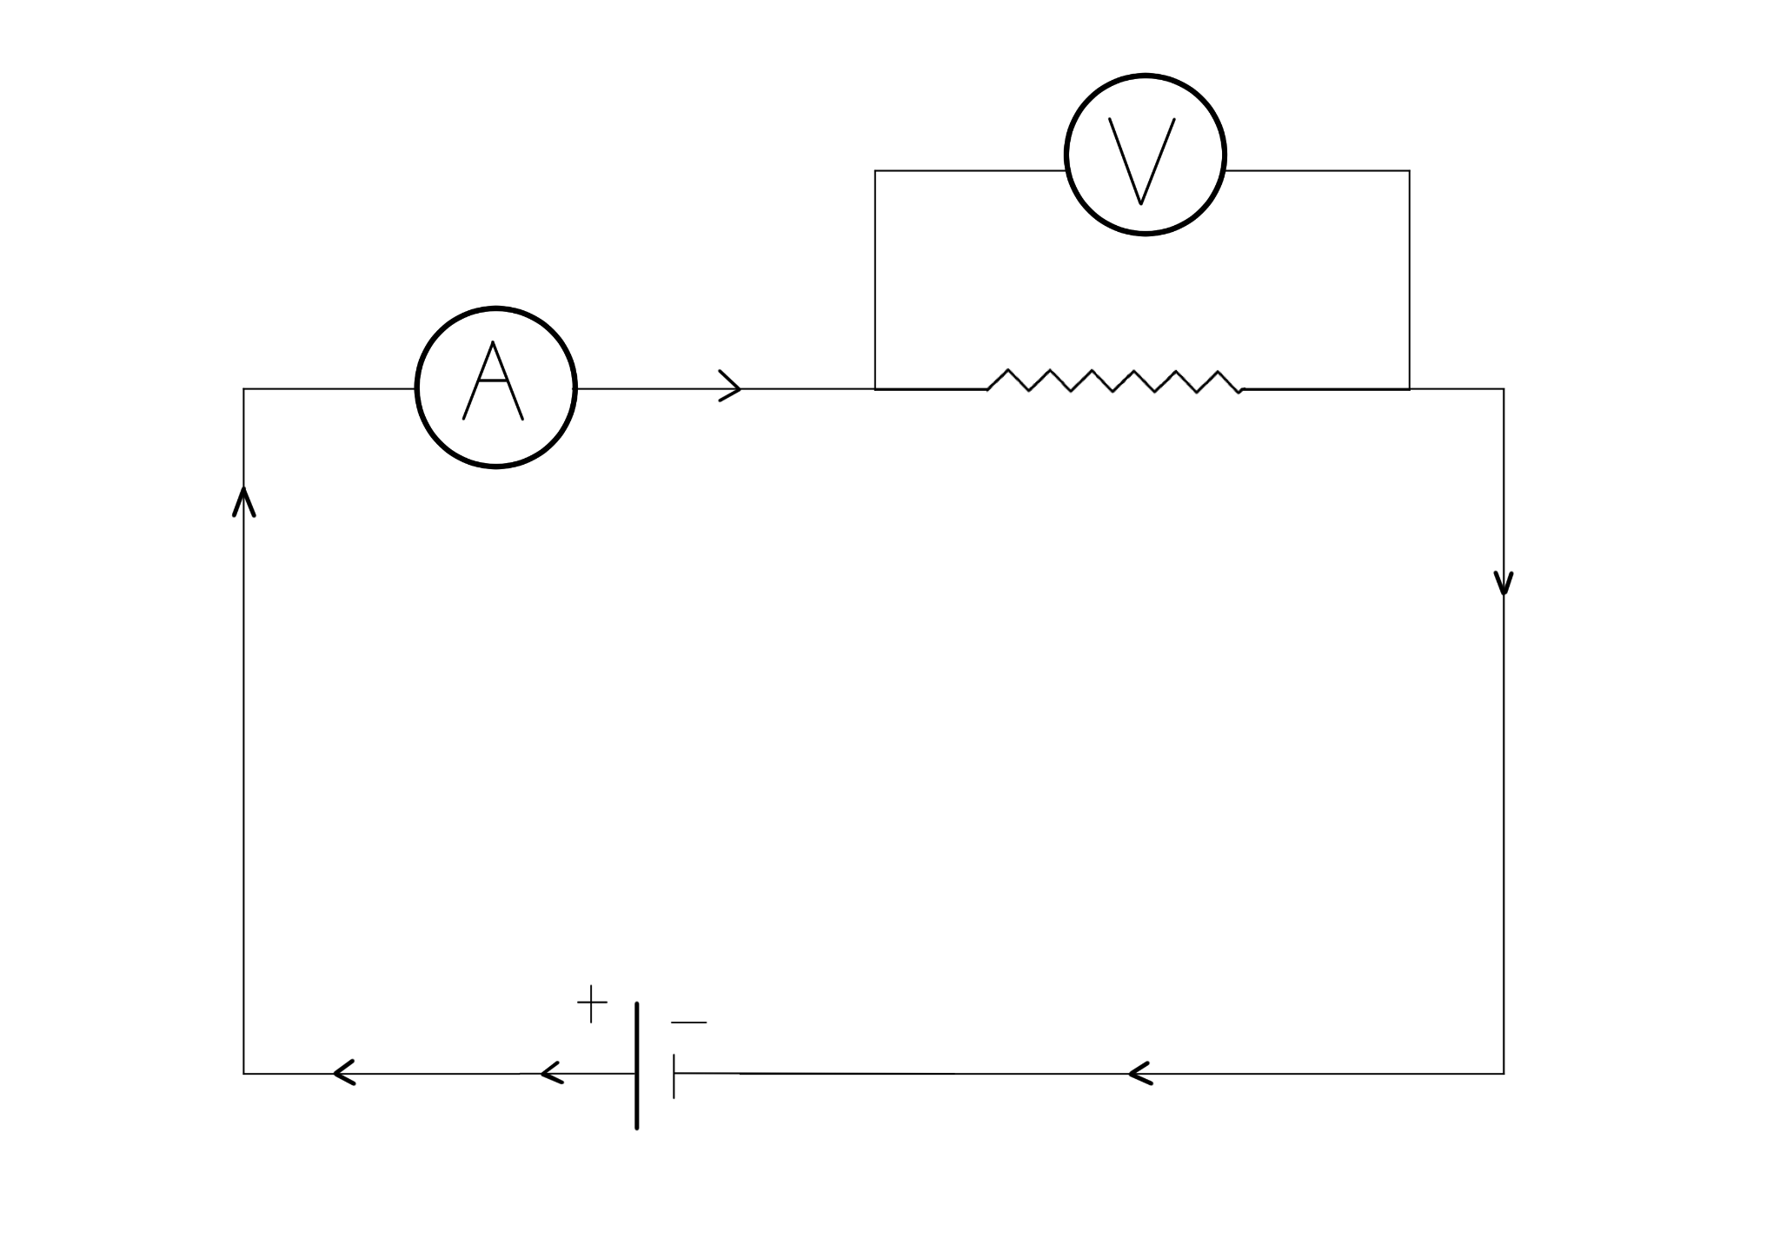
Light Refraction:  This experiment considers how light is refracted when an object is placed in two different substances. A pencil is placed in a substance and the angle of refraction is measured. | 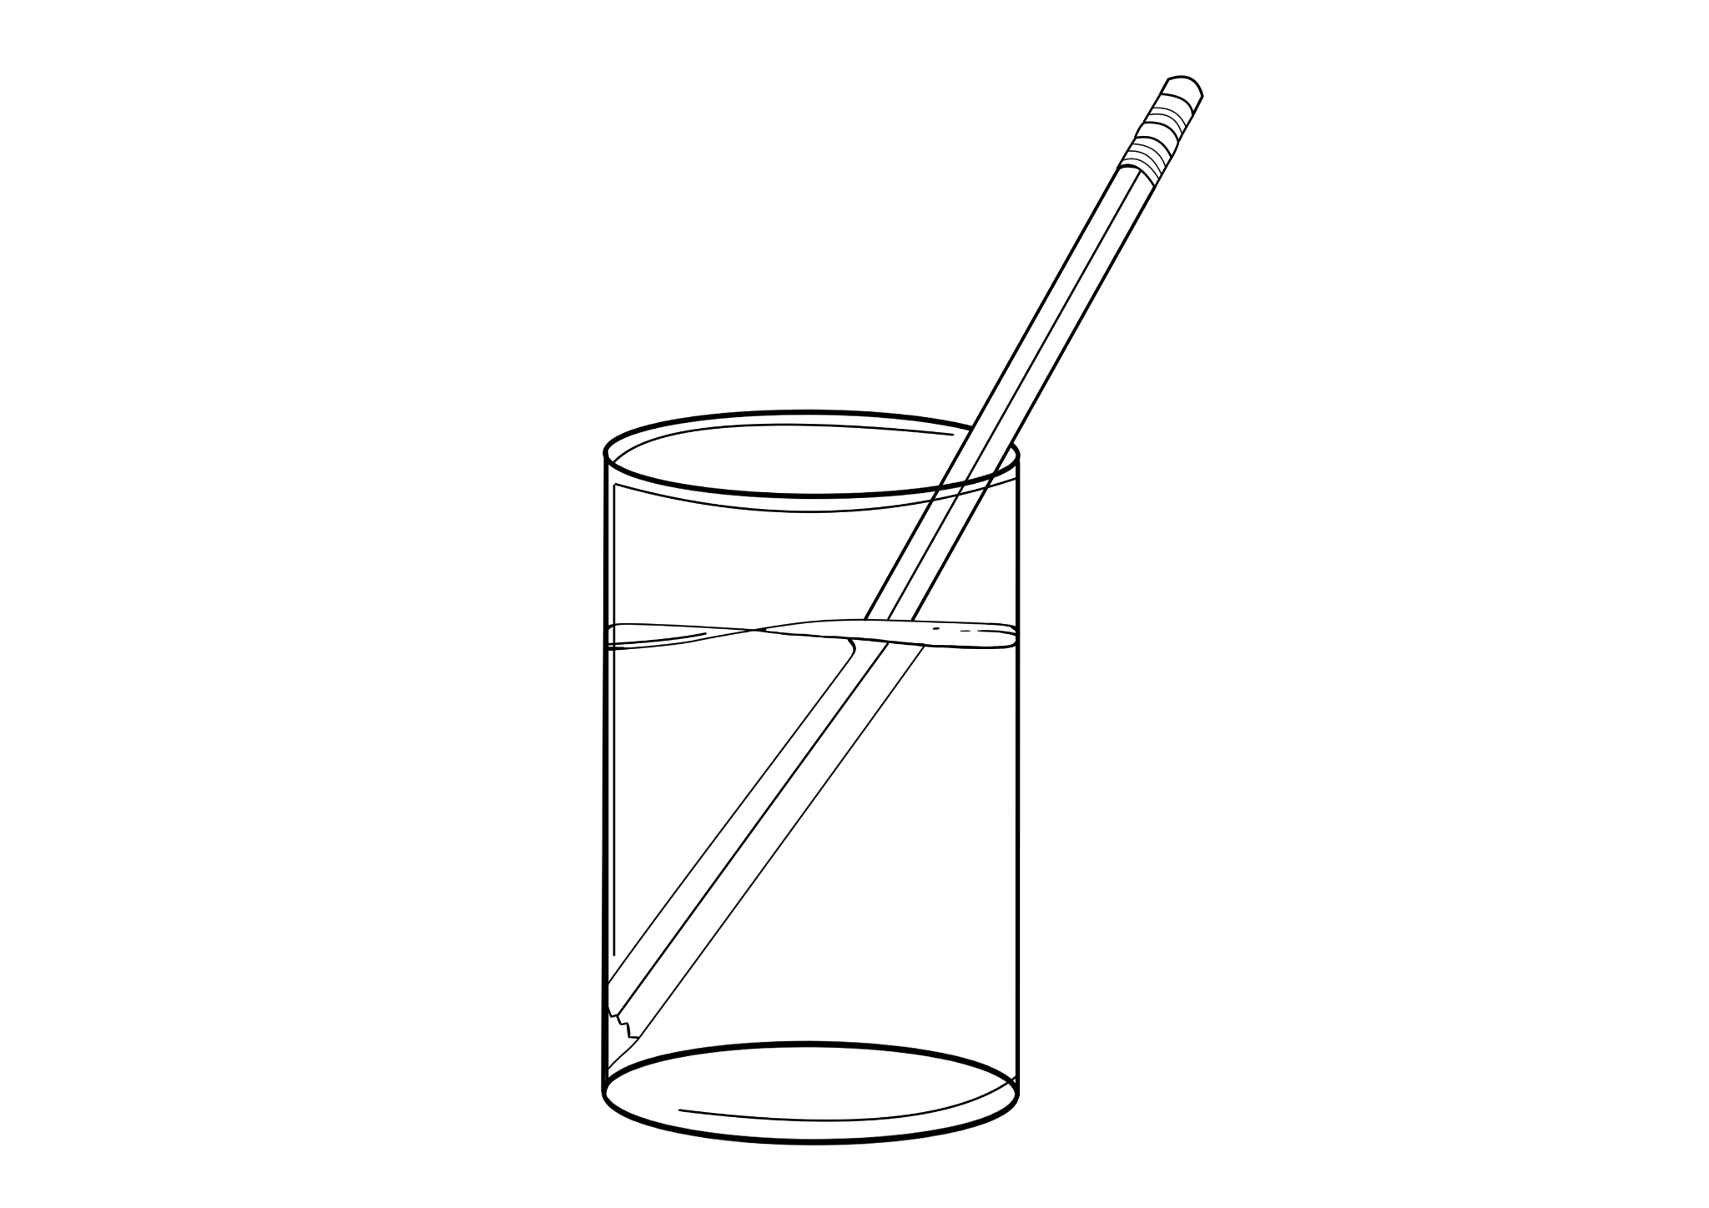
Phototropism:  This experiment tests plant growth and compares when a plant is or is not blocked from direct light. | 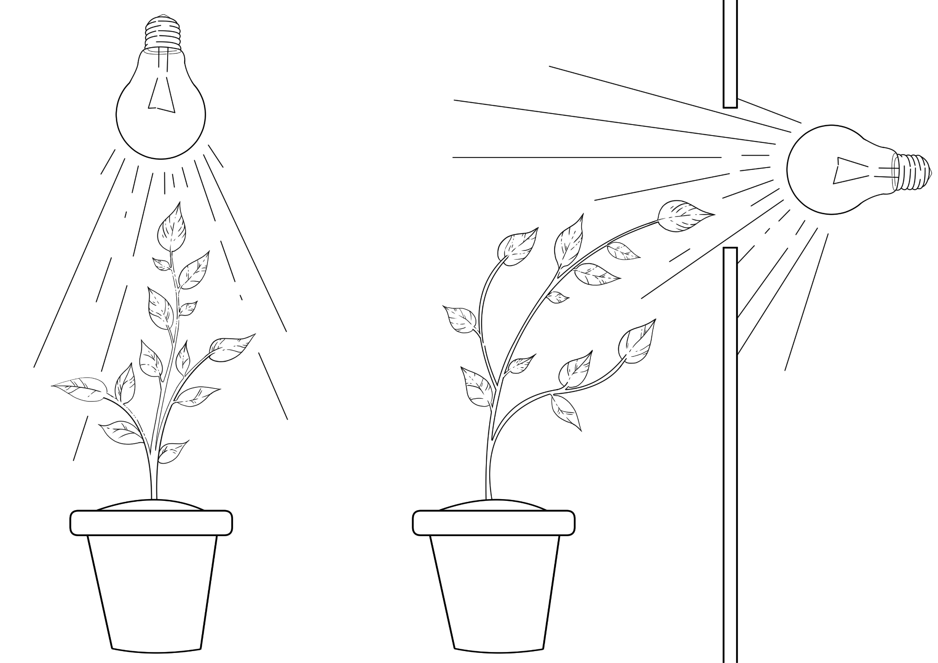
Atmospheric Pressure:  A can is heated over a burner and then placed in cold water to observe what happens when there is a change between the inner and outer air pressure. | 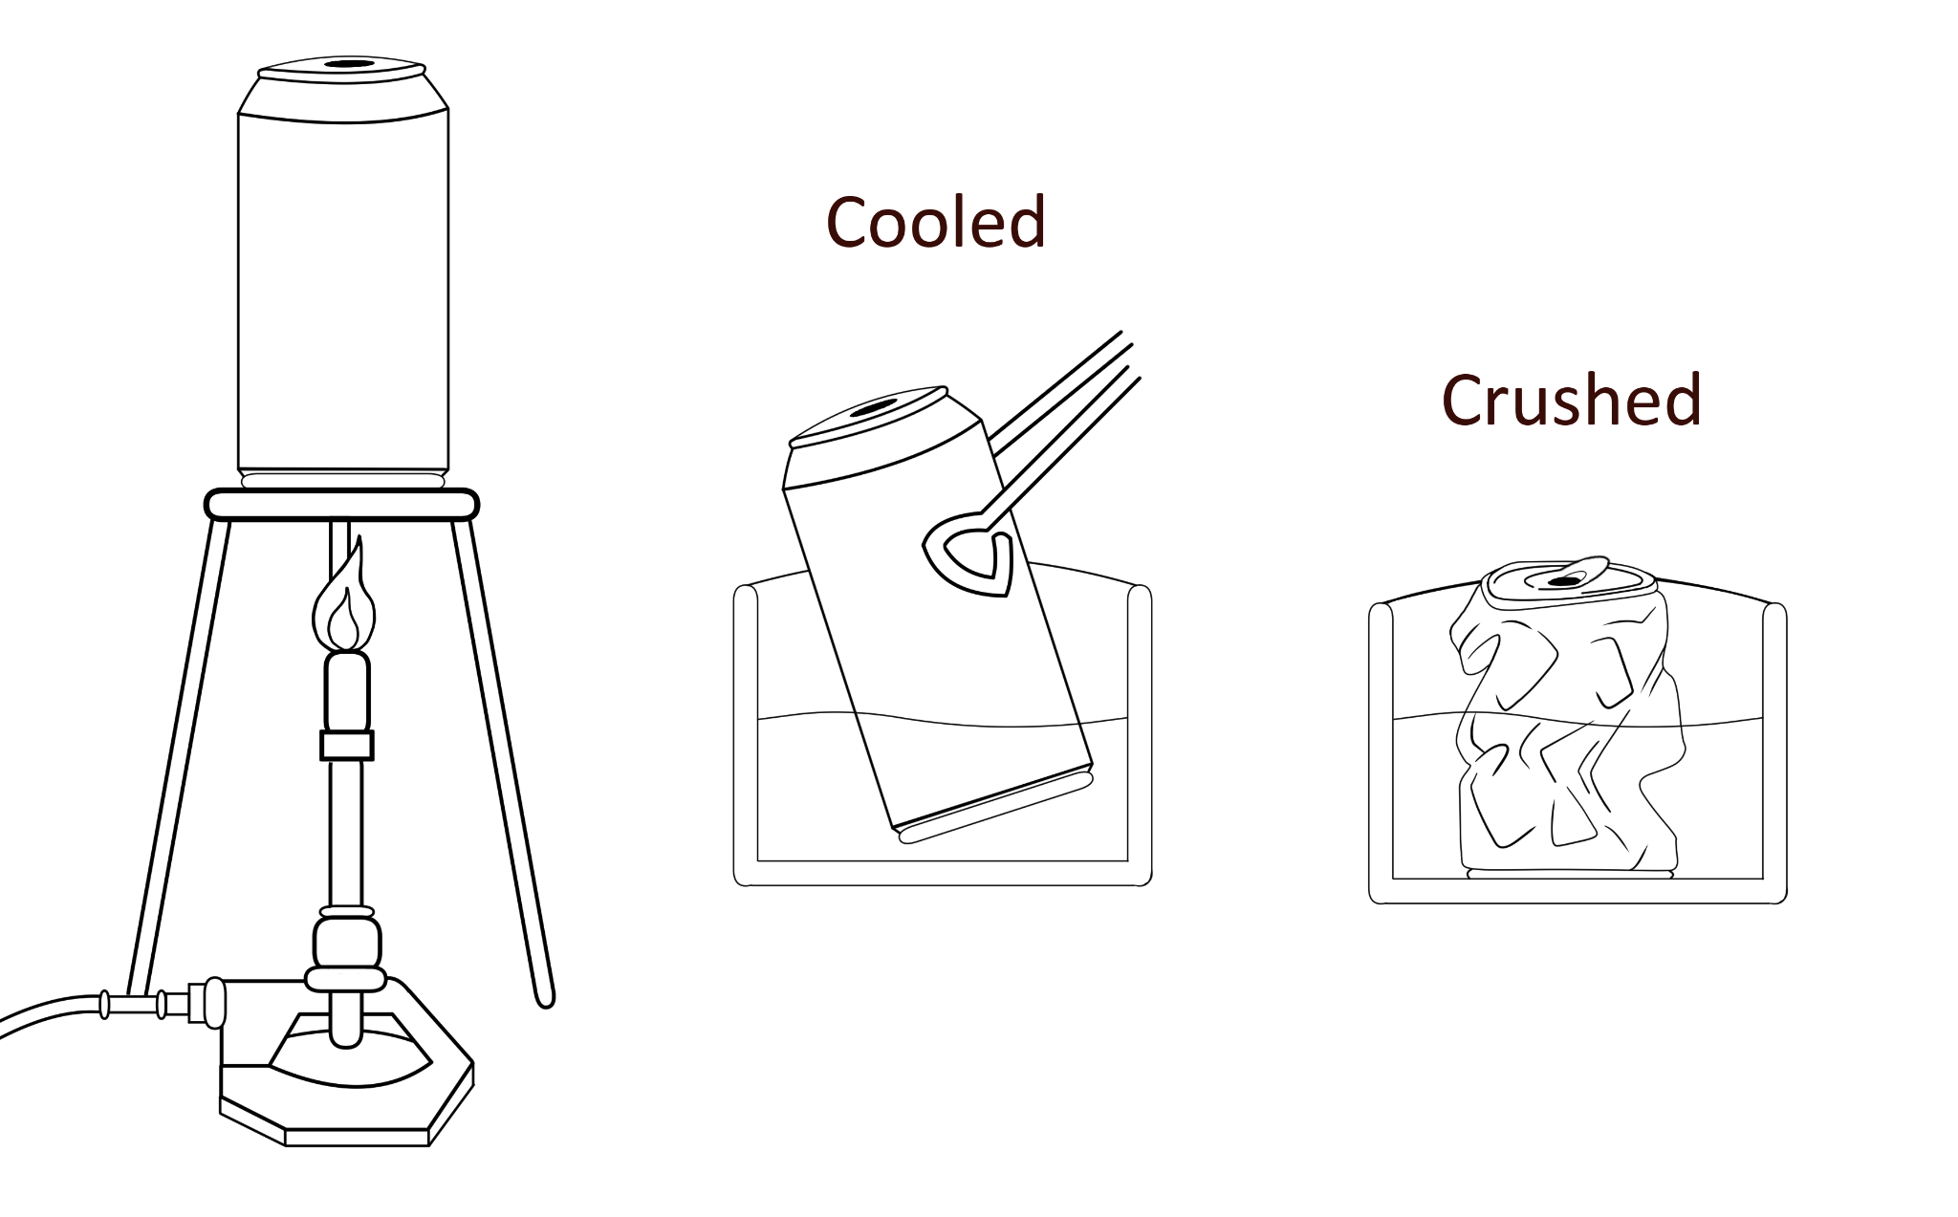
Animal Anatomy:  This diagram highlights the parts of the animal in two ways: broad categories and specific names. | 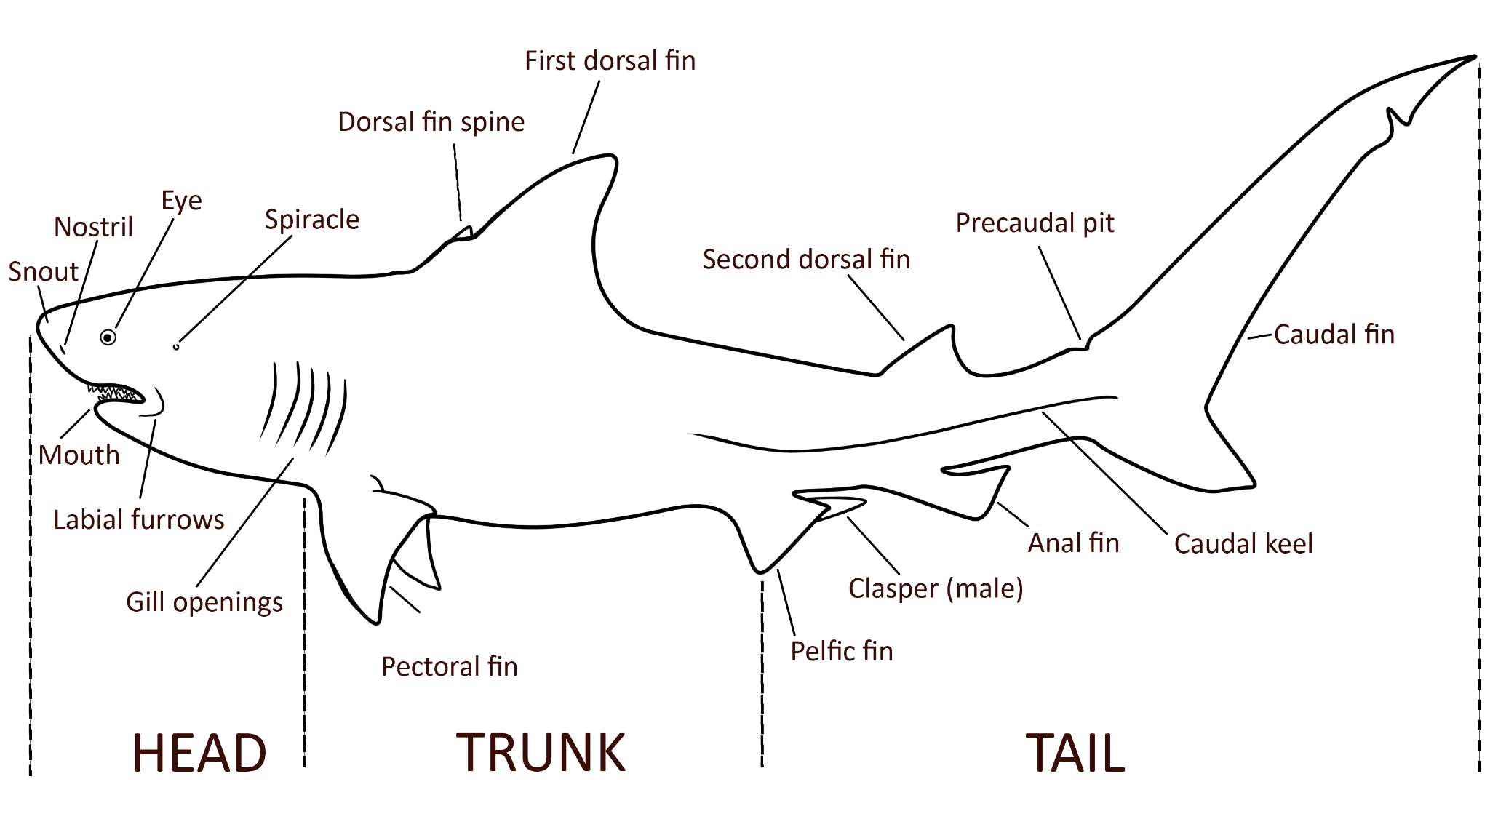
Gravity Guides:  The elliptical orbit takes the comet near the sun before being propelled farther into space, briefly nearing Earth. Note where the tail is in relation to the sun rather than the path. | 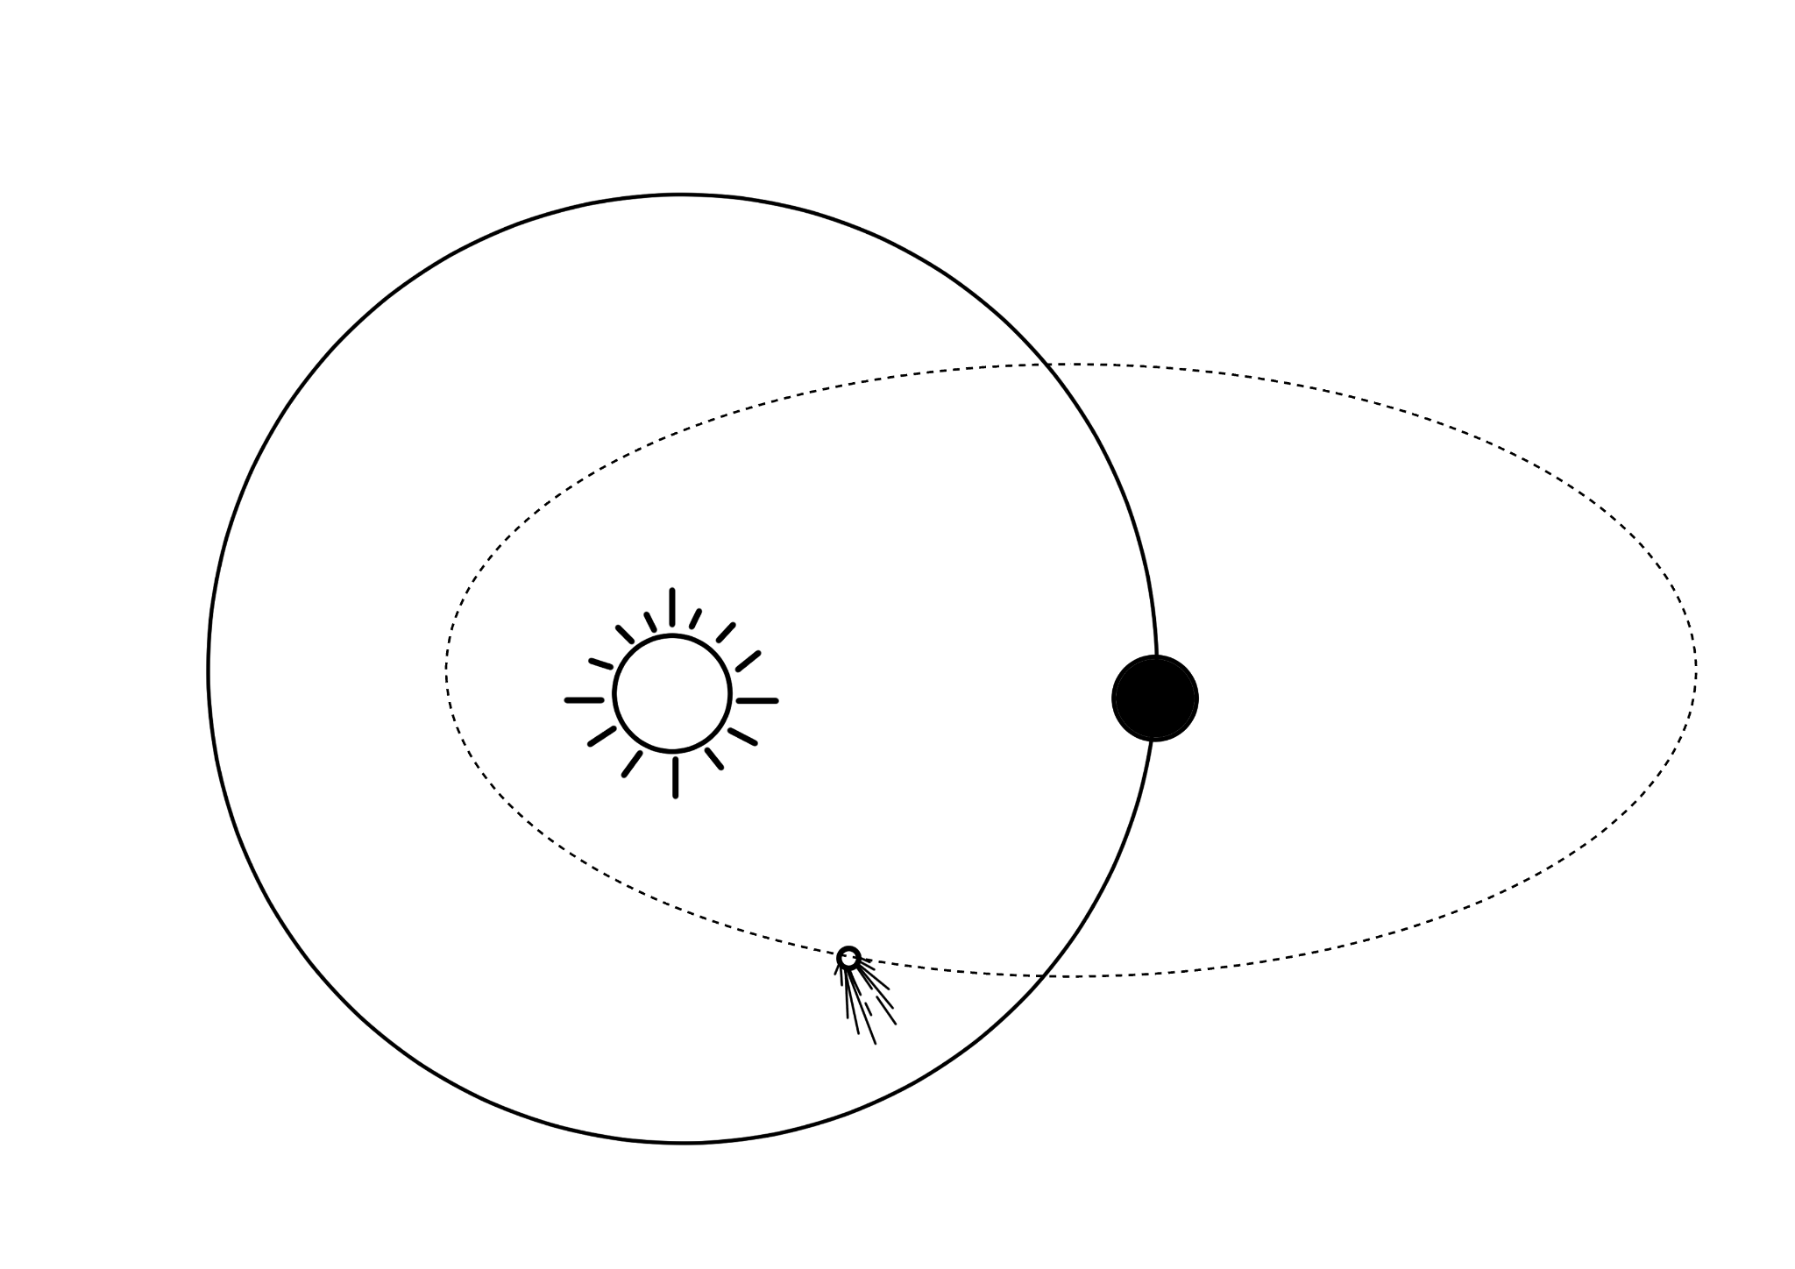
Mass of Magnesium:  To determine the impact of a heat source on the mass of magnesium, the substance is placed in a crucible above a heat source. The mass is measured before and after the magnesium is heated and changes color. | 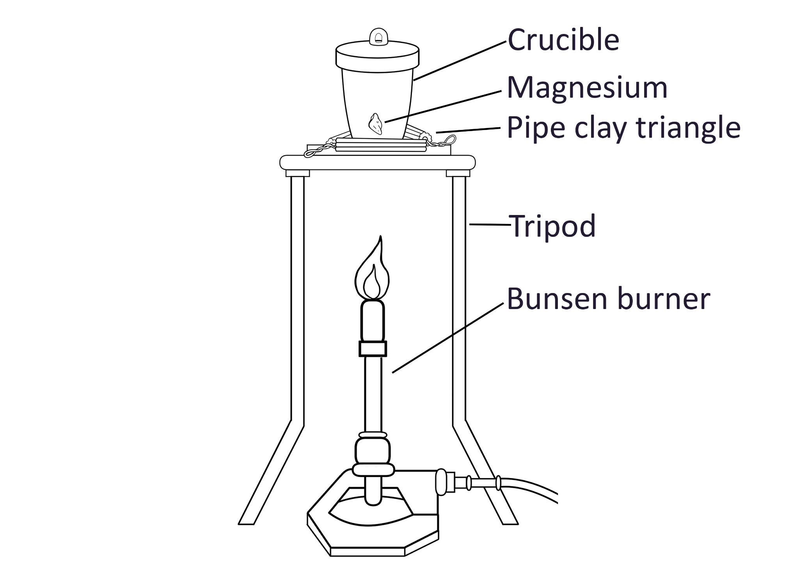
What Happens in a Vacuum:  The battery is connected to a circuit which includes a sound source. The apparatus is placed into a bell jar connected to a vacuum to remove the air and create a space of low pressure. | 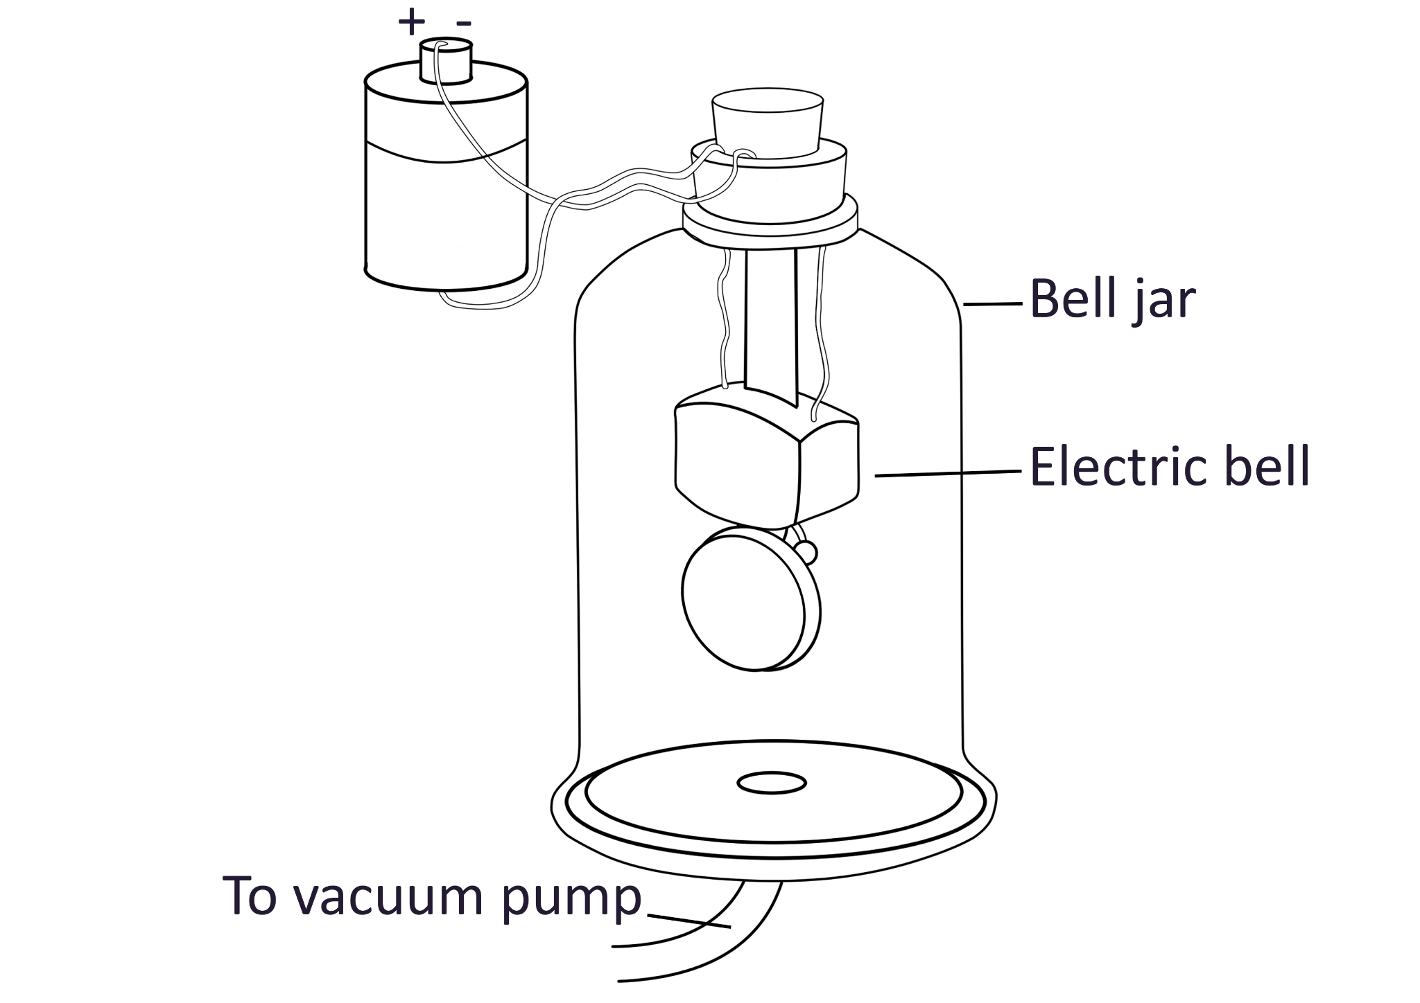
Salty to Fresh:  This apparatus uses a heat source under a jar of salty water to vaporize the water, condense it into a tube, and transport it to a new container for fresh water. | 