TRAIN OF THOUGHT

Passage 1

As a train travels along a track, it is maintaining a constant speed. To find the average velocity of the train, the distance traveled can be divided by the time taken using the formula below:

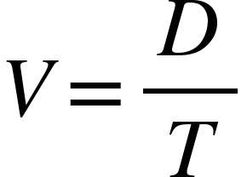

The train travels at a constant speed for 3 seconds. Table 1 shows the distance the train travels over those first three seconds. As the train moves through a town, it decelerates for safety. Deceleration is found the same way acceleration is calculated, by looking at the change of velocity over time. Table 2 shows its velocity. When the train leaves the town, it accelerates until it resumes a constant speed. Figure 1 shows a graph of the train's velocity as it travels on this trip.

Table 1: Distance  Time (s) Distance (m)  1 25  2 50  3 75 | Table 2: Velocity  Time (s) Velocity (m/s)  3 25  4 23.9  5 22.8  6 21.7  7 20.6  8 19.5
Figure 1: Record of train’s velocity over time
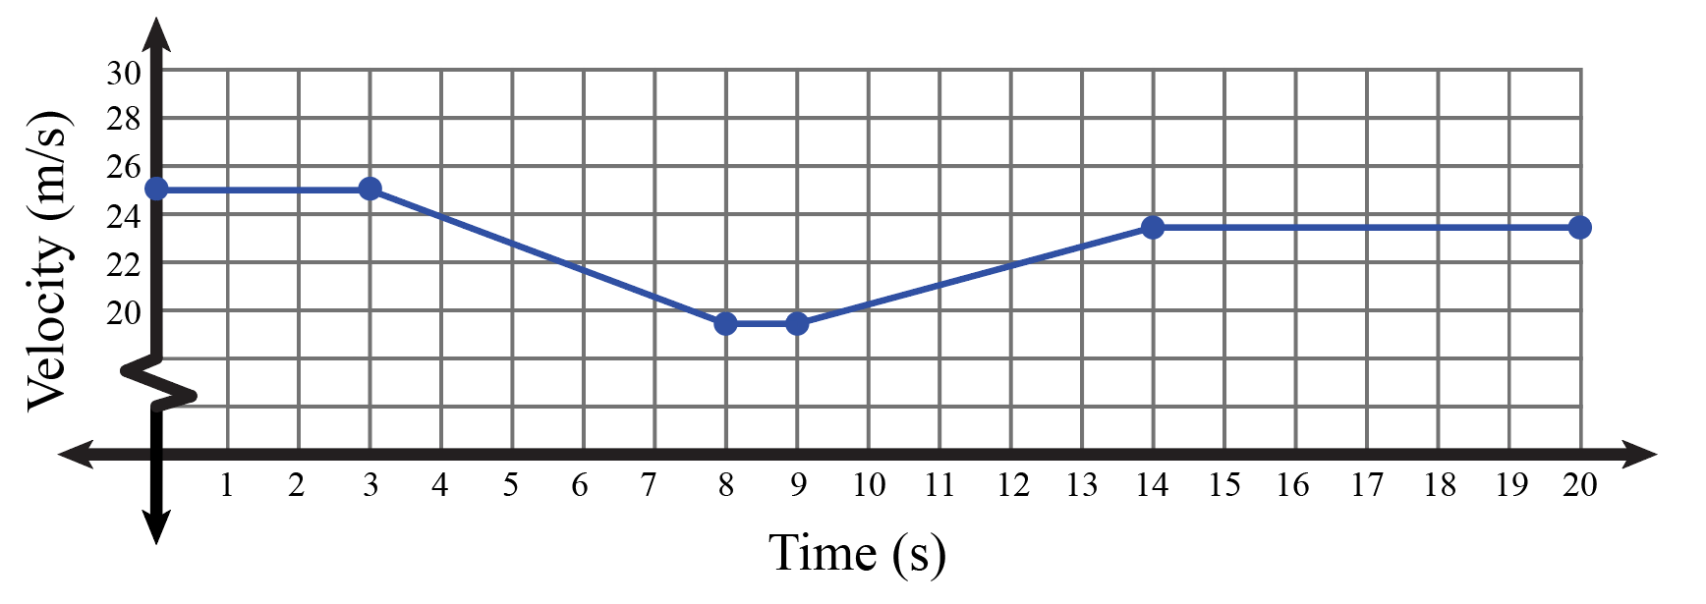

Questions:
- What is the train’s acceleration over the first 3 seconds?
- 75 m/s²
- 25 m/s²
- 50 m/s²
- 0 m/s²

- How far does the train travel in the first three seconds?
- 19.5m
- 50m
- 75m
- 25m/s

- What is the velocity of the train at 6 seconds?
- 22 m/s
- 21.7 m/s
- 23.9 m/s
- 22.8 m/s

- What is the deceleration for the train based on Table 2:
- 2 m/s²
- 1.5 m/s²
- 1.1 m/s²
- 1 m/s²

- The train accelerates from t = 9 to t = 14 to reach a velocity of 23.5 m/s at 14 seconds. Using Table 2 and Figure 1, what is the train’s acceleration over this period of time?
- 0.8 m/s²
- 1.5 m/s²
- 3 m/s²
- 2.1 m/s²

- Which is the best description of what is seen in Figure 1:
- The train maintains a constant speed, accelerates, maintains its speed, decelerates, and then returns to a constant speed.
- The train maintains a constant speed, decelerates, maintains that lower speed, accelerates, and then returns to its initial speed.
- The train decelerates, accelerates, and then maintains a constant speed.
- The train maintains a constant speed, decelerates, maintains that lower speed, accelerates, and then maintains its speed.

- If the conductor decided to not accelerate when exiting the town, what would you expect the graph to look like from t = 9 to t = 14?
A)  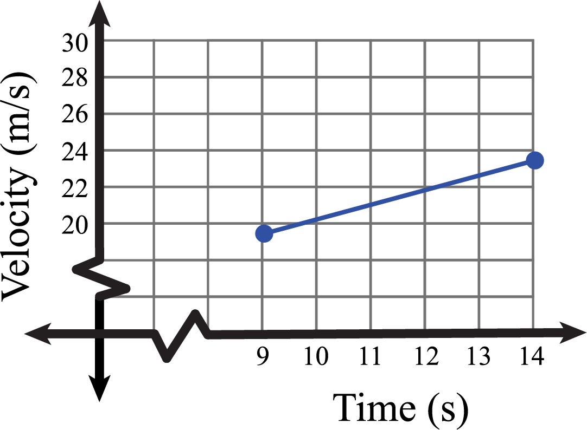 | B)  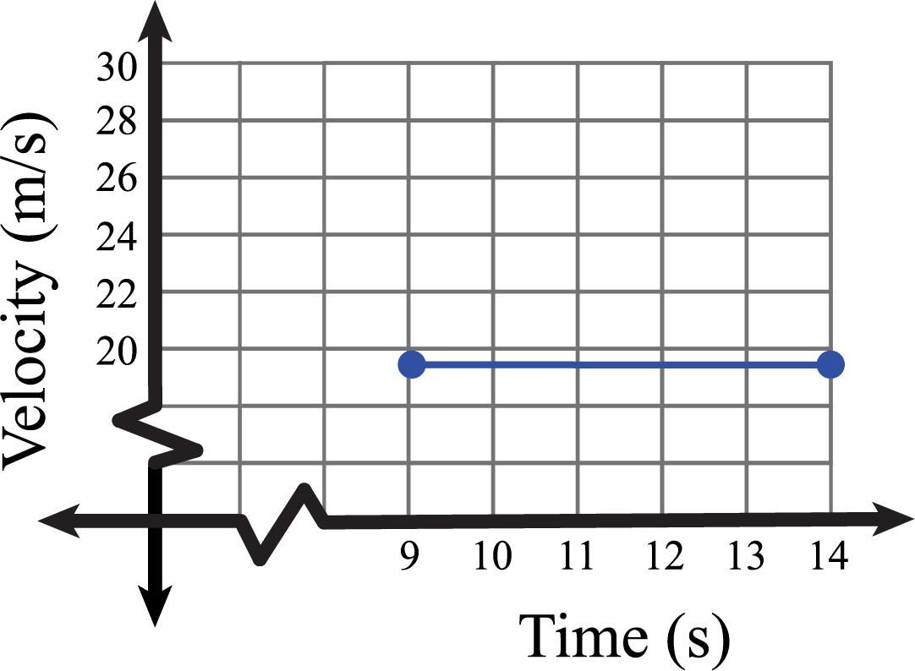
C)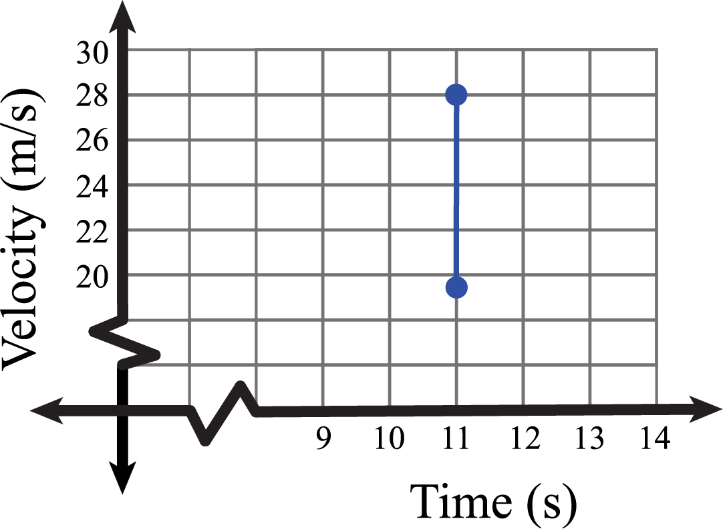 | D)  