Add | Add words or sentences to make the meaning clear.
Remove | Remove any unnecessary words or sentences.
Move | Move a word, phrase, or sentence to make meaning clear.
Substitute | Substitute or trade words or sentences to improve meaning or quality.

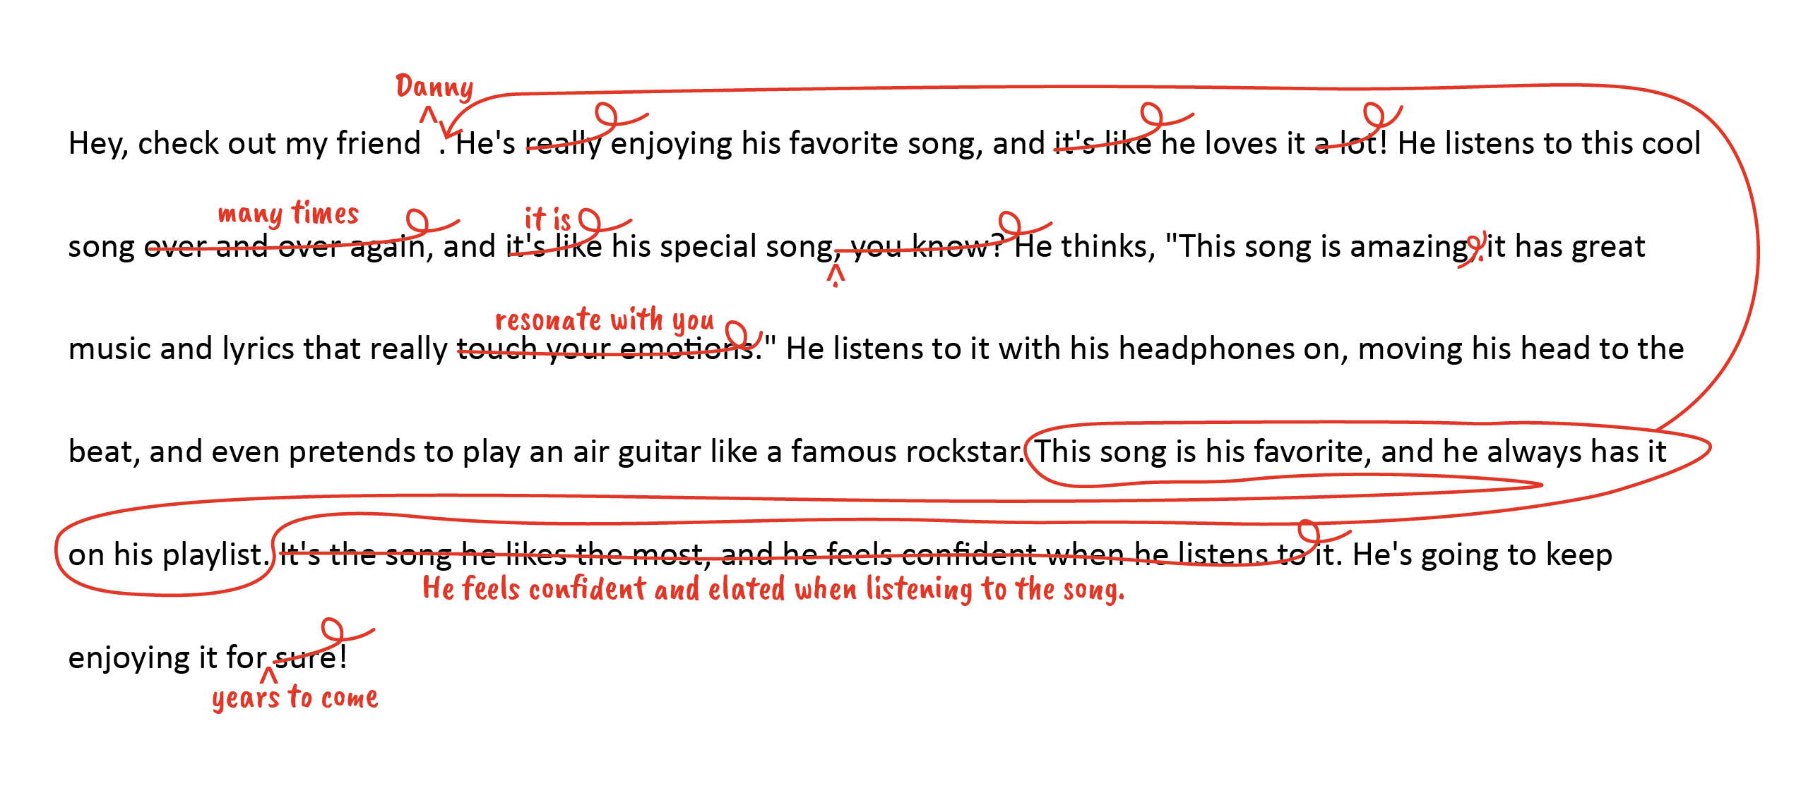

The English College and Career Readiness Standards: Knowledge of Language is comprised of 18 standards. We have focused on 5. For the complete list of standards associated with Usage Conventions, please refer to the C&C Readiness Standards.

