IT’S ELECTRIFYING

The questions below require you to use the table and figures to help you find an answer.

Make sure you select the correct tables or figures and information within them when answering each question.

A student wants to know what effect different combinations of resistors have on electrical current within a circuit. She wonders if replacing a resistor to increase the resistance from 10 ohms to 20 ohms will have the same result as adding a second resistor in parallel to the circuit with a value of 10 ohms. She hypothesizes that there will be no difference in current as long as the resistors add up to the amount. She sets up her experiment as shown in Figure 1 using a 9-volt battery. Then, she uses the ammeter to measure the current flowing to the resistor and the voltmeter to measure the voltage drop across the resistors. She remembers that Ohm’s law states V = IR where V is voltage, I is current and R is resistance. First, she tests her circuit with a 10-ohm resistor and then a 20-ohm resistor. She records the results of her experiment in Table 1. She then replaces her 20-hm resistor with two 10-ohm resistors in parallel to compare her results.

Figure 1  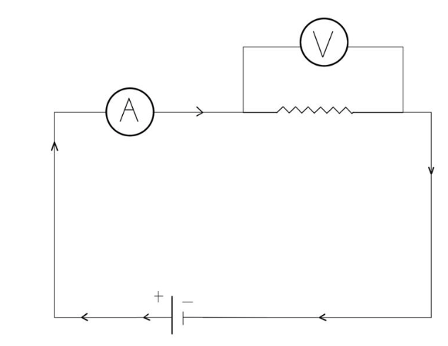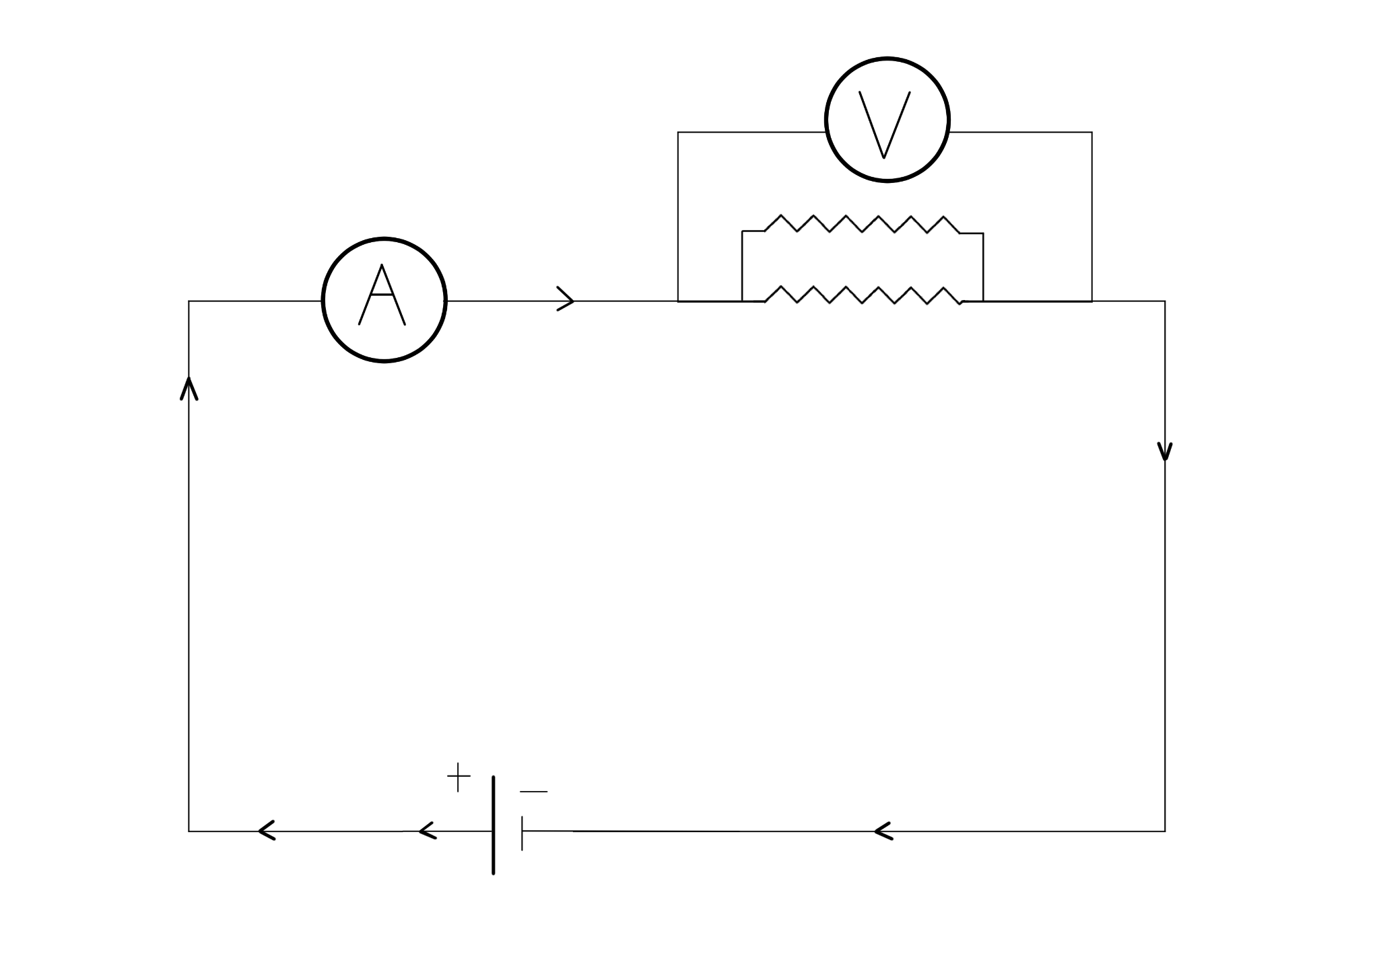 | Table 1  Replacing the Resistors Parallel Resistors  Resistance (ohms) Current (amps) Power (volts) Resistance (ohms) Current (amps) Power (volts)  10 0.9 9 10 & 10 1.8 9  20 0.45 9
The student notices that the amps measured were greater in the parallel circuit than using one 20-ohm resistor, or even when using one 10-ohm resistor. She notes that the way she designed the experiment seemed to weaken the resistors. She decides to replicate the experiment but change how she places the resistors from parallel to in a series, as shown in Figure 2, and measures the amps again.

Figure 2
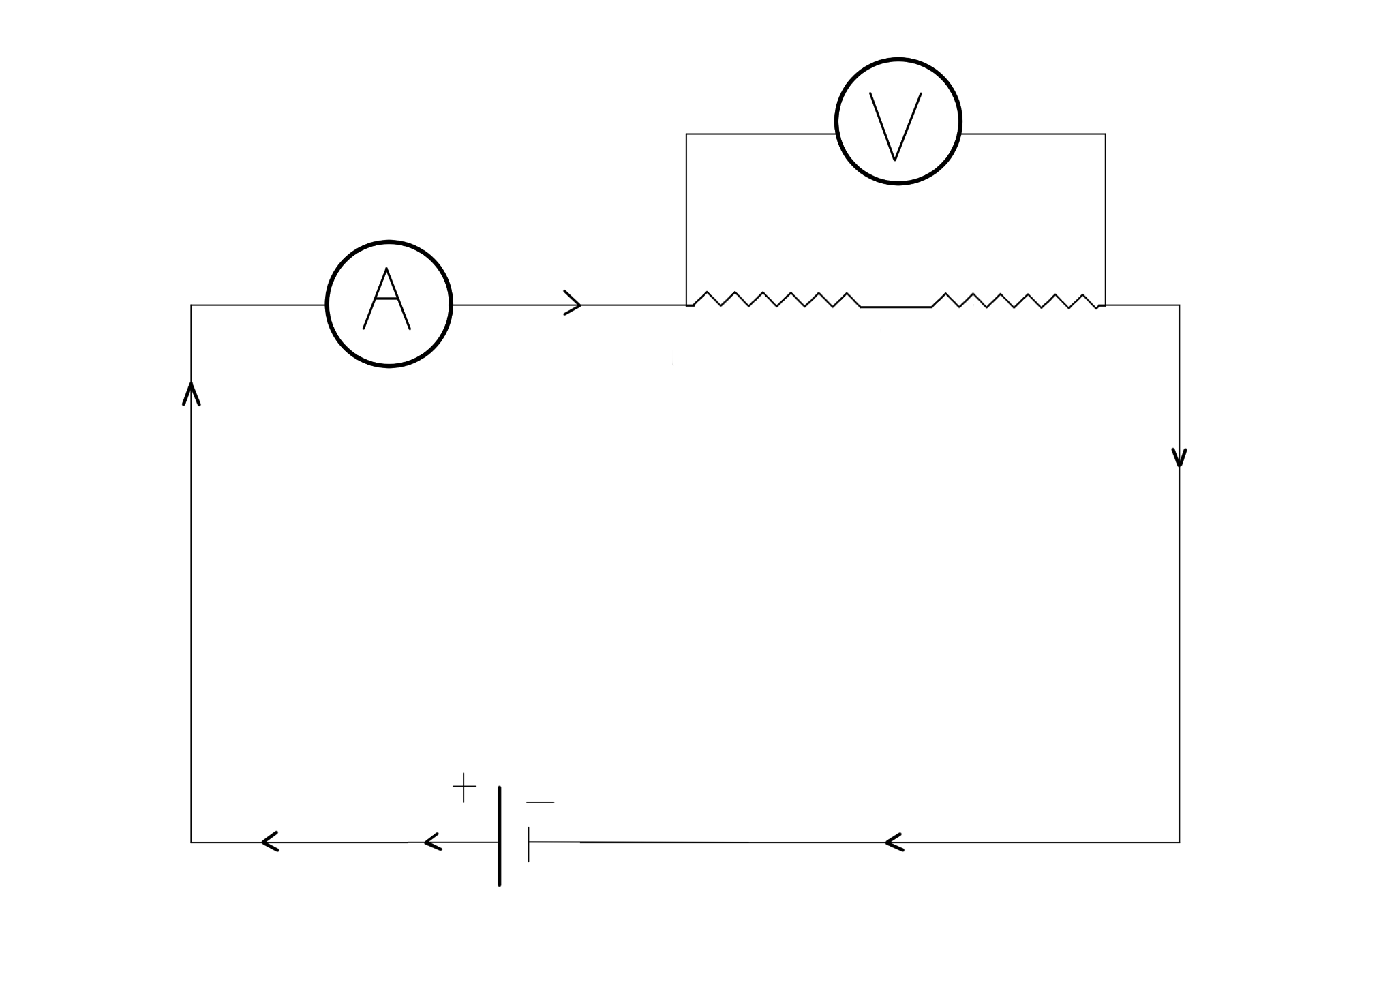

The result from this second experiment was 0.45 A, which she notes is the same as using a 20-ohm resistor. She concludes that placement of resistors matters in how they function within the circuit.

Questions:
- The main reason she changed the placement of the resistors was to:
- Test if the battery had lost any power.
- Test if the results were the same.
- Test if the voltmeter was working properly.
- Test if the ammeter was working properly.

- How did the circuit in Figure 2 differ from the circuit testing two resistors in Figure 1:
- The resistors in Figure 2 were in series, while the resistors in Figure 1 were in parallel.
- The resistors in Figure 2 were in parallel, while the resistors in Figure 1 were in series.
- The resistors in Figure 1 were in parallel, while the resistors in Figure 2 were in parallel.
- There were two resistors in Figure 1, while there was one resistor in Figure 2.

- Do the results from her first experiment support the hypothesis?
- Yes, because her experiment was set up as shown in Figure 2.
- Yes, because her results match with Table 1 for 20 ohms of resistance.
- No, because she found a difference between two 10-ohm resistors and one 20-ohm resistor, as shown in Table 1.
- No, because she set up her experiment as shown in Figure 2.

