PRACTICE PASSAGES

PULL(EY)ING YOUR WEIGHT

Passage 1

A student wants to know how adding additional pulleys to a system changes the force needed to lift a 50g mass. The formula for calculating weight (force) is Weight = mass × gravity
Where:
- Weight is the force measured in Newtons (N).
- Mass is the mass of the object in kilograms (kg).
- Gravity is the acceleration due to gravity, approximately 9.8 m/s².

She hypothesizes that with each added pulley, the force needed to lift the mass will go down by half. She sets up her experiment as shown in Figure 1. Then, she calibrates the spring scale to zero. She pulls the string and records the force needed to raise the mass to a set height on the spring scale. The force is then recorded in the Table. She then recalibrates the spring scale to zero and sets up the experiment a second time with two pulleys, as in Figure 2. The force needed to lift the mass to the same height as before is then recorded in the Table. Finally, after recalibrating the spring again, she sets up the experiment with three pulleys, as shown in Figure 3. She records the force needed a final time in the Table.

Figure 1 | Figure 2 | Figure 3
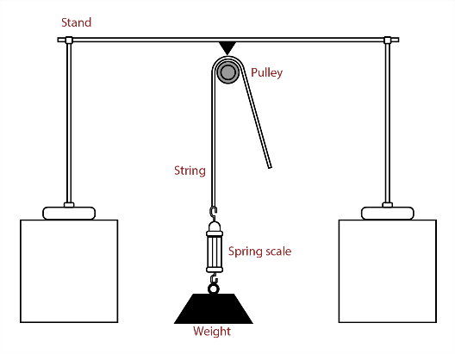 | 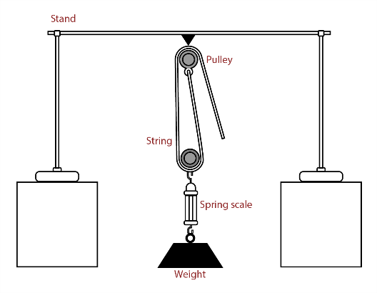 | 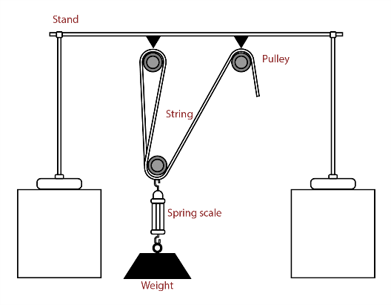

Number of Pulleys | 1 | 2 | 3
Mass | 50g | 50g | 50g
Force | 0.5 N | 0.25 N | 0.16 N

Questions:
- Why did the student recalibrate the spring scale between each experiment?
- Because it was faulty.
- To start from a consistent point to guarantee reliable readings.
- For no particular reason.
- To set it to the number of pulleys.

- What is the constant in this experiment?
- The number of pulleys.
- The length of the string.
- The force needed to lift the weight.
- The 50g mass.

- Was her hypothesis correct?
- Yes, because the force needed went down by approximately half with each experiment.
- Yes, because the force needed to lift the weight decreased with the third pulley.
- No, because the force needed to lift the pulley went down by less than half with three pulleys.
- No, her results were inconclusive.

- What force might you expect to be required to lift a 100g mass with two pulleys?
- 0.5 N
- 0.25 N
- 1 N
- 0.75 N

- Looking at the Table, what does adding a pulley do to the force required to lift the mass?
- Reduce the force needed by a fourth.
- Reduce the force needed by the number of pulleys.
- Reduce the force needed by half.
- Increase the force needed by half.

- What prediction could the student make about the force needed to lift the mass with a fourth pulley?
- The force needed, compared to one pulley, will be half.
- The force needed, compared to one pulley, will be one-third.
- The force needed, compared to one pulley, will be one-fourth.
- The force needed, compared to one pulley, will go up by one-fourth.

QUAKE IT OFF

Passage 2
Adapted from: “How is the Richter Scale Calculated.” (2023). SMS Tsunami Warning. https://www.sms-tsunami-warning.com/pages/richter-scale and Schmit, J. J. (July 8, 2017). Earthquake damage reporting. AmRRON. https://amrron.com/2017/07/08/modified-mercalli-intensity-scale-earthquake-damage-reporting/

Scientists use two types of scales to measure earthquakes: the Richter Scale to assess the magnitude of the earthquake which allows for comparison to other earthquakes around the globe and the Mercalli scale to measure and compare the severity of the same earthquake in multiple locations.

The Richter Scale measures an earthquake by the amount of energy released, allowing geologists to compare global earthquake magnitudes. Scientists most frequently use this scale. The use of seismic tools for measurements renders quick results. Table 1 shows Richter magnitudes and their associated effects.

The Mercalli scale measures the severity of the earthquake in different locations. In comparison to the Richter Scale, the Mercalli Scale measures an earthquake by the effects caused by that earthquake. Engineers most often use this scale. Survey data across an area is most frequently gathered; therefore, the collection of data takes more time. The Mercalli scale and its descriptors are listed in Table 2. Table 3 shows examples of earthquakes and their ratings on both the Richter and Mercalli scales.

Table 1
Richter Magnitude | Average Effects
0 - 1 | Cannot be felt
2 | Smallest quake people can feel
3 | People near the epicenter feel this quake
4 | Causes damage around the epicenter
5 | Damage done to weak buildings in the area of the epicenter
6 | Can cause great damage around the epicenter
7 | Can be detected all over the world. Causes serious damage
8 | Causes death and major destruction
9 | Rare, but could cause unbelievable damage

Table 2
Scale | Ground Conditions
I | Not felt or felt by very few.
II | Felt only by a few people, especially on upper floors
III | Felt quite noticeably, especially on upper floors
IV | Felt indoors by many, outdoors by a few
V | Felt by nearly everyone
VI | Felt by all, some heavy furniture is moved
VII | Very little if any damage in buildings of good design; considerable damage in poorly built structures.
VIII | Damage is slight in specially designed structures, damage great in poorly built structures.
IX | Damage is considerable in specially designed structures; substantial buildings have partial collapse
X | Most masonry and frames are destroyed with foundations. Landslides considerable.
XI | Few, if any, masonry structures are left standing. Bridges are destroyed. Broad fissures are in the ground.
XII | The damage is total. Waves are seen on ground surfaces. Objects are thrown upward in the air.

Table 3
Location | Richter | Mercalli
Great Chilean Earthquake (1960) | 9.5 | XII (Extreme)
Loma Prieta Earthquake (1989) | 6.9 | IX (Violent)
Sumatra-Andaman Earthquake (2005) | 9.3 | IX (Violent)
Haiti Earthquake (2010) | 7.0 | VII (Very Strong)
Napa Earthquake (2014) | 6.0 | VII (Very Strong)

Questions:
7. Based on Table 1, what is the lowest magnitude of earthquake that can be detected around the world?
- 3
- 5
- 7
- 9

8. Which scale would be preferable to use in an unpopulated area when an immediate measurement is needed?
- Richter, because it gauges energy from the earthquake and would provide fast results.
- Richter, because it explains the extent of structural damage and provides slower results.
- Mercalli, because it gauges damage from the earthquake and provides faster results.
- Mercalli, because it explains the extent of structural damage and has slower results.

9. An engineer collects survey data from residents after an earthquake, gathering data on what they experienced, and gives the earthquake a score of VII, what scale is he most likely using?
- Richter, because it uses survey data to evaluate earthquake damage and is reported using Roman numerals.
- Richter, because it uses seismographs to provide a numerical magnitude rating of energy released by the earthquake.
- Mercalli, because it uses survey data to evaluate earthquake damage and is reported using Roman numerals.
- Mercalli, because it uses seismographs to provide a numerical magnitude rating of energy released by the earthquake.

10. In Table 3 the Loma Prieta Earthquake and the Sumatra-Andaman Earthquake have the same Mercalli rating. What is the difference in their Richter scores?
- 3.6
- 3.5
- 16.2
- 2.4

11. Why would two earthquakes with the same Mercalli score have different Richter ratings?
- They should not, one of the scales must need to be recalibrated.
- Mercalli gauges damage and is based on population and structures in a location, so two different earthquakes could result in similar damage due to differences in population.
- Richter measures energy released and is based on population and structure surveys in a location, so the score could be different.
- Mercalli measures energy released and only gives one score to all earthquakes.

