CHAT STATION 1

Constants and Variables
In this example, what is being held constant and what varies?
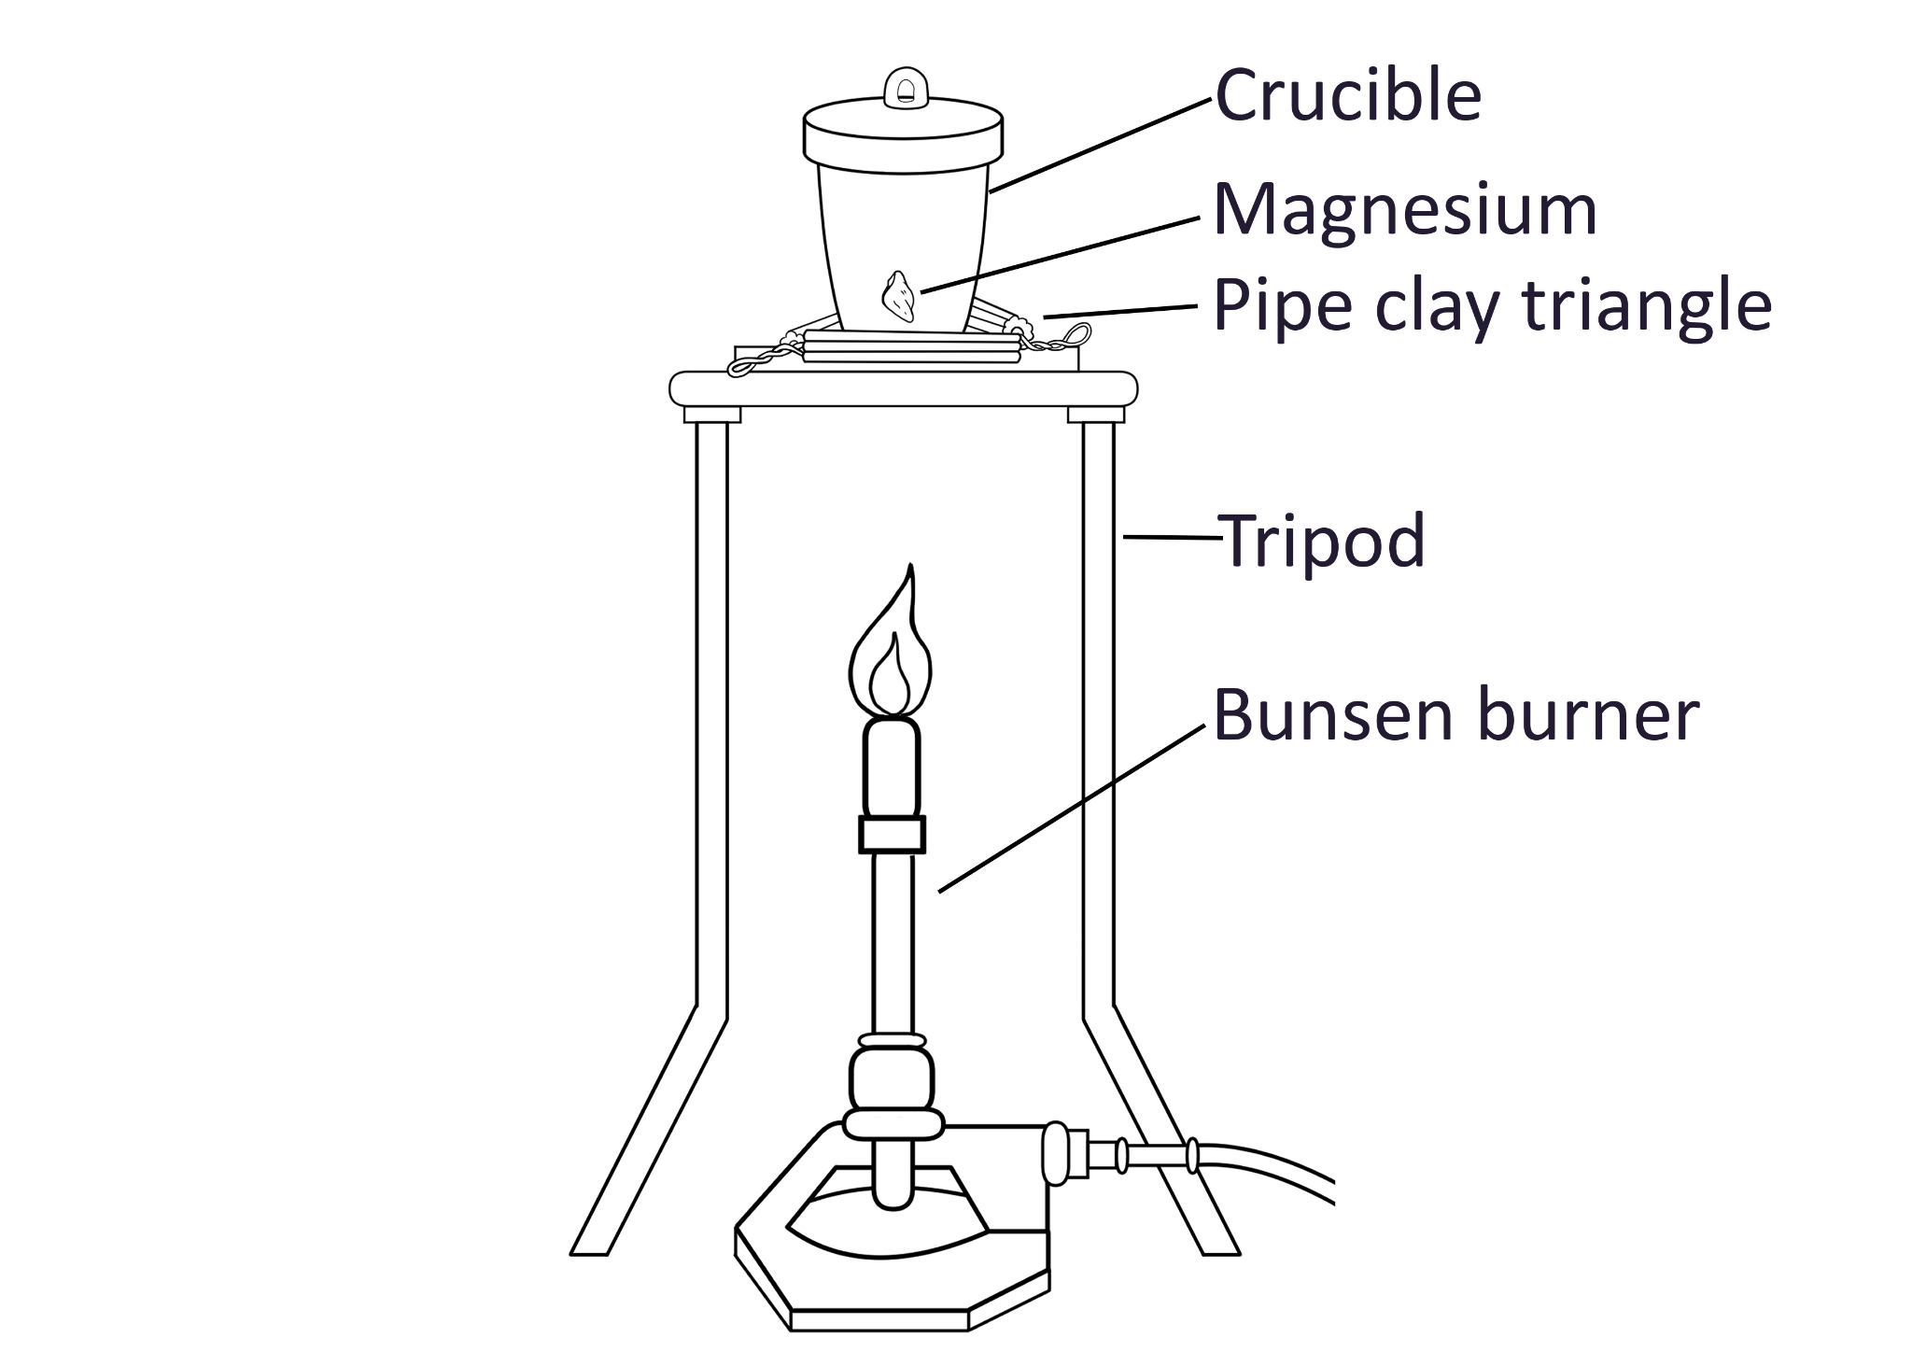

Experiment | Magnesium | Total | Oxygen
1 | 0.1 | 0.17 | 0.07
2 | 0.2 | 0.34 | 0.14
3 | 0.3 | 0.50 | 0.20
4 | 0.4 | 0.67 | 0.27

CHAT STATION 2

Constants and Variables
In this example, what is being held constant and what varies?

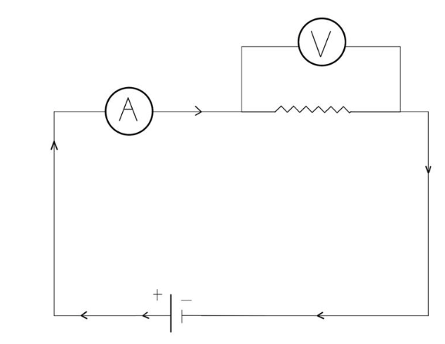
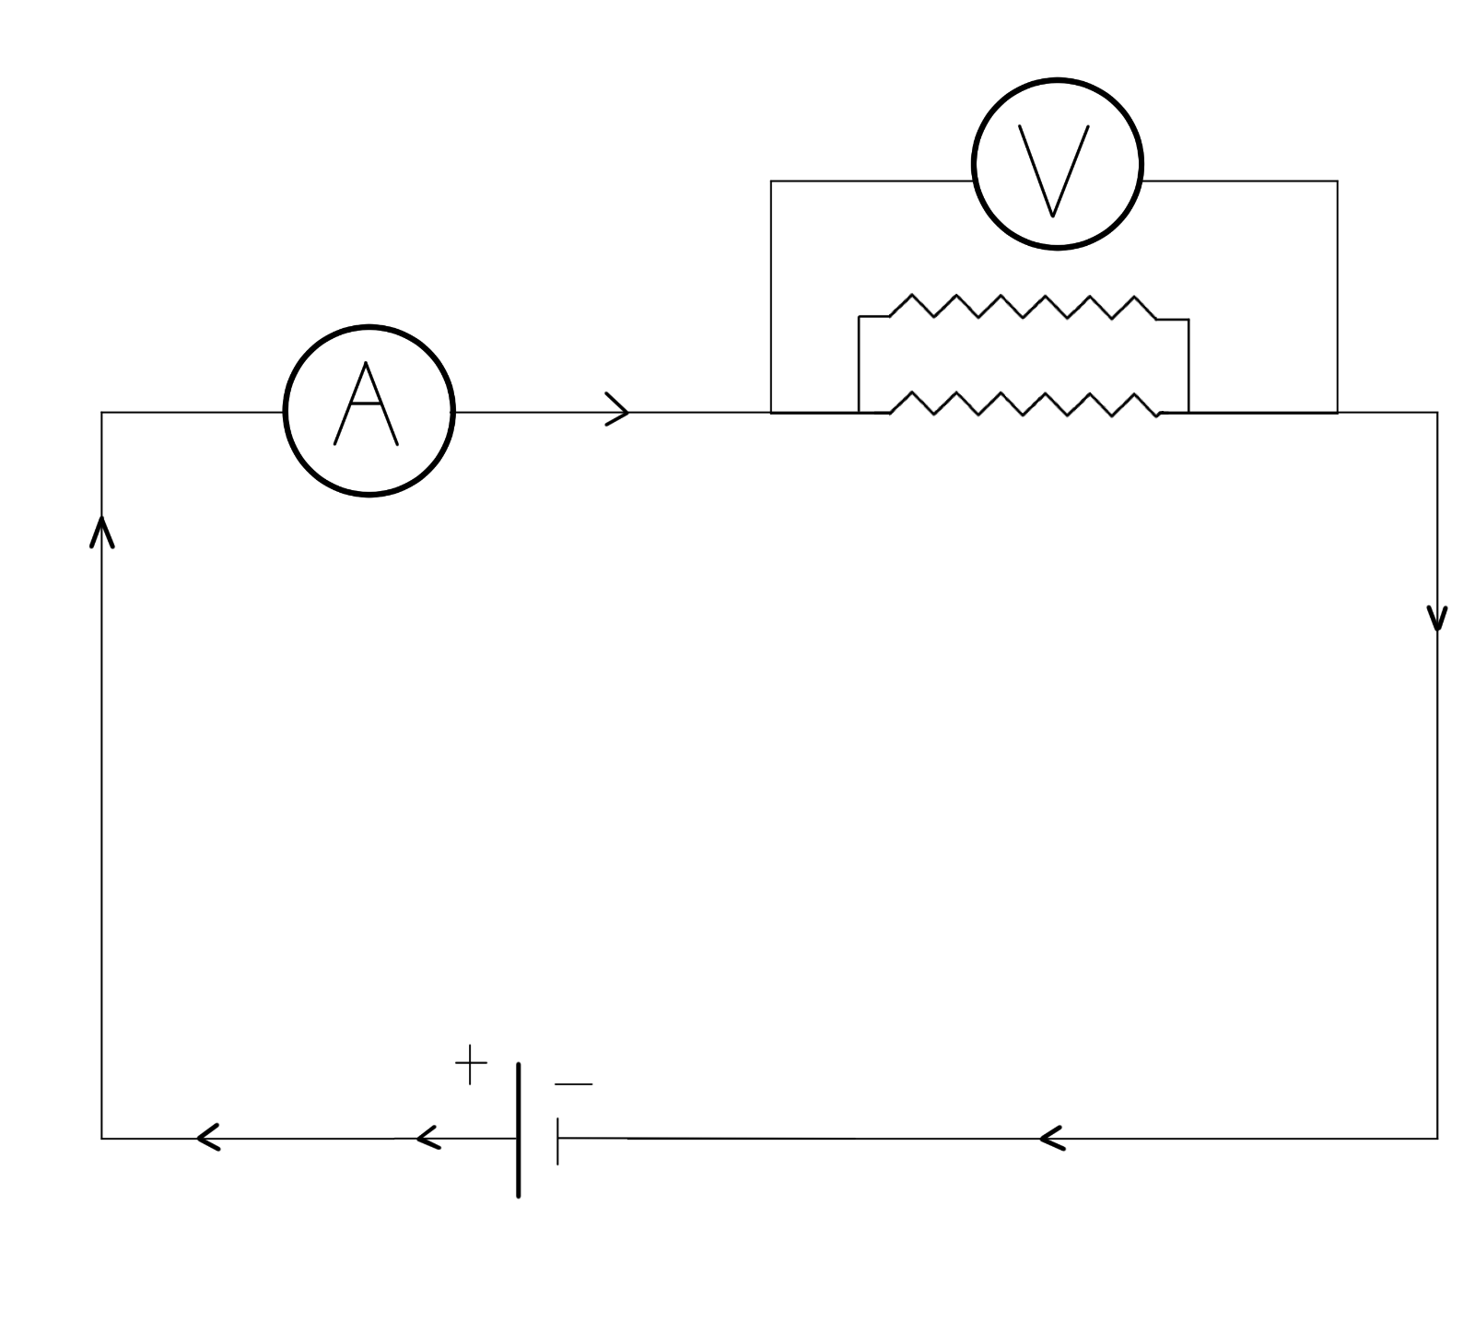

CHAT STATION 3

Constants and Variables
In this example, what is being held constant and what varies?

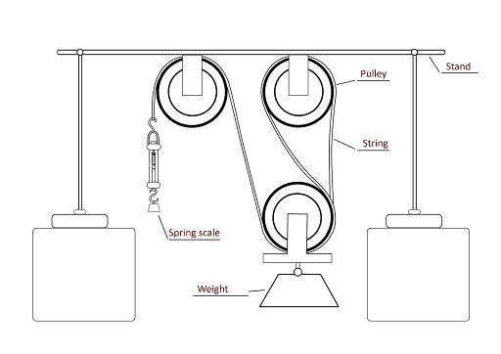

A student wants to learn how using a pulley changes the force needed to move an object. He hypothesizes that more pulleys will require less force. He sets up an experiment as illustrated on the right, adding a new pulley each time. He uses the spring scale to measure and record the force. He then creates a bar graph to analyze the data. He finds that using the pulley system results in using less force to move the weight.

CHAT STATION 4

Constants and Variables
In this example, what is being held constant and what varies?

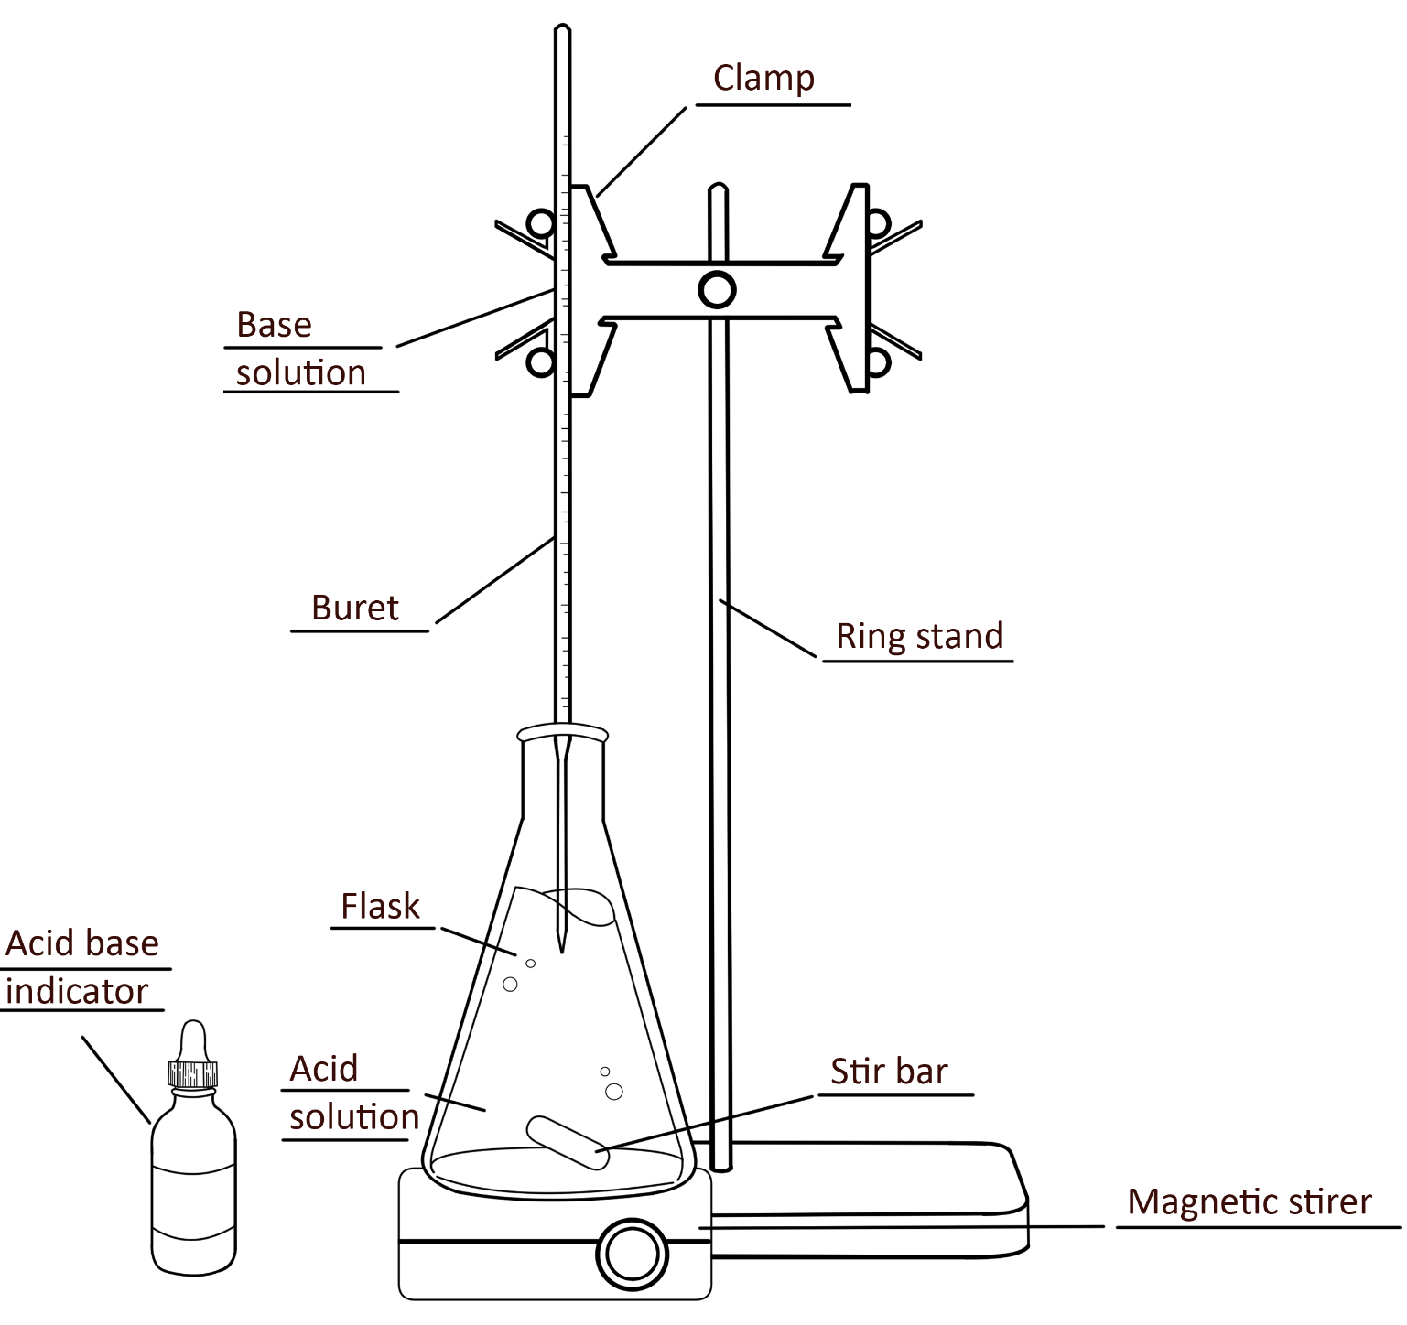
A scientist wants to determine the concentration of three acids. He hypothesizes that if he adds a known base, he can determine the acid content by when the solution is neutralized. He sets up an experiment as illustrated on the right. Then he uses the buret to slowly add the base to the acid. He notes the volume of the base that is required to neutralize the acid. He uses this volume to determine the acidity of the original solution. He repeats this for each acid solution.

