PRACTICE PASSAGES

SHARK WEEK

Passage 1

Sharks have a unique anatomy that allows them to navigate the ocean as an apex predator. Figure 1 shows the anatomy of a shark, including an overview of its three main body components as well as the name of each specific part.
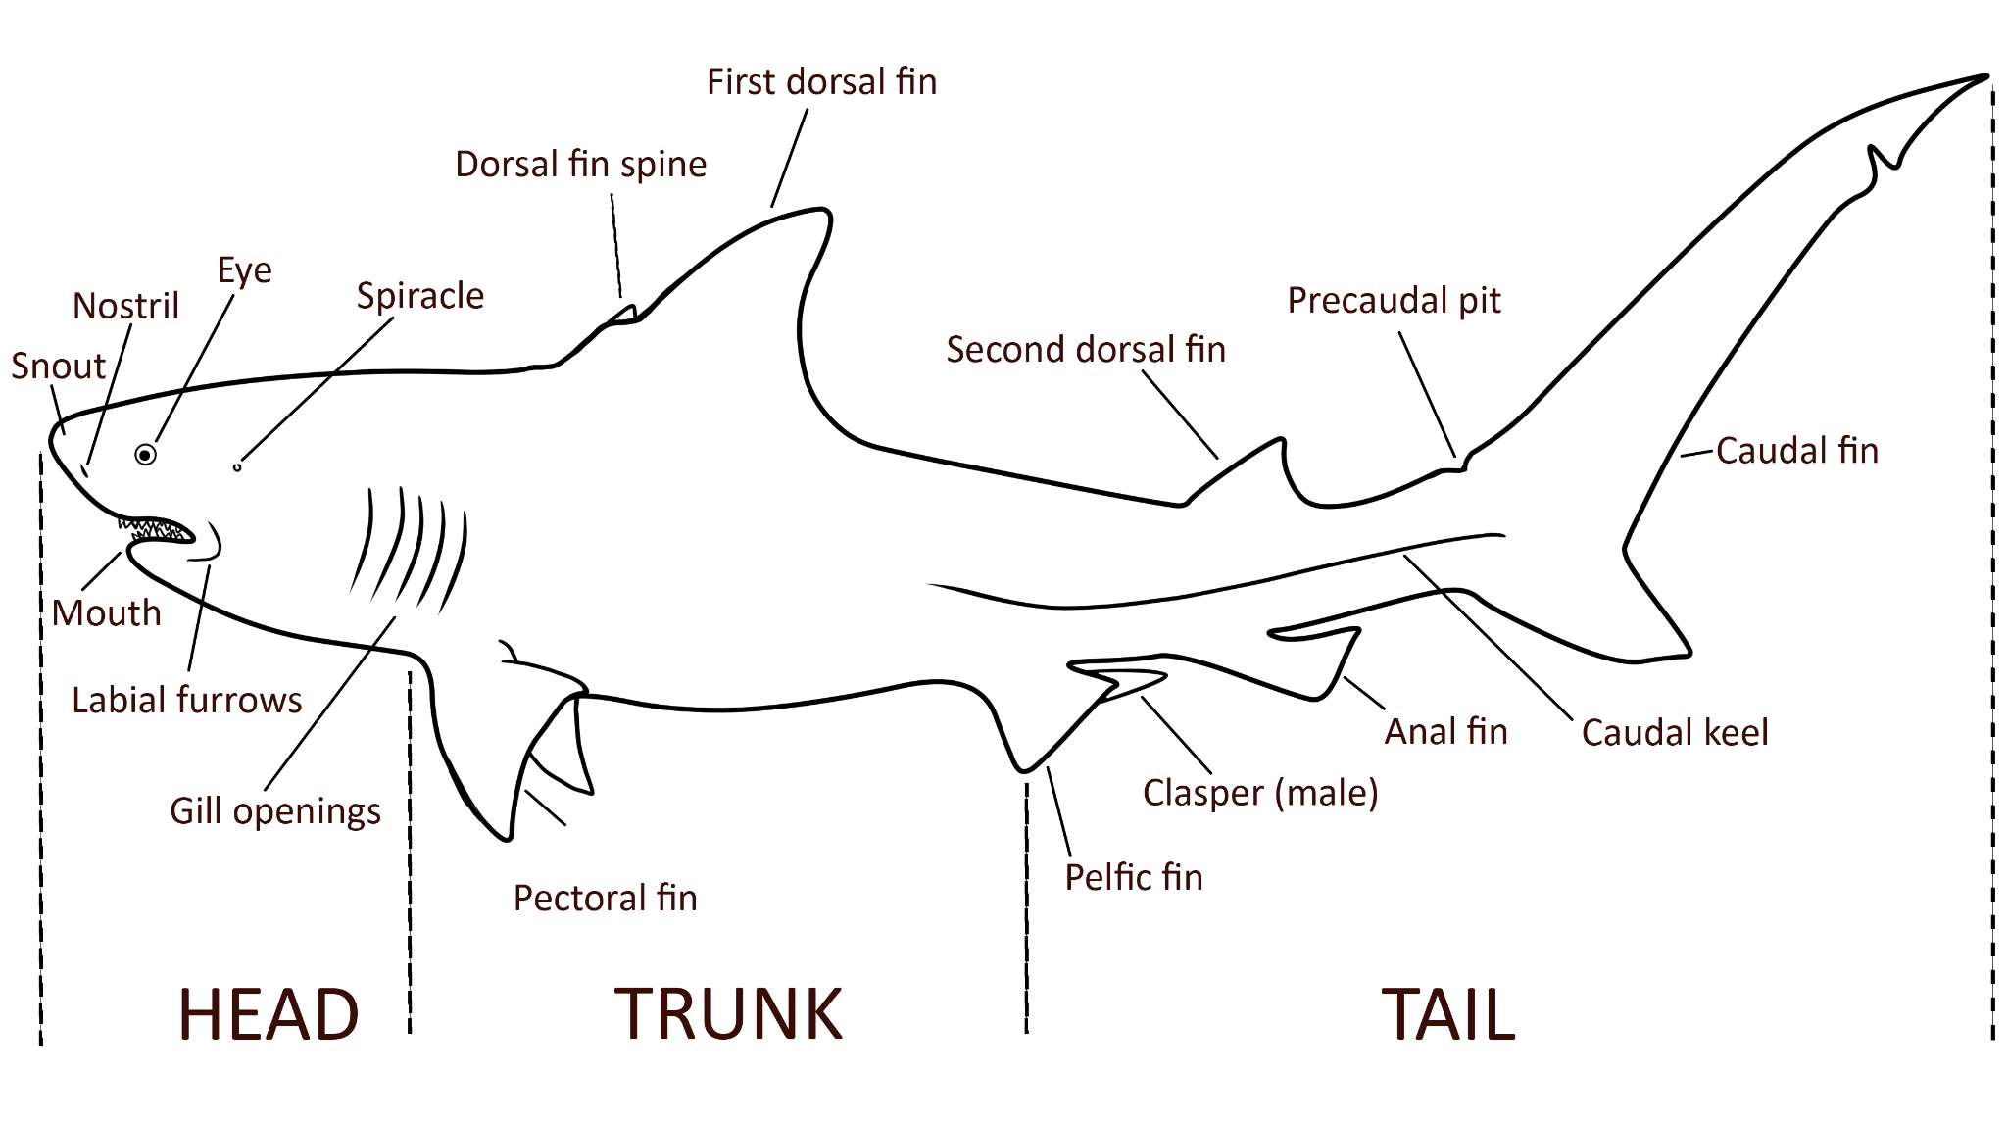
Sharks have a streamlined body shape that promotes faster speeds by reducing friction. Their bodies are divided into the head, trunk, and tail. The head contains the powerful jaws and sensory organs, while the trunk houses the muscles and internal organs. Table 1 includes key body parts of the shark and their functions.

Table 1
Part | Function
Caudal fin | propels the shark forward
Mouth: multiple rows of teeth | New teeth constantly replace the old. Different species have specialized teeth adapted for their specific diet, ranging from cutting and tearing to crushing hard shells.
Gill openings | Some sharks are able to extract oxygen from the water even while still, which further assists in their ability to attack prey.
Nostril | Sharks are able to differentiate the smells coming from each of their two nostrils and use that information to accurately track prey

These unique features of sharks have inspired scientists and inventors to use what they learn about shark anatomy to inform their work. Table 2 shows some of the inventions and innovations that have been based on shark anatomy. These are just some of the ways shark anatomy has inspired scientists and inventors.

Table 2
Part | Invention or Innovation
Caudal fin | Inspired the designs of water turbines to turn water movement into stored energy.
Mouth: multiple rows of teeth | Informs saw designs and how scientists explore the possibility of growing new teeth for humans
Shark skin | Inspired innovations in swimwear design and materials to enhance human swimming performance
Nostril | Inspired robotics designs to inform steering in odor-guided machines that seek out chemical leaks under water

Questions:
- Which shark fin is located in its trunk?
- Caudal fin
- First dorsal fin
- Spiracle
- Second dorsal fin

- According to the passage, which part of the shark includes its sensory organs?
- Tail
- Gill Openings
- Trunk
- Head

- Sharks are known to only swim forward. What physical trait might you attribute this to?
- The direction of the shark’s gills.
- The location of the shark’s mouth.
- The work of the caudal fin.
- The size of the trunk.

- What features of shark skin could have inspired swimwear?
- The skin is composed of scales that point toward the tail to reduce friction in the water.
- The skin propels the shark forward with powerful muscles.
- The shark is able to stay still in the water for extended periods of time.
- The shark can track and attack prey in the water.

- An innovator is considering designing a respirator to extract oxygen from water. Which part of the shark’s anatomy might he observe for inspiration?
- Dorsal fin
- Gills
- Mouth
- Nostril

- A shark’s skin is covered with scales called dermal denticles that are shaped like tiny teeth and discourage microbes and algae from growing on its skin. Which invention was inspired by this part of the shark’s anatomy?
- A glue stick that allows the glue to cover large surface areas.
- A hands-free umbrella to stay protected from the elements while working.
- An antibacterial film for hospitals that reduces the number of germs growing on surfaces.
- Protective helmets for the military.

- What is the most likely definition of the word dorsal?
- Upper side or back of an animal
- Tall
- Lower side or stomach of an animal
- Short

WHICH WAY DO I GROW?

Passage 1
A student is preparing for an upcoming science fair. They want to see how plants grow with light from different angles and of different intensities. In their first experiment, they want to test how being blocked from direct sunlight affects plant growth. They hypothesize that the plant with the direct sunlight will grow the largest in area. Using seedlings of the same type of plant, in the same soil, they set up the experiment as in Figure 1. They let the plants grow for four weeks, watering each plant the same amount and collecting data every two weeks. They decided to collect data such as height, leaf color, and shoot width (this is a measure of how wide the plant has grown.) The data from Experiment 1 is in Table 1.

Figure 1
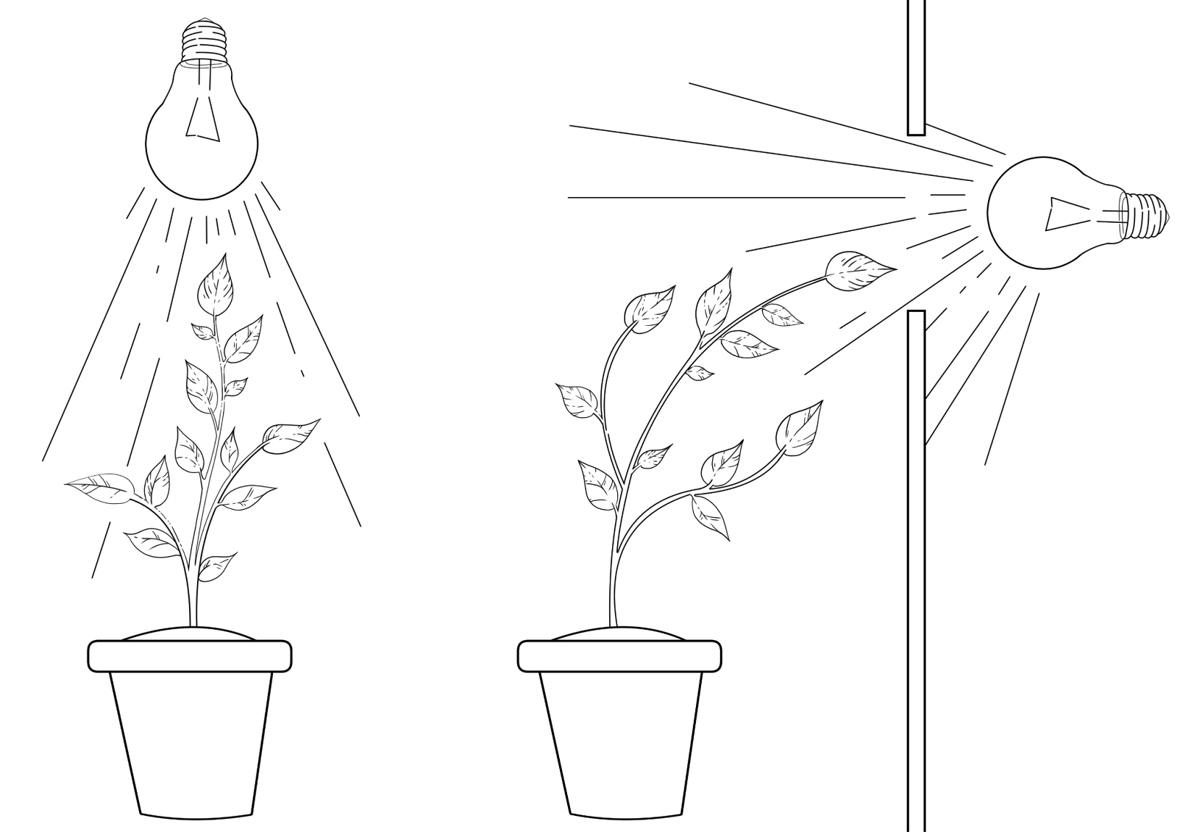

Table 1
Direct Light
Week | Height (cm) | Leaf Color | Shoot Width (cm)
0 | 3 | Light green | 2
2 | 6 | Dark green | 4
4 | 9 | Dark green | 6

Indirect Light
Week | Height (cm) | Leaf Color | Shoot Width (cm)
0 | 3 | Light green | 2
2 | 5 | Dark green | 5
4 | 7 | Dark green with yellow spots on the lower leaves | 9

In Experiment 2, they wanted to see how different intensities of light affected plant height over a four-week period and kept all other conditions the same. They set up the experiment, as in Figure 2. Likewise, they recorded the height under each condition in Table 2.

Table 2
Week | Low Light | Medium Light | High Light
0 | 3 cm | 3 cm | 3 cm
2 | 4 cm | 4.5 cm | 5 cm
4 | 5 cm | 6 cm | 5.5 cm

Questions:
- What is the control in Experiment 1?
- The type of plant.
- The amount of light.
- The color of the leaves.
- The ending shoot width.

- What might explain the yellow spots on the lower leaves of the indirect light plant in Experiment 1?
- The bulb got too hot.
- It didn’t get enough water.
- The lower leaves were not getting the same amount of light.
- The soil did not contain enough nutrients.

- Can the student confirm their hypothesis in Experiment 1?
- Yes, the direct light plant grew the tallest.
- Yes, the direct light plant had the greatest area.
- No, the indirect light plant had the largest width.
- No, the indirect light plant had the greatest area.

- In Experiment 2, what might be an explanation for the high light plant growing less than the medium light plant in Week 4?
- They are in different soil.
- The light intensity was too high, reducing growth.
- The growth was affected by the size of the pot they are planted in.
- It didn’t get enough water.

- The student decides that the soil may not contain enough nutrients. They try Experiment 2 again but give each different soil. What mistake in experimental design have they made?
- Introducing a second variable.
- Not choosing the right soils.
- Not moving the light higher, to prevent too much light.
- No mistakes were made.

- Assuming it continues to grow at the same rate, what height might they expect the medium light plant to grow to by Week 6?
- 8 cm
- 7 cm
- 7.5 cm
- Inconclusive from the evidence provided.

