PRACTICE PASSAGES

BUBBLING UP BALLOONS

Passage 1

A student is curious about the output of carbon dioxide (CO₂) from yeast and water solutions. He wonders if adding other substances would change the output of CO₂. He hypothesizes that there will be no difference between the three solutions because he thinks the yeast is the main factor in CO₂ production. He sets up an experiment to test his hypothesis using three bottles and three balloons. Each bottle contains 50mL of water. For the first experiment, he places 2 tsp of yeast in the balloon. In the next balloon, he places 2 tsp of yeast and 1 tsp of salt. In the final balloon, he places 2 tsp of yeast and 1 tsp of sugar. He then puts a balloon on each bottle and drops the contents into the water. After 5 minutes, he makes notes of his observations and draws what he sees.
Figure 1
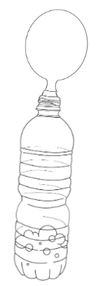  Yeast only | 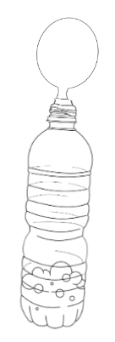  Yeast and salt | 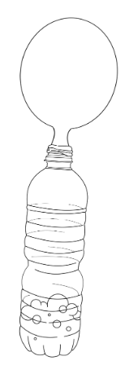  Yeast and sugar

Based on the results, he determines that the sugar and yeast mixture produced the most CO₂. He wonders if any other factors could impact CO₂ production and decides that the next time he experiments with yeast mixtures, he will test water temperature and how it relates to the amount of CO₂ released.

Questions:
- Based on the way the student set up the experiment, by observing the size of the balloons, he was able to monitor:
- How much balloons shrink.
- How much CO₂ was produced to fill the balloons.
- If balloons react to yeast.
- The water temperature of a yeast mixture.

- Which results support the claim that sugar helps yeast produce more CO₂:
- The bottles were all the same size.
- The bottles all contained the same amount of water.
- The bottle containing the yeast and sugar mixture had the largest balloon.
- The bottle containing the yeast and salt mixture had the smallest balloon.

- Based on the experiment, the addition of salt:
- Helps the yeast in production of ethanol.
- Has no effect on the production of carbon dioxide.
- Prevents the yeast from producing as much carbon dioxide.
- Helps the yeast in the production of carbon dioxide.

- The student wants to replicate the experiment but double the amount of water used in each bottle. To see similar results, he should also:
- Double only the sugar.
- Double only the salt.
- Double the contents of each balloon.
- Double only the yeast.

- When sugar is added to a yeast mixture, ethanol is produced as well as carbon dioxide. The student hypothesized that if more sugar is added, more ethanol will be produced. Is the data represented in this experiment consistent with this hypothesis?
- Yes, because the sugar mixture resulted in the largest balloon.
- Yes, because more sugar will make more carbon dioxide.
- No, because the sugar would overpower the yeast.
- No, because the experiment tested for carbon dioxide production, not ethanol.

- Assume the student sets up two more bottles, with one having only salt and the other having only sugar. What should he expect to see in these bottles:
- The sugar balloon would be more filled than the salt.
- The balloons would look deflated because there was no yeast present.
- The salt balloon would be smaller than the sugar.
- The balloons would look more full because there is no yeast present.

- Suppose the student tries a new experiment with yeast using different water temperatures. What other changes should be made to the experiment:
- All balloons should have only yeast so that salt or sugar doesn’t change the outcome.
- The bottles should be different sizes to account for water evaporation.
- The bottles with hotter water should have more water so it can maintain its temperature.
- The bottles with cooler water should have sugar added to encourage CO₂ production.

SPIN ME RIGHT ROUND

Passage 2

Two scientists disagree as to what has caused increased damage from hurricanes. Scientist 1 attributes the damage to climate change, while Scientist 2 feels like increased population in target zone areas has more to do with the damage reports. Their arguments are shared below.

Scientist 1
Scientist 1 proposes that the increase in intensity and frequency of hurricanes is the result of climate changes. She argues that the rise in temperatures globally has melted the polar ice caps, leading to warmer sea temperatures. This increase in temperature provides additional energy for hurricanes, causing them to strengthen and produce more damage. Citing data from the National Oceanic and Atmospheric Administration (NOAA), Scientist 1 contends that recent studies show a clear correlation between the increase in greenhouse gas emissions and the heightened frequency of category 4 and 5 hurricanes, which are the strongest categories that can occur. Furthermore, her research highlights the changing patterns of hurricane tracks, indicating a shift toward more dangerous paths. In support of her argument, Scientist 1 references specific instances, such as Hurricane Maria in 2017 and Hurricane Harvey in 2018, where she links the unprecedented intensity and rainfall to the warming climate.

Scientist 2
Scientist 2 is a leading expert in civil engineering and urban planning, whose research specializes in the impact of improved building structures on coastal regions during hurricanes. He hypothesizes that the increased damage due to hurricanes is directly related to human settlement patterns and advancement in building construction practices. The availability of resilient structures, such as reinforced buildings and storm-resistant housing, has encouraged more individuals to reside in areas prone to hurricanes. According to his investigations, data from the last two decades demonstrates a correlation between the rise of urbanization of these areas and escalation of hurricane damage. Therefore, Scientist 2 believes that the focus should be on more responsible urban planning and construction practices rather than just on climate change. Scientist 2 points to case studies where regions with stronger building codes and supportive infrastructure have experienced reduced casualties and property damage during hurricanes.

Questions:
- What contributing factor to the increase in damage due to hurricanes might both scientists include in their argument?
- Increased factory building in coastal areas as a contributing factor.
- The rising of sea levels in the Arctic Circle.
- The trend of young people moving to coastal areas.
- The lack of regulation on greenhouse gas emissions.

- The Saffir-Simpson Hurricane Wind Scale is a 1 to 5 rating based on a hurricane's sustained wind speed. This scale also estimates potential property damage. Who is most likely to use this scale when making their observations?
- Scientist 1, because it measures sustained wind speed.
- Scientist 2, because it measures potential property damage.
- Both, because it measures sustained wind speed and potential property damage.
- Neither, because it measures sustained wind speed and potential property damage.

- Based on the passage, would Scientist 1 or Scientist 2 be more likely to argue that advances in air conditioning systems have led to more people settling near the equator?
- Scientist 1, because air conditioning is bad for the environment.
- Scientist 1, because the air conditioning makes colder air, drawing in the hurricanes.
- Scientist 2, because better living conditions lead to more people moving.
- Scientist 2, because it shows the air is not actually heating.

- How does Scientist 2’s argument differ from Scientist 1’s?
- Scientist 2 feels climate change has more to do with hurricane damage than population change.
- Scientist 2 thinks hurricanes do not cause as much damage as people may think.
- Scientist 2 does not think temperature influences hurricanes.
- Scientist 2 feels hurricane damage has more to do with population change than climate change.

- Scientist 2’s argument would be weakened if which of the following observations was made:
- High hurricane damage is recorded further inland than previous years.
- A new form of concrete is developed, which reduces hurricane damage in some coastal areas.
- Greenhouse gas levels decrease, and the average number of hurricanes per year stays constant.
- The number of hurricanes decreases, but the intensity increases.

- Scientist 1 believes the rising sea levels play a role in increased hurricanes, what has caused these rising sea levels?
- Increased rain from the ocean atmosphere.
- Coastal nations processing more ocean water for personal use.
- The melting of the polar ice caps.
- Wastewater being placed back in the ocean.

- Scientist 1’s argument would be best supported by which of the following observations?
- Seeing decreased destruction of beachfront property in Florida.
- A year with more hurricanes, including a record amount of greenhouse gas emissions.
- Ocean temperatures remaining constant, while hurricane frequency increases.
- Hurricane paths staying constant over a five-year period.

WIND, SUN, AND RAIN ON THE PLAINS

Passage 3
A group of meteorologists at the National Weather Center are interested in analyzing weather patterns in three cities in Oklahoma. They wanted to conduct some observations that would allow them to compare the similarities and differences of the weather in the four cities. The meteorologists measured the average rainfall, average wind speed, and percentage of cloud cover over one week.

Observation 1
The meteorologists set up barometers at four different locations in each city. At midnight of each day, the amount of rain in each barometer was averaged together to find the average amount of rainfall each day, these results were collected in Table 1.

Table 1. Average Rainfall (cm.)
City | Day 1 | Day 2 | Day 3 | Day 4 | Day 5 | Day 6 | Day 7
Norman | 0.5 | 0.3 | 0 | 2.2 | 0 | 2.5 | 1.7
Lawton | 3.8 | 4.7 | 4.9 | 2.6 | 3.2 | 5.3 | 5.8
Tulsa | 10.3 | 8.6 | 7.5 | 6.3 | 9.1 | 13.2 | 11.4

Observation 2
In Observation 2, the meteorologists decided to set up cameras on the three tallest buildings in each city. These cameras took a picture every two hours. Using image analysis, they combined the images from each camera, each day, to calculate an average amount of cloud cover for each city. The results of this observation are found in Figure 2.

Figure 2. Average Wind Speed (km/hr)
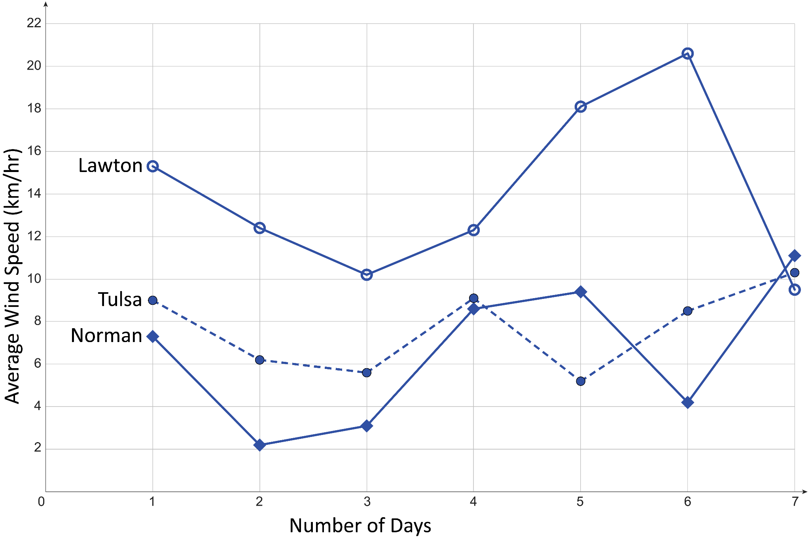
Observation 3
For Observation 3, the meteorologists wanted to capture the wind speed in each of the cities. They set up anemometers at five different places around each city, one centrally, and four at each corner of the city limits. Measurements were taken every four hours and averaged together each day over one week. The results of this observation are found in Table 3.

Table 3. Cloud Coverage
City | Day 1 | Day 2 | Day 3 | Day 4 | Day 5 | Day 6 | Day 7
Norman | 24% | 36% | 20% | 5% | 8% | 10% | 8%
Lawton | 2% | 4% | 1% | 3% | 6% | 8% | 2%
Tulsa | 65% | 40% | 27% | 15% | 82% | 65% | 70%

Questions:
- How many measurements/photos were taken in each city, each day, in Observation 2?
- 3
- 12
- 24
- 36

- Which observation collected the most measurements?
- Observation 1
- Observation 2
- Observation 3
- They all collected the same number of measurements.

- Which city got the most sun throughout the week?
- Norman
- Lawton
- Tulsa
- Inconclusive

- Does there appear to be any relationship between wind speed and rainfall?
- Yes, lower wind speed means higher rainfall.
- Yes, higher wind speed means lower rainfall.
- No, wind speed and rainfall do not appear related.
- Unable to tell from the data.

- How might meteorologists increase the accuracy of their measurements of rainfall?
- Use more accurate anemometers.
- Increase the number of barometers around the city.
- Collect measurements more often.
- Wait for a week that is predicted to have more rain.

- The meteorologists want to make a claim that Norman is always more cloudy than Lawton? What might be an issue with this assumption?
- They have only collected data for one week.
- The image analysis of cloud cover is not scientific enough.
- Norman was not cloudier over the week than Lawton.
- There is no issue with this assumption.

- The meteorologists want to expand their observations to learn more about weather across the United States, what might be the best set of locations for additional observation points?
- Wyoming, Colorado, Idaho, Nevada
- Washington, Maine, Texas, North Dakota
- Kansas, Oklahoma, Missouri, Arkansas
- New York, Tennessee, Kentucky, Ohio

