Contents
Overview ______________________________________________________________ | 3
Your Role as a Facilitator __________________________________________________ | 4
Career Café Checklist_____________________________________________________ | 6
Interest Surveys __________________________________________________ | 6
Templates & Resources___________________________________________________ | 7
Communication Templates _________________________________________ | 7
Resources ______________________________________________________ | 10

Overview

Using Career Interest Surveys and feedback from participating students, schools will strategically invite a group of professionals to participate in school-based career talks entitled Career Cafés. Career Cafés are an enrichment intervention designed to increase student awareness of different career fields. Each Café creates a structure through which students speak with community members about careers and colleges in a small-group atmosphere during the students’ lunch period, a related class period, or as part of an after-school club.

Career Cafés will (a) introduce students to new careers they may not otherwise have access to; (b) help raise students’ career aspirations and personal goals; and (c) provide students with a road map to achieve those goals. Guest speakers enrich learning by offering real-world insights, expertise, and diverse perspectives. Career Cafés inspire, motivate, and provide unique opportunities for students to connect with professionals and gain practical knowledge.



Your Role as a Facilitator

Your role as a facilitator for a Career Café is to organize and host a career talk that meets the interests of a small group of students. Follow this guide as it takes you through the checklist, order of events, and communication templates for organizing and facilitating your event. Career Cafés can be held either virtually or in-person. Remember to follow all established school volunteer guidelines when organizing and hosting a Career Café.

Students’ careers will be a big part of their lives after high school, so it is important to spend time helping them explore their options. There are so many great career possibilities that it can be hard to know where to start. Begin by looking for something that interests and excites your students by having them reflect on their personal interests, skills, and even values using our provided Interest Survey (see page 6) or one of your own. Guide them to consider careers that will help them further develop those parts of their lives. While these interests will likely change over time, it is never too early to begin exploring career opportunities. This exploration might lead students to notice careers they didn’t think they would like.
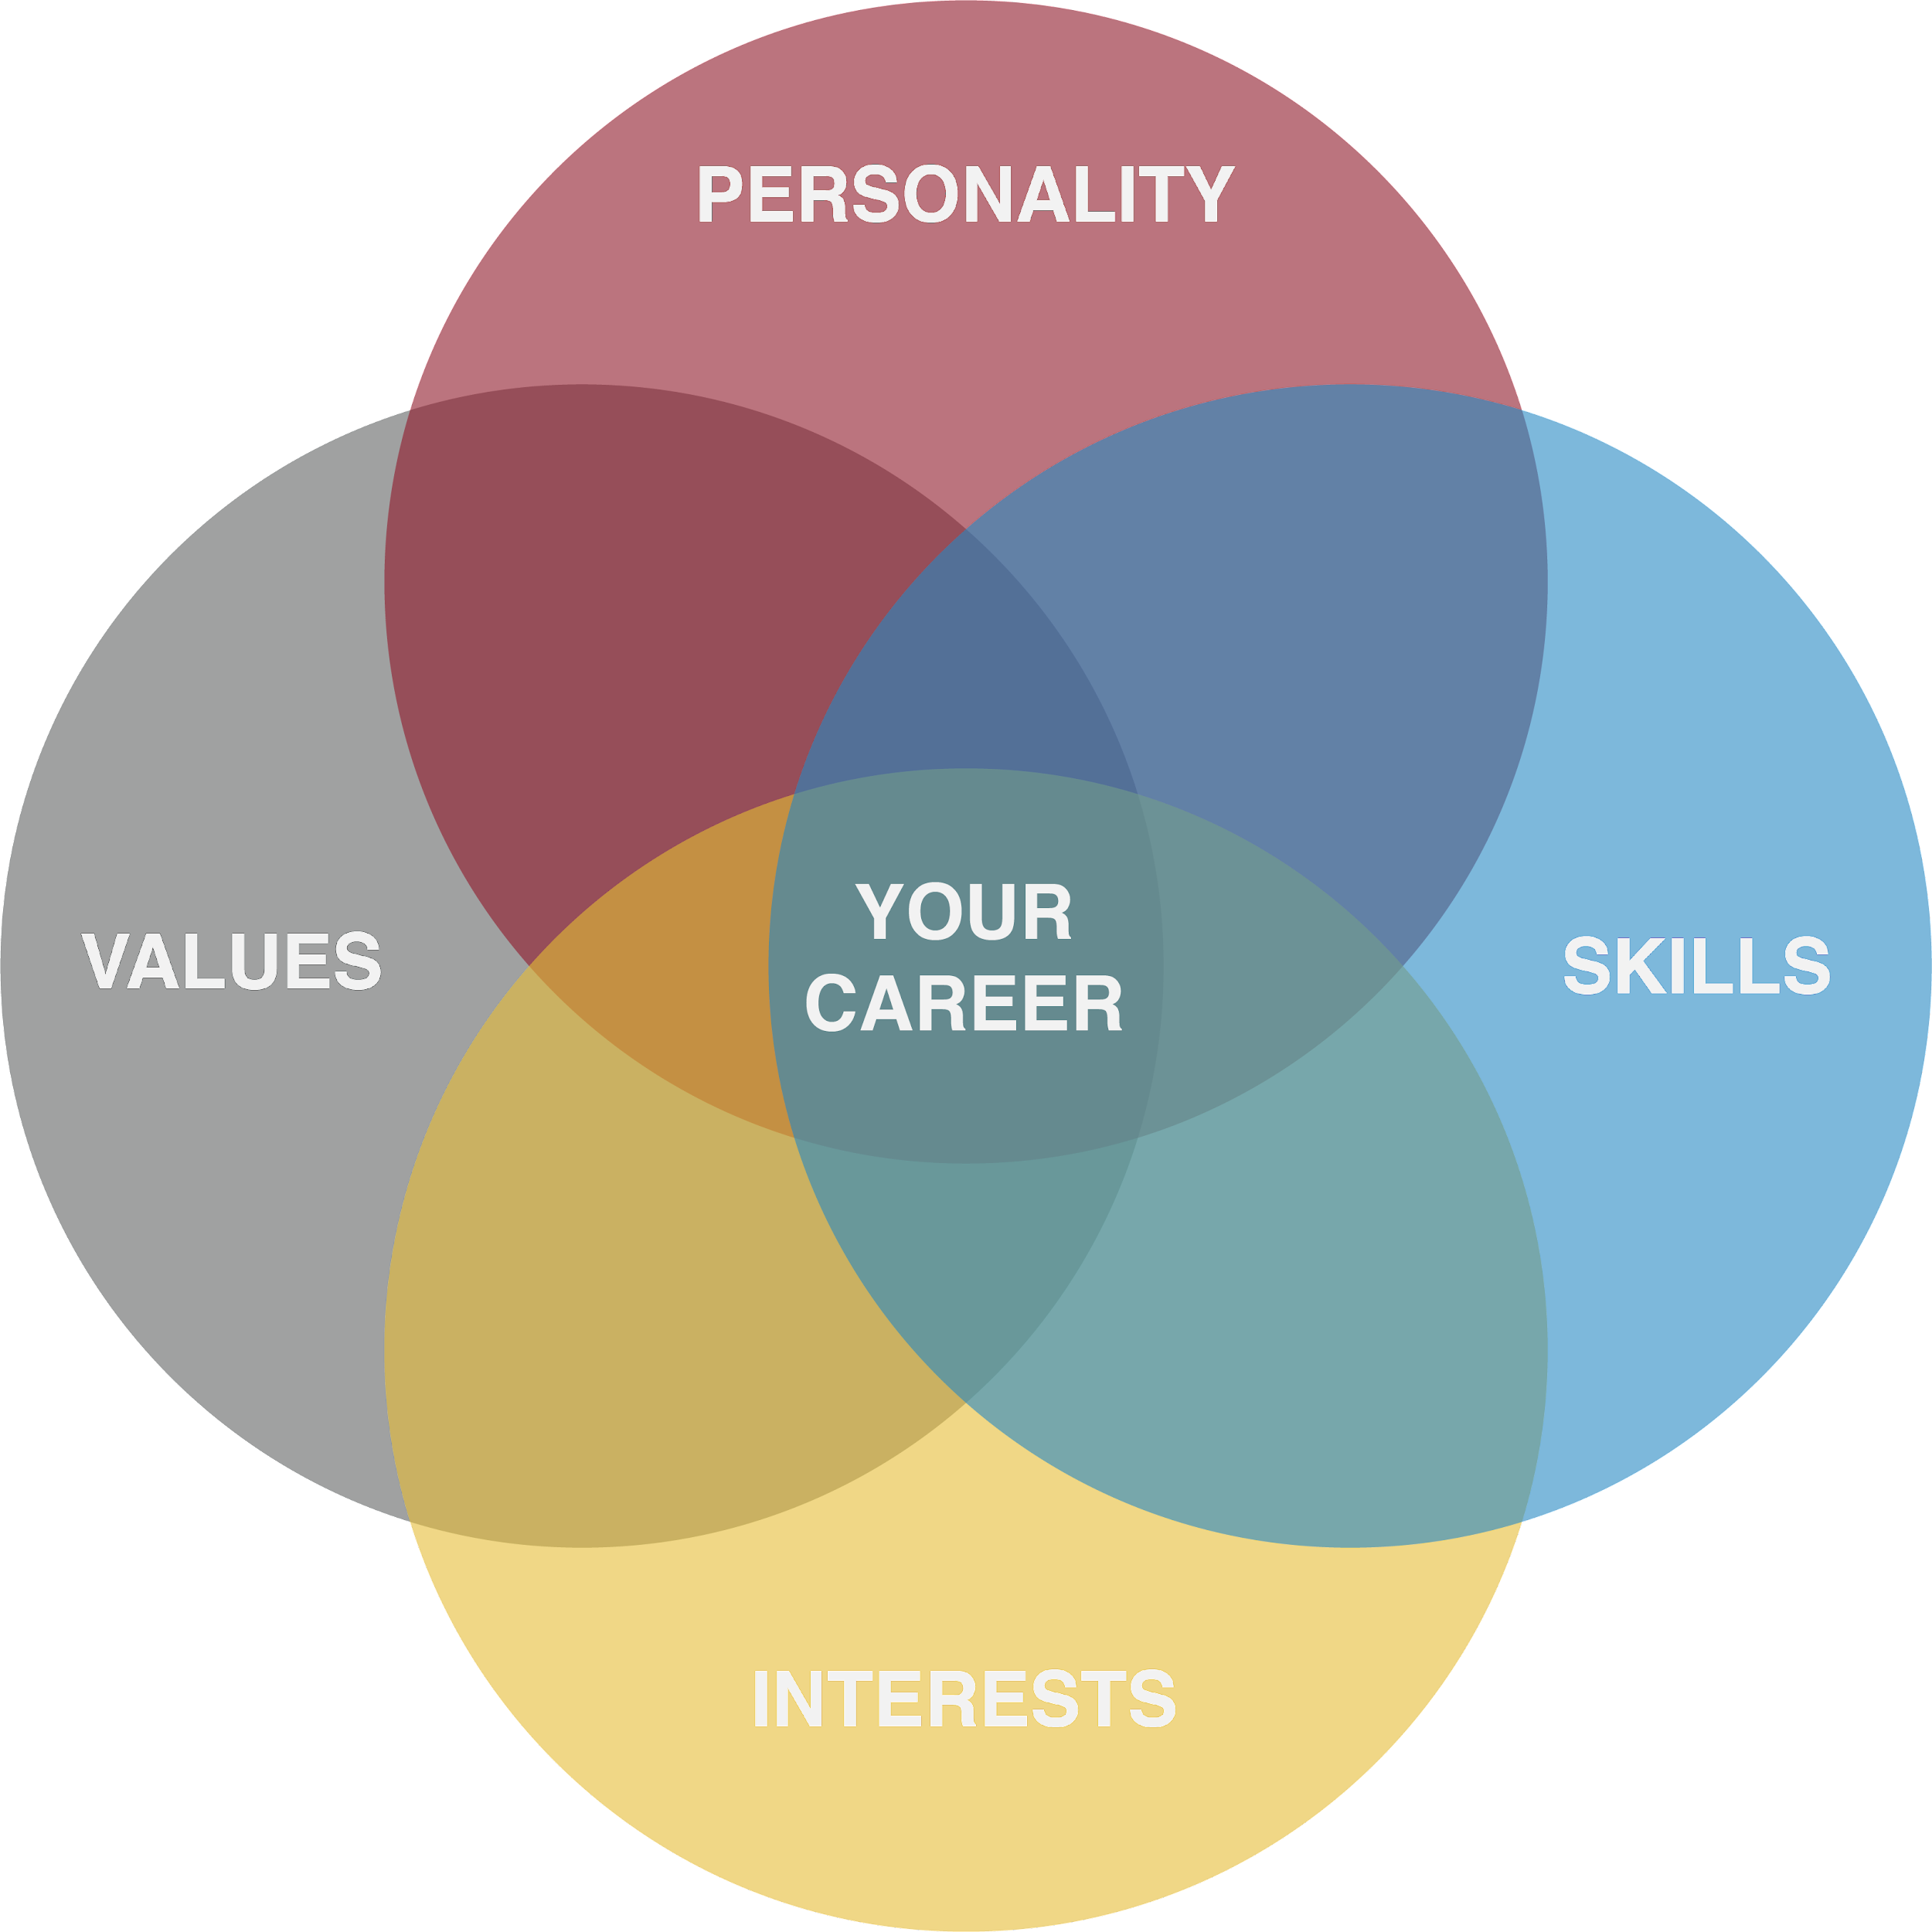

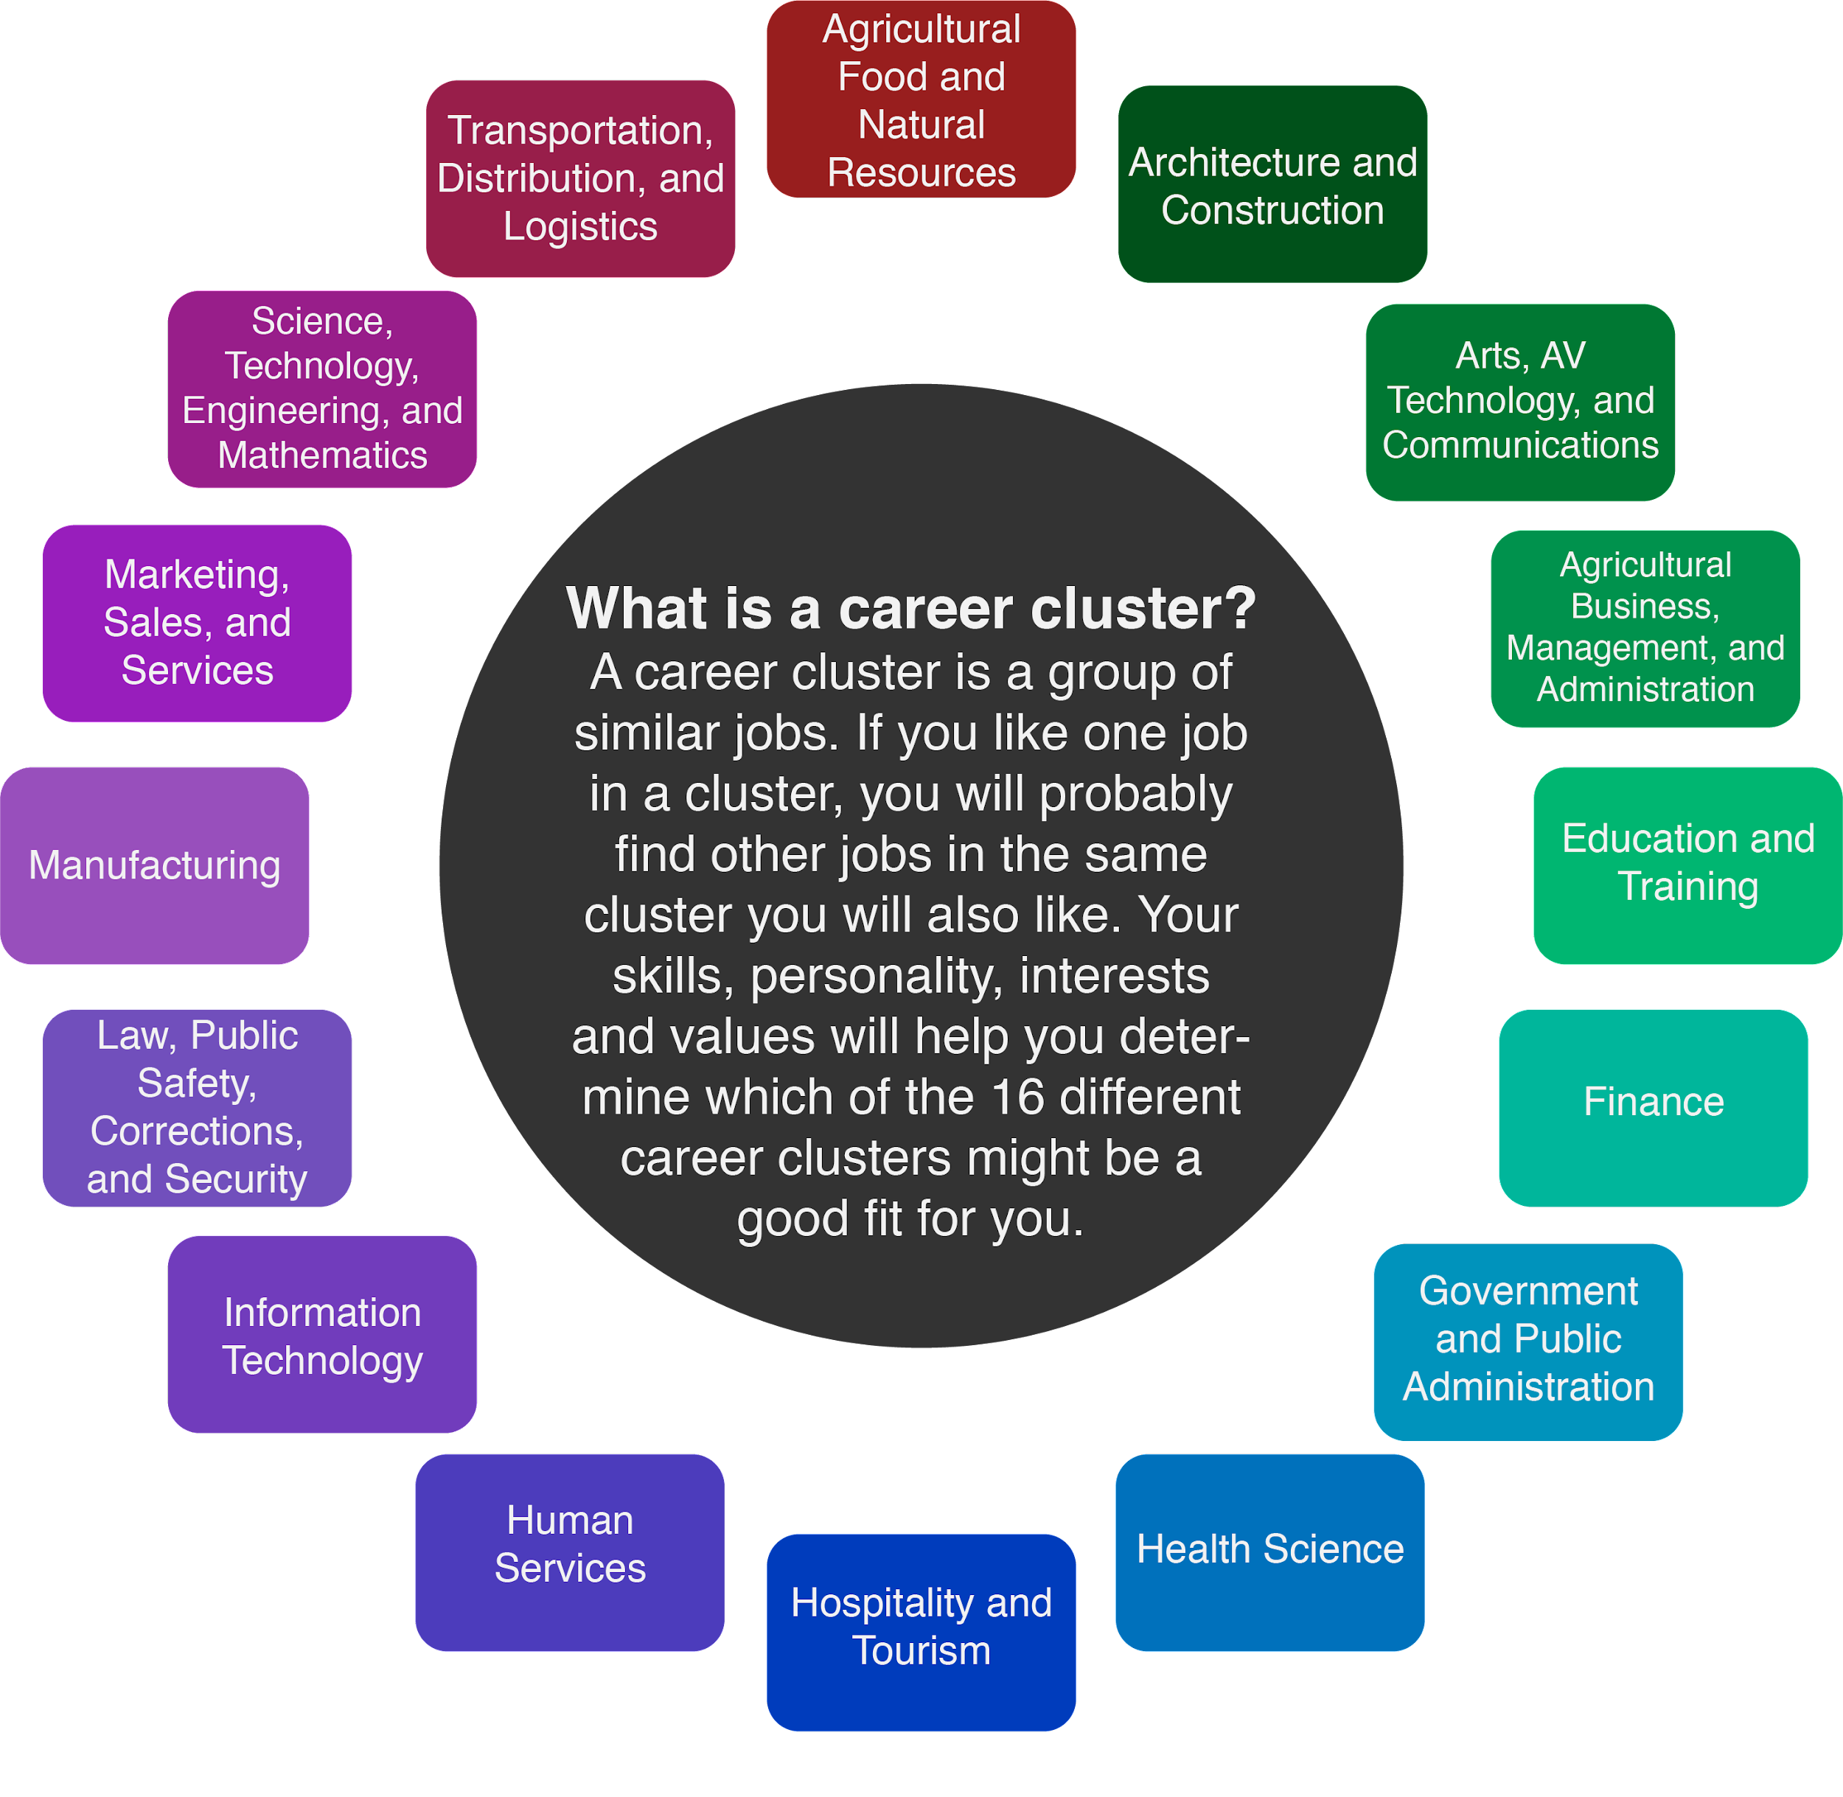

As students begin to experience other career events and career-related activities, encourage them to explore as many different careers and “career clusters” as possible (see image above for more details). Help them look for careers they have never thought about and see what happens—students might find a new passion to pursue! As you help students explore careers, always remind them that it is okay if they don’t know what they want to do yet and that their interests will likely change several times. Career Cafés are intended to start the conversation and help students begin thinking about how career choices might influence their lives.

Career Café Checklist
Interest Surveys | How do I gather data?
To help find relevant guest speakers first you need to gather data on what careers interest your students. These “Interest Surveys” may be conducted in a number of ways. You are free to use your own survey material or try out our K20 resources.
- 16 Ways to Survey Your Career - This student resource is a lesson teachers or school staff can facilitate with their students to collect paper results reflecting students’ career interests. Click on the hyperlink or type in the URL provided: http://k20.ou.edu/16ways.
- Career Cluster survey - This online survey is the same as the previous resource, yet it provides quick results and can be done independently by students. Note: Results are seen by students. It is up to the facilitator to determine how to gather the results from students (i.e. students can submit a screenshot in an LMS platform). Click on the hyperlink or type in the URL provided: https://tinyurl.com/K20CareerSurvey.
Additionally, the K20 Center’s Career Cluster Activities are available as next steps following the Café for additional career cluster information, extension, and enrichment.
Checklist | How do I plan for the event?
Schools will need one staff member willing to coordinate and facilitate each Career Café. This person will be responsible for all communication with the guest speaker, selecting students or a class, and leading the event. Responsibilities for this coordinator are outlined in the checklist below:
- Based on results from your chosen Interest Survey, recruit a speaker using the provided email template in this packet (see page 7).
  - To find a speaker, start with who you know! Ask colleagues, members of your PTA/PTO, and community partners who might know someone in the desired career area. You can also spread your search to social media by asking friends and family if they have a career connection.
- Recruit students interested in participating in this event.
- Using the Email Templates 2 and 3 provided (see pages 8-9), set up and send the video conference link, or provide instructions for locating the school, signing in, etc. for an in-person session, and send communication to the speaker.
  - Create and send video conference link/in-person instructions to the speaker.
  - Include the provided Guest Speaker Guide, Guest Speaker Template slides, and Guest Speaker Bio Template in your communication to the volunteer speaker so they can properly prepare for their session.
  - Ask if you can record their talk for an ICAP lesson [Optional].
- Facilitate the event on the day of the session.
  - Follow all school protocols for the in-person or virtual meetings.
- Complete the final steps of communication.
  - Send the speaker a thank you email, thank you card, or both (see page 9 for ideas)!

Templates & Resources

Use these communication templates to help recruit volunteer guest speakers, schedule your Career Café, and follow up with your guest afterward.

Communication Templates
- Email Template 1: Email to potential guest speaker(s) asking if they would like to volunteer.
- Email Template 2: Confirmation email that asks for the speaker's professional photo and career bio and provides the speaker with the Guest Speaker Guide.
- Email Templates 3a and 3b: Email including the video conferencing link, meeting ID, password, and any other information needed to join the meeting (virtual) or instructions for locating the school, signing in, etc. (in-person).
- Email Template 4: “Thank you” email to the guest speaker after the Café is complete.

Email Template 1 - Recruiting Speaker(s)
Hi, ______________.
My name is ______________, and I am __________________ at ____________________ in [city, state] ___________. We are organizing a small-group Career Café talk to help our students learn about potential career options.
We think that our students would benefit from hearing about your work as a ____________________. This is a great chance for you to share your knowledge with high school students who are eager to know more about your profession!
If you are interested in receiving more information and would consider being a guest speaker, please feel free to email me back at ______________________.
Sincerely,

Email Template 2 - Confirming Volunteer Session Information
Hi, _____________!

Thank you again for volunteering for our Career Café! We are so excited that you are interested in being our professional guest speaker.

Below is the date, time, and location we have scheduled your Career Café session:

Date: ___________________________

Time: ___________________________

Location: [include address, city, state, name of room (if available)] ________________________

Please confirm this time and email me your completed Guest Speaker Bio Template handout by ___________________ so that we can share these with our students.

In this email, we have included a Guest Speaker Guide to help you prepare for your Career Café session.

Let us know if you have questions and thank you again for volunteering! We will send more logistical information soon.
Sincerely,

Email Template 3a (Virtual Talk)- Meeting Details and Needed Info

Hi, _______________.

We hope this email finds you well. Here is the link, meeting ID, and password to your career talk on_________at ____________. You will also receive the following information in a calendar invite.
- Meeting Link:
- Meeting ID:
- Password:
Please respond to this email to let us know you received the link and are ready to go. Our students are looking forward to your career talk!

Thank you again and let us know if you need anything.

Sincerely,

Email Template 3b (In-Person Talk)- Meeting Details and Needed Info
Hi, _______________.

We hope this email finds you well. Your meeting is on ____________ at _________. Please arrive at least fifteen minutes early. You will want to park in the visitor parking spots located on _________ side of the building. Also, make sure to bring a photo ID for check-in at the main office, and one of our staff members will direct you to the room.

Here is our school address and contact information in case you need help locating us or have any questions:
Address: ____________________________
Phone Number: ______________________
Please respond to this email to let us know you are ready to go. Our students are looking forward to your career talk!
Thank you again and let us know if you need anything.
Sincerely,

Email Template 4 - Thank You
Hi, _________________.

Thank you for being a guest speaker for our Career Café event on _____________! We know your time is valuable and we are grateful that you spent some of it with us.

The students enjoyed hearing about your career and learned a lot from your session. We look forward to working with you again in the future if the opportunity ever arises.

Thank you again!

Sincerely,

Resources
- K20 YouTube Channel: Career Talks
  - These career talks are from the K20 Center’s “Zoom Into Your Career Expos,” so they are a little more broad, but still serve as good examples of how a career talk could be structured. Watch a few, and see what you think. Keep the parts you like, and adjust what you don’t!
- LEARN Career Cluster Activities
  - Interested in having students explore a specific career, either before or after the Career Café? Look through these engaging career activities that students can complete.
- Mynextmove.org
  - This website is linked in several of the LEARN career activities because it is such a helpful tool for career exploration. Use it before or after the career talk as part of an engaging activity to help students further explore this profession and others.
- Zoom Tutorial Page
  - If you want to use Zoom as your communications platform, use this link to access tutorials and the Zoom help center.

