MODIFIED APPOINTMENT CLOCK

Consider all 16 career clusters, plus college and the military. Are there any individuals in your community that you could reach out to? List their name next to the number that corresponds to the cluster. Use your Career Cluster Table handout for the 16 career clusters. Example: If you know a graphic designer, write their name next to the number 3 for the career cluster, Arts, A/V Technology, & Communication. The number 17 will be used for college and 18 for the military.

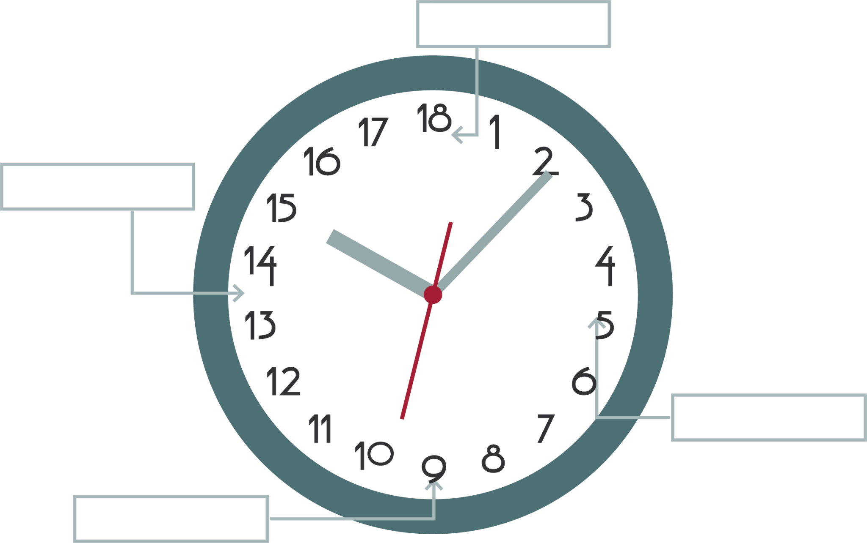

|  |  |
| --- | --- |
| 1. __________________________ 2. __________________________ 3. __________________________ 4. __________________________ 5. __________________________ 6. __________________________ 7. __________________________ 8. __________________________ 9. __________________________ | 1. __________________________ 2. __________________________ 3. __________________________ 4. __________________________ 5. __________________________ 6. __________________________ 7. __________________________ 8. __________________________ 9. __________________________ |