STUDENT SURVEY DATA

View sample Career Cluster survey data and collaborate with your group to find three (3) career speakers that match the needs and interests.

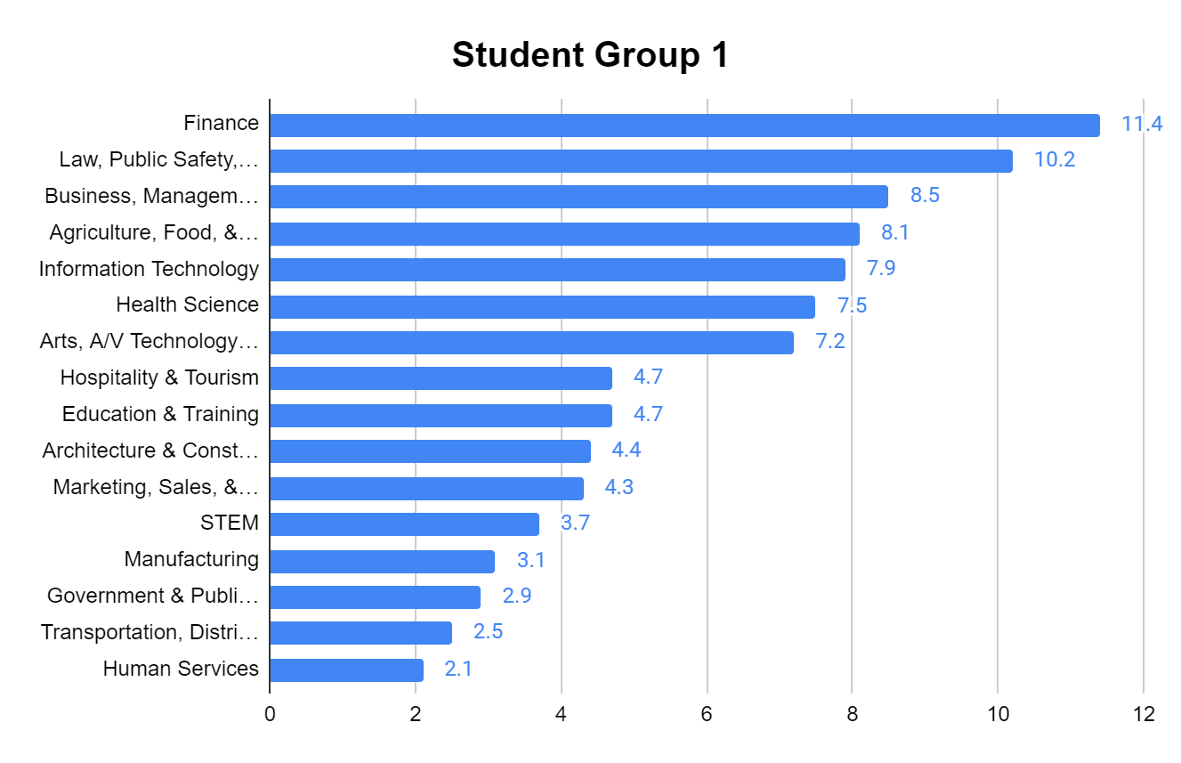

STUDENT SURVEY DATA

View sample Career Cluster survey data and collaborate with your group to find three (3) career speakers that match the needs and interests.

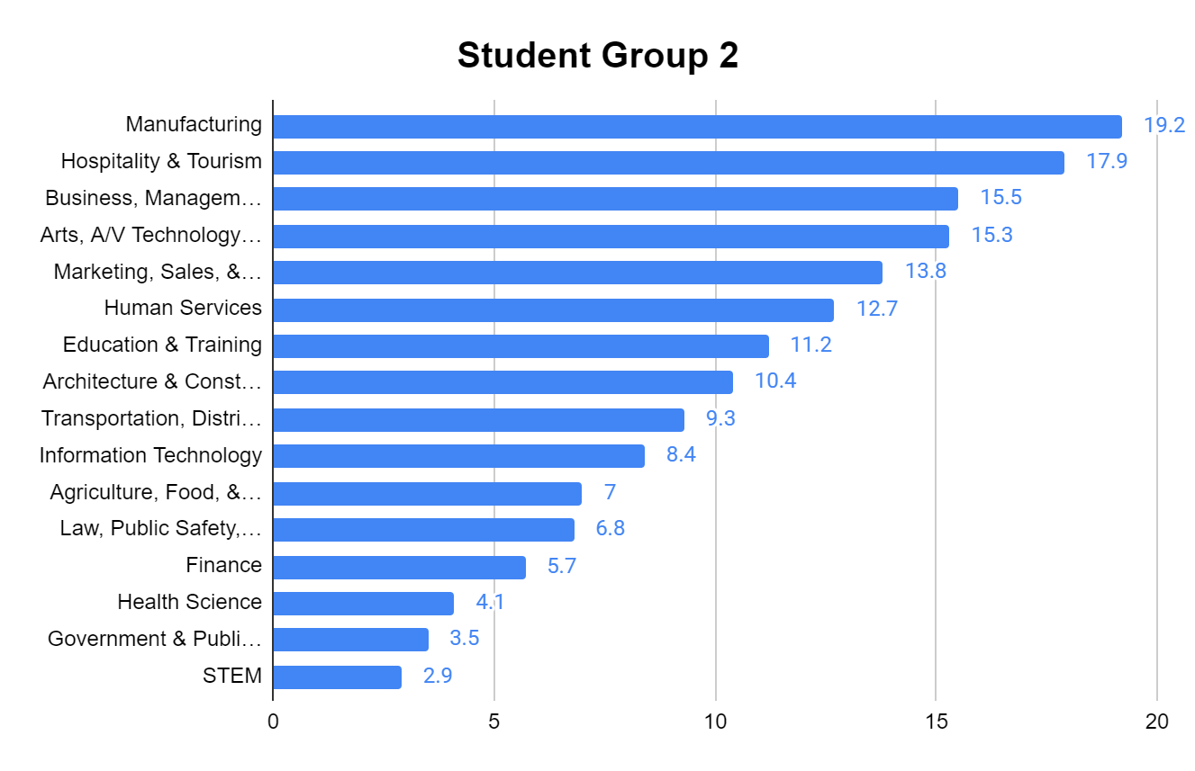

STUDENT SURVEY DATA

View sample Career Cluster survey data and collaborate with your group to find three (3) career speakers that match the needs and interests.

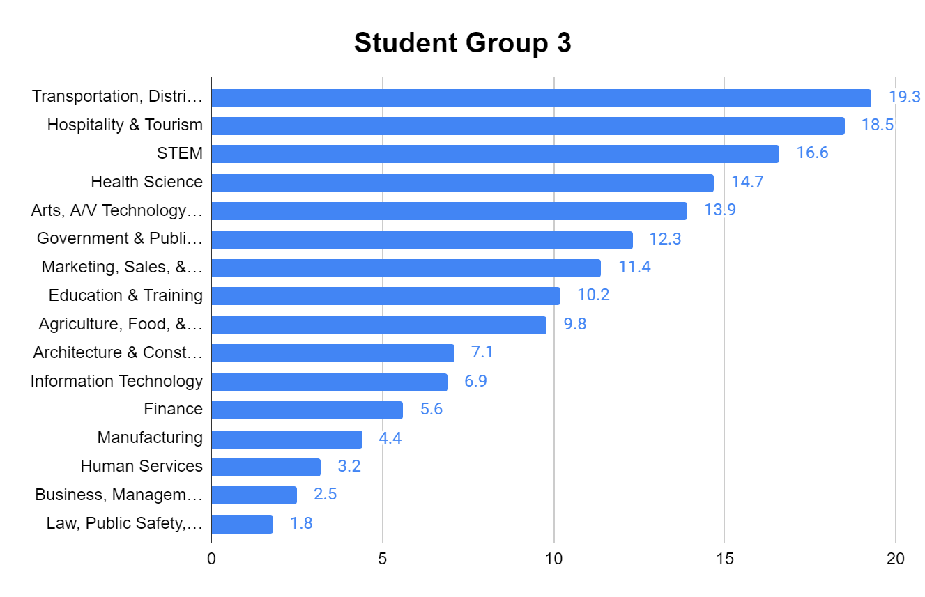

STUDENT SURVEY DATA

View sample Career Cluster survey data and collaborate with your group to find three (3) career speakers that match the needs and interests.

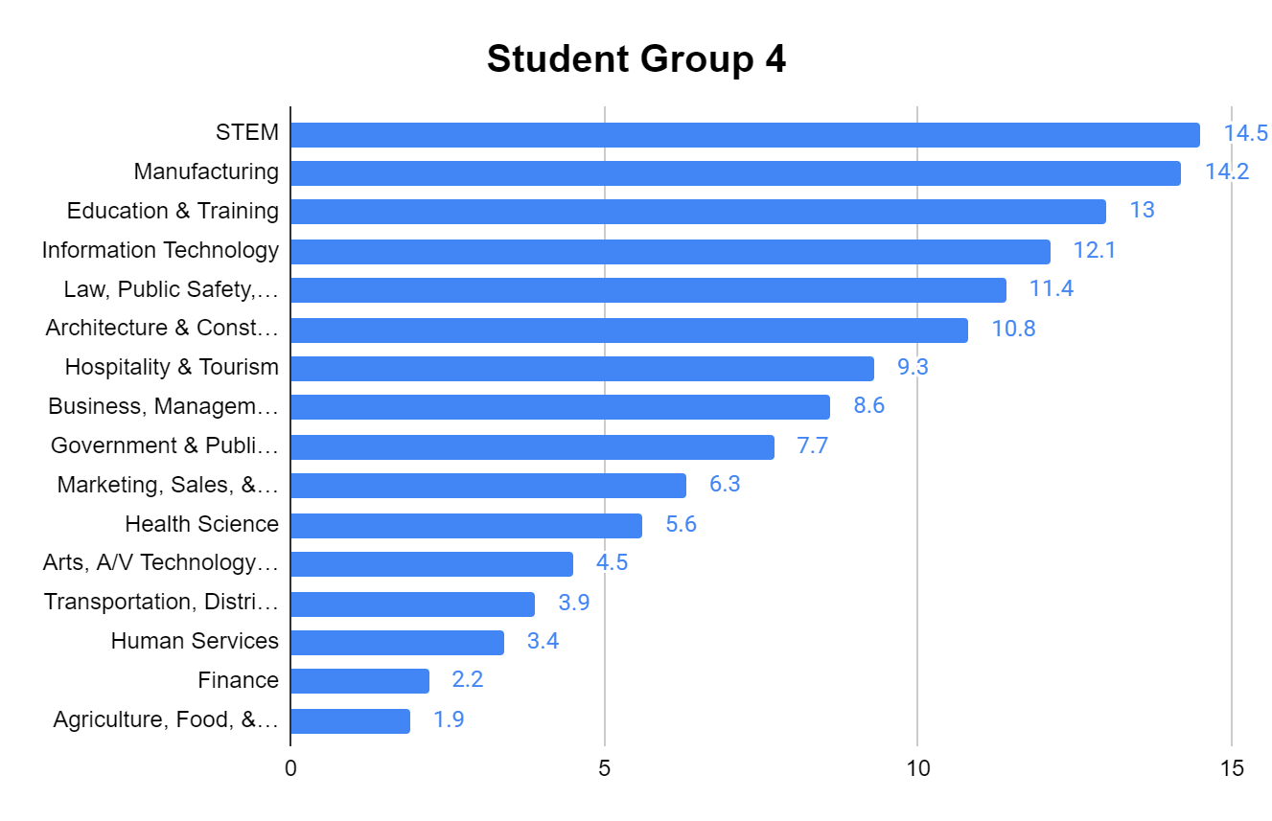

STUDENT SURVEY DATA

View sample Career Cluster survey data and collaborate with your group to find three (3) career speakers that match the needs and interests.

