
Find all of your school supplies
and gear here!
Choose the best option for your
budget and needs. Buy new,
used, or rent your books.
SUPPLIES AND
MORE
BEST VALUE
BUY
YOUR
BOOKS
HERE!


BOOKSTORE & LIBRARY
Email us your
schedule and we
will have your books
ready for pickup!
PRE ORDER

COURSE | NEW | USED | RENT
Comp 1010 | $60 | $30 | $15
Comp 1210 | $70 | $35 | $17
Chem 1010 | $333 | $97 | $44
Psych 1100 | $219 | $45 | $50
Gov 1100 | $289 | $141 | $50
Math 1001 | $273 | $77 | $29
Hist 1020 | $231 | $120 | $50
Acct 1010 | $142 | $96 | $51
Phil 1200 | $129 | $97 | $45
Span 0239 | $73 | $56 | $29
Musc 1070 | $125 | $46 | $24
Bio 1010 | $289 | $90 | $50
Bus 1100 | $125 | $80 | $49
PS 1001 | $105 | $69 | $35


HEALTH SERVICES

Providing health care services and wellness programs for currently enrolled students.

Our services include:
- Dental screening
- General Medical Care
- Immunizations
- Laboratory
- Health Education
Patients are responsible for costs associated with medical services, prescriptions, lab work,
immunizations, some procedures and materials for programs.
Student Health Services accepts Student Health Insurance only. The student-focused plan protects students at school, at home and while traveling or studying abroad.

Cost for Student Health Insurance:
$1,200 per semester


LOANS PROGRAM

GEAR UP university provides loans for students who are attending colleges, and career schools. Loans are a type
Program | Program Details | Annual Award  (subject to  change)
Subsidized Stafford Loan | Subsidized Stafford Loans are awarded on the basis of need. The interest that accrues on this loan while a student is in school is subsidized (or paid) by the federal government. Typically, the government will subsidize the interest rate until the loan enters into repayment (to include the grace period of the loan). | Up to  $5,500/  year
Unsubsidized Stafford Loan | Unsubsidized Stafford loans are not awarded on the basis of need. The student is responsible for the interest payments from the time the loan is disbursed until it is paid in full. You have the option to pay the interest as you continue to attend school or let the interest accumulate and be added to the principal of your loan. This  means that interest will “capitalize” and the total amount you repay will be higher than if you paid the interest all along. | Up to  $4,000/  year
Perkins Loan | Perkins loans are made to students through funds administered by the university. These limited funds are given to students with high need on first come, first served basis. The interest rate is fixed for the life of the loan at 5% and begins to accrue after a 9-month grace period. A borrower who has been attending  at least half-time is entitled to an initial grace period of 9 consecutive months after dropping below half-time enrollment. A borrower must repay his or her loan, plus interest, within ten years. The Perkins loan funds are very limited and awarded until funds are exhausted. | Up to  $5,500/  year
College Access Loan | College Access Loans (CAL) are non-need- based state loan programs. Oklahoma‘s CAL is  UCanGo2, an initiative of several state agencies. CAL loans are considered another type of Alternative loan that is intended to supplement traditional financial aid programs. The UCanGo2 office encourages college applicants to consider their options for Federal and State financial aid programs before applying for an alternative loan.

of financial assistance that enable students and parents to borrow money from the federal government, state
government, or private lenders. It is important for students and parents to be well informed
on the terms and conditions of loans prior to borrowing.


Have questions?
Contact or visit the following:
- GEAR UP Coach
- College Counselor
- FAFSA Counselor
Student Federal Aid
- 1-800-4-FED-AID (1-800-
433-3243) toll free
- 1-800-730-8913 (toll-
free TTY for the hearing impaired)

Looking for more sources of free money? Try studentaid.gov for tips on where to look and for a link to a free online scholarship search.



MEAL PLAN OPTIONS
Plan A:
$5,000/year
Any funds not used in semester 1 will roll over to semester 2. Can be used at any on campus dining or grocery option, unlimited availability seven days a week.
Plan B:
$4,200/year
Any funds not used in semester 1 will roll over to semester 2. Can be used at any on campus dining, unlimited availability seven days a week.
Plan C:
$3,600/year
Any funds not used in semester 1 will roll over to semester 2. Can be used at any on campus dining, unlimited availability five days a week (Monday-Friday).
Plan D:
$4,320/year
15 meals/week at campus cafeteria (maximum
$135/week = $2,160 per semester), available seven days a week.
Plan E:
$3,200/year
10 meals/week at campus cafeteria (maximum
$100/week = $1,600 per semester), available five days a week (Monday-Friday).



PARKING PERMIT

Resident Housing Student permit:
$195/year

Commuter student permit:
$350/year

motorcycle student permit:
$90/year

parking FAQs
Why do I have to pay for parking? Transportation services must operate exclusively through student fees. The use of state or tuition
revenue is not an allowable Future U expenditure for parking.

What if I forget to display my permit?
All vehicles are required to display a valid Future U parking permit when parked on university property. Parking citation will be issued to vehicles that do not display a permit.

What if I lose my parking permit?
Lost permits must be reported to the Future U Transportation Department immediately and a new permit may be purchased for $75.

HOUSING & RESIDENTIAL LIFE
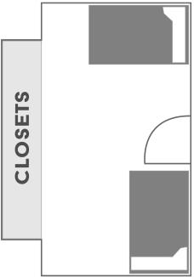
hughes - ray hall
$5,000/YEAR
The traditional style dorms have two students sharing one room and community style bathrooms. Rooms are fully furnished and have various amenities on site
including Waffle Coffeehouse that is open till 2 am. This housing is recommended for freshmen. A meal plan is required.

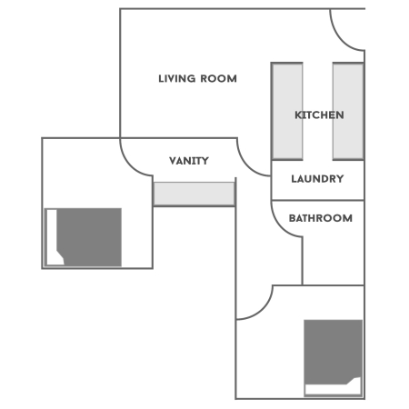
Buxton - Knight commons
$7,200/YEAr
The commons offer private Bedrooms with a shared bathroom. There is a community living room, fully furnished kitchen, laundry room and a study room available on each floor. A meal plan is required.

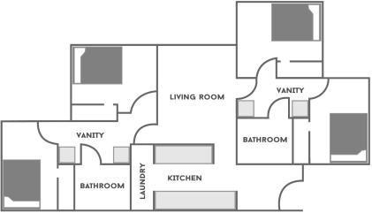
Dozier - rivas suites
$9,200/YEAR
Golden Suites offers apartment-style living on campus, each with four single bedrooms and two bathrooms. It also includes a fully furnished kitchen, living room, and laundry room. Reserved for upperclassmen. Meal plan not required.

Consider living at home to reduce costs. If you choose to live at home, purchase a commuter student pass at the Parking Pass booth.
Fill out the online profile to be matched with a roommate or choose your own!



SPORTS PACKAGES
Package A: $750 all sports pass
- All 7 home football games
- All home men’s basketball games
- Admittance to all men’s and women’s home games/matches for ALL sports

Package B: $550 Football+ pass
- All 7 home football games
- Admittance to all men’s and women’s home games/matches for ALL sports EXCEPT men’s basketball

Package C: $400 BASKETBALL+ pass
- All home men’s basketball games
- Admittance to all men’s and women’s home games/matches for ALL sports EXCEPT football
- Student eligibility will be verified by a swipe of the Student’s ID Card at the Athletic facility where the event is being held.
- Withdrawn students will no longer be eligible once withdrawn for the term.
- Excludes Playoff or Championship games.
- All charges will be billed to student Bursar account.

TECHNOLOGY



Our fully networked campus is also wireless. Students can access the internet
anytime anywhere on campus (libraries, computer labs, lounge and study areas).
Purchasing laptops through the university is OPTIONAL.

Advantages to purchasing the laptop through the University:
- We use the latest technology—our machines incorporate high speed processing and high capacity data storage in a portable unit to meet your needs.
- We load the computer with software that will support your studies.
- Purchases will post to student Bursar account— financial aid can be applied for payment.

GEAR UP University Laptop Program
13” Dell XPS 13
$1,400
  - 13.4-inch Infinity display (non-touch)

  - 14th Generation Intel Core i5 5200U Processor
  - 8GB Random Access Memory (RAM)
  - 128GB Solid State Drive
  - Internal US/English Backlit Keyboard
  - 3 Year Parts and Labor Warranty
  - Battery 1 year Warranty
  - 3 Year Accidental Damage Protection
  - MS Windows 11


14” MacBook Pro with Retina
$1,600
  - 14-inch display
  - Intel Dual Core i5 2.4GHz
  - 8GB Random Access Memory (RAM)
  - 256GB Solid State Drive
  - 3 Year Apple Care Protection Plan
  - No Accidental Damage Protection

11” MacBook air
$1,100

    - 11.6-inch (diagonal) LED-backlit glossy widescreen display
    - 4GB Random Access Memory(RAM)
    - 128GB PC-based flash storage
    - 1.4GHz dual-core Intel Core i5 (Turbo Boost up to 2.7GHz) with 3MB shared L3 cache
    - 3 Year Apple Care Protection Plan
    - No Accidental Damage Protection


12” Samsung Chromebook Pro
$329
- 12.3-inch QHD display
- 3:2 format enhanced for web
- Up to 9 hours of battery life



FINANCIAL AID AND BURSAR’S OFFICE

UNDERGRADUATE STUDENTS
Tuition and Fees
(Based on 15 credit hours/semester)
$9,000/semester
$18,000/year

PERSONAL/MISCELLANEOUS EXPENSES
$1,500/semester
$3,000/year

REMINDER:
Eligibility for financial aid requires minimum enrollment or 12 credit hours per semester (full time), and maintenance of satisfactory academic progress.



CAREER TECH:

MEALS

Groceries
 | MONTHLY COST | YEARLY COST
Thrifty | $350 | $4,200
Low Cost | $500 | $6,000
Moderate | $650 | $7,800
Gourmet | $750 | $9,000

FAST FOOD
Optional (Examples: Starbucks, McDonalds, Braum’s, Taco Bell)
MONTHLY COST | YEARLY COST
$350 | $4,200

CAREER TECH:

APARTMENT COSTS
All bills paid

*These prices reflect the cost per bedroom for this apartment. If you choose to live here, you will be living with roommates. If your roommates move out, you will become responsible for paying the total rent cost unless someone else rents the room(s).
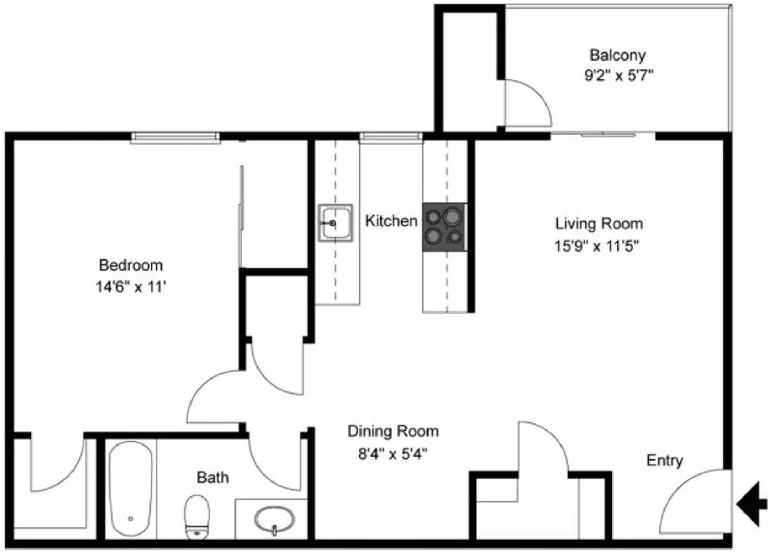
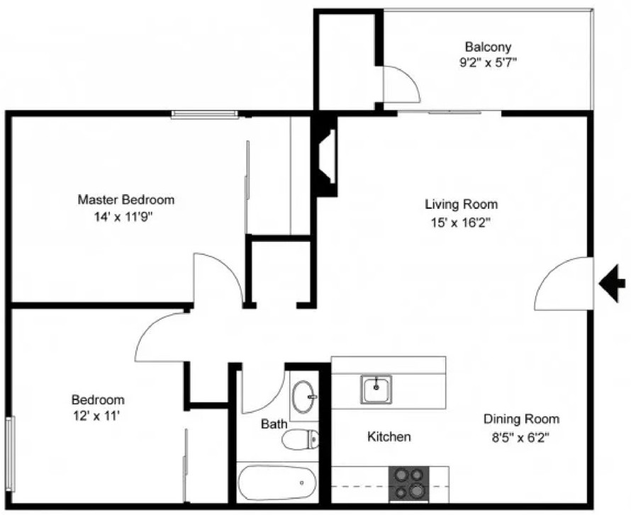

- bed, 1 bath
$8,520/year

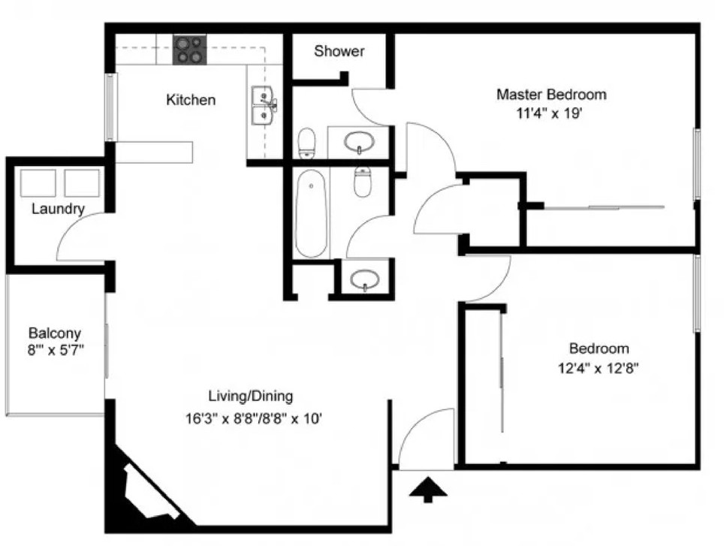
- bed, 2 bath
$5,550/YEAR
  - bed, 1 bath
$4,920/YEAR
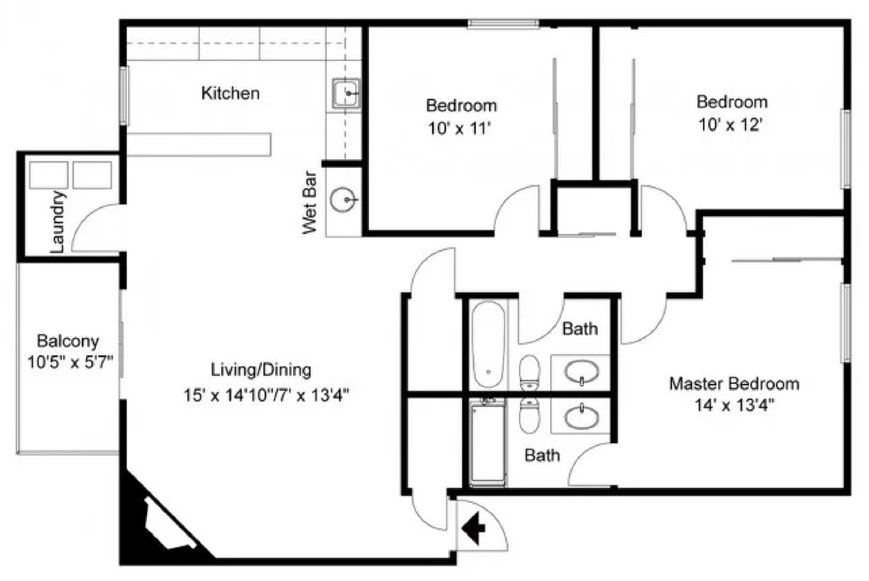
  - bed, 2 bath
$4,400/YEAR

Consider living at home to reduce costs. If you choose to live at home, purchase a commuter student pass at the Parking Pass booth.



STUDENT SERVICES

Providing support services for currently enrolled students.
Our services include:
    - Advising
    - Writing Center
    - Tutoring
    - Disability Services
    - Multicultural Office
    - Clubs
    - Greek Organizations
    - TRIO



CAREER TECH:

FINANCIAL AID AND BURSAR’S OFFICE

Nurse’s aid
ONE YEAR PROGRAM
Tuition | $1,706.25
Books | $148.00
Supplies | $152.00
Exams & Fees | $96.00
TOTAL (per year) | $2,102.25

Machinist
TWO YEAR PROGRAM
Tuition | $1,600.00
Required Tools | $20.00
TOTAL (per year) | $1,800.00


PART TIME WORK

ON CAMPUS JOBS
Job | Hourly Wage* | Weekly Earnings**
Federal Work Study Student | $10.00/hr | $100.00
Campus Coffee Shop Barista | $7.25/hr | $72.50
Writing Tutor | $13.00/hr | $130.00
Campus Custodian | $9.00/hr | $90.00
Campus Bookstore Clerk | $8.00/hr | $80.00

OFF-CAMPUS JOBS
Job | Hourly Wage* | Weekly Earnings**
Restaurant Hostess | $13.00/hr | $130.00
Barista | $14.50/hr | $145.00
Store Clerk | $12.50/hr | $125.00
Car Wash Attendant | $18.00/hr | $180.00
Library Aide | $17.00/hr | $170.00

*Wages are based on Oklahoma wages, 2023-2024.
**Weekly earnings are based on employment for 10 hours a week.

CAREER TECH ORGANIZATIONS

Nurse Aide Organization | Cost per year
NSNA (National Student Nurses’ Association) | $42.00
HOSA-Future Health Professionals | $17.00

Machinist Organization | Cost per year
National Tooling and Machining Association | $300.00
SkillsUSA | $30.00

Joining an organization is a great way to expand your horizons, make friends, network, and enhance your resume. Write the name of your organization on the “I Joined” sign and snap a picture!


FUTURE U: THE ENROLLMENT ADVENTURE

CAREER TECH: HEALTH CAREERS CERTIFICATION (NURSE AIDE)

Pre-Requisites
CPR
H.S. Biology
Courses | Hours
Career Exploration | 60
Health Careers Core I | 120
Health Careers Core II | 120
Anatomy & Physiology | 120
Medical Terminology | 60
Long Term Care Nurse Aide I | 60
Long Term Care Nurse Aide II | 60
Total | 600

Note: Your book fees are included in the tuition costs. You do not need to purchase books from the bookstore.

CAREER TECH: CONSTRUCTION AND MANUFACTURING CERTIFICATION (MACHINIST)

Pre-Requisites
Courses | Hours
Job Planning, Benchwork, and Layout I | 40
Measurements, Materials, & Safety | 60
Manual Lathe & Grinders | 80
Manual Mill & Drill Press | 80
Industrial Print Reading 1 | 80
Basic CNC* Lathe Operator | 80
Basic CNC Mill Operator | 80
Job Planning Benchwork & Layout II | 80
Industrial Print Reading II | 80
Basic CNC Lathe Operator II | 80
Basic CNC Mill Operator II | 80
CNC Milling Programming Setup & Operations | 120
CNC Lathe Programming, Setup & Operations | 120
Total | 1050

Note: Your book fees are included in the tuition costs. You do not need to purchase books from the bookstore.

CREATE YOUR CLASS SCHEDULE
Scan the QR code and create your Career Tech class schedule for the semester.


Career Tech

k20.ou.edu/career

*Choose a half day or full day schedule. Your choice will determine how long your program takes to complete:
- 1 Year Program:
  - Full day finishes in one year
  - Half day finished in two years

CREATE YOUR CLASS SCHEDULE
Scan the QR code for your degree and create your class schedule for the semester.

Accounting    k20.ou.edu/acc | Biology    k20.ou.edu/bio
History    k20.ou.edu/history | Math    k20.ou.edu/mat

COLLEGE CLUBS AND ORGANIZATIONS
Costs

Campus Club | $10.00
Greek Organization (Fraternity or Sorority) | $500.00

Campus Clubs
African Student Association
American Sign Language Club
Cooking Club
German Club
Glee Club
Golf Club
Hispanic American Student Association
Math Club
Running Club
Theatre Club

Greek Organizations
Alpha Chi Omega (Sorority)
Alpha Gamma Delta (Sorority)
Delta Delta Delta (Sorority)
Delta Gamma (Sorority)
Kappa Alpha Psi (Fraternity)
Kappa Alpha Theta (Sorority)
Kappa Sigma (Fraternity)
Lambda Chi Alpha (Fraternity)
Omega Delta Phi (Fraternity)
Pi Kappa Alpha (Fraternity)

Joining a club or organization is a great way to expand your horizons, make friends, and enhance your resume. Choose a campus club or Greek organization to join. Write the name or your club or organization on the “I Joined” sign and snap a picture!

COLLEGE CLASS SCHEDULES AND BOOK LIST

Freshman—Fall
Accounting | Class Days |  |  |  | Class Times
Comp 1010: Composition 1 | M |  | W | F | 9:00 - | 9:50
Math 1001: Business Math |  | T | TH |  | 9:25 - 10:40
Gov 1100: American Fed. Govt. | M |  | W | F | 10:00 - 11:50
Hist 1020: U.S. History to 1865 |  | T | TH |  | 1:00 - | 2:15
Bus 1100: Intro to Business Ethics | M |  | W | F | 12:00 - 12:50

Freshman—Fall
Math | Class Days |  |  |  | Class Times
Comp 1010: Composition 1 |  | T |  | TH | 9:25 - 10:40
SpC 1101: Speech Communication | M |  | W | F | 9:00 - | 9:50
Gov 1100: American Fed. Govt. |  | T |  | TH | 12:00 - | 1:15
Hist 1020: U.S. History to 1865 | M |  | W | F | 11:00 - 11:50
PS 1001: Healthy Life Skills | T |  |  |  | 1:30 - 4:30

Freshman—Fall
Biology | Class Days |  |  |  |  | Class Times
Comp 1010: Composition 1 | M |  | W |  | F | 10:00 -10:50
Bio 1010: General Biology |  | T |  | TH |  | 10:00 -11:15
Bio 1000: General Biology Lab | W |  |  |  |  | 1:00 - 4:00
PS 1001: Healthy Life Skills |  | T |  | TH |  | 12:00 - 1:15
PS 1000: Sport/Activity (Choice) | TH |  |  |  |  | 1:30 - 3:30

Freshman—Fall
History | Class Days |  |  | Class Times
Comp 1010: Composition 1 | M |  | W F | 9:00 - 9:50
SpC 1101: Speech Communication |  | T | TH | 10:00 -11:15
Gov 1100: American Fed. Govt. | M |  | W F | 11:00 - 11:50
PS 1001: Healthy Life Skills |  | T | TH | 12:00 - 1:15
PS 1000: Sports/Activity (Choice) | TH |  |  | 1:30 - 3:30

FUTURE U: THE ENROLLMENT ADVENTURE

FUTURE U: ACCOUNTING MAJOR DEGREE SHEET

Freshman—Fall |  | Freshman—Spring
Courses | Credit Hours | Courses | Credit Hours
Composition 1 | 3 | Composition 2 | 3
Business Math | 3 | Western Culture | 3
American Fed. Govt. | 3 | Personal Computing | 3
U.S. History to 1865 | 3 | Speech Communication | 3
Inro to Business Ethics | 3 | Financial Accounting | 3
Total Credit Hours | 15 | Total Credit Hours | 15

Sophomore—Fall |  | Sophomore—Spring
Courses | Credit Hours | Courses | Credit Hours
Biology | 3 | Earth Science | 3
Business Communication | 3 | Humanities Ancient to Med. | 3
Spanish I | 3 | Spanish II | 3
Managerial Accounting | 3 | Logic & Critical Thinking | 3
Healthy Life Skills | 3 | General Psychology | 3
Credit Hours | 15 | Credit Hours | 15

Junior—Fall |  | Junior—Spring
Courses | Credit Hours | Courses | Credit Hours
Macro Economics | 3 | Micro Economics | 3
Principles of Management | 3 | Principles of Marketing | 3
Intermediate Accounting | 3 | Cost Analysis | 3
Elements of Statistics | 3 | Computer Information | 3
Advanced Accounting | 3 | Business Finance | 3
Credit Hours | 15 | Credit Hours | 15

Senior—Fall |  | Senior—Spring
Courses | Credit Hours | Courses | Credit Hours
Business Analytics | 3 | Income Tax for Individuals | 3
Business Legal Environment | 3 | Business Policy | 3
Auditing | 3 | Accounting Internship | 9
International Business | 3
Consolidated Statements | 3
Credit Hours | 15 | Credit Hours | 15
 |  | Total Credit Hours | 120

FUTURE U: MATH MAJOR DEGREE SHEET

Freshman—Fall |  | Freshman—Spring
Courses | Credit Hours | Courses | Credit Hours
Composition 1 | 3 | Composition 2 | 3
Speech Communication | 3 | Western Culture | 3
American Fed. Govt. | 3 | Personal Computing | 3
U.S. History to 1865 | 3 | Logic & Critical Thinking | 3
Healthy Life Skills | 3 | College Algebra | 3
Total Credit Hours | 15 | Total Credit Hours | 15

Sophomore—Fall |  | Sophomore—Spring
Courses | Credit Hours | Courses | Credit Hours
Biology | 3 | Earth Science | 3
General Psychology | 3 | Art Appreciation | 3
Linear Algebra | 3 | Jazz History | 3
Analytic Geometry 1 | 3 | Analytic Geometry 2 | 3
Physical Mathematics 1 | 3 | Physical Mathematics 2 | 3
Credit Hours | 15 | Credit Hours | 15

Junior—Fall |  | Junior—Spring
Courses | Credit Hours | Courses | Credit Hours
Calculus 1 | 3 | Calculus 2 | 3
Differential Equations 1 | 3 | Differential Equations 2 | 3
Probability & Statistics 1 | 3 | Probability & Statistics 2 | 3
Complex Variables | 3 | Junior Seminar in Math | 6
Intro to Modern Algebra | 3
Credit Hours | 15 | Credit Hours | 15

Senior—Fall |  | Senior—Spring
Courses | Credit Hours | Courses | Credit Hours
Calculus 3 | 3 | Senior Seminar in Math | 3
Discrete Math Structures | 3 | Introduction to Analysis | 3
Senior Seminar in Math | 3 | Math Theory | 3
Senior Research Project | 6 | Math Internship | 6
Credit Hours | 15 | Credit Hours | 15
 |  | Total Credit Hours | 120

FUTURE U: BIOLOGY MAJOR DEGREE SHEET

Freshman—Fall |  | Freshman—Spring
Courses | Credit Hours | Courses | Credit Hours
Composition 1 | 3 | Composition 2 | 3
General Biology | 3 | U.S. History to 1865 | 3
General Biology Lab | 3 | Western Culture | 3
Healthy Life Skills | 3 | Speech Communication | 3
Sport/Activity (Choice) | 2 | American Fed. Govt. | 3
Total Credit Hours | 14 | Total Credit Hours | 15

Sophomore—Fall |  | Sophomore—Spring
Courses | Credit Hours | Courses | Credit Hours
General Psychology | 3 | Earth Science | 3
Personal Computing | 3 | Personal Finance | 3
Art Appreciation | 3 | Logic & Critical Thinking | 3
Video Game Music History | 3 | College Algebra | 3
Humanities: Ancient-Medieval | 3 | Foundation Science & Tech | 3
Credit Hours | 15 | Credit Hours | 15

Junior—Fall |  | Junior—Spring
Courses | Credit Hours | Courses | Credit Hours
General Chemistry 1 | 3 | General Chemistry 2 | 3
Organismal Biology | 3 | Cells and Systems | 3
Bio Calculus | 3 | Life Systems | 3
Biology Elective | 3 | Intro to Biological Research | 3
Junior Biology Seminar | 3 | Junior Research Project | 3
Total Credit Hours | 15 | Total Credit Hours | 15

Senior—Fall |  | Senior—Spring
Courses | Credit Hours | Courses | Credit Hours
Ecology | 3 | Biology in the Field | 3
Genetics | 3 | Biology Elective | 3
Microbiology | 3 | Senior Research Project | 6
Senior Biology Seminar | 6 | Senior Research Presentation | 4
Credit Hours | 15 | Credit Hours | 16
 |  | Total Credit Hours | 120

FUTURE U: HISTORY MAJOR DEGREE SHEET

Freshman—Fall |  | Freshman—Spring
Courses | Credit Hours | Courses | Credit Hours
Composition 1 | 3 | Composition 2 | 3
Speech Communication | 3 | Western Culture | 3
American Fed. Govt. | 3 | Personal Computing | 3
Healthy Life Skills | 3 | U.S. History to 1865 | 3
Sport/Activity (Choice) | 2 | Language 1 (Choice) | 3
Total Credit Hours | 14 | Total Credit Hours | 15

Sophomore—Fall |  | Sophomore—Spring
Courses | Credit Hours | Courses | Credit Hours
Biology | 3 | Earth Science | 3
General Psychology | 3 | College Algebra | 3
Art Appreciation | 3 | Contemporary Moral Problems | 3
U.S. History 1865 - Present | 3 | Historical Methods | 3
Language 2 (Choice) | 3 | World Regional Geography | 3
Credit Hours | 15 | Credit Hours | 15

Junior—Fall |  | Junior—Spring
Courses | Credit Hours | Courses | Credit Hours
Historical Research | 3 | Native American History | 3
Early Civilizations - 1350 | 3 | Modern Europe | 3
History Elective | 3 | History Elective | 3
European History - 1812 | 3 | Modern Europe | 3
Junior Research Project | 3 | Junior Seminar | 3
Total Credit Hours | 15 | Total Credit Hours | 15

Senior—Fall |  | Senior—Spring
Courses | Credit Hours | Courses | Credit Hours
World History 1 | 3 | World History 2 | 3
Regional History Studies | 3 | Oklahoma History | 3
Human Geography | 3 | War and Society | 3
Senior Thesis Project | 6 | Field Studies in History | 3
 |  | Senior Seminar | 4
Credit Hours | 15 | Credit Hours | 16
 |  | Total Credit Hours | 120

DISABILITY SERVICES: HIGH SCHOOL VS COLLEGE

High School | College
Laws Regarding Rights for Students with Disabilities
I.D.E.A. (Individuals with Disabilities Education Act) | A.D.A.A.A. (Americans with Disabilities Act of 1990)
Section 504, Rehabilitation Act of 1973 | Section 504, Rehabilitation Act of 1973
I.D.E.A. is about SUCCESS | A.D.A.A.A. is about ACCESS
Documentation for Services
The school, along with the student’s family, develops an Individualized Education Plan (IEP) and/or a 504 Plan. | It is your responsibility to request accommodations and provide evidence through supporting documentation such as a Disability Accommodation Letter.
The school is required to provide an evaluation at no cost to the student. | You bear the expense of the evaluation.
Advocacy (Self and Parental)
A student is identified by the school and support is provided both from the school and parents. | You are expected to self-identify and provide the necessary documentation for services.
The responsibility for arranging accommodations belongs to the school. | The responsibility for arranging accommodations can belong primarily to you, depending on the policies set forth at your school.
School staff will approach students if they believe they need further assistance. | Self-advocacy is important. You are expected to contact your professors if you feel you need further assistance.
Parents have access to student records and act as the student’s legal guardian to advocate for the student. | Parents do not have access to your records. You are considered your own legal guardian and advocate for yourself.

High School | College
Study Accommodations and Responsibilities
Study support and tutoring can be a service provided through an IEP or 504 plan. | Some colleges provide tutoring and study support through their disability services.  Others require you to seek out these resources in the same manner that all students on campus do. Check with your school’s disability services office to see what they provide.
Schedules and assignments may be structured by teachers based on the student’s IEP or 504 Plan. | You will manage your schedule and assignments on your own.
School counselors and teachers help all students plan their class schedule to meet graduation requirements. | All students have a staff advisor assigned to them who will help plan class schedules and check that you are meeting the requirements for graduation based on your chosen major.
Instruction
Teachers are required to provide modifications and accommodations listed in the IEP. | Professors are not required to modify their curriculum, but many will provide extra support if they are aware of your needs.
Reading and writing requirements are often short and re-taught as needed. | Reading and writing assignments are substantial and require more time to complete.
Teachers often remind students of incomplete assignments and due dates as well as provide information on missed work when a student is absent. | You are expected to speak up if you need information on missed assignments. This information can often be found in the course syllabus and missed notes can be gathered from classmates.
IEP and 504 Plan requirements may include modifications or accommodations for testing. | Depending on the policies set by your school, testing accommodations and modifications may or may not be available. Discuss this with your school’s disability services office early so you are prepared.

WRITING CENTER HELP SESSION SIGN-UP

First and Last Name | Date | Time
 | Monday | 4:00-4:30
 | Monday | 4:30-5:00
 | Monday | 5:00-5:30
 | Monday | 5:30-6:00
 | Tuesday | 4:00-4:30
 | Tuesday | 4:30-5:00
 | Tuesday* | 5:00-5:30
 | Tuesday* | 5:30-6:00
 | Wednesday | 4:00-4:30
 | Wednesday | 4:30-5:00
 | Wednesday | 5:00-5:30
 | Wednesday | 5:30-6:00
 | Thursday | 4:00-4:30
 | Thursday | 4:30-5:00
 | Thursday* | 5:00-5:30
 | Thursday* | 5:30-6:00
 | Friday | 4:00-4:30
 | Friday | 4:30-5:00
 | Friday | 5:00-5:30
 | Friday | 5:30-6:00
* Math tutors will be available as well.

FUTURE U: THE ENROLLMENT ADVENTURE








DIVERSITY
EVENTS

Multicultural Night
Student Services invites all cultures to showcase their culture on Sept. 15th

Karaoke Night w/ISA
India Student Association holds weekly karaoke night every Thursday at the Union.

Day of the Dead Street Festival
Hosted by the Hispanic Student Association Nov. 2nd
Black Royalty Pageant
Annual scholarship pageant hosted by the Black Student Association Feb 5th
April - Native American Powwow
The Native American Club holds their annual powwow on Apr. 16. All welcome!

ALL ARE WELCOME!
For more information come by the Multicultural Office located in Student Services.

STUDENT HOUSING
SCAN THE QR CODE BELOW

HTTPS://TINYURL.COM/4DJZZZFD


PARKING TICKET COSTS
Number of Offenses
First Ticket Second Ticket Third Ticket Fourth Ticket Fifth Ticket
Cost

$25.00

$50.00

$75.00

$100.00

$125.00


PROGRAM

AVAILABLE SHCOLARSHIPS:
Car Fund Scholarship Pell Grant
Study Abroad Scholarship Tribal Scholarship
TRIO Scholarship Veteran Scholarship

APPLY HERE


https://tinyurl.com/mrx3529b
here St., Any City





APPLY TO:  +123-456-7890
FUTURE U
SCHOLARSHIP
123 Anyw








BACK TO SCHOOL

Tutoring, Counseling, Mentoring, Financial Guidance, and other Supports
Come See Us
FutureUTRIO.com




Discover the path to success
Upcoming Events




Career Day at the Aquarium
Job Skills Workshop
Freshman Advising

Join us for fun at the Aquarium and learn about all the
awesome jobs in the marine biology field on Sat., Oct. 23. Sign up soon.
Need help with your resume? Want to practice for your
interview? Come to the Job Skills

Workshop on Wed.,
Nov 5th.
Available!


www.FutureUTRIP.com/events
All freshmen TRIO
students are required to attend the TRIO
Advising during the week of Sept. 9-13
from 1pm-4pm.
Choose your day and come by.





I joined

