RESEARCH & ONE-PAGER INSTRUCTIONS
RESEARCH: From the list below, select two Ivy League schools you’d like to learn more about. Then, use the QR code or web address link to go directly to the school’s website.
Once you have selected the college/university, you will use the Research Notes Organizer to guide your research. Your research will be turned into a visual One-Pager. Use the information directly from the college/university website.
ONE-PAGER INSTRUCTIONS & REQUIREMENTS: Once you have completed your research and recorded data on the Research Notes Organizer, you will create a visual representation for ONE of the schools you researched. It must include the following:
- Name of your school
- The essence of the school: Keep the school's name, colors, mascot, and culture in mind and represent that on your poster.
- The essence of the location: Where is the school located? What represents that area?
- Visually strong and appealing images: Print, draw, or use digital images on your one-pager. Include a border around the page that includes something related to the school.
- Mixture of words: Respond in a shortened format; that is, key phrases, words that stand out, or short sentences.
- Formatting & grammar: Make sure the one-pager is easy to read, and the information is clearly listed. Double-check for spelling, grammar, and typographical errors.
Ivy League Schools
  brown.edu |   columbia.edu |   cornell.edu |   dartmouth.edu
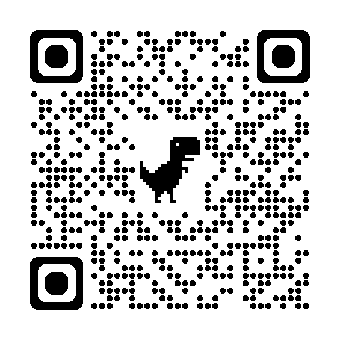  harvard.edu |   princeton.edu |   upenn.edu |   yale.edu
Ivy Plus Schools
  duke.edu |   mit.edu |   stanford.edu |   caltech.edu

