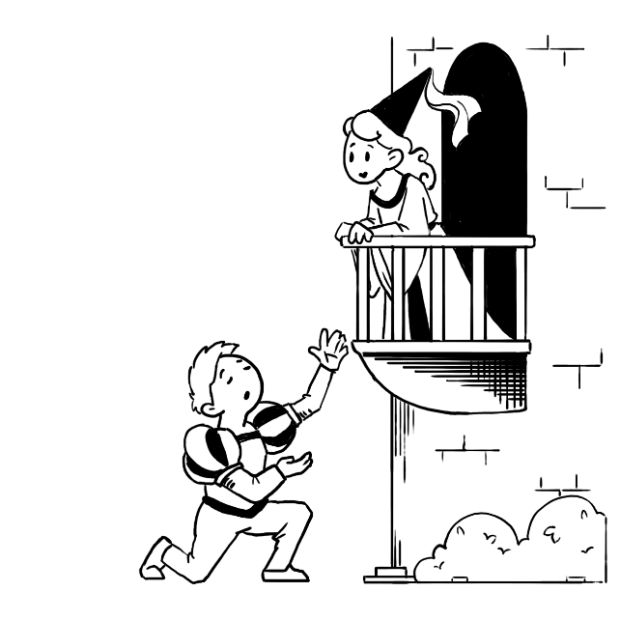  You've always liked theater. When you got to college, you tried out for the university production of Romeo and Juliet, and you got the part! At the first meeting of the cast and crew, the director tells everyone that rehearsal practices will be on Tuesday and Thursday afternoons from 12:00 to 2:00 p.m. | 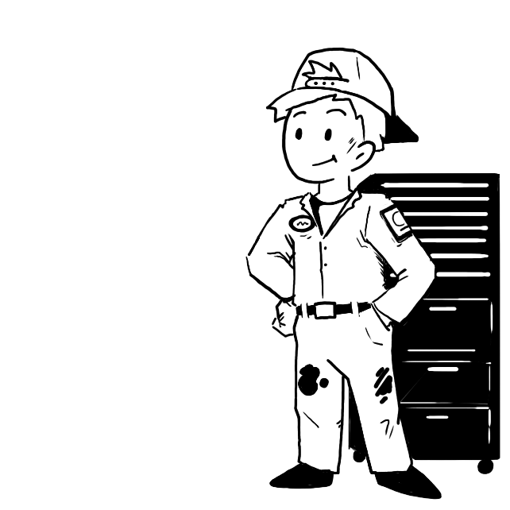  You just got trained for a job at an auto parts store. Your hours vary from week to week, and you are excited about how the job relates to your future career. After enrolling in the local Technology Center, you get the course schedule and discover that all required courses are only offered in the morning sessions.
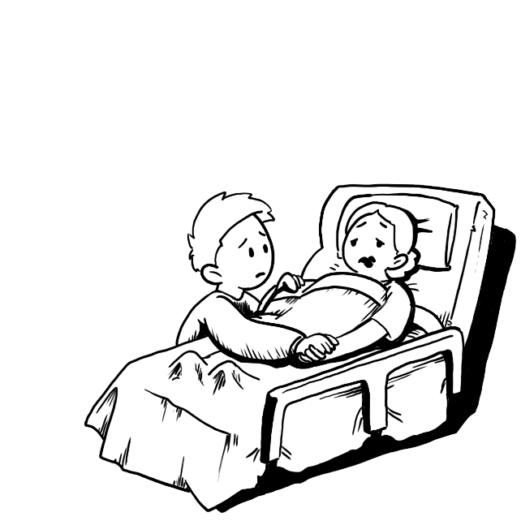  Your mom has recently been diagnosed with a critical illness. You are very close to your mom and are a secondary caregiver for her. Your mom insists that you go to college, so you’ve enrolled, attended freshman orientation, and started to work on a schedule of classes for the fall semester. You will live on campus but will need to be home every weekend. |   You have decided to major in music. You have made up a schedule for classes like Composition, Math, and Biology. Those courses keep you in class Monday, Wednesday, and Friday at 8:00 a.m., 10:00 a.m., and 12:00 p.m. When you talk with your music major advisor, you discover that every Friday at noon, you have required freshman choir practice at noon.

  You received a partial athletic scholarship to the college of your choice and are excited! When you arrive at training camp, you discover that practices & training run from 1:00 - 5:00 p.m. Monday-Friday and you are expected to be finished with all your classes by noon. You have to take a lab for your Biology class on Wednesdays at 1:30 p.m. It requires weekend group work. You will be traveling, practicing, or playing on Fridays and Saturdays and reviewing film on Sundays. |   You commute 45 minutes each way to campus and share a car with a sibling who needs it after 3:00 p.m. You need to avoid late afternoon classes to ensure you can leave campus by 3:00 p.m. Two of your required courses are only available at 1:00 p.m. and 3:30 p.m.
  You have a part-time job at a coffee shop, working 20 hours per week, with shifts primarily in the evenings and weekends. Your manager prefers that you work at least four days a week. You need to take an introductory accounting course this semester, but it’s only offered at 8:00 a.m.. |   You live at home and are responsible for taking care of your younger sibling after school from 3:00 p.m. to 6:00 p.m. on weekdays. You have a scholarship that requires maintaining a 3.0 GPA. You discover that your afternoon classes at the Technology Center end at 3:00 p.m. and you live 30 minutes from home.

