Lab Equipment
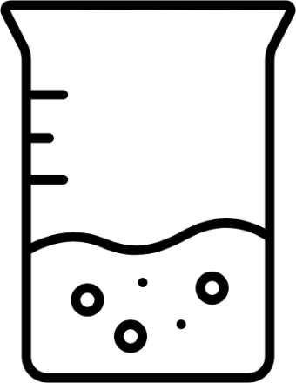 | 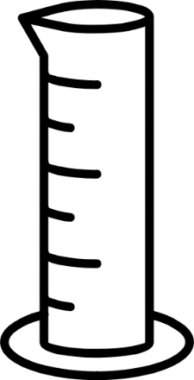
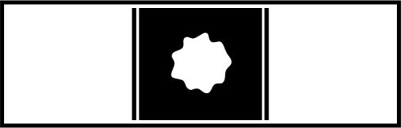 | 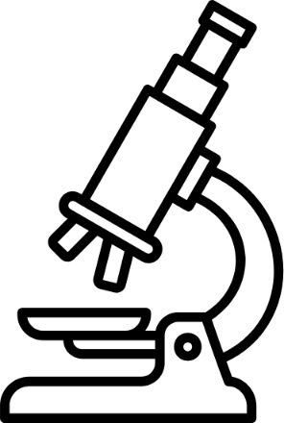
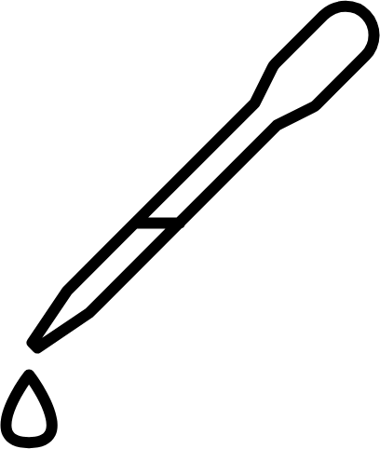 | 

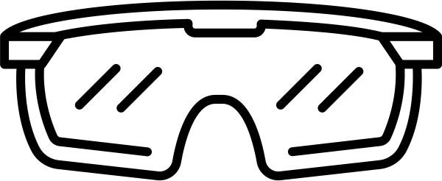 | 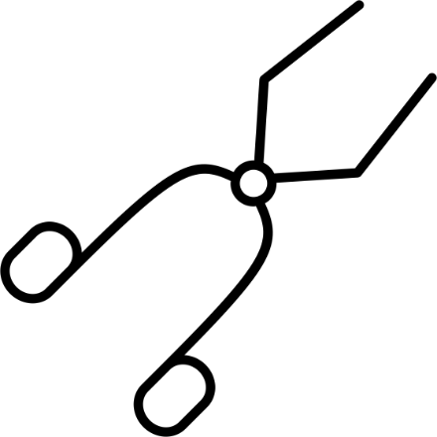
Beaker | Graduated  Cylinder
Glass  Slide | Microscope

Pipette | Scale
Safety  Goggles | Tongs
To measure amounts of liquids;  volume read in milliliters (mL) | To dispense liquids  in small amounts

To pick up large items | To hold specimen(s) for microscopic observation
To protect eyes during lab experiments, especially  from chemicals | To measure the mass of solids; mass read in grams (g)
To magnify objects that are too small for the eye to see | To mix chemicals and heating solutions; for covered, long-term storage of chemicals

Sources:
Capaya, J. (2016, June 5). Glass slide with specimen [Illustration]. The Noun Project. https://thenounproject.com/icon/glass-slide-with-specimen-497286/
crf. (2024, May 16). Graduated cylinder [Illustration]. The Noun Project. https://thenounproject.com/icon/graduated-cylinder-6899272/
Mbarki, N. (2019, December 14). Tongs [Illustration]. The Noun Project. https://thenounproject.com/icon/tongs-3360313/
Oktaviana, F. (2023, February 28). Beaker glass [Illustration]. The Noun Project. https://thenounproject.com/icon/beaker-glass-5602435/
Oktaviana, F. (2023, February 28). Laboratory pipette [Illustration]. The Noun Project. https://thenounproject.com/icon/laboratory-pipette-5602457/
Pujiyono, Y. (2024, July 24). Microscope [Illustration]. The Noun Project. https://thenounproject.com/icon/microscope-7106858/
rdesign. (2022, June 25). Safety goggles [Illustration]. The Noun Project. https://thenounproject.com/icon/safety-goggles-4977610/
yenaburger. (2024, September 1). Scale [Illustration]. The Noun Project. https://thenounproject.com/icon/scale-7214378/

