**Admissions**

http://k20.ou.edu/adm

**Bookstore**

http://k20.ou.edu/book

**Bursar**

http://k20.ou.edu/bur

**Financial Aid**

http://k20.ou.edu/fin

**Library**

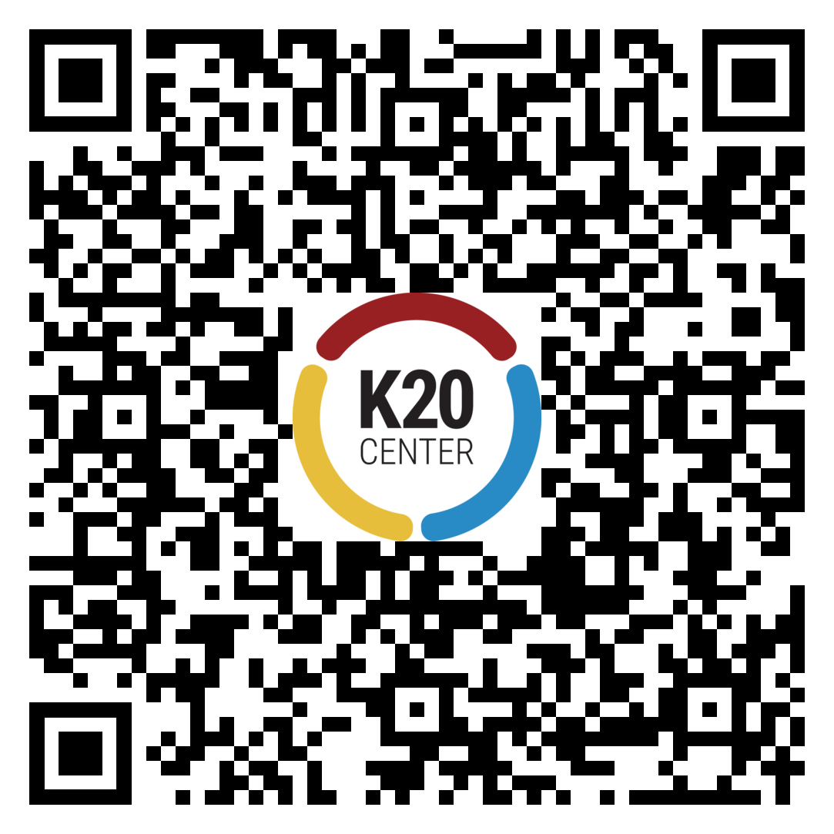

http://k20.ou.edu/lib

**Student Services**

http://k20.ou.edu/stud