Use these tools and your notes from the workshop to help you boost your resume!

Best Practices
Do | Don’t
Use bullet points on your resume.  Give specifics and numbers (even if averages).  Include relevant experience for what you are applying for.  Have one “master” resume with all your information.  Have a place where you can keep notes and information as new things come up (promotion at work, honor roll, etc.).  Use similar wording and verbiage on your resume that appear in the listing and on the website of the job you are applying for.  Use a professional email address. | - Write in paragraphs on your resume.  - Submit a resume that is longer than two pages.  - Use different fonts (bolding is ok, though).  - Use the same resume for everything.  - Include a headshot or photo of yourself.  - Include your address with contact information. Phone number and email work.  - Include high school information (after 5 years).

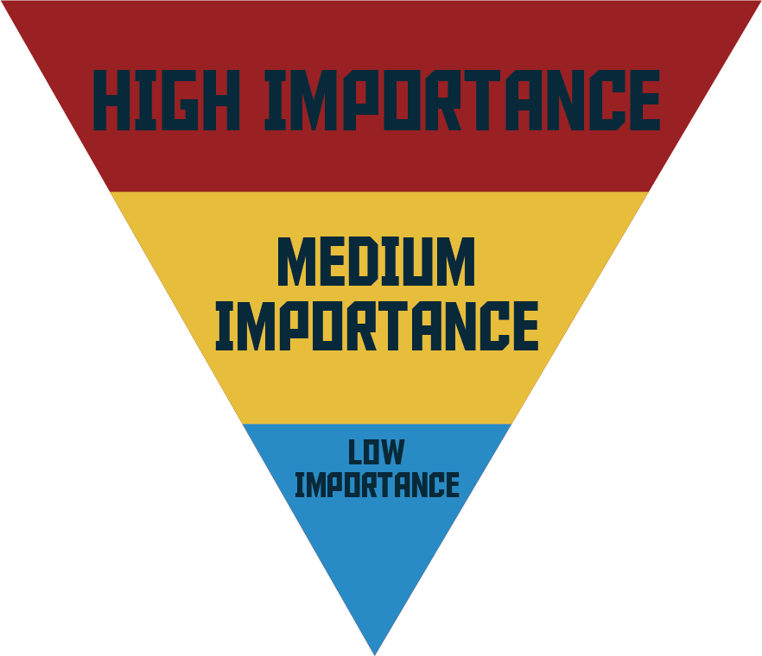
Notes:
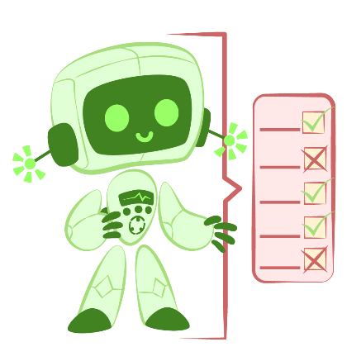
Cheat Sheet – using AI Chatbots as a tool for resume building
Use these AI chatbot prompts to help refine your resume.

Key Skills Analysis | Analyze this job description and tell me the top 5-6 critical skills and competencies the employer is prioritizing. [insert job description]
Keywords | Identify the 10-15 most important keywords from this job description that are likely to be applicant tracking filters or recruiter priorities.
Compatibility Check | Act as an applicant tracking filter. Compare this resume to the job description. Identify missing keywords, key gaps, and alignment strengths. Provide a compatibility score and recommendations for improvement. Here is the resume [insert resume]. Here is the job description [insert job description].
Introduction Statement | As a top resume writer, craft a compelling and succinct summary statement that immediately showcases my unique strengths and values to this employer.
Bullet Refinement | Re-write this bullet point to be more concise, action-oriented, and results-driven. Keep it under two lines.
Alternative Role Fit | Based on my resume, what other roles am I well suited for? Focus on roles where I already meet 70% of the criteria.
Career Transition | I am transitioning from [old role] to [new role]. Identify my strongest transferable skills and rewrite my resume to emphasize them in a way that aligns with industry expectations.

Notes:

