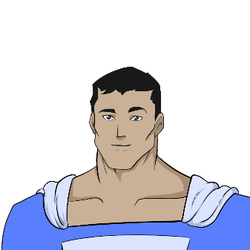
Objective / Purpose: HELP! There is a fire at Vast, the restaurant on the 50th story of the Devon Tower in downtown Oklahoma City! Emergency crews cannot reach the people inside, the elevator isn’t working, and the stairs are blocked by the debris.
Skills
- Ability to ________ helps to reach “new” heights as needed.
- Able to carry up to ______ thousand pounds, using super__________.
- _____________ gives the ability to see through ________and ________ to assess stressful situations accurately.
- Can “commute” long distances ____________, averaging _______ MPH either by _________ or on foot.
Experience
- Recently save ________ people from a fire on the _______ floor of the __________ Tower in downtown _________.

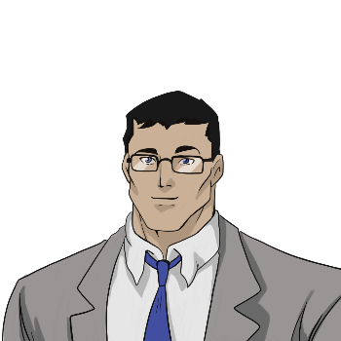
1-555-NOT-SUPER
344 Clinton St., Apt. 3B, Metropolis
@MildManneredClark


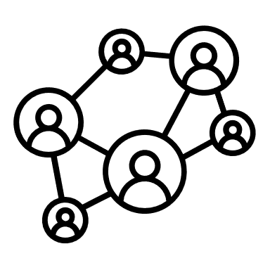
Objective / Purpose: Good news! Super(b)man recently saved 78 people from a fire!
A local journalist, Clark Can, was assigned to cover the story.
(plural noun)
(statistic)
(statistic)
(noun)
(noun)
(proper noun)
(verb-ing)
(adjective)
(adjective)
(adjective)
(adjective)
(verb-ing)
Education
- Attended _____________ University for a _______ degree in ___________, finishing in just _____ years with a _____GPA.
Skills
- ______________ techniques make it possible to gather ____________ accounts of events.
- A thorough understanding of __________ protocols and city infrastructure.
- Strong ________ skills put people at ease and make the interviewing process easier.
Experience
- Able to take an _____________ approach when _____________ victims and/or their _________.

(city)
(proper noun)
(statistic)
(adverb)
(adjective)
(superpower)
(noun)
(superpower)
(verb)
(statistic)
(noun)
(noun)
(statistic)
1-800-UP-UP-AWAY
Fortress of Solitude, Somewhere in the Arctic
@NotClarkCan
YOUR TURN!

(Name)

(Contact Information)

Education

Skills

Experience

